Dishes and their allergen content
Week 1
Dishes | 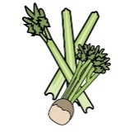 | 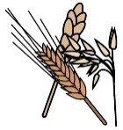 | 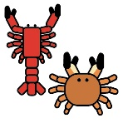 | 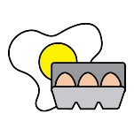 | 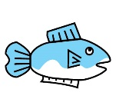 | 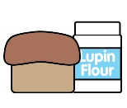 | 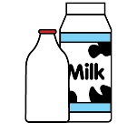 |  | 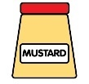 | 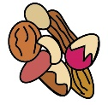 | 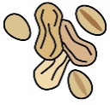 | 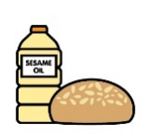 |  | 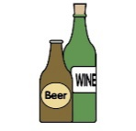
Monday | Celery | Cereals containing gluten* | Crustaceans | Eggs | Fish | Lupin | Milk | Mollusc | Mustard | Nuts† | Peanuts | Sesame seeds | Soya | Sulphur Dioxide
Mozzarella meatball melt | ✓ | ✓ |  | ✓ |  |  | ✓ |  | ✓ |  |  |  | ✓ | ✓
Mozzarella no-meatball melt |  |  |  |  |  |  | ✓ |  |  |  |  |  | ✓
Croissant and fruity jam |  | ✓ |  | ✓ |  |  | ✓ |  |  |  |  |  | ✓
Yoghurt |  |  |  |  |  |  | ✓
Fruit
GF/DF:No-meatball tomato pasta |  |  |  |  |  |  |  |  |  |  |  |  | ✓
GF/DF:Pancake and fruity jam |  |  |  | ✓
Vegan:No-meatball tomato pasta |  | ✓ |  |  |  |  |  |  |  |  |  |  | ✓
Vegan:Pancake and fruity jam
Jacket and cheese |  |  |  |  |  |  | ✓
Pasta |  | ✓
Salad | ✓
Vegetables
Cheese for jackets |  |  |  |  |  |  | ✓
Bread |  | ✓
Packed lunches |  | ✓ |  |  |  |  | ✓ |  |  |  |  | ✓

Dishes
Tuesday | Celery | Cereals containing gluten* | Crustaceans | Eggs | Fish | Lupin | Milk | Mollusc | Mustard | Nuts† | Peanuts | Sesame seeds | Soya | Sulphur Dioxide
Chicken Caesar salad wrap |  | ✓ |  | ✓ | ✓ |  | ✓ |  | ✓
Vegetable Caesar salad wrap |  | ✓ |  | ✓ | ✓ |  | ✓ |  | ✓
Apple pie and custard |  | ✓ |  | ✓ |  |  | ✓ |  |  |  |  |  | ✓
Yoghurt |  |  |  |  |  |  | ✓
Fruit
GF/DF:Chicken nugget salad wrap
GF/DF:Fruit cookie |  |  |  |  |  |  |  |  |  |  |  |  |  | ✓
Vegan:Veg nugget salad wrap |  | ✓
Vegan:Fruit cookie |  |  |  |  |  |  |  |  |  |  |  |  |  | ✓
Jacket and beans
Potatoes
Salad | ✓
Vegetables
Beans for jackets
Caesar dressing for wraps |  | ✓ |  | ✓ | ✓ |  | ✓ |  | ✓
Custard for pudding |  | ✓ |  | ✓ |  |  | ✓ |  |  |  |  |  | ✓
Bread |  | ✓
Packed lunches |  | ✓ |  |  |  |  | ✓ |  |  |  |  | ✓

Dishes
Wednesday | Celery | Cereals containing gluten* | Crustaceans | Eggs | Fish | Lupin | Milk | Mollusc | Mustard | Nuts† | Peanuts | Sesame seeds | Soya | Sulphur Dioxide
Sausage roast dinner |  | ✓ |  |  |  |  |  |  |  |  |  |  | ✓ | ✓
Quorn sausage |  | ✓
Chocolate brownie |  | ✓ |  | ✓ |  |  | ✓ |  |  |  |  |  | ✓
Yoghurt |  |  |  |  |  |  | ✓
Fruit
GF/DF:Roast sausage |  |  |  |  |  |  |  |  |  |  |  |  |  | ✓
GF/DF:Chocolate brownie
Vegan:Herby banger |  |  |  |  |  |  |  |  |  |  |  |  | ✓
Vegan:Chocolate brownie
Jacket tuna mayo sweetcorn |  |  |  | ✓ | ✓ |  |  |  | ✓
Roast potatoes
Vegetables
Tuna mayo for jackets |  |  |  | ✓ | ✓ |  |  |  | ✓
Yorkshire |  | ✓ |  | ✓ |  |  | ✓
Gravy
Gluten free Yorkshire |  |  |  | ✓ |  |  |  |  |  |  |  |  | ✓
Bread |  | ✓
Packed lunches |  | ✓ |  |  |  |  | ✓ |  |  |  |  | ✓

Dishes
Thursday | Celery | Cereals containing gluten* | Crustaceans | Eggs | Fish | Lupin | Milk | Mollusc | Mustard | Nuts† | Peanuts | Sesame seeds | Soya | Sulphur Dioxide
Bolognese jacket potato
Veg bolognese jacket potato |  | ✓
Iced apple cake |  | ✓ |  | ✓ |  |  | ✓ |  |  |  |  |  | ✓
Yoghurt |  |  |  |  |  |  | ✓
Fruit
GF/DF:Bolognese jacket potato
GF/DF:Iced apple cake
Vegan:Veg bolognese jacket |  | ✓
Vegan:Iced apple cake
Jacket and cheese |  |  |  |  |  |  | ✓
Jacket potatoes for bolognese
Salad | ✓
Vegetables
Bread |  | ✓
Packed lunches |  | ✓ |  |  |  |  | ✓ |  |  |  |  | ✓

Dishes
Friday | Celery | Cereals containing gluten* | Crustaceans | Eggs | Fish | Lupin | Milk | Mollusc | Mustard | Nuts† | Peanuts | Sesame seeds | Soya | Sulphur Dioxide
Hot dog | ✓ | ✓ |  |  |  |  | ✓ |  | ✓ |  |  | ✓ | ✓
Cheese and tomato pizza |  | ✓ |  |  |  |  | ✓
Ice cream and fruit |  |  |  |  |  |  | ✓
Yoghurt |  |  |  |  |  |  | ✓
Fruit
GF/DF:Hot dog |  |  |  | ✓
Gf/DF:Ice lolly
Vegan:Vegetable burger |  | ✓
Vegan:Ice lolly
Jacket and beans
Chips
Salad | ✓
Beans
Ketchup | ✓
GF/DF rolls for hot dogs |  |  |  | ✓
Rolls for hot dogs |  | ✓ |  |  |  |  |  |  |  |  |  | ✓ | ✓
Bread |  | ✓
Packed lunches |  | ✓ |  |  |  |  | ✓ |  |  |  |  | ✓

Review date: | 23.06.2025 | Reviewed by: | J Honess |  | 

