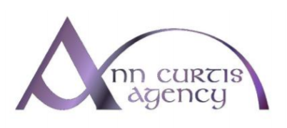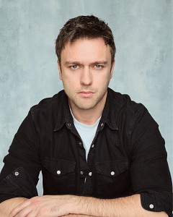
RICHARD Mc WILLIAMS

Eyes: Blue Hair: Brown Height: 5 11
Full Driving License: Yes, Additional Information:
Accents: American-California American-East Coast American-New England
American-Standard Dublin English-Standard Irish-Northern Irish-Southern RP
Showreel URL: https://app.spotlight.com/8017-9051-1807
Skills: Improvisation/ ADR-Additional Dialogue Recording, Commedia Dell ‘Arte Green Screen Meisner Technique Outdoor Performances, Horse-riding, Stage Combat

FILM & TV.
Harry Wild Role: Tadhg Farrell Director: Robbie Quinn Company: Metropolitan Pictures, Dynamic Television, Acorn Media Enterprises.
They Can’t Know About Me: Role: Frank Director: Michael Carolin Company: Western Front Studios

Loves Portrait Feature Film Role: William Director: John Lyde Company: Hallmark-Silver Peak Productions

Vikings T.V. Year: 2017Director: Various Role: Aethburth Company: World 2000 Entertainment

Fair City T.V Role: Michael O Brien Director: Various Company: RTE

Deadly Buzz Television Role: Jonjo Director: Christian Kraig Company: RTE

Shadow CabalT: Feature Film, Role: Keltus Director: John Lyde Company: Alarm Clock Films

Dawn of the Dragon Slayer: Feature Film Role: Will Shepherd Director: Anne Black Company: Arrow storm Entertainment

THEATRE

Doing Time: Stage Role: Mart Director: Paul Winters Company: Moat Theatre

Hamlet: Stage Role: Hamlet Director: Liam Halligan, Company: Smock Alley Theatre

Sanctuary Lamp: Stage Role: Francisco Director: Paul Brennan Company: Samuel Beckett Centre

The Comedy Of Errors Stage Role: Antipholus of Syracuse Director: Kristian Marken Company: Public Shakespeare Company

Casa Lisa: Stage Role: Declan Director: Liam Halligan Company: Quare Hawks

Richard III Type: Stage Role: Gloucester Director: Liam Halligan Company: Quare Hawks

Training: Gaiety School of Acting full time professional actor training, Focus Theatre Stanislavski Training, 1 year
Terry McMahon workshops, Gerry Grennell Bow Street Academy workshops

