Expectations and Guidelines for Candidates

The following are some expectations for those wishing to receive the Gifts of the Holy Spirit at Confirmation, a sacrament that completes the baptismal vows taken by parents and godparents at Baptism.

Expectations:

1. Being a Baptized Catholic or being received into the Catholic Church after Christian Baptism is required to be confirmed. We will contact you for a copy of your teens Baptismal Certificate if we do not have one on file.
2. Participation in ALL Confirmation sessions and Spirit Day Retreat.
3. Participation in the life of the church community that enables one to become a confirmed full member of the Catholic Church including, but not limited to: weekly Mass, daily prayer, reception of Reconciliation and the Eucharist, religious education in the context of Catholic Day School or PSR.
4. More fully developing one’s relationship with God.

# Selecting a Sponsor

A sponsor for Confirmation must be…

* At least sixteen years of age, but preferably an adult member of the Church.
* Fully initiated through the sacraments of Baptism, Eucharist, and Confirmation.   
  If married, in a marriage recognized by the Catholic Church.
* A practicing Catholic in good standing with the Church.
* A candidate may have a sponsor that is male or female but cannot be the parent of the candidate.
* Candidates may wish to choose one of their baptismal godparents to be their Confirmation sponsor, emphasizing the important relationship between the two sacraments.

All sponsors need to complete a Sponsor Commitment Form that is due October 16th. This form will be emailed to the parents to forward to the sponsor.

# DATE COMPONENT TIME LOCATION

* Material Due

**September 6 Opening Session #1** 2:00-4:15pm Olsavsky Center

4:30-5:30pm Mass Church

**September 25** **Session #2** 6:30-8:00pm Church/School

**\*October 16** **Session #3** 6:30-8:00pm Church/School

**\*Sponsor commitment form due**

**October 30 Sponsor Meeting** 7:00-8:15pmParish Hall

**\*November 13** **Session #4** 6:30-8:00pm Church/School

\***Confirmation** **Name Due**

**December 4 Session #5** 6:30-8:00pm Church/School

**January 8 Session #6** 6:30-8:00pmChurch/School

**\*February 21 Spirit Day Retreat** 10:00am-4:15pm Olsavsky Center

4:30-5:30pm Mass Church

**\*Service project record forms due (they can be turned in at any time during the year when service is done and form is completed).**

**\*Sponsor/Candidate Interview form due**

**March TBD Sponsor/Candidate** TBD SJA Church

**Practice**

**March 18** **Confirmation Mass**  7:00pm SJA Church

All forms will be emailed and can also be found on the SJA website: [www.stjoanofarcchurch.org](http://www.stjoanofarcchurch.org) under the Sacraments/Confirmation tabs. All forms may be submitted via email to: [officeoffaithformation@stjoanofarc.org](mailto:officeoffaithformation@stjoanofarc.org) or by USPS, or drop off.

**Components of the Preparation Process for the Reception of Confirmation**

**Faith Formation**  Instructional sessionsthat further each student’s religious education and encourage group faith sharing throughout each gathering.

**Faith Sharing**  Faith sharing between sponsor and candidateincludes staying in communication throughout the formation process and building a relationship based on shared Christian values.

**Confirmation Name** Each candidate will select a name that is meaningful to them; either a saint or a person of faith in their life that they admire.

Confirmation names are due Nov. 13th.

**Service Experience** We ask students to participate in 10 service hours prior to Confirmation. We want to encourage each student to live out their Christian calling to serve and to be a living witness to Christ in their community. We encourage students to try to perform some of the service hours with their sponsor. Service Record Forms are due February 21st.

**Spirit Day Retreat** Candidates will participate in a Spirit Day Retreat February 21st. The retreat will include the Sacrament of Reconciliation and Mass.

**Candidate Interview** After spending time with their candidate throughout these preparation months, we ask the candidate and sponsor to complete a brief questionnaire in person or via a video platform such as facetime. The interview sheet (to be filled out by the sponsor and given out to them at the Sponsor Meeting) is due by February 21st at the Spirit Day Retreat or it can be submitted via email to: [mvincenti@stjoanofrarc.org](mailto:mvincenti@stjoanofrarc.org)

**On-Going** During the Confirmation preparation year, candidates are

**Faith Formation** encouraged to take advantage of opportunities for prayer, and service through Youth Ministry in the Parish.

**Prayer Tim Fee:** There is a $60.00 Confirmation fee. This fee helps defray the cost of books,materials, instructional presenters, Spirit Day Retreat, Confirmation certificates, etc.

**Materials:** Each candidate will receive a folder containing: candidate session handouts, a Service Project Idea sheet, a Service Record Form, and this Confirmation Process Booklet.

Receive the Holy Spirit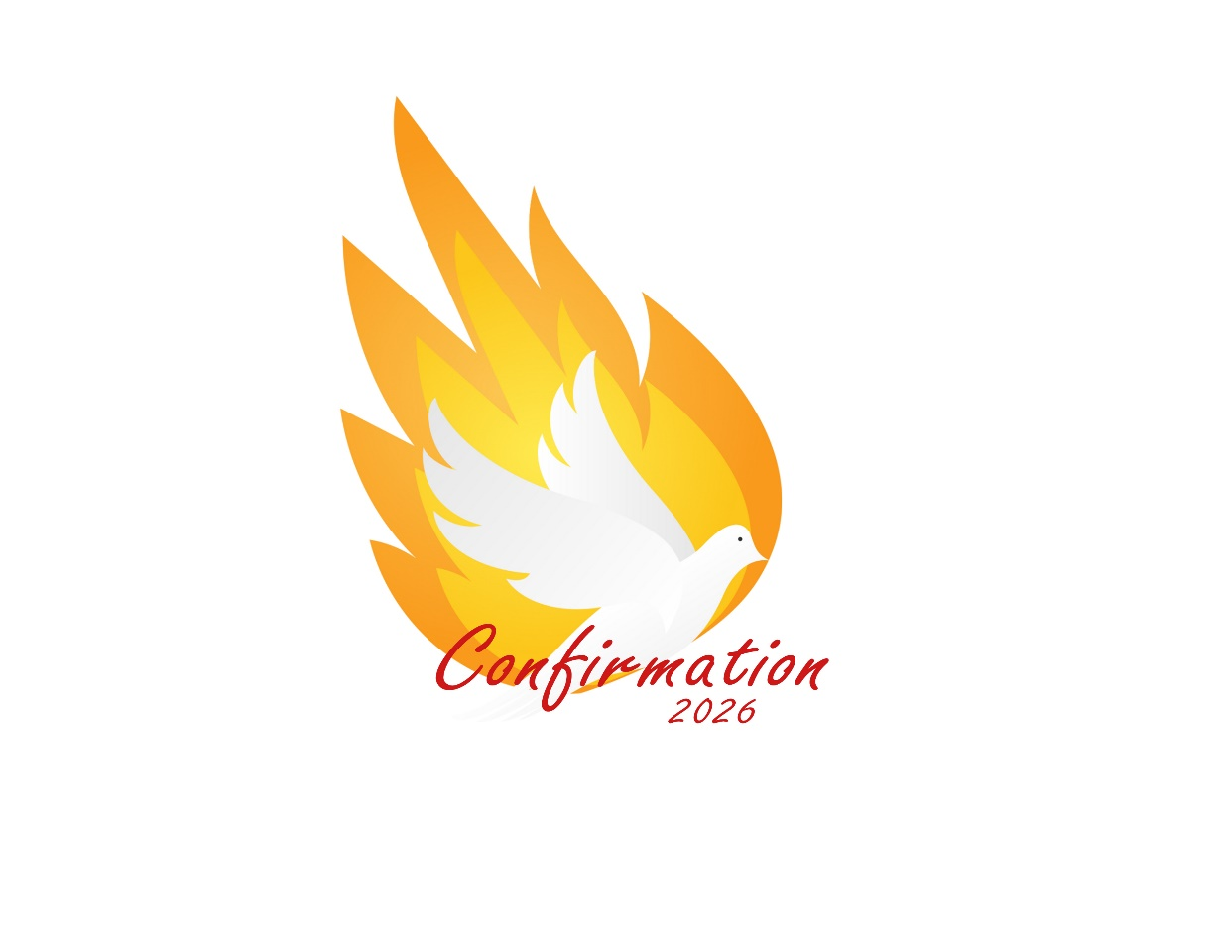

**Confirmation Process**

**St. Joan of Arc Church**

**2025-2026**