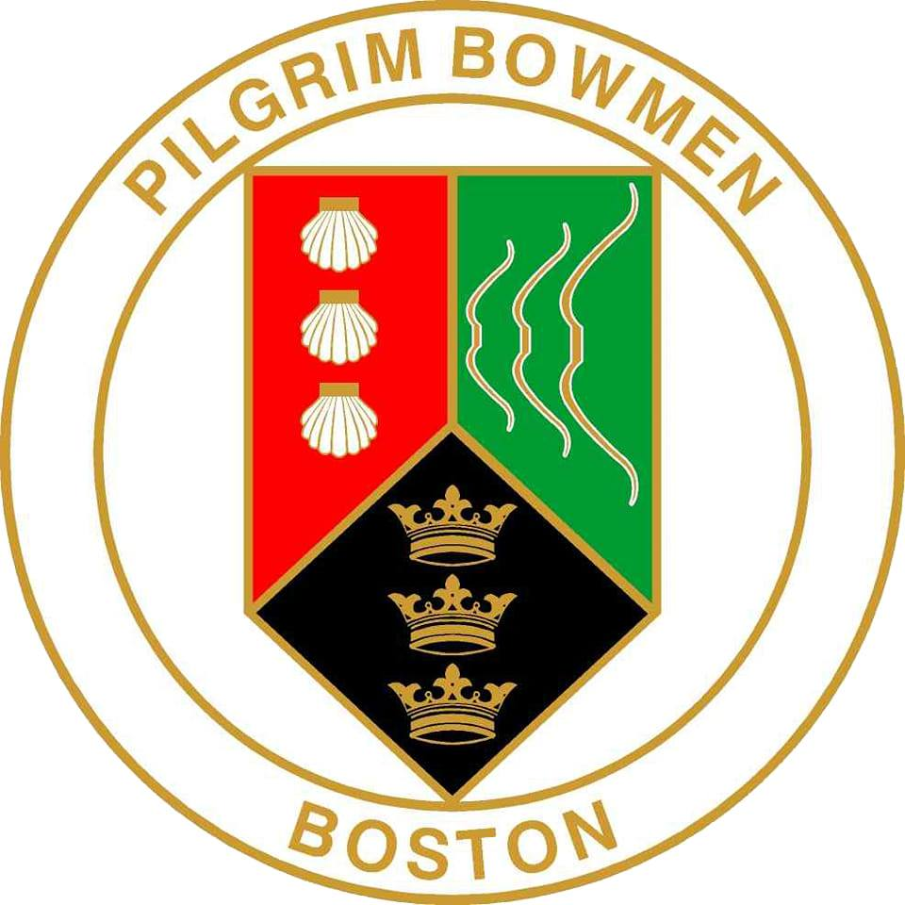Pilgrim Bowmen of Boston – Brass Monkey Shoot

American Round – By Request: Short American 40/30/20

The Pilgrim Bowmen of Boston invite you to take part in the Brass Monkey Shoot, featuring an American Round, including a Short American at distances of 40, 30, 20yards by request. The event will take place on Sunday, 15th February 2026, at the Mayflower Sports Ground, Rosebery Avenue, Boston, PE21 7QR. Sighters will begin at 11.00am.
Entry fees are set at £10.00 for seniors and £8.00 for juniors. Please send payment by BACS to Pilgrim Bowmen, Sort code 30-63-47, Account number 41413760, using the reference BM26-Surname.

All entries should be sent to:
Ben Beck, 83 Hardwick Estate, Kirton, Boston, PE20 1HQ
Email: benbeck88@outlook.com (entry by email is preferred but not mandatory)
Phone: 07596 882043

Photography
If you wish to take photographs at the event, please register with the organisers.

Special Requirements
If you need special arrangements due to disability or other reasons, please notify the organisers at the time of entry.

All rounds will be shot in ends of six arrows.

The closing date for entries is 1st February 2025

Entry Form
Name | Club | AGB No | G/L/J | American 60/50/40 or short American 40/30/20 | Style | Fee

Contact Details Refund details, in case of cancellation.
Name ………………………………………………
Phone ……………………………………………… Account number ……………………….
Email ………………………………………………
Sort code ……………………………….

Data Protection and Privacy
When entering the competition, data may be collected and shared with tournament organisers, scoring systems, and other competitors. Target lists and results lists may be published and may include: first name, gender, bow style, age category, club, round shot and AGB number, disabled (Y/N)

