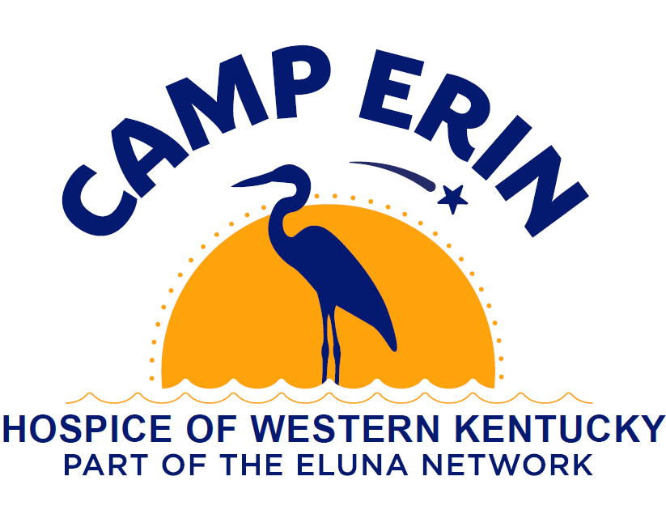
Who: Children and teens (age 6-17)
What: Largest national bereavement program for youth grieving the death of a loved one.
When: July 31st - August 2nd 2026
Where: Gasper River Youth Camp & Retreat Center (2695 Jackson Bridge Rd, Bowling Green, KY 42101)
Objectives:
- Normalize the grief process through bereavement education and support.
- Decrease the camper’s sense of isolation felt while grieving.
- Provide a framework for campers to process their grief in healthy ways.
- Build a toolbox of coping skills and resources that campers can use during and after camp.
- Allow campers the opportunity to remember, honor, and memorialize those who have died.
- Have fun!
It is:
- FREE!!!
- 3 days 2 nights (Friday afternoon/evening-drop off, Full Saturday, Sunday morning noon’ish pick-up)
- Largely outdoors
- Transportation from Owensboro will be an option
It is NOT:
- A licensed health care provider and does not provide counseling, psychological, psychiatric or other health care services to camp participants.

For more information contact Caleb Potter with Hospice of Western Kentucky

Phone: 270.316.9112
Email: cpotter@hospiceofwky.org

