INVITATION TO GIVING
PRAYER OF DEDICATION
ALL: Holy Father today we offer to you the thanks of our hearts for our salvation in Jesus Christ, the abiding presence of your Holy Spirit and the guidance from your holy word. Accept these gifts as tokens of our gratitude and bless them to the end that others might come to know your love through Jesus Christ. Amen.

DOXOLOGY

BENEDICTION

CONG. RESPONSE: # 69 (Refrain)

Music Director: Mark Smith Organist: Gay Smith
Liturgist Today: Mark Smith
Ministers: All members of the Congregation
Guest Minister Today: Pete Hill

220 E. Franklin Street
Clinton, MO 64735
660-885-5181
Website: fpcclintonmo.net
Email Address: pcclintonmo@gmail.com


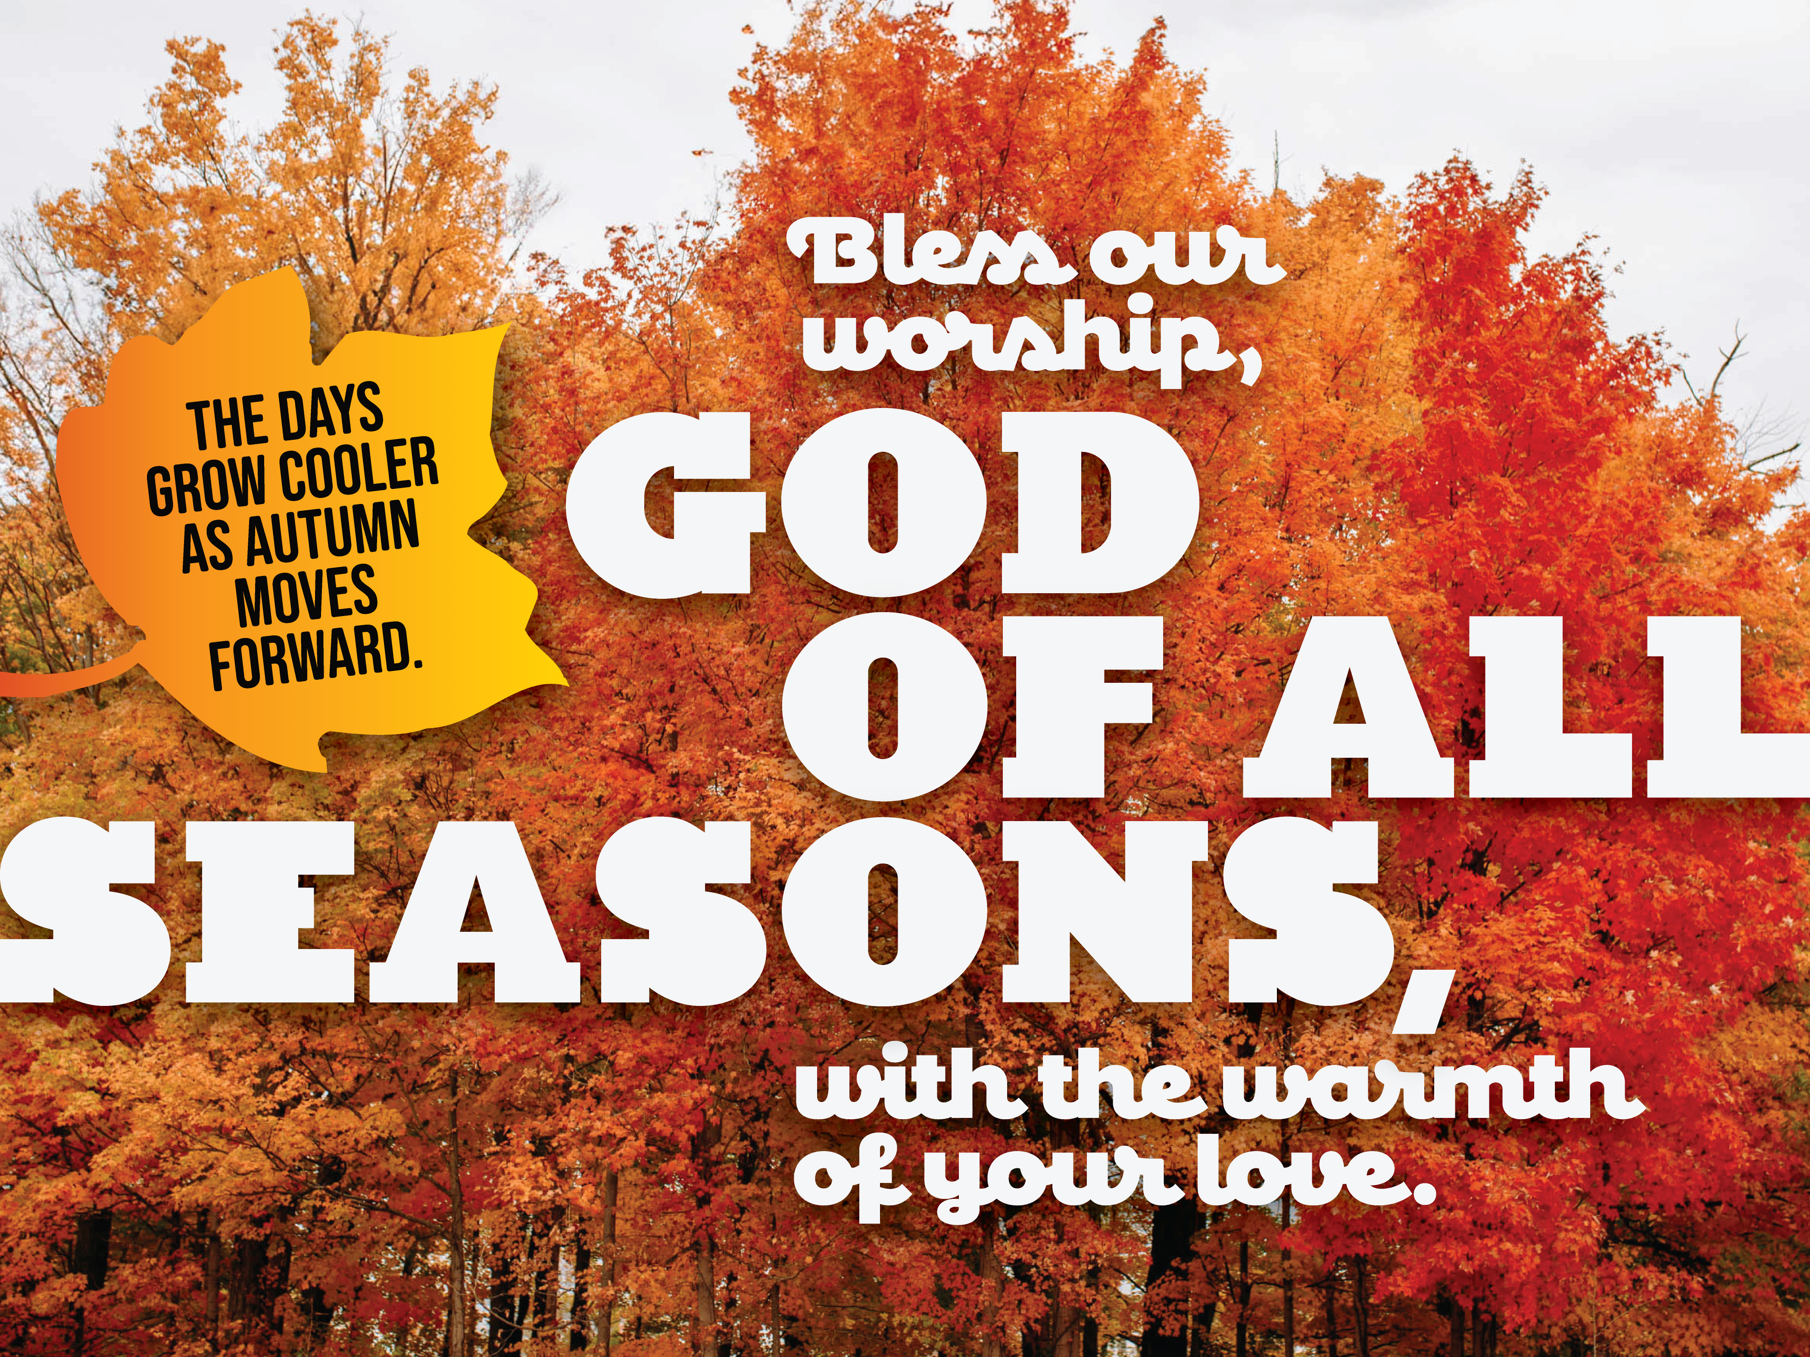
The First Presbyterian Church Clinton, Missouri October 12, 2025
 means those who are able may stand

PRELUDE

WELCOME AND ANNOUNCEMENTS

CALL TO WORSHIP
ONE: God blesses us with health, courage, faith and mercy.
ALL: We will praise God’s name.
ONE: Our God will supply all our needs according to his riches in Christ Jesus.
ALL: Let us give thanks to the Lord for his unfailing love and his wonderful deeds.

 HYMN: #761 Called as Partners in Christ’s Service

CALL TO CONFESSION

QUIET SELF REFLECTION

PRAYER OF CONFESSION
ALL: Faithful God, we come before you with many issues on our hearts. We get frustrated and angry at the way things are going in the world. When we don’t see your immediate intervention we are quick to dismiss you and any thought of your presence. Help us stop our selfishness and our quick anger. Release us from the
traps of quick tests of your faithfulness and help us see the “big picture” of your awesome love that spans all time. Help us shout your praises and live lives of joyful service. Amen.
WORDS OF ASSURANCE
ONE: It is God who provides all that we need, body and soul. When we are hungry and weak God maintains our spirit and holds us in the embrace of his eternal love. Give thanks to God and praise His name.
ALL: In Jesus Christ we are forgiven! Amen

STATEMENT OF FAITH (see insert)

ANTHEM We’re a Fellowship of Believers by Althouse

SCRIPTURE John 15: 12 - 17

MESSAGE Love is Something You Do Pete Hill

HYMN #693 Though I May Speak

PRAYERS OF THE PEOPLE THE LORD’S PRAYER
ALL: Our Father, who art in heaven, hallowed be thy name. Thy kingdom come, thy will be done, on earth as it is in heaven. Give us this day our daily bread, and forgive us our debts, as we forgive our debtors; and lead us not into temptation, but deliver us from evil. For thine is the kingdom, and the power, and the glory, forever. Amen.

