**England Netball –**

**East Midlands Regional Association**

**AGM**

**25th June 2025**



**England Netball East Midlands Region AGM**

**25th June 2025**

**AGENDA**

|  |  |
| --- | --- |
|  | Welcome |
|  | Apologies |
|  | Introduction of Regional Management Board |
|  | Appointment of Tellers |
|  | Voting Strength |
|  | Minutes of the last AGM |
|  | Regional Team's report |
|  | TSG reports: ROG, Competition; Officiating; Volunteer and Club Development |
|  | Governance & Finance report & Accounts |
|  | Acceptance of accounts |
|  | Proposed resolution changes to the constitution |
|  | Nominations & Election of Officers |
|  | Vote of Thanks |
|  | Close |

**1**

**East Midlands Regional Netball Associatio****n**

|  |  |  |  |  |  |  |
| --- | --- | --- | --- | --- | --- | --- |
| **Minutes of Annual General Meeting** | | | | | | |
| Date/Time | 27 June 2024 7pm-7:32pm | | Location | Zoom | | |
| **Attendees** | | **Initials** | **Representing** | **Attendees** | **Initials** | **Representing** |
| Sue Hunter | | SH | Regional Chair | Ruth Swaby | RSw | Boots NC |
| Sue Connor | | SC | Regional Vice Chair | Ian Marron | IM | Charnwood Rutland NC |
| Sarah Hollidge | | SHo | RMB- Appointed | Kathy Cox | KC | Grasshoppers NC |
| Liz Broomhead | | LB | RMB-Elected (unable to vote) | Val Kindred | VK | Knighton NC |
| Andy Scigliano | | AS | RMB-Elected | Elaine Spary | ES | Loughborough Town Netball League |
| Pam Weatherby | | PW | Nottinghamshire County | Rowena Hackwood | RH | Mollbuzzers NC |
| Kathy Stripp | | KS | Leicestershire County | Caroline Richards | CS | Stiletto NC |
| Charlie Sizer | | CSi | Derbyshire County | Rebecca Randell | RR | Swadlincote NC |
| Carol Spencer | | CS | Competition TSG |  |  |  |
| Jo Sharrock | | JS | Officiating TSG | Donna Palmer | DP | England Netball Partnership & Delivery Manager (non-voting) |
| Mary Yardley | | MY | Volunteer and Club Development TSG | Eleanor Udall | EU | England Netball Regional Officer (non-voting) |

|  |  |  |  |  |
| --- | --- | --- | --- | --- |
| **Apologies** | **Initials** |  |  | **Circulation List** |
| Morgan Williams | MW | RMB Appointed Member |  | Attendees |
| Sue Connor | SC | RMB Elected Member (Vice Chair) |  | Apologies |
| Mary Yardley | MY | Volunteer and Club Development TSG |  |  |
| Pam Weatherby | PW | Nottinghamshire Chair |  |  |
| Jenny Smith | JS | Melton Marvels |  |  |
| Yvonne Blunt | YB | Northamptonshire County Chair |  |  |

|  |  |  |
| --- | --- | --- |
| **Ref** | **Minutes** | **Led by** |
| **1.0** | **Welcome** | SH |
| **2.0** | **Apologies**   * As above | SH |
| **3.0** | **Introduction of the Regional Management Board** (RMB)   * Regional Management board and TSG leads were introduced and their role. | SH |
| **4.0** | **Appointment of Tellers**   * 2 tellers appointed – VK and KC | SH |
| **5.0** | **Voting Strength**   * 18 | SH |

**2**

|  |  |  |
| --- | --- | --- |
| **6.0** | **Minutes of 2024 AGM**   * These minutes were accepted as a true and correct record - Proposed: VK, Seconded: RS | SH |
| **7.0** | **Chair’s Report**   * The chair addressed the meeting and gave her report- Appendix 2. * Special thanks to RMB members, ROG, TSG Chairs and group members, coaches, officials, table officials and all the unsung heroes for all their support and continued hard work throughout the region. * Thanks also to all past and present staff members for all you do for the region- Ruby Mahal, Megan Sayers, Louise Key, Kelly Thomson, Ruth Pickthorn, Eleanor Udall, Claire Bowen, Donna Palmer. Best of luck was wished to Ruth on her move to Cornwall. | SH |
| **8.0** | **Regional Team and Regional Chair’s Presentation**   * Regional Achievements * Appendix 3 * EU and DP presented the Regional Office report * East Midlands Staff have achieved significant netball delivery across the England Netball programmes, and across the counties. Membership continues to grow and it reflects all the work that EN and the region work in partnership together on.   SH thanked by DP for her kind words for East Midlands team and it is their privilege to work with such a fantastic board and region of volunteers. | SH/EU/DP |
| **9.0** | **TSG Report**   * SH explained all reports were in the AGM pack which had been distributed prior to AGM- Appendix 4 | SH |
| **10.0** | **Accounts Report and Acceptance of Accounts**  Appendix 5 (accounts and supporting notes). | SH |
| **11.0** | **Acceptance of Accounts**   * Floor accepted accounts true and correct. * Accepted as true and accept record. – Proposed by VK and seconded by JS. | SH |
| **12.0** | **Constitution- Proposed Resolutions**   * Changes to 7.8 regarding expenses referencing the by-laws (increasing to HMRC recommendations). * Changes agreed: 16 (2 not on camera to vote)   Constitution proposed changes are accepted as true and correct. | SH |
| **13.0** | **Nominations and Election of Officers**   * Re-standing of all board members: agreed: 16/16. * RH applied for Regional Chair position: agreed: 16/16. * Acceptance as true and correct- VK and KC agreed * RH congratulated as now the Regional Chair of East Midlands. She extended her thanks to Sue and looks forward to working with everyone. | SH |
| **14.0** | **Vote of Thanks**   * VK on behalf of members, clubs and counties, thanked to Sue and the RMB and TSGs on a great job, especially for SH as off coming Regional Chair. * SH thanked all those in attendance. | VK |
| **15.0** | **Close -7:32pm** | SH |

**East Midlands Regional Netball Association**

**3**

**East Midlands Regional Netball Association**

**Appendix 1- Regional Management Board Structure Diagram**

**4**

**East Midlands Regional Netball Association**

**Appendix 2- Chair Report 2024**

Having delivered my first chairman’s report in June 2009, I find it hard to believe that writing this is fifteen years on!

In those dark and distant days, Regional Goalden Globes as One Awards were known then were presented at our AGM and there was only a national celebration event. You can see from the photos currently being shown we were all younger and fitter then!! However, looking at the personnel we are all still involved. This illustrates what a great bunch of resolute volunteers we have within the East Midlands Region. All I can say about the winners is that 2009 was Leicestershire’s year taking five Goalden Globe Awards and two out of three Jean Staley regional awards.

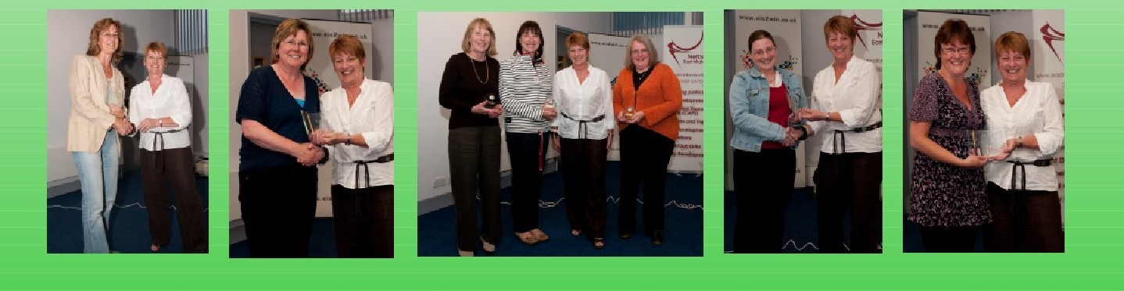

Here ends the history lesson!

Moving swiftly on, and, in approximately forty-five minutes time, you will be voting for my replacement, and I will be handing over the mantel of Regional Chair. Never for a moment did I expect when I took on the role, I would I still be here fifteen years later!

I am grateful that I have this opportunity to offer sincere and special thanks to specific volunteers, namely the Regional Management Board, Regional Operating Group and Technical Support Groups for putting up with me for so long. The support throughout my tenure has been amazing; these groups give so much to facilitate Netball within the East Midlands thank you all you do an exceptional job.

Thanks, must also go to all regional members and volunteers, all the team managers, coaches, umpires, table officials, the unsung heroes who wash the kit and share their cars, not forgetting the parents who transport the juniors. All of whom give freely of their time and ability to ensure that netball in the region happens.

On the 7th of July at the Raddison Blu Hotel, Castle Donnington, we will be celebrating the amazing contribution of some of these volunteers when we host our regional “One Awards”. Again, this year we have exceeded the nominations received across all national and regional award categories. All nominations are anonymised, and every county is asked to participate along with the previous year’s young volunteer, a board member & Volunteer and club TSG Chair, in the selection process and boy what a task they have, thank you all for carrying out such and onerous time-consuming task we couldn’t celebrate the volunteers without you.

We continue to have two teams from the region in the National Premier League namely Charnwood Rutland in Premier Division 1 finished seventh and Northants Storm in Premier Division 3 finished 3rd. This is a fantastic achievement by both teams, and we congratulate you all on the hard work and endeavour to remain within this league.

Our regional presentation along with the reports from the Regional Operating Group and Technical Support Group Chairs, details all the data and regional achievements for the past year. You will note on the Regional Management Group Structure that we have created a sub-group of Governance and Finance. This group covers the topics Of Safeguarding, Equity & Diversity and Neuro Diversity, which are growing in relevance in all sports today and I can only say thank you to

**5**

**East Midlands Regional Netball Association**

members for stepping up and accepting the responsibility. Each member has specific knowledge and qualifications in each of the topics. Indeed, this group hosted an introduction/foundation conference early this year attended by over thirty people and are there to help regional members going forward and are planning further workshops soon.

Finally, a special thanks to all regional England Netball Staff past and present, led by Donna Palmer, Partnership and Delivery Manager who are an amazing bunch and go beyond their roles to support the region. Eleanor Udall Regional Officer, Claire Bowen Derbyshire & Nottinghamshire NDO, Ruby Mahal previously Leicester NDO, Megan Sayers Leicestershire NDO, Louise Key Lincolnshire NDO, Kelly Thomson Northants NDO, and finally Ruth Pickthorn Nottinghamshire NDCC and our amazing “One Awards” host, who unfortunately, advises she is leaving the region and moving to Devon, although she advises she will come back to host our awards, we will miss you Ruth and hold you to returning for the “One Awards”.

Sue Hunter

Regional Chair

**6**

**East Midlands Regional Netball Association**

**Appendix 3- East Midlands Regional Office Report**



**Regional Achievements**

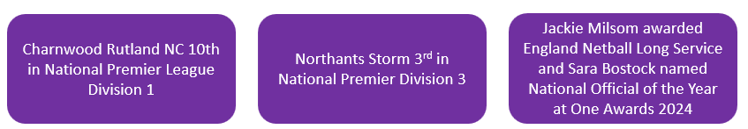

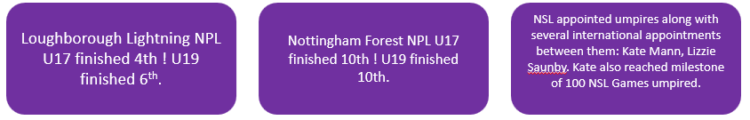

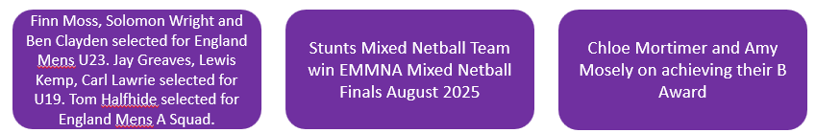

**7**

******East Midlands Regional Netball Association**

**Regional Achievements**

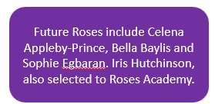

**Regional Achievements**

Coach of the Year – Children & Young People – Jackie Gallagher

Coach of the Year - Adults - Jennifer Williams

Community Official of the Year (in honour of Sheelagh Redpath) – Sara Bostock

Outstanding Contribution of the Year (in memory of Mary Bulloch) – Ursula Hammond

Pioneer of the Year (in memory of Muriel McNally) – Beth Jackson

Unsung Hero of the Year (in a Club or League) – Sarah Cottrell

Club of the Year - Hawks Netball Club

Young Volunteer of the Year – Amelia Hockey

Teacher of the Year – Tracy Elliott

Inclusion Award – Hawks Netball Club

East Midlands Jean Bourne Back to Netball Award - Marianne Turvill

East Midlands Jean Perkins Walking Netball Award – Carol Smikle

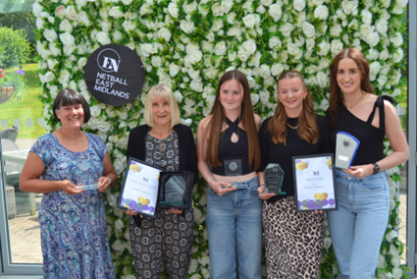East Midlands Jean Staley Award – Jane Morrell

East Midlands Long Service Award – Liz Alop

East Midlands Long Service Award – Sarah Hollidge

East Midlands Special Recognition – Sue Hunter

East Midlands Special Recognition – Andy Scigliano

East Midlands Special Recognition – Debbie Hopkinson

East Midlands Special Recognition – Maria Shaw

East Midlands Special Recognition – Debbie Edwards

**8**

**Ea****st Midlands Regional Netball Association**



**Programme Delivery**

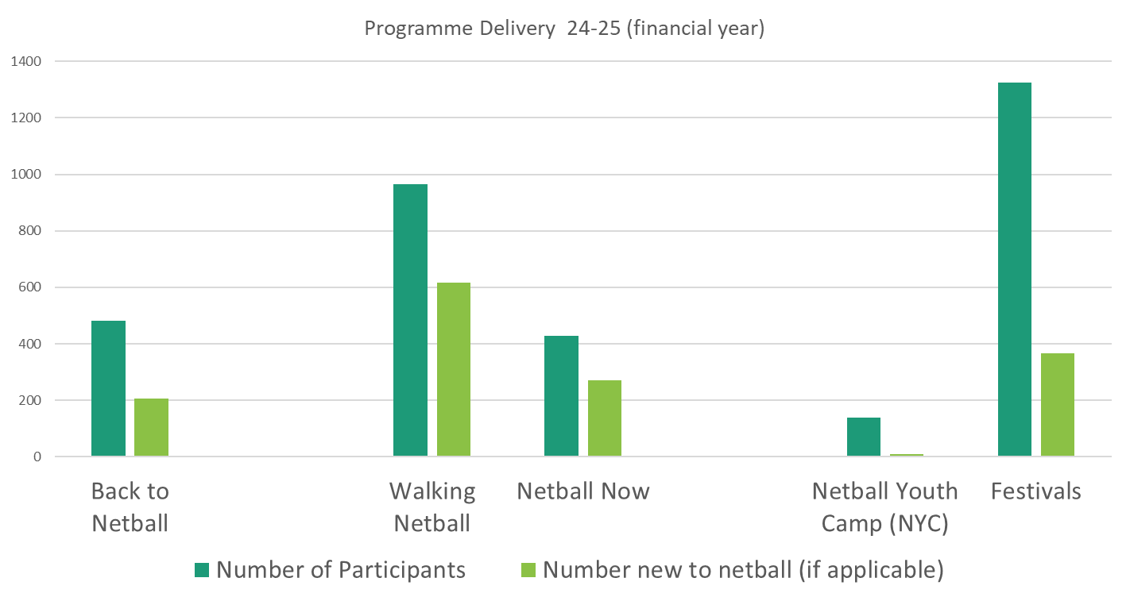



**County Delivery**

**9**

**East Midlands Regional Netball Association**



Membership

**104% members have renewed**

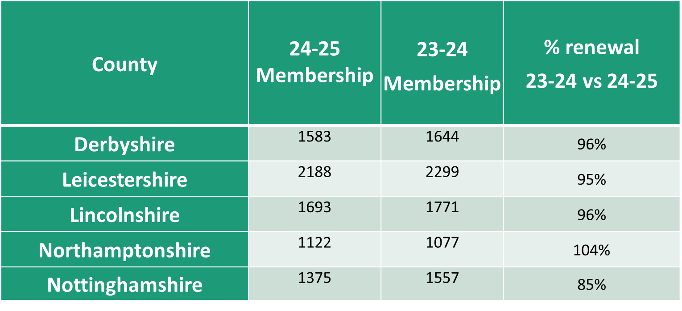



Membership category breakdown

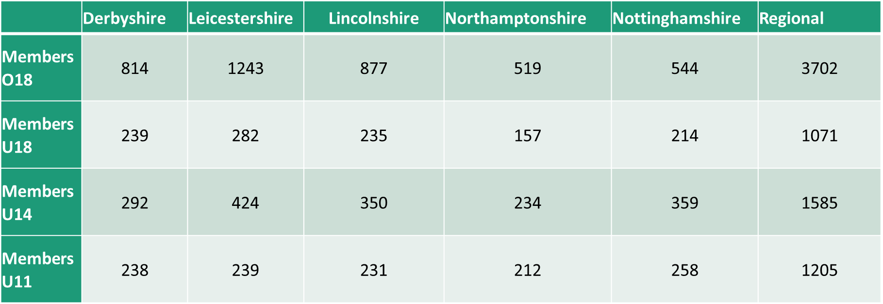

**10**

**East Midlands Regional Netball Association**

**Courses Coaching**

Level 1 Coaching has continued to go virtual

Level 2 Coaching has continued to be a blended course of virtual and practical delivery.

England Netball Coaching Level 1- Now virtual, 33 awarded learners

England Netball Coaching Level 2- 2 courses delivered, 15 learners awarded

Walking Netball Host Training- 7 learners awarded

**Courses Officiating**

Into and C Award Officiating course delivery has continued to be virtual.

Into and C Award Officiating course delivery has continued to be virtual.

1 new A Award umpire (Clare Kitchen)

2 new B Award umpires

26 new C Award umpires

74 Into Officiating Awards

**Coming Up – 25-26**

6th July- NSL Grand Final (O2 Arena)

6th July- East Midlands One Awards (Raddison Blu, East Midlands)

October- National One Awards TBC

**11**

**East Midlands Regional Netball Association**

**Regional Operating Group (ROG) Chair’s report**

Sue Connor

Purpose of this paper: To provide a summary of the work of ROG during 2025.

Detail:

The Regional Operating Group (ROG) has consisted of the following members:

• Sue Connor ROG Chair

• Carol Spencer Competition TSG Chair

• Jo Sharrock Officiating TSG Chair

• Mary Yardley Volunteering & Club TSG Chair

• TBA Coaching TSG Chair

ROG performs the following roles:

• A delegated decision-making group for operational issues

• Agrees the content of Key Focus Areas and other operational agenda items

• Approves grant funding requests up to £1000 on behalf of RMB

• A communications forum to ensure coherent planning and delivery

• Oversees, on behalf of RMB, the coherent implementation of an agreed Regional Strategy

The group is responsible for working towards the targets set by the Region in line with the England Netball Plans. These plans reflect the needs of the Region in relation to the development of clubs, schools, volunteers, players, coaches, officials and competition.

The TSGs were formed in 2013, and they play a vital role in the development of netball throughout the region and without them we would not function. All counties are invited to have representatives on each of the TSG groups to help support the work of their CNA and the Region.

The groups have been chaired by amazing leaders throughout so many years and even prior to the formation of the TSGs, the same leaders were managing competition, coaching and officiating. However, we are now ready for a change of leadership as there have been a number of resignations.

Carol Spencer has been leading the Competition structure for so many years and has seen it increase and develop to include more teams and better competitive opportunities for all ages. Her attention to detail has been incredible and she has led and supported the hard-working members of the group. The new Chair of Competition will be Carla Garey, who has had many years of experience in the development of netball through her role at club and county level

Jo Sharrock has been instrumental in establishing a coherent and functional Officiating Group over the past few years but was a member of the TSG for many years before she took on the role of Chair. The management of umpires for a wide range of events has not always been easy but the support given to umpires re training, mentoring and assessment has been evident thanks to Jo and other members of the TSG. The new Chair of Officiating will be Lizzie Saunby who will bring a great deal of experience and knowledge to the role as a highly qualified umpire, tutor and assessor.

We have not had a Chair of Coaching for the last two years but thankfully that is to change, and we look forward to Vicky Otterburn taking on that role. Vicky was previously a member of the Coaching TSG and is now engaged in coaching at club, county and Superleague level.

Mary Yardley continues to Chair the V&C TSG and the group has initiated so many new ideas over the past year in relation to sustainability, deaf netball and young people as advocates of netball. Mary is such an advocate for the development of volunteers and supporting new initiatives thanks to her many years as a volunteer in netball.

**12**

ROG continues to monitor and approve Grant funding requests. If you wish to apply for funding support to enhance your development, then please look on the website for details or contact the EN Regional Officer.

My thanks to all TSG chairs and their committee members for their hard work in enhancing the experience of netball players across the Region and it would be remiss of me not to mention Eleanor Udall, the EM Regional Officer who has recently left EN. She has been an amazing advocate for ROG and the TSGs and was always available to support, advise and help in whatever capacity. We will miss her, and she will be a hard act to follow.

....and finally, I too have resigned from my post as ROG chair, after many years but I am delighted to say that Andrea Scigliano will be taking on that role and it could not be in better hands. Andy has so much knowledge and experience in netball and has been a member of RMB for many years together with her work at club and county level.

It has been a pleasure being part of the structure for so long and I look forward to netball in the East Midlands continuing to grow and develop.

Sue Connor (ROG Chair)

**13**

**East Midlands Regional Netball Association**

**Competition Technical Support Group report**

**DATE:** Report loosely covers the playing period 12th May 2024 – 13th May 2025

Members of the Competition Technical Support Group

Lead Carol Spencer

Regional League Secretary Lynn Moore

Junior League Secretary Ruth Swaby

County Reps

* Caroline Richards & Sara Bostock (Derbys)
* Val Kindred &Kathy Stripp (Leics)
* Clare Kitchen & Carolyn Blackburn (Lincs)
* Yvonne Blunt (N’Hants)
* Lindsey Haywood (Notts)

The Competition TSG consists of the TSG Lead, the Regional League Secretary, the Junior League Secretary and up to two representatives from each county carrying one vote per county.

The Competition TSG meets every other month to plan all aspects of competition including rules and regulations, procedures and protocols, budgets, eligibility, allocation of events and event management.

We also appraise every event and implement changes to improve the quality of netball we provide at regional level.

Our aim is to provide a high level of competition, at a reasonable price, at quality venues and ultimately give teams a positive experience - win or lose, so I would like to thank all members of the Competition TSG and the numerous volunteers within the counties whose tireless work ensures that competition provided in the East Midlands is well organised and I hope appreciated.

We welcome all feedback, but unfortunately not all suggestions can be adopted as we are restricted by national regulations and limited by availability of indoor facilities, but we do take all comments on board and try to make competitions fair and equitable while providing a positive experience for all participants – players, coaches and members of the team benches, umpires, spectators, technical officials and the rest of the volunteer work force.

This was the last year of a stand-alone Junior League. From September 2025, the Junior League will be the feeder competition for the National Clubs Competition in line with all other regions. There will only be one division in each of the U14 and U16 sections, but we have increased the opportunity to ten teams in each age group. The 2025-6 Junior League will continue to be held indoors at Ratcliffe College and Soar Valley under the leadership of Ruth Swaby. We are so lucky to have Ruth.

The qualifying tournaments for next season’s Junior League are as follows and entry forms are available on the regional website.

* U14 Junior League Qualifying Tournament will be on 15th June at Soar Valley, Leics
* U16 Junior League Qualifying Tournament will be on 29th June at Soar Valley, Leics

**14**

England Netball encouraged regions to adopt a Cup and Plate approach to the regional round of the National Schools Competition to give a second opportunity of trophies and medals to those schools not qualifying for the finals. We did this for a couple of years, but with a region of only five counties it had limited scope and was very confusing for all concerned. So, in 2026 we are holding the three age groups over two weekends (Saturday, Sunday, Saturday) which will allow schools to play a round robin format giving players more court time. This will negate the need for a cup and plate.

We are very lucky to have the Sir David Wallace Sports Hall three-court indoor venue in addition to the two courts at the Netball Centre, all at Loughborough University - both with excellent facilities and helpful staff, but we have to share these facilities with other sports and events as well as students, which means we don’t always get the dates and times we would like for the Regional League. Availability of court time means that there might be anything from just one to twelve games week.

Lynn Moore has done an amazing job as League Secretary since the league started in 2006 and has decided to step down from September. She has been the epitome of efficiency and I’m sure all the teams will join me in thanking her.

Although the playing season starts in September, the preparation starts in January with booking facilities and producing the Competition Calendar. The availability of courts, national deadlines, Bank Holidays and clashes with other competitions and events are all factors we have to take into consideration when preparing the calendar which means it isn't always possible to avoid school holidays especially when the region's counties have different half terms.

The 2025- 2026 calendar will be included on the regional website when the facilities have been confirmed some time at the end of July.

The 2024/5 season will be my last as Competition TSG Lead. The last 20 years have been very rewarding seeing the competitions grow and the team’s flourish. I wish my successor all the best and I know you will be supportive as she takes on this role.

**Competition Results 1st May 2024 –1st May 2025**

**BEE NETBALL - 12th May 2024**

1. Charnwood Purple
2. Louth
3. Charnwood Blue
4. Lincoln City
5. Hawks
6. Charnwood Black
7. Fenland
8. Ripley
9. Charnwood Whit

**U12 TOURNAMENT - 19th May 2024**

1. Bramcote
2. Louth
3. Charnwood
4. Bingham
5. Nottingham City
6. Futureprint NC
7. Washingborough
8. Lincoln City
9. Northants Storm
10. Ashby
11. Market Harborough
12. Cliftonettes

**15**

**JUNIOR LEAGUE QUALIFYING TOURNAMENTS**

U14s Section 16th June 2024 18 entries – 2 sections of 9 played in a round robin – the top four in each section qualified for Division 1 and the next four qualified for Division 2

**Division 1 Division 2**

Allestree Long Eaton

Northants Storm Purple Nottingham City

Charnwood B Cliftonettes Red

Charnwood A Grasshoppers

Stamford Rutland Northants Storm Black

Bramcote Cliftonettes Jade

Lincoln City Bingham Red

Louth Stapleford

U16s Section 30th June 202413 entries – played in 2 sections – top three in each section qualified for Division 1. Teams finishing in 4th/5th place played off to identify remaining two places in Division 1. The remaining teams will be offered a place in Division 2

**Division 1 Division 2**

Bramcote Charnwood B

Lincoln City Market Harborough

Louth Northants Storm Black

Bingham Stamford Rutland

Charnwood A Brigg & District

Northants Storm Purple

Allestree

Notts City

**JUNIOR LEAGUE 2024-5**

**U14 Division 1**

1. Bramcote
2. Lincoln City
3. Allestree
4. Nottingham City Sapphires
5. Louth
6. Charnwood Rutland A
7. Northants Storm Purple
8. Bingham Blue

**U14 Division 2**

1. Stamford & Rutland
2. Market Harborough
3. Charnwood & Rutland B
4. Northants Storm Black

**U16 Division 1**

1. Lincoln City

(Games not concluded)

1. Charnwood & Rutland A
2. Bramcote

Northants Storm Purple

Charnwood & Rutland B

Louth

Allestree

Stamford & Rutland

**16**

**U16 Division 2**

1. Nottingham City Swifts
2. Cliftonettes Red
3. Cliftonettes Jades
4. Long Eaton
5. Northants Storm Black
6. Grasshoppers
7. Bingham
8. Stapleford

**5. REGIONAL SCHOOLS TOURNAMENT 1st February 2025**

**U14 CUP**

1. Branston (Lincs)
2. KGGS (Lincs)
3. Nottingham Girls High School (Notts)
4. Trent College (Derbys)

**U14 PLATE**

1. St Martins (Leics)
2. Ecclesbourne (Derbys)
3. Loughborough High School (Leics)
4. Oundle (N’Hants)

5th= Bishop Stopford (N’Hants)  
5th= West Bridgford (Notts)

**National Schools U14 Finals**

Top two qualifiers from each Region)

Branston finished 15=/18 whilst KGGS finished 17th=/18

**U16 CUP**

1. Stamford (Lincs)
2. KGGS (Lincs)
3. Queen Elizabeth (Derbys)
4. Uppingham (Leics)

**U16 PLATE**

1. Nottingham Girls High School (Notts)
2. West Bridgford School (Notts)
3. St Martins (Leics)
4. Trent College (Derbys)
5. 5th= Northampton Girls High School (N’Hants)

5th= Oundle School (N’Hants)

**National Schools U16 Finals**

(Top two qualifiers from each Region)

KGGS finished 9th=/18, Stamford finished 17th=h/18

**U19 CUP**

1. Oakham School Leics)
2. Repton School (Derbys)
3. Stamford High School (Lincs)
4. Leicester Grammar School (Leics)

**17**

**U19 PLATE**

1. Priory LSST (Lincs)
2. Spoone School (N’Hants)
3. West Bridgford School (Notts)
4. Trent College (Derbys)
5. 5th= Bilborough College (Notts)

5th= Oundle (N’Hants)

**National Schools U19 Finals**

(Top two qualifiers from each Region)

Oakham School finished 17th=/18, Repton School finished 17th=/18

**6. NATIONAL CLUBS**

U16 National Clubs 23rd March 2025

1. Charnwood Rutland
2. Lincoln City
3. Ashbourne
4. Nottingham City
5. Northants Storm
6. Futureprint
7. Louth
8. Allestree
9. Cliftonettes
10. Market Harborough

**U16 National Finals** - 3/4th May 2025

Charnwood Rutland finished 17/18, Lincoln City finished 16/18

**U14 National Clubs** 13th April 2025

1. Lincoln City
2. Bramcote
3. Allestree
4. Louth
5. Charnwood
6. Northants Storm
7. Market Harborough
8. Bingham
9. Pennine

**U14 National Finals** - 17/18th May 2025

Lincoln City finished 14 /18, Bramcote finished 18/18

**REGIONAL LEAGUE 2024-2025**

|  |  |  |  |  |
| --- | --- | --- | --- | --- |
|  | Division 1 | Division 2 | Division 3 | Division 4 |
| 1 | Hinckley Hurricanes | Hucknall Town | Derby Roses | Foxhall Jets |
| 2 | Northants Storm 1 | TFC Leics Too | Hawks | Bridgford Blues |
| 3 | TFC 1 | Ashby Giants | Lincoln City 2 | Northants JMs |
| 4 | Bridgford Navy | Nottingham City | Ashby Titans | Bramcote |
| 5 | Charnwood Rutland | Grasshoppers 1 | Cliftonettes Navy | Brigg Impacts 1 |
| 6 | Cliftonettes Scarlet | Grasshoppers 2 | Charnwood Rutland 2 | Fenland Panthers |
| 7 | Lincoln City | Falcons Yellow | Moll Buzzers |  |
| 8 | Nottinghamshire Sirens | Northants Storm 2 | Sleaford Barge |  |

Hinckley Hurricanes qualified for the Premier League Play offs but did not qualify

**18**

**PREMIER LEAGUE 2024-5**

Charnwood Rutland finished 10th in Division 1 and were demoted to Division 2

Northants Storm finished 3rd in Division 3

**REGIONAL LEAGUE QUALIFYING TOURNAMENT 27th April 2025**

1. Hampton Harriers
2. Nottingham City
3. Future Print
4. Aircare
5. Brigg & District
6. Fenland

**Playing Opportunities**

There are regional competition opportunities available at every level. Some of the competitions are open entry and others require clubs to qualify through a county round.

**Schools U14s, U16s, U19s** - The top two in each age group from each county qualify for the Regional Finals which are held every January/February. The top two in each age group from the Regional Finals go forward to the National Finals held annually in March. For 2026 each age group will be held on a separate day rather than all age groups on the same day. This will allow for a round robin tournament for each age group giving players more fulfilling day.

**Bee Netball** - Open entry for affiliated players Years 5 & 6- small clubs can combine players for the day - usually held in May. Talks are ongoing about the possibility of including a section for U11’s seven-a-side teams

**Clubs U12s** - Open entry for affiliated players - small clubs can combine players for the day - usually held in May/June

**Junior league Qualifying Tournament** – Open entry Tournament for each age groups (U14 and U16). Players must be members of the club they are representing. The top placed ten teams in each age group will form the Junior League

**Junior League (U14 and U16 sections)** – Teams play 1 hour matches indoors on Sunday afternoons at Soar Valley and Ratcliffe College. The league runs between September and February/March, and the winners and runners up in each age group go forward to represent the region at the National Club Finals held over a weekend in April/May

**Regional League** - 2025/6 will be the last season for Division 4. Thereafter, there will only be 3 divisions. Access to Division 3 will still be through the Qualifying Tournament. The League is played on Sunday’s mornings between September and April. It is the intention that all matches are played indoors at Loughborough University. Winners of Div 1 go forward to the National Play offs to compete for a place in the National Premier League.

**Regional League Qualifying Tournament** – In spring 2026 the bottom two teams from Division 3 will play in an open entry Qualifying Tournament to decide the teams making up Division 3 for the 2026/7 league

Please check with your County Secretary, Competition Representative or the East Midlands Netball website for details of entry into any of the above competitions.

Carol Spencer - Competition TSG Lead

Comp TSG. AGM Report May 2025

**19**

**East Midlands Regional Netball Association**

**Officiating Report – May 2025**

Since the last AGM, it has been a busy time in the region regarding officiating.

The news came out at the beginning of last summer, that there were to be two NSL franchise in the Region with Loughborough Lightning retaining their place and Nottingham Forest Netball joining. It is no secret that my initial reaction was ‘what, more trials!’ Thank you to Loughborough Lightning and especially Josie Pointon, who just got on with their trial plans with the usual efficiency which made it easy for us to provide the support. As a new franchise, it was a steep learning curve for Nottingham Forest to get everything together in a very short period of time. My thanks go to all the umpires who supported them in this process. We look forward to the continued development of our relationship with Nottingham Forest into next year.

We are always happy to support these trials as it is a good opportunity for us to work without elite umpires, especially those working towards their A Award. Although we have not had any new A Award umpires this year, I am expecting success at the start of next season.

We do, however, have a new International Umpire in Lizzie Saunby and our congratulations go to her. We also congratulate Kate Mann and Heather Gleadall on their international appointments this year.

We have assessed eight umpires for their B Award, with three of them being successful. This is a low percentage compared to that we are used to. There are several reasons we have identified which could have affected this and plans are in place to offer more support to this level of umpire from next season.

Unusually, we did have challenges providing umpires for our Regional Schools Tournament. This tournament is usually oversubscribed by umpires and for many is the highlight of their season. Unfortunately, this year’s tournament also clashed with an international fixture at The Motorpoint Arena, Nottingham. This took many personnel who would normally have been at the school’s tournament, especially for the technical officials. This is the price we pay for producing so many excellent technical officials, qualified to work on international matches.

The U16 and U14 tournaments were well supported by umpires and mentors this season, and my thanks goes to them all. There are changes to organisation of these age groups for next season, but we will continue to support our umpires wherever we can.

Securing umpires for matches has continued to cause problems when battling against leagues and tournaments paying a wide range of amounts for their service. For the first time, there will be payments for umpires and mentors, initially in division one of the regional leagues and at regional tournaments for next season.

Having been in this role for over 10 years, it is now time for me to resign this position and take some time back to spend with my family. Lizzy Saunby will be taking over as Regional Officiating Lead. This is an exciting time for East Midlands Officiating as Lizzy has lots of new ideas and plans, she wants to put in place. East Midlands Officiating is certainly in very good hands. I will continue to support Lizzy wherever I can. I will still be tutoring, assessing, and mentoring within the region.

The next year promises great things as Lizzie rolls out a development day for umpires and then she, along with many of our technical officials will be on international duty at the World Youth Cup in Gibraltar in September.

Finally, I would like to thank Pam Weatherby, Donna Beckett, Robyn Rogers, Claire Ludden, and Debbie Edwards for all their hard work and support on the Officiating TSG.

Jo Sharrock - Regional Officiating Lead – Retired!

**20**

**East Midlands Regional Netball Association**

**Volunteer and Club Development Report for AGM 2025**

Members of the Group

Lead – Mary Yardley

Derbyshire Rep - Vacant

Leicestershire Rep – Kathy Stripp

Lincolnshire Rep – vacant

Northamptonshire Rep – Vacant

Nottinghamshire Rep – Pauline Shipman

Appointed Member - Kimberley Durham

Appointed Member – Chloe Hemmings

Appointed Member – Beth Jackson

Appointed Member – Abi Wilcockson

Regional Officer (RO) – Eleanor Udall until 6th May. Kelly Thomson NDO Northamptonshire to support as R O until new appointment made.

The main focus for the first half 2024 was the organising of the East Midlands and One Awards Event. This was held on 7th July at the Radisson Blu Hotel, East Midlands Airport where a buffet lunch was served. The Region was pleased that 104 nominations were received covering all of the categories.

The TSG decided to highlight the work it had been doing on sustainability by creating a display for the Awards Event. Centre pieces of flowers for the tables were made using recycled water bottles as well as the netball decorations from previous years.

People were very positive about the display and engaged with members of the TSG as to how they are already trying to reduce their carbon footprint.

Thanks must go to Eleanor our Regional Officer, members of the TSG and the team of helpers on the day who prepared the room ready for the event.

The winners of the Awards for 2024 can be found on the East Midlands Netball website. Congratulations to them all.

Of those winners that went forward to the National One Awards, congratulations go to Sara Bostock who was awarded the Sheelagh Redpath Community Official Award presented on 19th October 2024 at the National Motorcycle Museum and Conference Centre. At the National Awards Jackie Milsom was presented with her England Netball Long Service Award.

This year’s Regional and One Awards Event is on the 6th July, again a buffet lunch at the Radisson Blu Hotel. Unfortunately, this clashes with the NSL finals but the Award Event was booked prior to us knowing of other events. As with other Regions, the number of nominations is lower than the last few years, but all nominees are worthy of recognition. Thanks also to those who took the time to nominate the numerous volunteers who contribute to netball in many and various ways.

**21**

Progress has been made regarding investigating sustainability. With the help of Sarah Hollidge, a Policy has been written, and once adopted, the TSG can really promote its ideas and guidelines. Sarah and Kimberley have also taken the Save Today, Play Tomorrow training delivered by Birmingham County Football Association but can be adapted to netball. The TSG hopes to encourage others to undertake the training and are looking at ways of supporting volunteers and clubs to do so.

<https://www.sportengland.org/guidance-and-support/facilities-and-planning/sustainability/birmingham-county-fa-influencing>

Kimberley and Chloe met with a recycling company who would recycle netballs but for use as a fossil fuel, so not ideal. Subsequently Kimberley has been in discussion with a company that would use shredded netballs for play areas or equestrian centres. Discussions are ongoing.

Market Harborough Netball Club have; with the support of a grant from Leicestershire Netball Association, introduced a Pledgeball pilot scheme. This has been successful, and the TSG hopes to encourage East Midlands clubs to adopt the initiative. <https://pledgeball.org>

Other members of the group have been liaising with and supporting the East Midlands Deaf Netball group with coaching, administration and awareness of diversity needs.

The group is sad to lose Eleanor, a RO who has gone above and beyond to support the TSG. Eleanor was an absolute pleasure to work with over the last 5 years and will be sorely missed. We welcome Kelly Thomson on a temporary basis and hope that the limited time that she has been allotted doesn’t prove too daunting. Thanks for stepping in Kelly at such a crucial time.

Keep up the good work all you dedicated volunteers and wishing our Clubs all the best for 2025/2026.

Mary Yardley May 2025

**22**

**East Midlands Regional Netball Association**

Governance & Finance Technical Support Group (TSG)

The group is dedicated to ensuring that the region operates with a robust framework of policies and protocols, positioning itself as a organiser in governance and financial oversight. By fostering collaboration and maintaining rigorous standards, the TSG supports the smooth functioning of operations while prioritising ethical practices and sustainability within the region

The G&F TSG group is a collective of five members who ensure that as a region we comply with regional policies and procedure, and Sport England Tier 1 governance. We meet on a quarterly basis (more frequently if required) to review. Upon agreeing final drafts for all documentation policies and procedures these are presented to the Regional Management Board (RMB) for ratification and subsequent implementation.

All TSG groups should they wish to introduce and or, re-work their relating groups policies, refer to the G&F TSG to ensure that governance is complied with and as a region we are meeting all requirements. Sport England have delegated National Governing Bodies (NGBs) the task of overseeing compliance of the Tier 1 code of governance.

The annual report highlights this year's achievements, such as Tier 1 Governance compliance under the England Netball health check and the development and ratification of the new sustainability policy. It also discussed transforming the 12-25 grant into a club development grant for regional clubs' growth.

We have provided hardship grants to performance athletes in regional franchise programs and supported County Performance Academies with £1K grants per County to address rising living costs. Below are further details on each element.

In addition, we review and revise all regional policies and procedure on a regular basis updating as new NGB and or government guidance is issued, thus ensuring that we continue to meet statutory governance requirements.

# Tier 1 Governance Compliance

## Overview

Achieving Tier 1 Governance compliance represents a landmark for our region. It reflects our commitment to excellence, transparency, and adherence to best practices. This compliance enhances credibility, fosters trust among stakeholders, and ensures effective operational standards. This is a working live document, revisited and reviewed regularly, on updates to all policy documents and changes within the RMB.

## Steps Towards Compliance

* Establishing comprehensive policies and procedures to meet Sport England Tier 1 standards.
* Conducting regular audits to ensure transparency and accountability.
* Providing governance guidance to leadership and key personnel.
* Engaging with independent advisors to confirm adherence to compliance requirements.

## Impact of Compliance

Tier 1 Governance compliance has positively impacted our organizational structure and introduced efficiencies in decision-making processes. It has strengthened community confidence and ensured that resources are utilised effectively for the benefit of all stakeholders.

# Development Grant for Clubs

## Purpose

The development grant program is designed to provide financial aid and support to all clubs, enabling them to strengthen infrastructure, improve services, and implement specific initiatives.

**23**

## Grant Distribution

The grants are distributed on receipt of a duly completed application form (available on our website) these will be reviewed equitably, ensuring transparency and inclusivity in the allocation process. Each club will receive funding based on the following criteria:

* Demonstrated of specific project.
* Alignment with organizational goals and objectives.
* Proposed plans for utilizing the grant to drive development.
* Performance and compliance with governance standards.

## Achievements

Thanks to the availability of development grants, clubs have the opportunity to develop specific projects without impacting on their membership funds:

* Improved infrastructure and facilities for members.
* Expanded programs and activities to engage the community.
* Enhanced training and development opportunities for volunteers.
* Boosted sustainability through innovative practices.

## Success Stories

We look forward to receiving clubs shared inspiring stories of club growth and achievements resulting from receipt of a development grant. Hopefully, these will highlight the transformative impact of the funding and its contribution to community well-being.

# County Academy Performance Grant

This grant was implemented several years ago on England Netballs withdrawal of financial support to Counties. It is an ad hoc grant reviewed annually and not necessarily guaranteed. This last season 2024-2525 due to the cost-of-living crisis it was agreed to give each county £1K to assist players.

# Conclusion

# The annual report highlights and celebrates the regions success in achieving Tier 1 Governance compliance and the empowerment of athletes and clubs through grant opportunities. Together, these milestones underscore our dedication to advancing excellence and inclusivity. We look forward to continuing this journey, striving for greater achievements, and fostering growth across our community.

# Looking Ahead

Building on this year's accomplishments, the organization plans to:

* Strengthen governance frameworks for sustained compliance.
* Expand grant programs to reach more clubs and initiatives.
* Increase community engagement and participation in our programs.
* Explore partnerships to enhance resources and capabilities.
* Recruit more volunteers.
* Volunteers and new members are invited to express interest in joining this or any other regional TSG at any time – please feel free to speak to us.

This vision for the future ensures that we remain committed to growth, innovation, and impact in the years to come.

Sun Hunter – Governance & Finance 2025

**24**

**25**

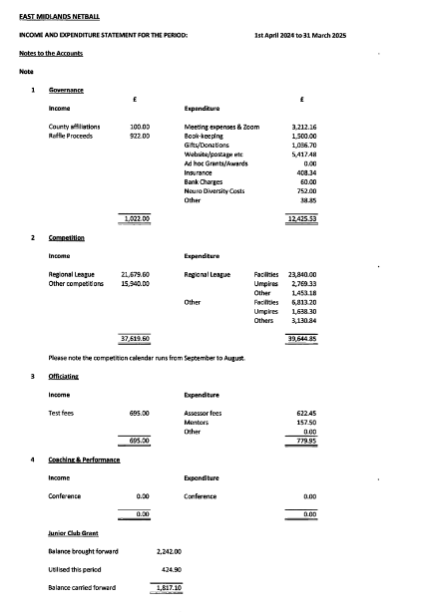

**26**

**East Midlands Regional Netball Association**



# Resolution Proposal Form for AGM

|  |  |  |  |  |  |  |
| --- | --- | --- | --- | --- | --- | --- |
| Name of Individual or Group Proposing Resolution: | | Sarah Hollidge, Governance & Finance Group | | | | |
| Please submit a separate form for each Resolution and return to: Regional Office at East Midlands Netball via email to eastmidlands@englandnetball.co.uk: | | | | | | |
| No later than: | **Wednesday 28 May 2025** | | | | | |
| **Original Constitution Entry** | | | | | | |
| Ref:  1.2  2.1  2.2  2.3  7.2.1 | The Regional Association will use the current England Netball logo as approved by England Netball the Board of Directors until such time as this is deemed necessary to comply with any change to the England Netball logo.  Also reference “Board of Directors” | | | | | |
| **Proposed Constitution Entry** | | | | | | |
| Ref:  1.2  2.1  2.2  2.3  7.2.1 | The Regional Association will use the current England Netball logo as approved by England Netball (meaning the Board of Directors at England Netball), until such time as this is deemed necessary to comply with any change to the England Netball logo.  Replace all reference to Board of Directors, with England Netball | | | | | |
| Proposed by:  (Print name) | SARAH HOLLIDGE | | Member Number | 3011889 | Date: | 25/05/2025 |
| Seconded By:  (Print name) | CAROL SPENCER | | Member Number | 49331 | Date: | 25/05/2025 |

**27**

|  |  |  |  |  |  |  |
| --- | --- | --- | --- | --- | --- | --- |
| Name of Individual or Group Proposing Resolution: | | Sarah Hollidge, Governance & Finance Group | | | | |
| Please submit a separate form for each Resolution and return to: Regional Office at East Midlands Netball via email to eastmidlands@englandnetball.co.uk: | | | | | | |
| No later than: | **Wednesday 28 May 2025** | | | | | |
| **Original Constitution Entry** | | | | | | |
| 4  4.1.4 | GUIDING PRINCIPLES  work together with England as ‘one team aligned to one dream’ for the benefit of Netball within the East Midlands Region and as such we will succeed or fail together | | | | | |
| **Proposed Constitution Entry** | | | | | | |
| 4.1.4  4.1.9 | work together with England Netball in line with their current strategy, for the benefit of Netball within the East Midlands Region  (Removing reference to a previous specific EN strategy and making the point more generic)  Drive an inclusive culture by informing and challenging ourselves, our partners and leaders at all levels of our sport to cultivate a sense of belonging for all who join us.  (new paragraph taken from ENs recommended constitution) | | | | | |
| Proposed by:  (Print name) | SARAH HOLLIDGE | | Member Number | 3011889 | Date: | 25/05/2025 |
| Seconded By:  (Print name) | CAROL SPENCER | | Member Number | 49331 | Date: | 25/05/2025 |

# Resolution Proposal Form for AGM

# Resolution Proposal Form for AGM

|  |  |  |  |  |  |  |
| --- | --- | --- | --- | --- | --- | --- |
| Name of Individual or Group Proposing Resolution: | | Sarah Hollidge, Governance & Finance Group | | | | |
| Please submit a separate form for each Resolution and return to: Regional Office at East Midlands Netball via email to eastmidlands@englandnetball.co.uk: | | | | | | |
| No later than: | **Wednesday 28 May 2025** | | | | | |
| **Original Constitution Entry** | | | | | | |
| 6  6.1 | STRUCTURE OF REGIONAL ASSOCIATION  The Regional Management Board has the authority to establish and determine terms of reference, set roles and responsibilities and dissolve various groups, forums and Technical Support Groups (hereinafter referred to as TSGs) at its sole discretion to assist with the management and operation of the Regional Association. | | | | | |
| **Proposed Constitution Entry** | | | | | | |
| 6.1 | The Regional Management Board has the authority to establish and determine terms of reference, set roles and responsibilities and create or dissolve various groups, forums and Technical Support Groups (hereinafter referred to as TSGs) at its sole discretion to assist with the management and operation of the Regional Association. | | | | | |
| Proposed by:  (Print name) | SARAH HOLLIDGE | | Member Number | 3011889 | Date: | 25/05/2025 |
| Seconded By:  (Print name) | CAROL SPENCER | | Member Number | 49331 | Date: | 25/05/2025 |

**29**

|  |  |  |  |  |  |  |
| --- | --- | --- | --- | --- | --- | --- |
| Name of Individual or Group Proposing Resolution: | | Sarah Hollidge, Governance & Finance Group | | | | |
| Please submit a separate form for each Resolution and return to: Regional Office at East Midlands Netball via email to eastmidlands@englandnetball.co.uk: | | | | | | |
| No later than: | **Wednesday 28 May 2025** | | | | | |
| **Original Constitution Entry** | | | | | | |
| 7  7.2.2  7.2.4  7.2.6  7.2.10 | REGIONAL MANAGEMENT BOARD  The Regional Management Board will work with England Netball Regional Staff on an ad hoc basis to prepare and submit a budget to England Netball to deliver national targets according to regional need and will be accountable to the England Netball Board of Directors for the use of such funds in achieving these targets  The Regional Management Board shall, where asked to by England Netball, submit an Annual Report and independently examined accounts to England Netball on the significant activities held at Regional and County level.  The Regional Management Board has the authority to establish and determine terms of reference, set roles and responsibilities and dissolve various groups, forums and TSGs at its sole discretion to assist with the management and operation of the Regional Association.  All persons who are appointed to by the Regional Management Board to assist in any way with the Regional Association’s activities shall become Members of the Regional Association and hence of England Netball and in the first instance membership fees shall be paid by the Regional Association. | | | | | |
| **Proposed Constitution Entry** | | | | | | |
| 7.2.2  7.2.4  7.2.6  7.2.10 | REMOVED – there has been no requirement from EN over recent years to submit such a budget. Should this form part of a particular project in the future, then EM RMB will commit to supplying any required information.  The Regional Management Board shall, where asked to by England Netball, submit an Annual Report and independently examined accounts to England Netball  Removed – duplicate of paragraph 6.2  Removed and incorporated within 7.3.1 | | | | | |
| Proposed by:  (Print name) | SARAH HOLLIDGE | | Member Number | 3011889 | Date: | 25/05/2025 |
| Seconded By:  (Print name) | CAROL SPENCER | | Member Number | 49331 | Date: | 25/05/2025 |

# Resolution Proposal Form for AGM

**30**

|  |  |  |  |  |  |  |
| --- | --- | --- | --- | --- | --- | --- |
| Name of Individual or Group Proposing Resolution: | | Sarah Hollidge, Governance & Finance Group | | | | |
| Please submit a separate form for each Resolution and return to: Regional Office at East Midlands Netball via email to eastmidlands@englandnetball.co.uk: | | | | | | |
| No later than: | **Wednesday 28 May 2025** | | | | | |
| **Original Constitution Entry** | | | | | | |
| 7 (continued)  7.3.1 | STRUCTURE OF REGIONAL MANAGEMENT BOARD  The composition of the Regional Management Board shall be ..(detailed in points a-g) | | | | | |
| **Proposed Constitution Entry** | | | | | | |
| 7.3.1  7.3.1.1  7.3.1.2 | The details within a a-g are replaced with a table  A table with text on it  AI-generated content may be incorrect.  The Regional Management Board may, from time to time, appoint Members with relevant knowledge and experience on a short-term basis to carry out specific and time-bound strategic work and will not have any voting rights  England Netball membership for Appointed members of the Board with will be paid by the regional Association for the first year of office. | | | | | |
| Proposed by:  (Print name) | SARAH HOLLIDGE | | Member Number | 3011889 | Date: | 25/05/2025 |
| Seconded By:  (Print name) | CAROL SPENCER | | Member Number | 49331 | Date: | 25/05/2025 |

**31**

|  |  |  |  |  |  |  |
| --- | --- | --- | --- | --- | --- | --- |
| Name of Individual or Group Proposing Resolution: | | Sarah Hollidge, Governance & Finance Group | | | | |
| Please submit a separate form for each Resolution and return to: Regional Office at East Midlands Netball via email to eastmidlands@englandnetball.co.uk: | | | | | | |
| No later than: | **Wednesday 28 May 2025** | | | | | |
| **Original Constitution Entry** | | | | | | |
| 7  7.3.2  7.3.3  7.3.4  7.3.7 | STRUCTURE OF REGIONAL MANAGEMENT BOARD  Regional Management Board members listed in 7.3.1 sub clauses a-f above have voting rights. Voting Members must not be a paid employee of England Netball. For clarity, should a member hold more than one position on the Regional Management Board then the voting entitlement is one vote.  Voting Members must not be a paid employee of England Netball. For clarity, should a member hold more than one position on the Regional Management Board then the voting entitlement is one vote. In the event of a tie in Votes cast on any item of business the Chair shall have a further casting vote  Specific England Netball personnel are invited to attend Regional Management Board meetings as a communication link with England Netball. Minutes of the meeting will be taken by the Regional Office personnel   * + 1. Regional Management Board Members shall serve for a term of three years from date of election unless vacated earlier in accordance with 7.7.1 (delete – included in table) | | | | | |
| **Proposed Constitution Entry** | | | | | | |
| 7.3.2  7.3.3  7.3.4  7.3.6 | Voting Members must not be a paid employee of England Netball. For clarity, should a member hold more than one position on the Regional Management Board then the voting entitlement is one vote.  Remove first sentence – duplicate of above.  In the event of a tie in Votes cast on any item of business the Chair shall have a further casting vote  Specific England Netball personnel may be invited to attend Regional Management Board meetings as a communication link with England Netball. Minutes of the meeting will be taken by the Regional Office staff  Removed – included in table | | | | | |
| Proposed by:  (Print name) | SARAH HOLLIDGE | | Member Number | 3011889 | Date: | 25/05/2025 |
| Seconded By:  (Print name) | CAROL SPENCER | | Member Number | 49331 | Date: | 25/05/2025 |

# Resolution Proposal Form for AGM

|  |  |  |  |  |  |  |
| --- | --- | --- | --- | --- | --- | --- |
| Name of Individual or Group Proposing Resolution: | | Sarah Hollidge, Governance & Finance Group | | | | |
| Please submit a separate form for each Resolution and return to: Regional Office at East Midlands Netball via email to eastmidlands@englandnetball.co.uk: | | | | | | |
| No later than: | **Wednesday 28 May 2025** | | | | | |
| **Original Constitution Entry** | | | | | | |
| 9  9.1.1  9.1.15  9.3.1(d) | GENERAL MEETINGS OF THE EAST MIDLANDS REGION (AGM AND EGM)  The Annual General Meeting shall be held annually on a date to be determined by the Regional Management Board  Business to be transacted at the Annual General Meeting shall be:  a) To receive reports  Members of the Regional Management Board | | | | | |
| **Proposed Constitution Entry** | | | | | | |
| 9.1.1  9.3.1.(d) | The Annual General Meeting shall be held annually  Business to be transacted at the Annual General Meeting shall be:  a) To receive Chair’s report. (Reports from each of the TSG Leads will be sent out as part of the AGM pack prior to the meeting)  Members of the Regional Management Board (as per table 7.3.1) | | | | | |
| Proposed by:  (Print name) | SARAH HOLLIDGE | | Member Number | 3011889 | Date: | 25/05/2025 |
| Seconded By:  (Print name) | CAROL SPENCER | | Member Number | 49331 | Date: | 25/05/2025 |

# A black and white logo AI-generated content may be incorrect.Resolution Proposal Form for AGM

# A black and white logo AI-generated content may be incorrect.Resolution Proposal Form for AGM

|  |  |  |  |  |  |  |
| --- | --- | --- | --- | --- | --- | --- |
| Name of Individual or Group Proposing Resolution: | | Sarah Hollidge, Governance & Finance Group | | | | |
| Please submit a separate form for each Resolution and return to: Regional Office at East Midlands Netball via email to eastmidlands@englandnetball.co.uk: | | | | | | |
| No later than: | **Wednesday 28 May 2025** | | | | | |
| **Original Constitution Entry** | | | | | | |
| 12-24 | Links to EN guidance and policies | | | | | |
| **Proposed Constitution Entry** | | | | | | |
| 12 – 24 | Updated links for all relevant policies included, including the new EN Gender Eligibility and Participation Policy | | | | | |
| Proposed by:  (Print name) | SARAH HOLLIDGE | | Member Number | 3011889 | Date: | 25/05/2025 |
| Seconded By:  (Print name) | CAROL SPENCER | | Member Number | 49331 | Date: | 25/05/2025 |

34

|  |  |
| --- | --- |
|  | **Nomination form for elected members of the**  **Regional Management Board** |

**Nominee details (Please print clearly and use black ink)**

|  |  |  |  |  |
| --- | --- | --- | --- | --- |
| Nomination for the post of (tick appropriate box below): | | | | |
| Governance and Finance Chair | X | Elected Member | |  |
| Full name of Nominee:  Sarah Hollidge | | Membership number (ENID):  3011889 | | |
| Address:  25 Chestnut Way, Repton, Derbyshire, DE65 6FQ | | | | |
| Signature of Nominee: Sarah Hollidge | | | Date: 24/5/25 | |
| Proposed by (please print): | | Seconded by (please print): | | |
| Carol Spencer | | Andrea Scigliano | | |
| Address:  Old Fayling  81 Main Street  Papplewick, Notts  NG15 8FE | | Address:  Tarn Hows, Gullet Lane  Kirby Muxloe LE9 2BL | | |
| Membership number of Proposer:  49331 | | Membership number of Seconding Nominator:  17686 | | |
| Signature: Carol Spencer | | Signature: Andrea Scigliano | | |
| Date: 26/5/25 | | Date: 26/5/25 | | |
| Please attach a completed copy of the ‘Person Specification’ form for the post for which you have been nominated, together with a netball curriculum vitae and any employment information which you may feel is relevant. Please return to the Regional Office no later than: **28th May 2025 via email-** [eastmidlands@englandnetball.co.uk](mailto:eastmidlands@englandnetball.co.uk) | | | | |

35

|  |  |
| --- | --- |
|  | **East Midlands Regional Management Board**  **Elected Member – Application Form** |

Please print clearly in blue or black ink/ electronically complete and return, along with the nomination form, to the Regional Office (eastmidlands@englandnetball.co.uk)

|  |  |  |  |
| --- | --- | --- | --- |
| Name of Nominee: | Sarah Hollidge | | |
| In support of a nomination for the post (please tick): | | | |
| Governance and Finance Chair | | X | Elected Member |  |
| We aim to appoint Board Members who collectively have the skills, abilities and experience appropriate to the needs of the Regional Management Board. We do not expect members to have all the individual skills and experience. Each member will bring their own qualities – tell us about yours. Please attach separate sheet if insufficient space available; please ensure that you have clearly indicated which section the attachment relates to. | | | |
| ***Business Skills and Experience:* performance monitoring; financial monitoring; risk management; strategic thinking; legal compliance...**   * Over 25 years of global business experience, with focus on strategy development, transformation and digital solutions to enhance performance, always underpinned with strong governance practices and financial acumen * A track record of identifying risks and opportunities early, ensuring decisions are based on well-considered evidence and insights. From an Insights perspective I am a Motivating Director. * Defined and deployed robust governance methodology across numerous roles – Global Operational Excellence (across 200 sites), EMEA Lean Six Sigma lead (spearheaded governance adopted globally) * Spearheaded the Global Operational Excellence Council for Pepsi, crafting a global three-year strategic roadmap, focussed on 3 key pillars of People, Processes and Systems / Digital. Impacting 200+ sites globally, 50,000+ employees (Pepsi – Global Operational Excellence Director) | | | |
| ***Interpersonal Skills and Experience:* leadership; relationship and people management; influencing and networking; communication**  Throughout my career, I have worked across multiple cultures and stakeholder groups demonstrating the courage to ask challenging questions that have uncovered critical issues, leading to actionable solutions, consistently modelled inclusive leadership, ensuring that all stakeholders feel heard and valued. My willingness to make difficult decisions—always guided by evidence, ethics, and empathy—has been consistent throughout my career. | | | |
| ***Knowledge and Understanding of sporting competition and development pathways...***  I have been part of both the Derbyshire Netball Board (in various roles – Chair, Safeguarding, Resolution Lead, General Member) and East Midlands Netball Board (General Member) for over 10 years, where I have been actively engaged in all elements of competition and development pathways.  I have also experienced the development pathway as a parent of an athlete, seeing first hand the impact it has. | | | |

36

|  |
| --- |
| ***Please list any prior experience of serving as a board member for a non-profit organisation…***  I have been part of both the Derbyshire Netball Board (in various roles – Chair, Safeguarding, Resolution Lead, General Member) and East Midlands Netball Board (General Member) for over 10 years, where I have been actively engaged in all elements of relating to the development of netball in the County and Region.  Including completion of Tier 1 governance requirements, development days, and day to day operational issues. |
| **Understanding of equality and ethical issues in sport, including Duty of Care, Safeguarding…**  I am committed to upholding the highest standards of ethical governance, with a clear understanding of equality, inclusion, and safeguarding within a sporting context.  I have recently participated in England Netball’s Inclusion Policy consultation sessions, gaining valuable insight into their updated approach and the importance of creating welcoming environments for all.  In my role as Derbyshire Safeguarding / Resolution lead I have worked closely with England Netball on several safeguarding matters, ensuring that complaints are handled appropriately and in line with our duty of care to all participants. This experience has deepened my understanding of the practical and emotional aspects of safeguarding and the importance of equitable treatment across all areas of the game. |
| **Understanding and experience of voluntary sports organisations and the relationship between voluntary and paid staff…**  I have a strong and sustained commitment to voluntary sport, having contributed at club, county, and regional levels within netball. This has given me direct insight into the vital role volunteers play at every stage of the game — from grassroots to governance — and I maintain close connections with volunteers across the East Midlands.  In parallel, I have worked closely with England Netball staff on a number of workstreams, giving me a clear understanding of the complementary roles played by paid professionals and volunteers. I appreciate the importance of fostering mutual respect and clear communication between both groups, ensuring alignment of purpose while recognising their different motivations and capacities.  I believe successful collaboration relies on listening, valuing each perspective, and ensuring volunteers are supported and empowered as essential partners in delivering the sport’s ambitions. |

|  |  |  |  |
| --- | --- | --- | --- |
| **A passion for the development of sport…**  I believe passionately in the power of sport to change lives. Netball, in particular, plays a vital role in building confidence, connection, and resilience — especially for women and girls. I’ve seen first-hand how participation in sport can support mental health, foster belonging, and empower individuals both on and off the court.  That’s why I’m committed to the development of the game at every level — from grassroots participation through to performance pathways and leadership roles. Ensuring opportunities are inclusive, accessible, and sustainable is key to keeping our sport thriving and relevant for future generations. | | | |
| ***Knowledge, understanding and experience of England Netball’s vision and strategic plan, systems and structures and their wider national and regional policies and opportunities for the development of the sport….***  I have a strong working knowledge of England Netball’s vision and strategic plan, having engaged directly with national and regional initiatives aimed at growing the game and improving the experience for all participants. I understand and support the strategic priorities of *belonging, growth, and leadership*, and the shift towards a more inclusive and sustainable model for the sport.  Through my governance role at regional level, I have worked within the systems and structures that connect local clubs to national strategy, helping to ensure alignment and effective delivery.  I see real opportunity in continuing to bridge the national strategy with the lived experience of players, coaches, officials and volunteers in our region — ensuring that policies land well, and that the game remains relevant and accessible for all | | | | |
| ***Knowledge of East Midlands Regional Management structure…***  I have a strong understanding of the East Midlands Regional Management structure, having served on the Regional Board for over 10 years and as a member of the Governance and Finance Committee over the past year. This experience has given me clear insight into how the Board, G&F Committee, ROG (Regional Operational Group), and TSGs (Technical Support Groups) interact to support the effective running of netball across the region. I understand the importance of collaboration and clear communication across these groups to ensure alignment with national priorities while meeting the needs of our regional members. | | | | |
| **Criminal convictions…..**    No  ~~Yes~~  Have you ever been convicted of any criminal offence?  Please delete as appropriate | | | | |
| **DECLARATION**  I declare to the best of my knowledge and belief, all particulars I have given are complete, true and accurate. I understand that any false declaration, information, omission, or misleading statement may lead to my being prevented from acting as a volunteer for EMRMB now or in the future. | | | | |
| **Signed: Sarah Hollidge** |  | **Date: 24/5/25** |  | |
| **Print Name:Sarah Hollidge** |  |  |  | |

** Full CV provided to the Board as part of application process

**38**

|  |  |
| --- | --- |
|  | **East Midlands Regional Management Board**  **Elected Member – Application Form** |

Please print clearly in blue or black ink/ electronically complete and return, along with the nomination form, to the Regional Office (eastmidlands@englandnetball.co.uk)

|  |  |  |  |  |
| --- | --- | --- | --- | --- |
| Name of Nominee: | Dannii Donovan | | | |
| In support of a nomination for the post (please tick): | | | | |
| Chairman | |  | Elected Member |  |
| Vice-Chairman | |  |  | |
| We aim to appoint Board Members who collectively have the skills, abilities and experience appropriate to the needs of the Regional Management Board. We do not expect members to have all the individual skills and experience. Each member will bring their own qualities – tell us about yours. Please attach separate sheet if insufficient space available; please ensure that you have clearly indicated which section the attachment relates to. | | | | |
| ***Business Skills and Experience:* performance monitoring; financial monitoring; risk management; strategic thinking; legal compliance...** As an EDI Manager, I closely monitor the effectiveness of Equality, Diversity, and Inclusion practices in teaching and organisational processes, writing policies, implementing training programs, conducting equality impact assessments, and strategically planning initiatives. I ensure the alignment with legal compliance, such as the Equality Act 2010, while fostering an inclusive culture and promoting equitable outcomes across all practices. | | | | |
| ***Interpersonal Skills and Experience: leadership; relationship and people management; influencing and networking; communication…*** In my roles as an EDI Manager, Safeguarding Lead, and Training and Development Consultant, I have demonstrated strong leadership skills, fostering professional relationships and empowering others through clear communication and meaningful interactions. I excel in relationship and people management, establishing trust and collaboration within teams, while influencing and networking effectively to drive organisational goals. My ability to communicate with clarity and empathy has been instrumental in building strong professional connections and inspiring positive change. | | | | |

**39**

|  |
| --- |
| ***Knowledge and Understanding of sporting competition and development pathways...*** Through my role as a Training and Development Consultant at CPSU and my work with elite athletes in further education, I have gained clear insight into the high-performance sports environment. Ensuring athletes' voices are heard, safeguarding their well-being, and raising awareness of their rights has been pivotal in promoting safety in sports. This experience has provided me with a comprehensive understanding of sporting competition and development pathways, enabling me to address the diverse needs of the sporting communities and support its growth effectively. |
| ***Knowledge, understanding and experience of Netball competition and development pathways, performance strategies, programmes and activities…*** I have developed extensive knowledge and experience in netball competition structures, player development pathways, and performance strategies. My holistic perspective allows me to address the varied needs of the netball community, fostering growth, ensuring well-being, and promoting the continued development of the sport at all levels. |
| ***Please list any prior experience of serving as a board member for a non-profit organisation…****None* |
| **Understanding of equality and ethical issues in sport, including Duty of Care, Safeguarding**… I am a registered social worker with over 10 years of experience in child protection and safeguarding. Currently, I serve as the Designated Safeguarding Lead for ESF Events, the UK’s most prestigious youth sporting events and leading specialist sports tour operator, where I ensure the welfare and safety of participants through robust safeguarding measures. My role in Further and Higher Education and with the NSPCC CPSU (Child Protection in Sport Unit) enables me to lead and inspire teams, contributing to the strategic development of netball within the region. I actively embed Equality, Diversity, and Inclusion (EDI) initiatives into my work, utilising trauma-informed practices to champion progressive policies and inclusive leadership. My dedication to promoting EDI practices and fostering community engagement highlights my commitment to addressing equality and ethical issues in sport and ensuring participant well-being, accessibility and inclusivity at all levels. |

|  |
| --- |
| **Understanding and experience of voluntary sports organisations and the relationship between voluntary and paid staff…** I have extensive experience working with voluntary sports organisations, giving me a deep understanding of their structures, operations, and the essential role of volunteers. My expertise includes managing and supporting volunteers, ensuring their contributions are aligned with organisational goals and their efforts are both valued and recognised. I feel I have the necessary qualities at fostering collaboration between voluntary and paid staff, navigating dynamics with mutual respect and effective communication to achieve shared objectives. Additionally, I have developed and implemented strategies that optimise contributions from both groups, addressing challenges such as workload balance and resource allocation to build cohesive, high performing teams that drive organisational success and community engagement. |
| ***A passion for the development of sport…*** My passion for netball and commitment to its growth and inclusivity motivate me to apply for the Regional Board Member role. Having engaged with the sport from diverse perspectives—player, coach, safeguarding lead, and advocate for equality—I am inspired to give back to the community that has profoundly shaped me. I am eager to contribute to the strategic development of netball within the region, promoting accessibility and fostering a culture where individuals at all levels can thrive |
| ***Knowledge, understanding and experience of England Netball’s vision and strategic plan, systems and structures and their wider national and regional policies and opportunities for the development of the sport….***  Looking ahead, my ambition is to continue driving Equality, Diversity, and Inclusion (EDI) initiatives alongside trauma-informed practices within netball. My ultimate goal is to ensure that the sport remains inclusive and welcoming, breaking down barriers to participation. I am committed to nurturing talent across all levels, from grassroots programmes to elite pathways, ensuring netball continues to empower and inspire communities. |
| **Knowledge of East Midlands Regional Management structure**… I already have an understanding of the management structure but would be interested in expanding and building on my current knowledge. |

**40**

|  |  |  |  |
| --- | --- | --- | --- |
| **Criminal convictions…..**    Yes  **No**  Have you ever been convicted of any criminal offence?  Please delete as appropriate | | | |
| **DECLARATION**  I declare to the best of my knowledge and belief, all particulars I have given are complete, true and accurate. I understand that any false declaration, information, omission, or misleading statement may lead to my being prevented from acting as a volunteer for EMRMB now or in the future. | | | |
| **Signed:** |  | **Date:** |  |
| **Print Name:** | **Dannii Donovan** |  | **22.04.2025** |

**41**