Minutes of Annual General Meeting
Date/Time | 25 June 2025 7:06pm-7:32pm |  | Location | Zoom
Attendees |  | Initials | Representing | Attendees | Initials | Representing
Rowena Hackwood |  | RH | Regional Chair | Rachel Bussey | RB | Interim Partnerships and Delivery Manager (NV)
Sue Connor |  | SC | Regional Vice Chair | Ian Marron | IM | RMB – Appointed
Sarah Hollidge |  | SHo | RMB - Appointed | Emma Bailey | EB | Northampton Dragons
Andy Scigliano |  | AS | RMB - Elected | Jackie Brookes | JB | K-Town Nets
Anne Henderson |  | AH | NCNA Vice-Chair | Libbie Behrens | LB | Luna Lights
Abbie Wilson |  | AW | Grasshopper Netball Club | Liz Broomhead | LBr | RMB – Appointed
Bethan Walker |  | BW | Swadlincote Netball | Lizzie Saunby | LBa | Officiating TSG lead
Carla Garey |  | CG | Ashby NC | Margaret Nwagwu | MN | Players NC
Carol Spencer |  | CS | Competition TSG | Megan Sayers | MS | England Netball Development Officer (NV)
Claire Sanders |  | CSa | Nottingham Forest Netball (NV) | Morgan Williams | MW | RMB – Appointed
Claire Bowen |  | CB | Bingham Netball Club | Pam Weatherby | PW | Nottinghamshire County
Dannii Donovan |  | DD | RMB – Elected Member | Samantha Nethercott | SN | K-Town Nets
Kathy Cox |  | KC | Grasshopper Netball Club (NV) | Sara Bostock | SB | Moll Buzzers
Kathy Stripp |  | KS | Leicestershire County | Sue Hunter | SH | Ex Chair of EMRNA & Honorary Life Member
Keri Moorhouse |  | KM | Charnwood Rutland NC | Judith Munson | JM | Loughborough Town Netball League

Apologies | Initials |  |  | Circulation List
Angela Howat | AHo | Gracedieu Netball Club |  | Attendees
Carloine Richards | CR | Stiletto Netball Club |  | Apologies
Charlie Sizer | CSi | Derbyshire County
Christie Neale | CN | Hinckley Hurricanes
Louise Key | LK | Fenland Netball Club
Matthew Tapp | MT | Northamptonshire
Naomi Stenhouse | NS | Lincoln City
Yvonne Blunt | YB | Northamptonshire

Ref | Agenda Item | Led by
 | Welcome | RH
 | Apologies  - As above | RH
 | Introduction of Regional Management Board  - Regional Management board were introduced – Appendix 1 | RH
 | Appointment of Tellers  - 2 tellers appointed RB and SHo | RH
 | Voting Strength  - 24 | RH
 | Minutes of the last AGM  - Minutes of the last AGM were displayed on screen after they appeared corrupt in the pack.  - These minutes were accepted as true and correct record – Proposed: KS, Seconded: SC | RH
 | Chair’s report  - The chair addressed the meeting and gave her report  - Special thanks to RMB members, ROG, TSG Chairs, group members and NDOs for all their support and hard work throughout the region.  - Congratulations to Nottingham Forest and Loughborough Lightning for their performances this year.  - Special thanks to Sue Hunter, Jo Sharrock, Carol Spencer and Lynn Moore as they stand down for their roles on the RMB and TSG.  - Thanks to Eleanor Udall, who recently left her role as East Midlands Regional Officer, for all her hard work with governance and volunteering and community development. Thanks to Megan Sayers and Kelly Thompson for their interim support.  - RH thanked AS for taking over as ROG Chair and SHo, subject to election, for taking over Governance & Finance. RH also congratulated LS for taking over as Chair of Officiating, Vicky Otterburn for taking over Chair of Coaching and CG for taking over Chair of Competition.  - Thanks to Kamila Wszolek who had been appointed as Competition Secretary and Rob Mann for taking on the role as Mixed Netball TSG Chair | RH
 | Regional Team & Regional Chair’s Presentation  - RB presented the Regional Office report - Appendix 3  - Regional achievements  - Regional membership figures shared  - Thanks to the region’s volunteers, past and present RMB members and to the England Netball staff team | RB
 | TSG reports: ROG, Competition; Officiating; Volunteer and Club Development  - RH explained all reports were in the AGM pack which had been distributed prior to the AGM and are taken as read. | RH
 | Governance & Finance report  - Distributed prior to the AGM and taken as read – Appendix | RH
 | Acceptance of accounts  - Floor accepted accounts true and correct | RH
 | Proposed resolution changes to the constitution  - SHo explained changes were shared and distributed in the AGM pack prior to the meeting  - To adopt England Netball wording and remove old terminology, inline with their current policies  - Agreed: 15  - Constitution proposed changes are accepted as true and correct | All
 | Nominations & Election of Officers  - SHo standing for election – transferring from appointed to elected  - JB appointed as teller for this section only as SHo standing for election  - Agreed: 15  - DD standing for election and introduced herself to the group  - Agreed: 18 | RH
 | Vote of Thanks  - KS thanked Sue, Carol and Jo for their contributions to the board. Welcomed new members to the RMB and TSGs and thanked them for stepping into their new roles. | KS
 | Close – 7:55pm | RH

Appendix 1 – Regional Management Board Structure Diagram

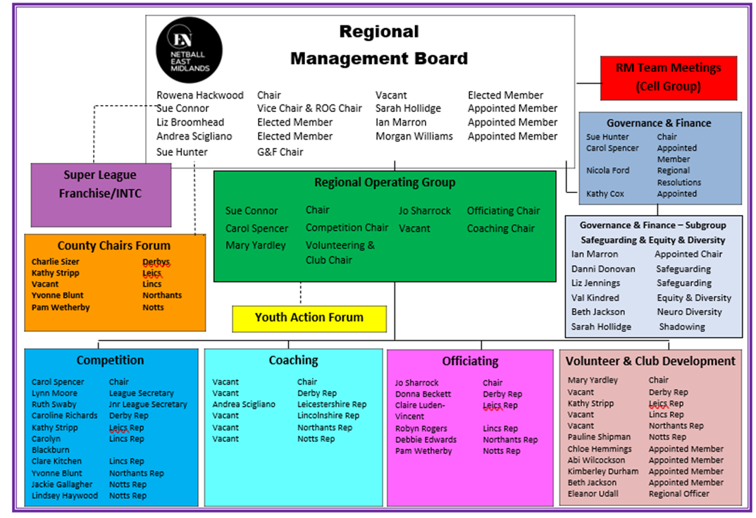



Appendix 2 – East Midlands Regional Office Report


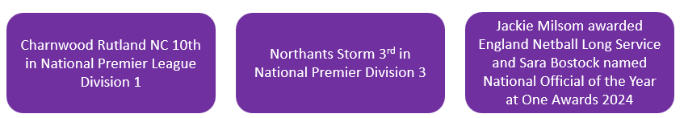
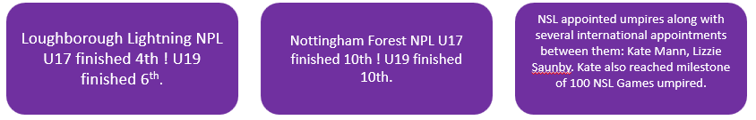
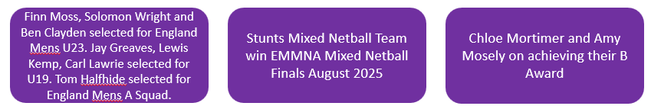

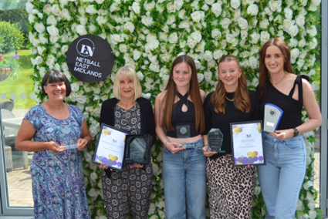

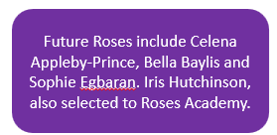
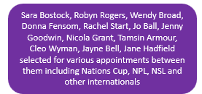
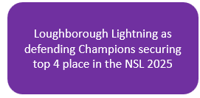
Coach of the Year – Children & Young People – Jackie Gallagher
Coach of the Year - Adults - Jennifer Williams
Community Official of the Year (in honour of Sheelagh Redpath) – Sara Bostock
Outstanding Contribution of the Year (in memory of Mary Bulloch) – Ursula Hammond
Pioneer of the Year (in memory of Muriel McNally) – Beth Jackson
Unsung Hero of the Year (in a Club or League) – Sarah Cottrell
Club of the Year - Hawks Netball Club
Young Volunteer of the Year – Amelia Hockey
Teacher of the Year – Tracy Elliott
Inclusion Award – Hawks Netball Club
East Midlands Jean Bourne Back to Netball Award - Marianne Turvill
East Midlands Jean Perkins Walking Netball Award – Carol Smikle
East Midlands Jean Staley Award – Jane Morrell
East Midlands Long Service Award – Liz Alop
East Midlands Long Service Award – Sarah Hollidge
East Midlands Special Recognition – Sue Hunter
East Midlands Special Recognition – Andy Scigliano
East Midlands Special Recognition – Debbie Hopkinson
East Midlands Special Recognition – Maria Shaw
East Midlands Special Recognition – Debbie Edwards

