The use of metals and minerals is closely related to the economic growth of any society. Increasing global consumption leads to a sharply rising demand for metals and minerals. When countries develop, they often go through a phase of strong increase in the usage of metals for buildings, infrastructure, electronics, transport, etc. Many countries have already gone through this development phase, but other countries have this development phase still ahead of them.

Today and into the near future, the single most important factor that affects the raw material consumption globally is an increasing world population in the transition to fossil-free energy. If the production rates are not balanced with the demand, it will slow down the pace of the energy transition. For example, a typical electric car requires several times the mineral inputs of a conventional car because the battery and other components contain metals. Also, for instance, an onshore wind plant requires a significantly larger amount of minerals compared to gas-fired power plants.

To reach the climate goals agreed upon in the Paris agreement, the mineral demand for clean energy technologies will rise to at least four times by 2040, or six times if the climate-neutral scenario by 2050 is to be reached. Therefore, the energy sector will be the largest consumer of metals in the coming decades according to the International Energy reports, (IEA 2021).

Although some metals are used in very small quantities in our everyday devices, their exceptional chemical characteristics make them unique and indispensable. Raw materials with unique properties that enhance technological functions are significantly boosting the performance of our devices and we would not be able to achieve the same performance and processing capabilities without them.

For some metals, certain countries are the only major suppliers, and they are almost in complete control of the global supply chain. The share of production of energy transition minerals and fossil fuels is illustrated in Figure 1. China dominates the mining of rare earth elements which are important for high-tech applications, including electronics, renewable energy, and defence technologies, whereas the Democratic Republic of Congo dominates the extraction of cobalt, Indonesia has a big share in nickel extraction and Australia and Chile dominate the extraction of lithium. Transition to renewable energy technologies creates an increasing demand for metals such as lithium, copper, cobalt, and nickel.

The economic interdependence between countries often leads to supply tensions. Overall, the European Union countries contribute marginally and are completely dependent on the import of refined products. China plays a key role in terms of processing copper, nickel, cobalt, and lithium.

Importantly, the diagram in Figure 1, shows commodities that are mainly produced in other countries, for example, cobalt and lithium, are mostly processed in China, which gives China control over the raw material flows for these commodities as well. According to USGS Mineral Commodity Summaries (2022) report, the total minerals mined in 2021 was roughly 2.8 billion tonnes.

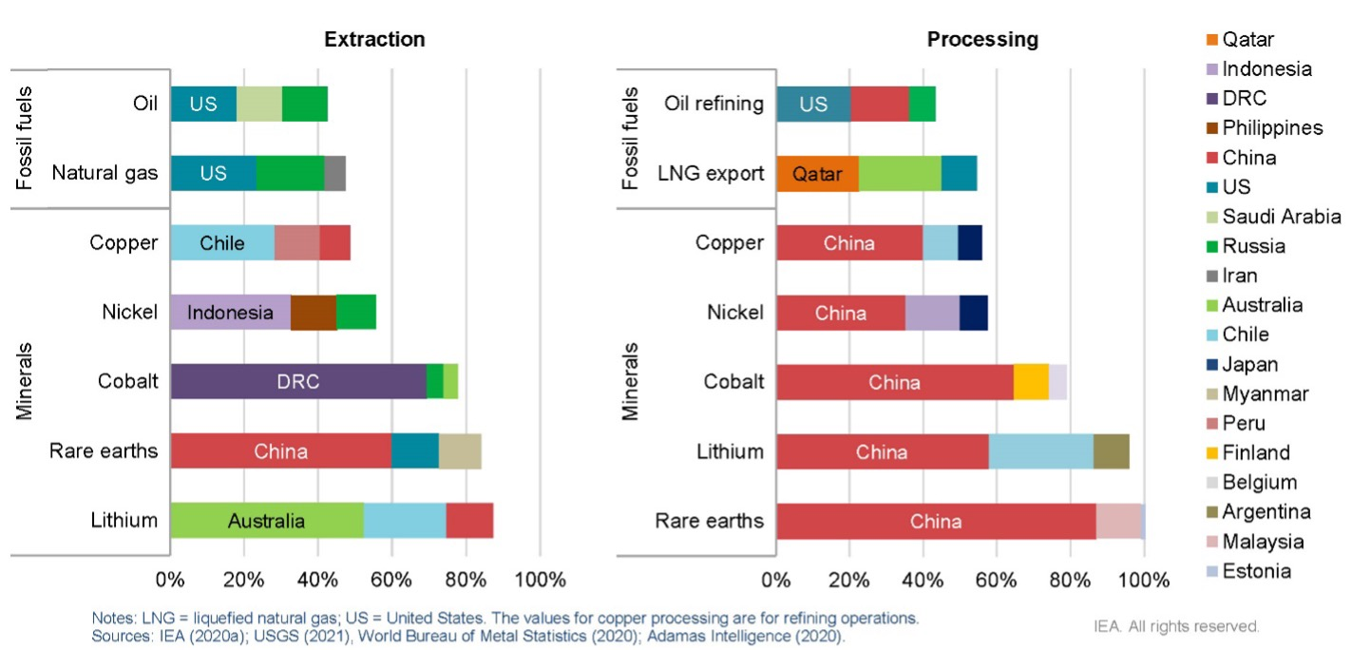

*Figure1: Commodities in countries extracting and processing*

There are options available to ensure a well-grounded supply of these raw materials and the focus must be on the development of new mines and refineries within Europe, and on financing mining projects worldwide in exchange for stable supply agreements. Investments in foreign countries can lead to an unstable supply, but they are highly necessary, since if Europe would assure the internal supply of metals today, it would still need to import raw materials to keep up with the increasing demand.

Several global factors are hindering the production rates of critical raw materials, and the most important ones are the high geographical concentration of production, long project development times, growing scrutiny of environmental and social performance, and higher exposure to climate risks. It is of high importance to finance investments in diversified sources of new supply, promote technology innovation, improve the scale-up of recycling, promote higher environmental and social standards, and strengthen international collaboration. Only then will there be enough critical raw materials to fulfil the Paris Agreement.

When a country has an urgent need for a reliable and open supply of raw materials to continue its widescale development of renewable energy systems, recycling is a necessary but very complicated task. It often leads to downgrading or “degradation of use” of recycled metals because metals lose their technological performance during recycling, and they are reused for other purposes, thus a supply of unused raw materials is needed.

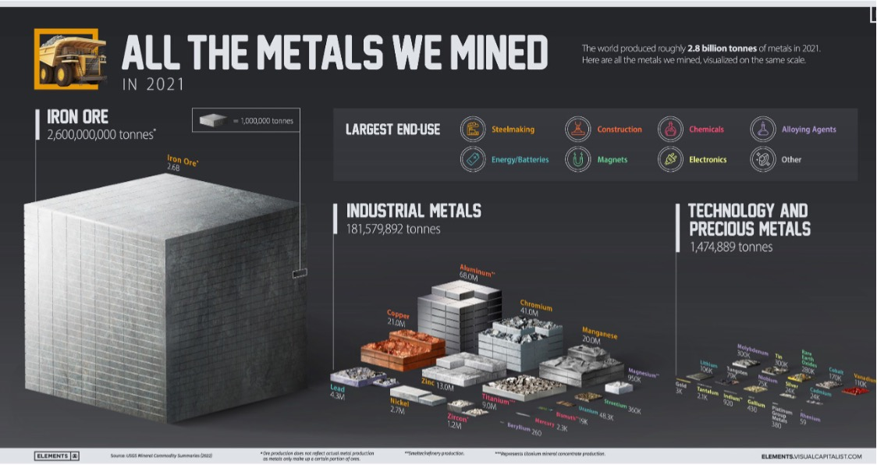 Figure 2. Production of metals worldwide 2021

The US, Australia, and Japan are investing in rare earth mining and processing to reduce dependency on China. It remains to be seen whether it will remain a long-term challenge due to China’s entrenched infrastructure and expertise.