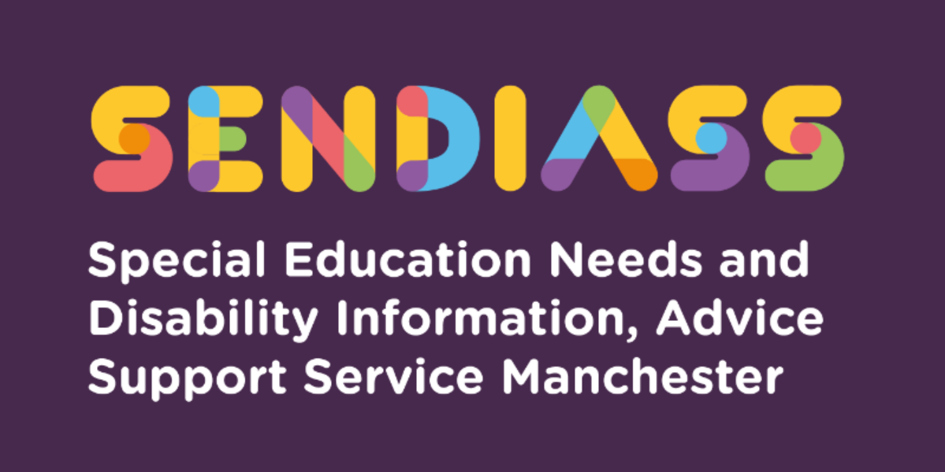

**Special Educational Needs and Disabilities Information Advice and Support Service (SENDIASS)**

SENDIASS offers **information, advice and support** for:

* Parents and carers of children and young people with SEND
* Young people directly
* Professionals

The service is **free, impartial, and confidential**.

**Who do we help?**

Manchester residents who are:

* Parents/carers of children and young people (0–25 yrs) with SEND
* Young people (16–25 yrs) with SEND
* Professionals needing signposting or info on the SEND Code of Practice

**What can we help with?**

* **SEND Support**: Guidance on accessing support in school, preparing for meetings.
* **Making informed decisions**: Clarifying priorities, exploring options, identifying goals.
* **EHC needs assessments & plans**: Legal processes, annual reviews, challenging decisions.
* **When things go wrong**: Disagreement resolution, mediation, tribunal appeals, exclusions.
* **Legal processes**: Advice on rights under the Children & Families Act (2014), SEND Code of Practice (2015), Equality Act (2010).
* **Signposting**: To other support groups and services.

**How to contact us:**

* **Phone**: 0161 209 8356 (24-hour confidential helpline — leave name, contact number, and brief message)
* **Email**: [sendiass@manchester.gov.uk](mailto:sendiass@manchester.gov.uk)
* 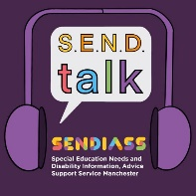**Website**: [https://www.iasmanchester.org](https://www.iasmanchester.org/)
* **Manchester SENDIASS Podcasts**  [**Listen to our SEND Talk podcasts**](https://www.iasmanchester.org/podcasts)
* **Manchester SENDIASS YouTube channel** https://www.youtube.com/@SENDIASSManchester

**QR code for the Website QR code Facebook page**