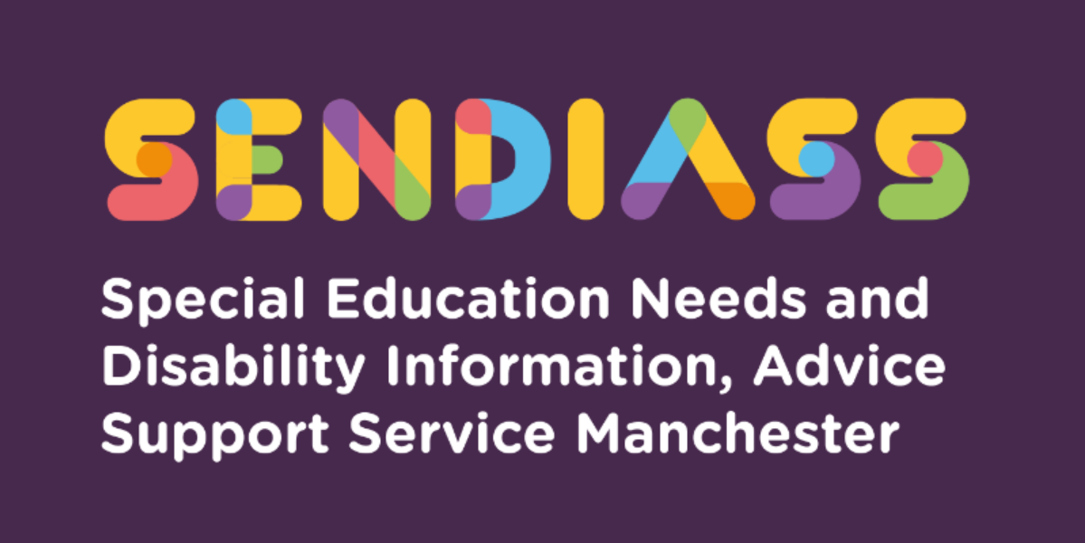

horizontal line

# **Funding for Special Educational Needs or Disability (SEND) Support**

**Factsheet Number 5 August 2025**

horizontal line

**Disclaimer**: This is a guide and should not be treated as legal advice. Although SENDIASS Manchester makes all reasonable efforts to ensure that the information contained in this factsheet is accurate and up to date at the time of publication, we cannot accept responsibility for outcomes suffered because of reliance placed upon it.

# All hyper links are correct as of August 2025.

# This information is about funding for SEND in mainstream schools including academies and free schools.

## **What is SEND funding for?**

The SEND Code of Practice says schools must:

…use their best endeavours to make sure that a child with SEND gets the support they need – this means doing everything they can to meet children and young people’s SEND (6.2)

Schools should use some of their budget to buy resources and make provision for children who need additional help. This can take many forms. For example, children with SEND might need:

* Some changes to the curriculum
* Special equipment or teaching materials.
* The use of additional information technology
* Small group work
* Support in the classroom.
* A base to work in or have quiet time.

## **Where does funding for SEND come from?**

All mainstream schools have money for special educational needs support and resources. Schools can decide how to spend this money. This is called delegated funding. This part of the school’s income is sometimes called the notional SEND budget or Element 2 funding.

## **SEND Provision in schools can be funded from three sources:**

### **Element 1**

All schools get money for each pupil at the school. This is called the Age Weighted Pupil Unit (AWPU), and it is part of schools’ delegated funding. Some of this money is to make general SEND provision. This might, for example, include the cost of providing the Special Educational Needs Co-ordinator (SENCO) and some other resources.

The local authority provides Element 1 funding for the schools it is responsible for. The local Schools Forum agrees the formula that determines how much money the school gets for each pupil. The Education Funding Agency provides Element 1 funding for academies and free schools.

### **Element 2**

Element 2 funding is to provide SEND support that is additional to or different from the support that most other children get. Pupils who are identified as requiring this level of support should be registered as at SEN Support.

The local authority provides Element 2 funding for schools it is responsible for. The local Schools Forum agrees the formula that determines the amount of money the school gets. The Education Funding Agency provides Element 2 funding for academies and free schools. Element 2 funding is also part of schools’ delegated budget.

Government guidance says schools should provide up to the first £6,000 of additional or different support for those children who need it, including those with an Education, Health, and Care plan. This does not mean that the school will spend £6,000 on every child with SEND. Sometimes schools use funds to help groups of children. Some children will need less help – and other children may need more.

You can ask your school how it uses its SEND budget to support your child. This information should be included in the annual SEND report on the school’s website.

### **Element 3**

Some children have such complex needs that the school may request some additional funding to ‘top-up’ to Elements 1 and 2. The local authority is responsible for managing Element 3 funding (sometimes called the ‘high needs block’), which can be used to make specific provision for an individual child or a group of children, if the school or academy can show there is an exceptional level of need. Element 3 funding is provided through an EHC plan and if schools identify this level of support is required, they will make a request for a special education needs assessment and if agreed an Education, Health and Care plan may be issued.

## **Who manages the school’s SEND resources?**

“It is for schools, as part of their normal budget planning, to determine their approach to using their resources to support the progress of pupils with SEND. The SENCO, head teacher and governing body or proprietor should establish a clear picture of the resources that are available to the school. They should consider their strategic approach to meeting SEND in the context of the total resources available, including any resources targeted at particular groups, such as using the pupil premium.” (6.97)

School governors are responsible for the school’s policy on SEND and how the resources are used. The head teacher and the SENCO ensure that the policy is put into practice. The SENCO organises support for individual children, but every teacher is responsible for making sure that your child’s special educational needs are met in the classroom by using Quality First Teaching approaches, which is about teachers using the resources available to them to deliver high quality and inclusive teaching. At the same time schools’ policies should support the planning, implementing, tracking, monitoring, and reviewing of every child’s progress.

The SEND Information Report on the school’s website tells you more about the arrangements for SEND support and how to contact the SENCO.

## **How can I find out what support and resources my child is getting?**

The first step is to talk with your child’s teacher or the SENCO. This may be at a parents’ evening, a support plan meeting, or a review. You can ask for a written copy of any support plan or Provision Map in place for your child.

If the school feels your child requires additional resources and support at SEND Support level, you should be informed and involved in the planning and review of your child’s progress.

|  |
| --- |
| **Contact Details for SENDIASS Manchester**  Helpline Telephone number: 0161 209 8356. Please clearly leave your name, contact number and a brief message on the answerphone and a member of the team will contact you within 24 hours or the next working day.  **Or**  Email your query to us: [**sendiass@manchester.gov.uk**](mailto:sendiass@manchester.gov.uk) leaving your name, child’s name and their date of birth.  You can complete our website contact form: [**Contact Us (iasmanchester.org)**](https://www.iasmanchester.org/contact)  Visit Manchester SENDIASS website [**About SENDIASS Manchester (iasmanchester.org)**](https://www.iasmanchester.org/)  Manchester SENDIASS Podcasts [**Listen to our SEND Talk podcasts**](https://www.iasmanchester.org/podcasts)  Manchester SENDIASS YouTube channel [**https://www.youtube.com/@SENDIASSManchester**](https://www.youtube.com/@SENDIASSManchester)    **QR code for the website QR code for Facebook page** |