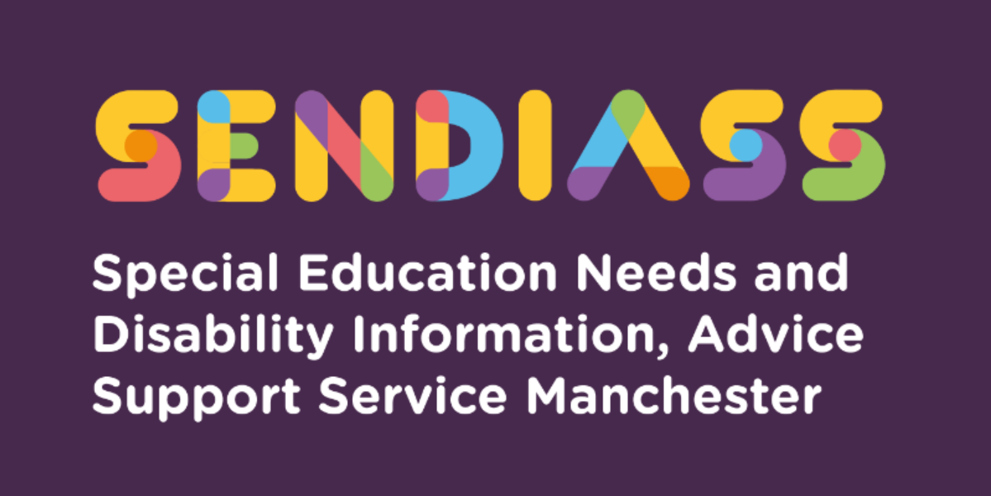

horizontal line

# **SEND support in mainstream schools.**

**Factsheet Number 4 August 2025**

horizontal line

**Disclaimer**: This is a guide and should not be treated as legal advice. Although SENDIASS Manchester makes all reasonable efforts to ensure that the information contained in this factsheet is accurate and up to date at the time of publication, we cannot accept responsibility for outcomes suffered because of reliance placed upon it.

All hyperlinks in this factsheet were correct as of August 2025.

## This information is about the support that mainstream schools should provide for children with Special Education Needs or Disabilities (SEND).

**The SEND Code of Practice says:**

All children and young people are entitled to an education that enables them to make progress so that they:

* Achieve their best.
* Become confident individuals living fulfilling lives, and
* Make a successful transition into adulthood, whether into employment, further/higher education, or training

# **Section 20: Children and Families Act 2014 (When a child or young person has special educational needs)**

**A definition:**

1. A child or young person has special educational needs if he/she has a learning difficulty or disability which calls for special educational provision to be made for him or her.
2. A child of compulsory school age or a young person has a learning difficulty or disability if he/she —
3. has a significantly greater difficulty in learning than most others of the same age, or
4. has a disability which prevents or hinders him or her from making use of facilities of a kind provided for others of the same age in mainstream schools or mainstream post-16 institutions.
5. A child under compulsory school age has a learning difficulty or disability if he or she is likely to be within subsection (2) when of compulsory school age (or would be likely if no special educational provision were made).
6. A child or young person does not have a learning difficulty or disability solely because the language (or form of language) in which he/she is or will be taught is different from a language (or form of language) which is or has been spoken at home.

## **The duties on schools to make SEND provision.**

Schools and settings support children with a wide range of SEND and all schools have a duty under the Equality Act 2010 towards individual disabled children and they must make reasonable adjustments to prevent them from being put at a substantial disadvantage.

A child has SEND when their learning disability or disability means they require special educational provision which is different from or additional to that normally available to children of the same age.

The SEND Code of Practice says all mainstream schools, including Alternative Provision and Pupil Referral Units must:

* Use their best endeavours to make sure that a child with SEND gets the support they need – this means doing everything they can to meet children and young people’s SEND.
* Ensure that children and young people with SEND engage in the activities of the school alongside pupils who do not have SEND.
* Designate a teacher to be responsible for coordinating SEND provision –the Special Educational Needs or Disability Co-ordinator (SENCo)
* Inform parents when they are making special educational provision for a child.
* Publish a SEND information report and their arrangements for the admission of disabled children, the steps being taken to prevent disabled children from being treated less favourably than others, the facilities provided to enable access to the school for disabled children and their accessibility plan showing how they plan to improve access progressively over time.

## **What is SEND support?**

The purpose of SEND support is to help children achieve the outcomes or learning objectives set for them by the school. Schools should involve parents in this process.

Every school must publish a SEND information report about the SEND provision the school makes. You can find this on the school’s website. You can also ask your child’s teacher or the school’s Special Educational Needs Coordinator for information on the SEND provision made by the school.

The Local Offer published by Manchester City Council also sets out what support it expects early year’s settings, schools, and colleges to make for all children and young people with SEND.

### [SEN Support in Mainstream Schools | Help & Support Manchester](https://eur03.safelinks.protection.outlook.com/?url=https%3A%2F%2Fhsm.manchester.gov.uk%2Fkb5%2Fmanchester%2Fdirectory%2Fadvice.page%3Fid%3D8r-7LFnbgp0&data=05%7C02%7Cmargarette.lee-chapman%40manchester.gov.uk%7C48991e8286ab4f38ec5e08dd9ed053f6%7Cb0ce7d5e81cd47fb94f7276c626b7b09%7C0%7C0%7C638841339783900831%7CUnknown%7CTWFpbGZsb3d8eyJFbXB0eU1hcGkiOnRydWUsIlYiOiIwLjAuMDAwMCIsIlAiOiJXaW4zMiIsIkFOIjoiTWFpbCIsIldUIjoyfQ%3D%3D%7C0%7C%7C%7C&sdata=nvAtfYZSC9wBYGPeSTBIKSpXde6%2FjdsVQONm%2FOPYLH0%3D&reserved=0)

SEND support can take many forms, including:

* A special learning programme for your child
* Extra help from a teacher or a learning support assistant
* Making or changing materials and equipment
* Working with your child in a small group
* Observing your child in class or at break and keeping records
* Helping your child to take part in class activities.
* Making sure your child has understood things by encouraging them to ask.
* A variety of questions and to try something they find difficult.
* Helping other children work with your child or play with them at break time.
* Supporting your child with physical or personal care, such as eating,
* Getting around school safely, toileting or dressing.

## **Who decides what SEND support my child has?**

### The SEND Code of Practice says:

Class and subject teachers, supported by the senior leadership team, should make regular assessments of progress for all pupils. These should seek to identify pupils making less than expected progress given their age and individual circumstances.

The school should then decide if your child needs additional support. The school should talk to you and your child about this. If a young person is sixteen or older the school should involve them directly.

Sometimes you may be the first to be aware that your child has some special educational needs. If you think your child may need, SEND support, you should talk to your child’s teacher or to the Special Educational Needs Coordinator.

If you are not happy about the support your child has, you can ask to talk to the Special Educational Needs Coordinator (or head teacher). You can also find out more by looking at “Where can I get more information, advice or support?” at the end of the leaflet.

## **A Graduated Approach**

The SEND Code of Practice says:

Where a pupil is identified as having SEND, schools should take action to remove barriers to learning and put effective special educational provision in place.

When your child is identified as having SEND, the school should use a graduated approach based on four steps.

These are:

A visual image describing the Graduated Response four step cycle of: Assess, Plan, Do and Review

### **Assess**

Teaching staff should work with the Special Educational Needs Coordinator to assess your child’s needs, so that they give the right support. They should involve you in this and, where possible, seek your child’s views.

The SEND Code of Practice says:

Schools should take seriously any concerns raised by a parent. Sometimes schools will seek advice from a specialist teacher or a health professional. They should talk to you about this first.

### **Plan**

If the school decides that your child needs SEND support, it must tell you. The school should talk with you about the outcomes that will be set, what help will be provided and agree a date for progress to be reviewed.

### **Do**

Your child’s class or subject teacher is usually responsible for the work that is done with your child and should work closely with any teaching assistants or specialist staff involved. The school should tell you who is responsible for the support your child receives.

All those who work with your child should be made aware of their needs, the outcomes sought, the support provided and any teaching strategies or approaches that are required.

### **Review**

The school should review your child’s progress, and the difference that the help your child has been given has made, on the date agreed in the plan. You and your child should be involved in the review and in planning the next steps.

**The SEND Code of Practice says**:

Schools should meet with parents at least three times a year. Sometimes it helps to involve other professionals in further assessment or to support planning the next steps. If your child has not made reasonable progress, it will be important to agree with the school what should happen next.

You and the school can look at the Local Offer to see what support is available that could help achieve your child’s outcomes.

|  |
| --- |
| **Contact Details for SENDIASS Manchester**  Helpline Telephone number: 0161 209 8356. Please clearly leave your name, contact number and a brief message on the answerphone and a member of the team will contact you within 24 hours or the next working day.  **Or**  Email your query to us: [**sendiass@manchester.gov.uk**](mailto:sendiass@manchester.gov.uk) leaving your name, child’s name and their date of birth.  You can complete our website contact form: [**Contact Us (iasmanchester.org)**](https://www.iasmanchester.org/contact)  Visit Manchester SENDIASS website [**About SENDIASS Manchester (iasmanchester.org)**](https://www.iasmanchester.org/)  Manchester SENDIASS Podcasts [**Listen to our SEND Talk podcasts**](https://www.iasmanchester.org/podcasts)  Manchester SENDIASS YouTube channel [**https://www.youtube.com/@SENDIASSManchester**](https://www.youtube.com/@SENDIASSManchester)    **QR code for the website QR code for Facebook page** |