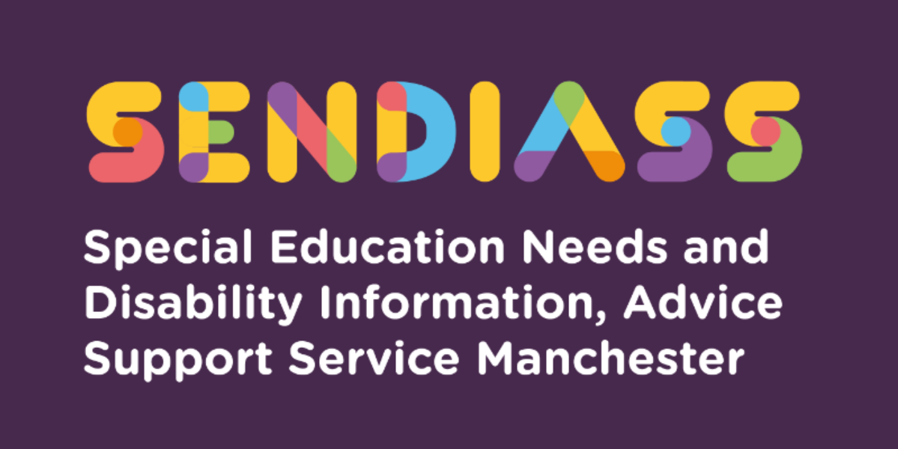

horizontal line

**Admission to Academies**

**Factsheet Number 38 August 2025**

horizontal line

**Disclaimer**: This is a guide and should not be treated as legal advice. Although SENDIASS Manchester makes all reasonable efforts to ensure that the information contained in this factsheet is accurate and up to date at the time of publication, we cannot accept responsibility for outcomes suffered because of reliance placed upon it.

The hyperlinks in this factsheet are correct as of August 2025.

Here is a list of the 10 most frequently asked questions about Academies/Free Schools.

**1.What is an Academy/Free School?**

An academy is an independent school, which is not funded by or under the control of the Local Authority (LA). Instead, the school is funded directly by central government and is governed by a contract (called a ‘Funding Agreement’) between the Secretary of State for Education and the organisation which runs the school (the ‘Academy Trust’). Academies have more freedom than maintained schools, for example regarding controlling their budgets and curriculum.

The legal issues surrounding academies can be complicated because, although they may seem independent as their legal obligations arise out of their Funding Agreement, they are also sometimes bound by legislation, which applies to all schools.

In addition, an Act of Parliament can sometimes override what a Funding Agreement says. The legal status of academies has led to confusion in some areas, regarding children who have EHC plans.

Free schools are a type of academy and, legally, they function in the same way as academies.

## **2.What is in An Academy's Funding Agreement and Where Can I Find This**?

Despite its name, a ‘Funding Agreement’ does not just cover the academy’s financing but covers all aspects of the school’s governance including admissions and SEND.

Funding Agreements for early academies often did not say very much about SEN, but as academies have become more common this changed. SEN is now usually covered in Annex 3 (or C) of the Funding Agreement. A ‘model' Funding Agreement is often used by newer academies, but this has changed over time (for example, regarding SEN).

Various model Funding Agreements can usually be found on the Department for Education’s website (www.education.gov.uk). Funding Agreements for academies should also be freely available, although these can be more difficult to find.

## **3.What is a 'Special' Academy?**

A 'special academy' is legally the same as a ‘mainstream’ academy in the sense that it is also an independent school funded centrally and not under the LA’s control.

Admissions to a special academy, however, will usually be via an EHC plan. Young people and parents can ask for a special academy to be named in section I of their, or their child's, EHC plan (as they can for any school - maintained or independent/non-maintained) and the LA must consider this request. The LA is required to consult as normal with the special academy before naming it in the EHC plan, but once it is named, the academy is under a statutory duty to admit the child or young person.

## **4.I would like my child's EHC Plan to name a (Mainstream) Academy. Can the school refuse to be named?"**

## As always when there is a dispute, the first place to look is the academy’s Funding Agreement. The 2012 'model' Funding Agreement was the first to say that if an LA proposes to name the Academy in a child’s EHC plan, the academy must agree unless this would be incompatible with the efficient education of other children and no reasonable steps can be taken to secure this compatibility (which essentially puts the academy in the same position as a maintained school).

The 2012 'model' Funding Agreement also set out that if the academy refuses to be named but the LA nevertheless names the academy, the academy must comply with this, although it has the right to complain to the Secretary of State for Education if it has been named by the LA against its will. If the academy complains to the Secretary of State for Education when it has been named by the LA against its will, any decision of the Secretary of State is final, subject to any right of appeal the parents of a child or young person might have.

From September 2014, these provisions have applied to those with EHC plans, as far as the relevant provisions of the Children and Families Act 2014 relating to SEN and disability do not apply to academies and free schools.

## **5.What if the academy refuses to admit my child?**

This can be a problem. The difficulty is that any obligation to admit a child is a contractual one between the academy and the Secretary of State, so cannot be enforced by the LA, First Tier Tribunal or even a Court, if the academy does not comply.

However, in one case (July 2012) the Upper Tribunal decided that the Tribunal could hear such cases. The result of this decision is that, in practice, academies can usually be compelled to admit a child (although the legal technicalities are far from straightforward and there is likely to be more litigation on this issue).

The starting point is that if an academy is refusing to be named in your child’s EHC plan, find out what the academy’s Funding Agreement says about admissions for children with EHC plans.

[For special academies, the school is under a statutory duty to admit a child once it is named in section I so these complications should not arise.]

## **6.I want my child to attend an academy, but the LA will not agree to name it in an EHC plan - what do I do?**

LAs have a legal duty to educate all children and young people in mainstream schools unless this is incompatible with their or their parents’ wishes or the efficient education of others. Here, the term ‘mainstream school’ includes academies.

The general principle is that children and young people should be educated in accordance with their and their parents’ wishes, as far as is compatible with the provision of efficient instruction and training and the avoidance of unreasonable public expenditure. This should also, in theory, apply equally to academies as to any other type of school. However, this does not mean the LA has to agree to a particular school and often questions about ‘public expenditure’ and comparative costs can arise.

If the LA refuses to name an academy and instead names another school, you should appeal to the Tribunal against the contents of the EHC plan as usual. (A separate issue will also be whether the academy itself agrees to be named, as discussed in the previous question.)

In theory - yes; but you should look at the particular academy’s Funding Agreement to see what it says about the duty to make the provision in an EHC plan.

## **7.If my child has an EHC plan and attends an academy does this mean that the la is no longer responsible for the EHC plan?**

No; although the academy has a duty to put the EHC plan provision in place, this does not absolve the LA of its ultimate responsibility to ensure the educational provision specified in an EHC plan is made for your child.

All the other legal duties also apply, for example, formally reviewing the EHC plan at least every 12 months at an annual review and amending the EHC plan in advance of ‘Phase Transfers’ (such as primary to secondary school).

## **8.Can an academy set a limit on the number of pupils with EHC plans in the school?**

No. The admission of each child or young person with an EHC plan must be considered independently and in line with the academy’s Funding Agreement. As we said above, many academies have Funding Agreements which say that the academy must agree to be named in a child or young person’s EHC plan unless their attendance at the school would be incompatible with the efficient education of others and there are no reasonable steps that can be taken to remove the incompatibility.

Setting a quota on the number of children with EHC plans would be inconsistent with this. If the Funding Agreement itself contains a quota, it is likely that this would be discriminatory and therefore unlawful.

## **9.My child's school is converting into an academy, and I am unhappy about this - what can I do?**

Whilst there are consultation procedures that must be followed when a school converts into an academy, provided these have been complied with then there is little that can be done to stop the conversion.

In some high-profile cases parents have successfully campaigned to stop a conversion, but this has been due to the strength of the campaign rather than any legal process involved.

## **10.Why are so many schools converting into academies?**

Academies Act 2010 gave all schools (including primary and special schools) the chance to become academies. The Act explained how new schools could be set up as Academies and how existing maintained schools could convert into academies. The Act also removes the need for LAs to be consulted when an academy is set up.

The Academies Bill, which set out the government’s vision for this change and resulted in the Act, said that becoming academies would give schools more freedom and flexibility, would cut bureaucracy and would drive up standards. This was attractive to many schools and those looking to establish new schools and there has been an increase in the number of academies.

The Act explained how new schools could be set up as Academies and how existing maintained schools could convert into academies. The Act also removes the need for LAs to be consulted when an academy is set up.

The Academies Bill, which set out the government’s vision for this change and resulted in the Act, said that becoming academies would give schools more freedom and flexibility, would cut bureaucracy and would drive up standards. This was attractive to many schools and those looking to establish new schools and there has been an increase in the number of academies.

|  |
| --- |
| **Contact Details for SENDIASS Manchester**  Helpline Telephone number: 0161 209 8356. Please clearly leave your name, contact number and a brief message on the answerphone and a member of the team will contact you within 24 hours or the next working day.  **Or**  Email your query to us: [**sendiass@manchester.gov.uk**](mailto:sendiass@manchester.gov.uk) leaving your name, child’s name and their date of birth.  You can complete our website contact form: [**Contact Us (iasmanchester.org)**](https://www.iasmanchester.org/contact)  Visit Manchester SENDIASS website [**About SENDIASS Manchester (iasmanchester.org)**](https://www.iasmanchester.org/)  Manchester SENDIASS Podcasts [**Listen to our SEND Talk podcasts**](https://www.iasmanchester.org/podcasts)  Manchester SENDIASS YouTube channel [**https://www.youtube.com/@SENDIASSManchester**](https://www.youtube.com/@SENDIASSManchester)    **QR code for the website QR code for Facebook page** |