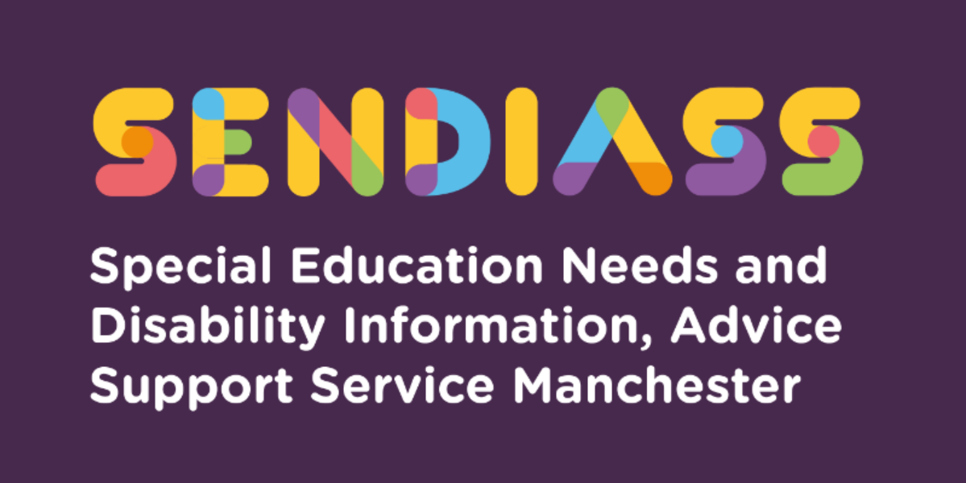

horizontal line

**Education other than at school (E.O.T.A.S.)**

**Factsheet Number 37 August 2025**

horizontal line

Disclaimer: This is a guide and should not be treated as legal advice. Although SENDIASS Manchester makes all reasonable efforts to ensure that the information contained in this factsheet is accurate and up to date at the time of publication, we cannot accept responsibility for outcomes suffered because of reliance placed upon it.

The hyperlinks in this factsheet are correct as of August 2025.

Before reading this factsheet, it may be helpful to read the following factsheets found on our website at [Factsheets](https://www.iasmanchester.org/factsheets-new)

Number 1 Education, Health, and Care Plans (EHCPs)

Number 21 Elective Home Education (EHE)

Number 19 Section 19 Duty to Provide Education for Children of Compulsory School age not in school.

**Education other than at school (EOTAS)**

There are two pieces of legislation, which relate to EOTAS:

**The Education Act 1996** – sets out to ensure that all children have access to education.

**Section 7 of the EA 1996** contains the parental duty to ensure that their child of compulsory school age receives a suitable full-time education, by regular attendance or otherwise.

**Section 9 of the EA 1996** confirms the principle that children should be educated in accordance with their parents’ wishes (subject to that being compatible with the efficient instruction and training and the avoidance of unreasonable public expenditure).

**Section 19 of the EA 1996** places a duty on an LA to make provision for alternative education for pupils who cannot attend school for some reason (including exclusion, health needs, medical conditions, or some other reason).

It sets out the responsibilities of local authorities to provide education other than an at school and only applies to pupils of compulsory school age although authorities have a power to provide alternative education for those over compulsory school age. EOTAS under section 19 is usually a short-term response to particular circumstances and are usually temporary. PRUs, hospital schools, alternative provision and home school tutors are examples of education provision used as a short-term response.

**Section 319 of the EA 1996** contains a similar power in respect of the special educational provision for a child with an EHCP.

An example of case law regarding medical evidence is below- that even without medical evidence the local authority still had a duty to arrange suitable alternative education provision for the child under the category of “otherwise.”

[18 011 706 - Local Government and Social Care Ombudsman](https://www.lgo.org.uk/decisions/education/alternative-provision/18-011-706)

The Education Act 1996 does not define otherwise but the courts have described this widely as meaning to cover any other situation where it is not reasonably possible for a child to take advantage of any existing suitable education e.g. children without a school place, no medical evidence is readily available or cannot attend school due to emotionally based school avoidance.

If school or college is not appropriate for the child or young person, the LA can arrange for any special educational provision which the child or young person requires, to be delivered somewhere other than in a school, college or early years setting.

This is often known as **‘education otherwise than at school.’** The LA would then be responsible for continuing to secure and fund that provision.

This could include therapies which are classed as educational provision, such as speech and language therapy.

**What are some examples of EOTAS?**

• Online schooling

• Home tuition

• Other tuition centres

• Hospital schooling

It is also worth remembering that anything which educates or trains a child or young person is to be treated as special educational provision. For a young person, such as education or training could take place in a non-educational setting.

**The Children and Families Act 2014**

**Section 61 of the CAFA** confirms that if it deems it inappropriate for a child or young person to have special education provision made for them in a school or other educational setting, then the LA can arrange for that special educational provision to be made for them “otherwise than in such a setting.” It can only be done in consultation with the parents or young person if it is satisfied that it would be inappropriate for the provision to be made at a school, also for post 16 or early years setting.

**What makes an educational setting “inappropriate”?**

This has been considered in the case of **TM v London Borough of Hounslow,**

which confirmed that the full effect of the word “inappropriate” must be considered, and that the LA must determine whether a school setting would “not be suitable” or

“Not be proper.” The CAFA 204 does not define inappropriate, but the courts have said that it is not enough for a local authority to ask whether a school “could” meet a child or young person’s SEN. The local authority is obliged to ask whether provision of education at school would not be “suitable and proper” having regard to all the circumstances of the individual case These circumstances might include, without giving any exhaustive list, (which must depend on the facts of the case) consideration of the following matters:

• the child’s background and medical history

• the educational needs of the child

• the facilities that can be provided by a school

• the facilities that could be provided other than in a school

• the comparative cost of the possible alternatives to the child’s educational provisions

• the child’s reaction to education provisions, either at a school or elsewhere

• the parents’ wishes

The LA would have to consider all the circumstances.

**If a child or young person has an EHCP:**

It is essential that Section F (the provision for the child or young person) of the

EHCP *specifies* the package which will be delivered.

There remains a lack of clarity over what is to be specified in Section I (the setting).

This is because the **Children and Families Act 2014** states that the LA must specify the name of the school or other institute the child or young person will attend (or the **type** of school or institute to be attended).

As a result of this, parents/young people will need to argue that the reference to EOTAS should be specified in section F *as well as* what the package contains and leave Section I being left blank. However, a parent or young person may request a personal budget and a direct payment. If the local authority agrees to this, the parent or young person would commission the provision directly through the use of direct payments which would mean the local authority is not responsible for securing the SEP.

Where the reason for the need for EOTAS is straightforward and short term e.g. a broken leg or a planned operation then there is nothing to suggest that the EHCP needs amending or reviewing as it is likely that the young person will be back in school before the process is complete.

**horizontal line**

**Does EOTAS apply to children and young people who do not have EHCPs?**

If a child or young person with SEN (but without an EHC plan) is home educated, the LA **does not** have any duties to provide special educational provision.

The Code states, however, that LAs should fund the SEN needs of home-educated children *where it is appropriate* to do so (paragraph 10.30).

This is an opportunity to fully identify all the child or young person’s needs and work out what educational support they may need. It may be that, with the right support,

the child or young person can continue in their educational placement. Alternatively, they may require special educational provision which could be provided other than at school. If a child or young person is in a situation where their school or college placement is in danger or breakdown, or is unsuitable, it may be worth asking the LA for an **EHC** **needs assessment.**

**horizontal line**

**EOTAS can be complex and unique to the young person therefore there is no one size fits all.**

**Below is another explanation of EOTAS from parents’ point of view, which again may be helpful.**

[EOTAS: Education Otherwise Than at School. What is it, and can I get it? - Special Needs Jungle](https://www.specialneedsjungle.com/eotas-education-otherwise-than-at-school-what-is-it-and-can-i-get-it/)

You may also wish to read pages 64-67 related to the law and EOTAS using the link below.

[Noddy-No-nonsense-Guide-to-SEN-law-2023-March-2.pdf (matrixlaw.co.uk)](https://www.matrixlaw.co.uk/wp-content/uploads/2023/03/Noddy-No-nonsense-Guide-to-SEN-law-2023-March-2.pdf)

|  |
| --- |
| **Contact Details for SENDIASS Manchester**  Helpline Telephone number: 0161 209 8356. Please clearly leave your name, contact number and a brief message on the answerphone and a member of the team will contact you within 24 hours or the next working day.  **Or**  Email your query to us: [**sendiass@manchester.gov.uk**](mailto:sendiass@manchester.gov.uk) leaving your name, child’s name and their date of birth.  You can complete our website contact form: [**Contact Us (iasmanchester.org)**](https://www.iasmanchester.org/contact)  Visit Manchester SENDIASS website [**About SENDIASS Manchester (iasmanchester.org)**](https://www.iasmanchester.org/)  Manchester SENDIASS Podcasts [**Listen to our SEND Talk podcasts**](https://www.iasmanchester.org/podcasts)  Manchester SENDIASS YouTube channel [**https://www.youtube.com/@SENDIASSManchester**](https://www.youtube.com/@SENDIASSManchester)    **QR code for the website QR code for Facebook page** |