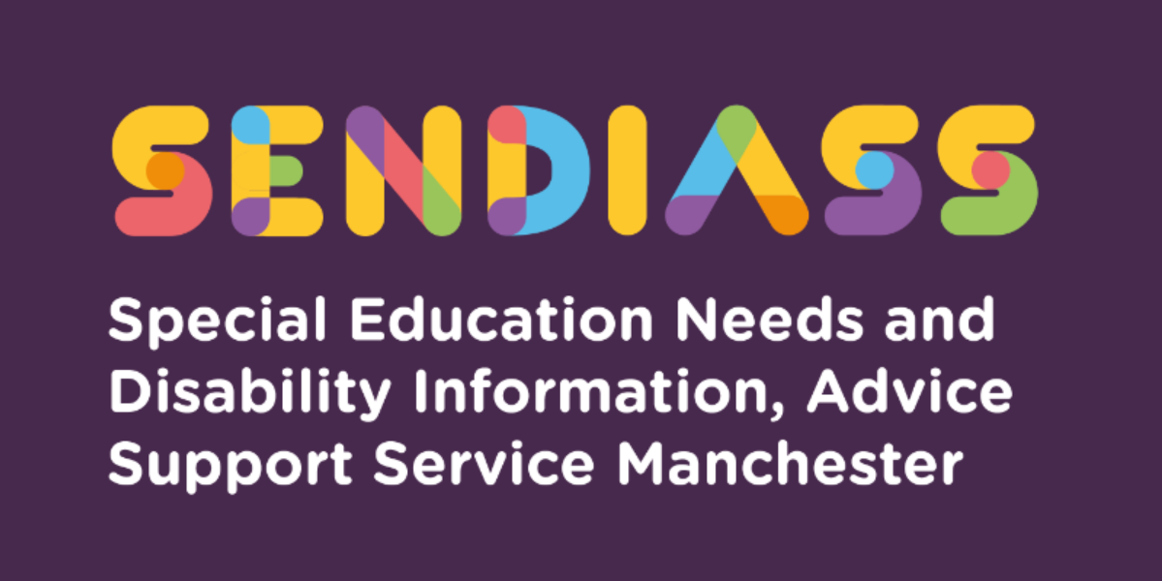

What if I do not agree with decisions about Special Education Needs or Disability (SEND) provision?

Factsheet Number 36 August 2025
Disclaimer: This is a guide and should not be treated as legal advice. Although SENDIASS Manchester makes all reasonable efforts to ensure that the information contained in this factsheet is accurate and up to date at the time of publication, we cannot accept responsibility for outcomes suffered because of reliance placed upon it.
The hyperlinks in this factsheet are correct as of August 2025.
This factsheet tells you about what you can do if your child has Special Educational Needs or Disability (SEND) and you are unhappy about the help they are getting from education, health services or social care.

The SEND Code of Practice says:

Decisions about provision for children and young people with SEN or disabilities should be made jointly by providers, parents, and children and young people themselves, taking a person-centred approach, with the views of children, young people and parents considered when those decisions are made. (11.1)

First steps

If you are not happy about the help that your child has at school then the first step is to talk to their teacher, the Special Educational Needs Co-ordinator (SENCO) or the head teacher.

If your child has an Education, Health, and Care Plan, you can also contact the Education, Health, and Care Plan Team by emailing sen@manchester.gov.uk or by ringing 0161 245 7439 (email and number correct as of August 2025).

SENDIASS (Special Educational Needs and Disabilities Information, Advice Support Service) Manchester can help you prepare attending a meeting with any of the relevant professionals. If you still have concerns, we can help you decide what to do next.

What next?

If you still have a problem, you might be able to:
- Seek help to put your concerns forward.
- Make a complaint.
- Ask for independent disagreement resolution or mediation.
- Appeal against a decision.

SENDIASS Manchester can tell you more about each of these and help you decide what to do.

Seeking help

SENDIASS Manchester has produced a factsheet number twenty three called preparing for school meetings (Factsheets (iasmanchester.org)) and it might be useful to read this in preparation for any meeting with professionals or services first. Also, it might be helpful to ask a friend or relative to attend a meeting with you. The service has also produced a podcast for you to listen to on this subject Preparation for a school meeting podcast Series 1 number 2.

SENDIASS Manchester can give you impartial information and advice about ways forward and tell you about national groups that provide information and advice.

Making a complaint

Schools and colleges, Manchester City Council and the health service have a complaints procedure. Schools and colleges complaints procedures can be found on their website. The procedure for complaints about city council services can be found on Manchester City Council’s website.

If you are not happy about the provision being offered by health services, you should contact the Patient Advice and Liaison Service (PALS) – contact the National Health Service for details of your local PALS.

You will usually need to:
- Have tried to resolve your complaint by speaking to the right people.
- Put your complaint in writing, using the word ‘complaint.’
- Be clear about all the issues you want resolved.
- State what you want to happen.
- Give a reasonable time by which you would like a response.

If you are not happy with the outcome of making a complaint or feel that it has not been dealt with properly, SENDIASS Manchester can give you information on what to do next.

You can find out more about complaints procedures in the SEND Code of Practice sections 11.2 and 11.67 to 11.111. If you want help to understand the different procedures, or advice on which to use, please contact SENDIASS Manchester.

Disagreement resolution

Most disagreements can be sorted out by talking with the school, college, local authority, or Clinical Commissioning Group (CCG) (for health-related issues).
The SEND Code of Practice says:
Decisions about provision for children and young people with SEND should be made as soon as possible. In most cases this will be achieved by all services working closely together and agreeing what should be provided with parents and young people. (11.3)
The SEND Code of Practice says:

Local authorities must make disagreement resolution services available to parents and young people. Use of the disagreement resolution services is voluntary and must be with the agreement of all parties. The service, while commissioned by it, must be independent of the local authority – no-one who is directly employed by a local authority can provide disagreement resolution services. (11.6)

In Manchester, there are a number of approved independent providers who offer a trained mediator to facilitate a discussion. The purpose is to look for a way forward that all the parties accept. The service is free to parents and families and confidential - and you can choose whether to use it. The list of mediators can be found on the Local Offer website.

The disagreement resolution service is there to help resolve disagreement between parents or young people and the organisations that are responsible for making provision for children and young people with special educational needs.

These can be:
- How early years providers, schools and further education institutions carry out their duties for children and young people with SEND.
- For governing bodies and proprietors of schools it includes using their “best endeavours” to meet children and young people’s SEND. This includes children and young people receiving SEND support and those with Education Health and Care Plans (EHC plans).
- For local authorities this includes keeping education and care provision under review, assessing needs, and drawing up EHC plans.
- Health or social care provision, where these are being considered as part of an EHC needs assessment or form part of an EHC plans.

Disagreement resolution services can also be used:
- During EHC needs assessments
- While EHC plans are being drawn up
- While waiting for SEN and Disability Tribunal appeals
- At a review of a child or young person’s EHC plans
- During re-assessment of a child or young person’s education, health, and care needs.

SENDIASS Manchester can help you decide if independent disagreement resolution is the right way forward.

You can find out more about disagreement resolution services in the SEND Code of Practice sections 11.6 to 11.10.

Mediation

Mediation is a type of disagreement resolution. The service is free to parents and carers and is confidential.

The SEND Code of Practice says:

Mediation can take place following decisions by a local authority not to carry out an EHC needs assessment, not to draw up an EHCP, after they receive a final EHCP or amended plan, following a decision not to amend an EHCP or a decision to cease to maintain an EHCP. (11.13)

If you wish to register an appeal with the First Tier Tribunal (SEN and disability) you first must consider mediation unless it is about a placement disagreement only (do contact SENDIASS about this however as in most cases, there will be more that you may need to challenge than just the placement). This is called mediation advice. Once you have had the mediation advice you can decide whether you want to go to appeal.

If you choose mediation the local authority (or Clinical Commissioning Group (CCG), if a health need or provision is in dispute) must take part. The meeting will be arranged within 30 days following a self-referral.

An independent mediator runs the meeting. When the meeting has finished the mediator issues you with a certificate within three working days. You need this certificate to register an appeal to the First Tier SEN and Disability Tribunal.

Mediators must be trained and accredited and are independent of the local authority and CCG.

If you decide not to go to mediation the mediation adviser will issue you with a certificate within three working days. You will need this certificate to register an appeal to the First Tier SEN and Disability Tribunal.

SENDIASS Manchester can help you decide if mediation is the right way forward.

You can find out more about mediation in the SEND Code of Practice sections 11.13 to 11.38.

Do I have to choose between making a complaint and/or using disagreement resolution and mediation?

Usually, you can follow more than one route. For example, you can still make a complaint if you have already tried disagreement resolution. SENDIASS Manchester can explain your rights and the different procedures.

Appeals

The SEND Code of Practice says that parents and young people can appeal to the tribunal about:
- A decision by a local authority not to carry out an EHC needs assessment or reassessment.
- A decision by a local authority that it is not necessary to issue an EHC plan following an assessment.
- The description of a child or young person’s SEN specified in an EHC plan, the special educational provision specified, the school or other institution or type of school or other institution (such as a mainstream school/college) specified in the plan or that no school or other institution is specified.
- An amendment to these elements of the EHC plan
- A decision by a local authority not to amend an EHC plan following a review or reassessment.
- A decision by a local authority to cease to maintain an EHC plan (11.45)

You can find out more about appeals to the SEN and Disability Tribunal in the

SEND Code of Practice sections 11.39 to 11.55.

The SENDIASS team can explain the tribunal process to you or visit our website.

at https://www.iasmanchester.org/tribunals

Contact Details for SENDIASS Manchester

Helpline Telephone number: 0161 209 8356. Please clearly leave your name, contact number and a brief message on the answerphone and a member of the team will contact you within 24 hours or the next working day.
Or
Email your query to us: sendiass@manchester.gov.uk leaving your name, child’s name and their date of birth.

You can complete our website contact form: Contact Us (iasmanchester.org)

Visit Manchester SENDIASS website About SENDIASS Manchester (iasmanchester.org)

Manchester SENDIASS Podcasts Listen to our SEND Talk podcasts

Manchester SENDIASS YouTube channel https://www.youtube.com/@SENDIASSManchester

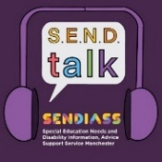



QR code for the website QR code for Facebook page

