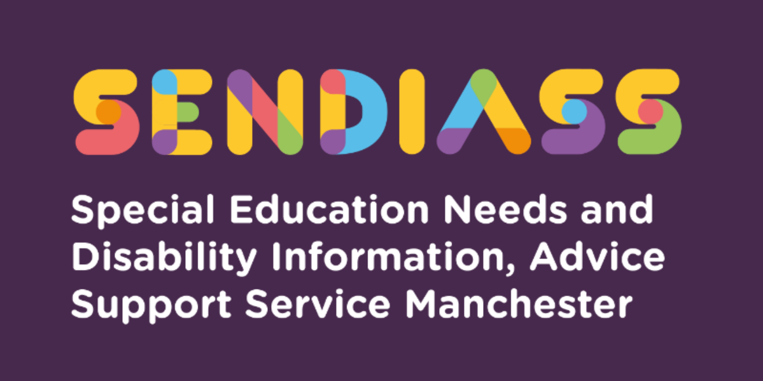

horizontal line

# **Manchester Hospital School - Leo Kelly**

**Factsheet Number 35 August 2025**

horizontal line

**Disclaimer**: This is a guide and should not be treated as legal advice. Although SENDIASS Manchester makes all reasonable efforts to ensure that the information contained in this factsheet is accurate and up to date at the time of publication, we cannot accept responsibility for outcomes suffered because of reliance placed upon it.

## **What is the Leo Kelly Centre?**

Leo Kelly Centre (LKC) is part of the Manchester Hospital School and offers educational provision to children and young people, who live in Manchester and who are prevented from attending their base school because of medical or mental health issues.

Unlike other special schools, students do not have to have an Education, Health, and Care plan (EHC Plan) to access the provision.

**What does the LKC provide?**

The LKC offers highly specialist teaching and learning in a small, nurturing environment. It is in place for children and young people with very high Social Emotional Mental Health (SEMH) needs which, despite their own school’s best efforts, are not having their needs met. Schools are expected to have used all resources at their disposal to support the young person first, including use of the ‘Emotionally based School Avoidance” package of support before a referral is made.

Schools or the Local Authority should refer to Manchester Hospital School as soon as the young person has been or will be absent from school for more than 15 days in a calendar year and as soon as they are aware that the school believes it is not able to meet need. Supporting evidence from a medical practitioner is required.

It is also a “step down” provision for young people leaving hospital.

Schools are no longer charged for using the Leo Kelly School as the local authority have now commissioned this service under Section 19 to provide alternative provision. However, schools are still responsible for the transport costs.

## **What are the entry criteria?**

Young people who meet the threshold for entry to the LKC are likely to display similar characteristics.

They can be, though not exclusively:

* Socially anxious and/or isolated.
* Unlikely to leave their home.
* Unable to travel independently.
* Unable to make friends except through online chat rooms.
* Unable to regulate their anxiety and emotions and will withdraw into themselves.
* At risk of Child Sexual Exploitation (CSE) and/or drug and alcohol abuse

Some young people may also have experienced childhood trauma, have a diagnosed eating disorder, obsessive compulsive disorder (OCD), have suicide tendencies and are likely to be at extremely considerable risk of self-harm.

Most young people who do not meet the criteria are likely to be:

* Able to leave their home and take part in activities in their community.
* Still attending their school, albeit for a small amount of time
* Unable to control their emotions and direct their anxiety in anger towards others.
* Violent and aggressive

## **What are the benefits to accessing this provision?**

Schools can access appropriate advice and suitable provision for those young people with the highest needs when they need it. The entry route and criteria for admission are explicit and transparent. The model is sustainable and not drawing funds away from children being taught in hospital. The Manchester Hospital School supports mainstream schools through an outreach offer especially with young people who “refuse” to attend and to support special schools with students with mental health needs.

All pupils allocated a place at the LKC will be dual rolled with their home school throughout the placement. Any EHC plans will not name the hospital school but name the mainstream, with support from Manchester Hospital School, Leo Kelly Centre.

## **Referrals**

Referrals to the LKC are made by completing a form available on the school website. The referral can be initiated by the base school with the support of a medical professional and with the support of the base school. The definition of a medical practitioner can include a school nurse, GP, CAMHS staff and paediatric consultants.

Once received, the referral form is checked by the Assistant Head in charge of referrals and if satisfied then the referral goes to a panel.

The fortnightly multi-agency panel, consisting of representatives from health, education and MCC, will then determine if the referral can be considered as part of the Local Authority Section 19 Duty or whether the school, with support, should be required to meet the child’s needs.

The LKC does not allow visits to the site prior to being admitted and it is not a residential school.

The centre offers GCSEs and an access pathway for an alternative curriculum learning more practical skills i.e., cooking, textiles, and social skills.

## Once a referral is accepted and whichever pathway chosen, LK offers:

* Senior Leaders who will make decisions in the best interests of the child and will work with, and challenge schools to ensure children who cannot attend their own school are not missing their education or experiencing social isolation where this could be avoided.
* Senior Leaders will advocate for this group of learners and ensure all our staff provide excellent quality and good value for money.
* Liaison with the home school or MCC to determine what provision is required, the objectives, the expected outcomes, and the timelines to achieve them.
* A thorough assessment of needs which is a baseline and identifies gaps in and barriers to learning.
* An individual education plan linked to other documents such as an EHCP, set out in writing and which is regularly monitored and reviewed with the child, the family, and the school or MCC.
* Education which is flexible and appropriate to meet physical or mental health needs.
* Education which prevents learners from slipping behind their peers
* Education which reduces learner’s anxiety about what they are missing by not being at school.
* Education which is provided at the home or in a community setting.
* Full time education equivalent to what a pupil would have received at school or, as much as the pupil can manage.
* Education which is planned and delivered by highly specialist and well-trained staff.
* Staff who are consistently linked to the pupil throughout their journey at our school.
* A route back to the home school or on to a new placement
* Support with the transition back to school or on to college.
* Support and advice to families and to schools.
* Support and advice to professionals.
* Opportunities for pupils to sit external examinations.
* Opportunities for pupils to receive independent careers advice and guidance.
* One to one tuition in the home or community setting
* A pool of teachers able to provide high quality one to one tuition to any pupil who cannot access school for whatever reason.

Diagram showing the Re-engagement with Learning Pathway (RELP)

Diagram showing the Re-engagement with Learning Pathway (RELP) continued

**Definitions for above diagrams:**

## **Re-Engagement with Learning Pathway (RELP)**

This pathway has been developed to support learners who have become disengaged from learning because of their mental or physical health or both. The outcome of the work is to move the pupil along the pathway, to re-engage them with learning, to find activities which interest them and to move forward at a pace which does not overwhelm them. Pupils on this pathway have exceptionally high needs.

## **Access to Learning Pathway (ALP)**

This pathway has been developed to support learners who are keen to learn and very engaged with their schoolwork. They are afraid of falling behind their peers and want to be back to school as soon as possible. They long for contact with their friends and to remain part of their school community.

These learners benefit from remote or face to face one to one tuition based in their home. They may also benefit from a package which utilises online learning as well as face to face learning.

They may also benefit from an AV1 robot to reduce their isolation within their homes. Pupils on this pathway have exceptionally high health needs which are preventing them from attending school.

**Not in employment, education, or training (NEET)**

Emotionally Based Schools Attendance Toolkit (EBSA)

|  |
| --- |
| **Contact Details for SENDIASS Manchester**  Helpline Telephone number: 0161 209 8356. Please clearly leave your name, contact number and a brief message on the answerphone and a member of the team will contact you within 24 hours or the next working day.  **Or**  Email your query to us: [**sendiass@manchester.gov.uk**](mailto:sendiass@manchester.gov.uk) leaving your name, child’s name and their date of birth.  You can complete our website contact form: [**Contact Us (iasmanchester.org)**](https://www.iasmanchester.org/contact)  Visit Manchester SENDIASS website [**About SENDIASS Manchester (iasmanchester.org)**](https://www.iasmanchester.org/)  Manchester SENDIASS Podcasts [**Listen to our SEND Talk podcasts**](https://www.iasmanchester.org/podcasts)  Manchester SENDIASS YouTube channel [**https://www.youtube.com/@SENDIASSManchester**](https://www.youtube.com/@SENDIASSManchester)    **QR code for the website QR code for Facebook page** |