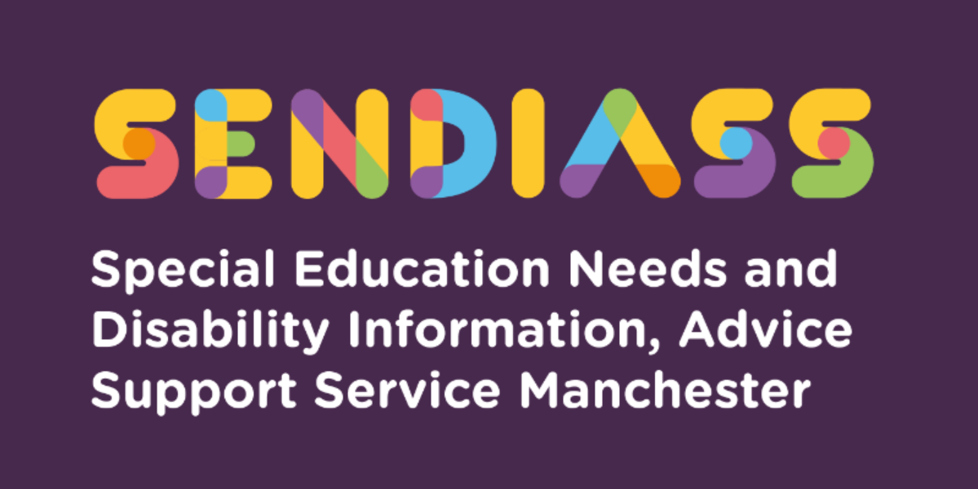

horizontal line

# **A Diagnosis of Autism**

**Factsheet Number 31 August 2025**horizontal line

**Disclaimer**: This is a guide and should not be treated as legal advice. Although SENDIASS Manchester makes all reasonable efforts to ensure that the information contained in this factsheet is accurate and up to date at the time of publication, we cannot accept responsibility for outcomes suffered because of reliance placed upon it.

**The hyperlinks in this factsheet are correct as at August 2025.**

**An autism diagnosis- what does it mean?** [An autism diagnosis](https://www.autism.org.uk/advice-and-guidance/topics/diagnosis?utm_source=The%20National%20Autistic%20Society&utm_medium=email&utm_campaign=14594453_MKT_SB_AKHProf_Newsletter%2001.08.2024&utm_content=Diagnosis%20Stat%20button&Keywords=Diagnosis%20Stat%20button&dm_i=YA3,8OT5H,2J4WCF,102NJ9,1)

<https://www.autismunderstood.co.uk>

There is a fantastic new website - [Autism Understood](https://eur03.safelinks.protection.outlook.com/?url=https%3A%2F%2Flnks.gd%2Fl%2FeyJhbGciOiJIUzI1NiJ9.eyJidWxsZXRpbl9saW5rX2lkIjoxMDYsInVyaSI6ImJwMjpjbGljayIsInVybCI6Imh0dHBzOi8vYXV0aXNtdW5kZXJzdG9vZC5jby51ay8_dXRtX2NvbnRlbnQ9JnV0bV9tZWRpdW09ZW1haWwmdXRtX25hbWU9JnV0bV9zb3VyY2U9Z292ZGVsaXZlcnkmdXRtX3Rlcm09IiwiYnVsbGV0aW5faWQiOiIyMDIzMDgyMy44MTUyMjA3MSJ9.erkOobp_H3twaBf1a0VV1Qm_8jMp95tQKTthayisUEc%2Fs%2F1111742414%2Fbr%2F224663662437-l&data=05%7C01%7Cmargarette.lee-chapman%40manchester.gov.uk%7Cb41dd880e7cf40a4e39808dba3c220dd%7Cb0ce7d5e81cd47fb94f7276c626b7b09%7C0%7C0%7C638283826397974390%7CUnknown%7CTWFpbGZsb3d8eyJWIjoiMC4wLjAwMDAiLCJQIjoiV2luMzIiLCJBTiI6Ik1haWwiLCJXVCI6Mn0%3D%7C3000%7C%7C%7C&sdata=mb9m87XcEMJzUW6Na6hHrDxrxas9t5UswXvCQRxwq%2Bk%3D&reserved=0) - created by [Spectrum Gaming](https://eur03.safelinks.protection.outlook.com/?url=https%3A%2F%2Flnks.gd%2Fl%2FeyJhbGciOiJIUzI1NiJ9.eyJidWxsZXRpbl9saW5rX2lkIjoxMDcsInVyaSI6ImJwMjpjbGljayIsInVybCI6Imh0dHBzOi8vd3d3LnNwZWN0cnVtZ2FtaW5nLm5ldC8_dXRtX2NvbnRlbnQ9JnV0bV9tZWRpdW09ZW1haWwmdXRtX25hbWU9JnV0bV9zb3VyY2U9Z292ZGVsaXZlcnkmdXRtX3Rlcm09IiwiYnVsbGV0aW5faWQiOiIyMDIzMDgyMy44MTUyMjA3MSJ9.ce5ip7fPAoY6xYU0fLCHB3pXVFdM5ocBxoRBodNYzSA%2Fs%2F1111742414%2Fbr%2F224663662437-l&data=05%7C01%7Cmargarette.lee-chapman%40manchester.gov.uk%7Cb41dd880e7cf40a4e39808dba3c220dd%7Cb0ce7d5e81cd47fb94f7276c626b7b09%7C0%7C0%7C638283826397974390%7CUnknown%7CTWFpbGZsb3d8eyJWIjoiMC4wLjAwMDAiLCJQIjoiV2luMzIiLCJBTiI6Ik1haWwiLCJXVCI6Mn0%3D%7C3000%7C%7C%7C&sdata=l1djBftWH3idHBa6mFVmH6fuKzPvRok1ee6M6wptvoY%3D&reserved=0) in co-production with lots of autistic young people across Manchester. When young people are told they are autistic, they are rarely told what this means. There is also a lot of online misinformation about autism. Autism Understood fills in the gaps. The idea is that all autistic young people should be offered access to this site to help them make sense of their diagnosis. Even though it is designed for young people, it is also useful for parents, professionals, and anyone who wants to learn more about the lived experience of autism.

## **Understanding the needs of young people with autism (neurodivergent).**

There are four areas of difference, which can be seen in those diagnosed with autism:

* Their understanding and use of language
* Their social skills and sociality with others
* Their sensory processing
* Their methods of flexible thinking and requirement to have their own space and routines.

Being able to understand their needs and the consequences of not having those needs met can lead to high anxiety and stress responses i.e., fight, flight and/or freeze.

Please listen to this podcast [Experiences of autism as a young person](https://our-turn-to-talk.zencast.website/episodes/experiences-of-education-as-an-autistic-person?mc_cid=42f6771cb9&mc_eid=2550448cf1)

**Experiences of Education as an Autistic Person explores:**

* The sensory challenges autistic young people can face at school.
* The demands of the school environment on autistic students and the support schools can put in place.
* Social challenges faced at school by autistic students and the ways in which they have overcome the difficulties that school life presented.

**There are two types of autism profile groups, who are poorly understood:**

* Young people with pathological demand avoidance and
* Girls with autism without a learning disability

The Pathological Demand Avoidance Profile (PDA) is seen by high anxiety levels (Asperger’s included), who are a high-risk group as they are often driven to avoid everyday demands and expectations to an extreme extent. Their demand avoidant behaviour caused by anxiety leads to a consequent need to be in control. Children and young people with a PDA profile have the risks of exclusion, off-rolling, home-education, contact with the criminal justice system (although this tends to be pre-dominantly male) and sometimes inappropriate hospital admission.

## **Girls with autism without a learning disability**

Girls often go undiagnosed or are diagnosed late and are often misunderstood as they present very differently to the male profile. 61% of children and young people aged under 18 living in in-patient units are female.

Girls with autism can:

* Escape into fantasy.
* Have good expressive language but difficulty processing language.
* Have more thought and attention problems.
* Have intense interests.
* Sensory processing difficulties
* Be confused and isolated by female peers or “flit” between groups.
* Study and initiate behaviours to “pass as normal.”
* Keep a lid on things at school but explode from stress at home.

Girls with autism may face the following risks:

* Missed diagnosis resulting in unmet need.
* Struggle to concentrate on academic learning.
* Bullying
* Low self-esteem, self-depreciation, depression
* Struggle to function independently.
* Vulnerable to unsafe or abusive situations
* Anxiety: catastrophic thinking/anxiety related physical conditions e.g., irritable bowel syndrome
* Unmet need leading to crisis: school refusal, withdrawal, selective mutism, shut down, lashing out at self (self-harm, eating disorders, substance misuse)

Trigger points can be:

* Stressful life events
* Transitions (activity to activity, year to year, Key stage to Key stage and transition to adult services.)
* Puberty (hormones, changing body, new feelings, social interactions more complex and awareness of being different)

## Inclusive education principles and recommendations for children and young people with autism (now to be known as neurodivergent)

* Well-resourced and targeted funding
* Early identification of need and early intervention
* Adequate and appropriate support
* Recognition of the role of special schools in supporting inclusion and harnessing expertise
* Working in partnership with parents and professionals
* Training for teachers and support staff to improve autism awareness and understanding.

## **What can you expect from an educational setting?**

* That they follow the advice and guidance available from professionals as appropriate.
* They set up an effective communication method with you to make sure that information is shared.
* Use visual timetables to support routines.
* Once identified – is the school/GP aware and is there a need for a developmental assessment?
* Does the young person need an EHC assessment/plan and if so, is the school implementing it?
* Once diagnosed – what post diagnostic support is available and what local support groups are there? In Manchester there are the monthly Post Diagnostic Group sessions run by One Education.
* That they identify your child or young person’s strengths as well as their areas of need (Person Centred Profile or called “All About Me”)
* Is the young person at risk of school exclusion/school refusal?
* Is the young person struggling with understanding, using language, and getting on with others – Have they been referred to Speech and Language Therapy (SALT)?
* Is the young person struggling with sensory issues with self-care or organisational skills – have they been referred to occupational therapy?
* Is the young person’s mental health and wellbeing suffering – are they referred to Children and Adolescent Mental Health Service (CAMHS)?
* Involve the family to review and support the achievement of targets in the educational setting and at home.
* That all staff undertake Autism Awareness Training
* That your child or young person continues to be part of the whole class grouping when and where appropriate make adaptations where e.g. a quiet area/workstation/time out space etc.
* Autism can affect each person differently as many young people have an uneven profile of abilities, which can lead professionals assuming that there is no need for social care support. Often the young person with autism and without learning difficulties can sometimes be blocked from social care services because they do not qualify for learning disability or mental health services.

**What it does not mean:**

* That your child will automatically need to be entitled to 1-1 support from an adult.
* That your child will automatically be entitled to an Education, Health and Care Plan (EHC plan).
* That your child will have to move educational setting.

**Recommended support.**

* Local services should work with and support families of children and young people with autism.
* Local authorities should provide health and therapeutic services e.g., speech and language therapy, occupational therapy, physiotherapy.
* Central government should provide appropriate financial benefits e.g., P.I.P., universal credit.
* Other organisations can provide a range of other services and forms of support e.g., advocacy, legal advice, online support, parent training and residential care.
* Local services should be co-ordinated by a local multi-agency group.

It is essential that the young person has a “Circle of Support” which can include friends, adults they trust and if not then CAMHS support or autism friendly activities.

Does the family of the young person have a support network and what can be done to support and address the challenges faced by the family i.e., community, the wider society, health and service providers? Is there a professional team around the child i.e., Health, Education and Social Care?

## **For more information go to:**

* [National Autistic Society](https://www.autism.org.uk/?msclkid=34ee703eae7711ec986ee8e3e804b1e1)
* [Autism.org.uk - Pathological demand avoidance (PDA) Guide](https://www.autism.org.uk/about/what-is/pda.aspx)
* [Contact for Disabled People website](https://contact.org.uk/help-for-families/information-advice-services/)
* [Autism | Special Educational Needs](https://www.witherslackgroup.co.uk/advice-and-support/autism/) – Witherslack Group

## Getting the right EHC plan resources:

* [IPSEA website](https://eur03.safelinks.protection.outlook.com/?url=https%3A%2F%2Fwww.ipsea.org.uk%2Fasking-for-an-ehc-needs-assessment&data=04%7C01%7Ctracy.feeley%40manchester.gov.uk%7C09d00c6419dc4b93162708da0b2e37cc%7Cb0ce7d5e81cd47fb94f7276c626b7b09%7C0%7C0%7C637834590371384543%7CUnknown%7CTWFpbGZsb3d8eyJWIjoiMC4wLjAwMDAiLCJQIjoiV2luMzIiLCJBTiI6Ik1haWwiLCJXVCI6Mn0%3D%7C3000&sdata=fJeSgJ%2BoUH6UpJk0YcBq2lTZn%2FxeNnySBeroV7B36ho%3D&reserved=0)

“Keeping it all inside” a comprehensive Guide to Autism by the Autism Girls Network [Here](https://autisticgirlsnetwork.org/keeping-it-all-inside.pdf?utm_medium=email&_hsmi=72366789&_hsenc=p2ANqtz--vi9pxzcSYxpU21Iybri1p6Vp-W-mnTzLxDMgLQjD5vcNd8GToU4aOqy4gHkJLUvdcYup-S4WP-ZwO5kMSmWIUGtXcWuTLYMXqbZ4oiYpqW4FXb-0&utm_content=72366789&utm_source=hs_email)

## **Meeting parent/carer needs:**

* [Carers Trust website](https://carers.org/article/carers-assessment)

## **Social Care support:**

# [Supporting Treatment and Appropriate Medication in Paediatrics (STAMP)](https://www.england.nhs.uk/learning-disabilities/improving-health/stamp/)

**Quirky and Parenting Autistic Podcasts**

<https://sites.libsyn.com/437067>

**Why autism is a difference not a deficit- video.**

The video from the Autism Education Trust highlights strengths and differences that autistic people may experience in three areas of development and explains how there is no such thing as a ‘typical autistic person.’

Ten reasonable adjustments for the classroom for autistic pupils that require.

them - A checklist created by the Autism Education Trust

<https://www.autismeducationtrust.org.uk/sites/default/files/2023-05/10-Reasonable-Adjustments-for-the-classroom-Checklist.png>

**A delightful book to read with super illustrations - highly recommended.**

He’s Not Naughty! A children’s guide to Autism by Deborah Brownson ISBN 978-1-78592-872-7

|  |
| --- |
| **Contact Details for SENDIASS Manchester**  Helpline Telephone number: 0161 209 8356. Please clearly leave your name, contact number and a brief message on the answerphone and a member of the team will contact you within 24 hours or the next working day.  **Or**  Email your query to us: [**sendiass@manchester.gov.uk**](mailto:sendiass@manchester.gov.uk) leaving your name, child’s name and their date of birth.  You can complete our website contact form: [**Contact Us (iasmanchester.org)**](https://www.iasmanchester.org/contact)  Visit Manchester SENDIASS website [**About SENDIASS Manchester (iasmanchester.org)**](https://www.iasmanchester.org/)  Manchester SENDIASS Podcasts [**Listen to our SEND Talk podcasts**](https://www.iasmanchester.org/podcasts)  Manchester SENDIASS YouTube channel [**https://www.youtube.com/@SENDIASSManchester**](https://www.youtube.com/@SENDIASSManchester)    **QR code for the website QR code for Facebook page** |