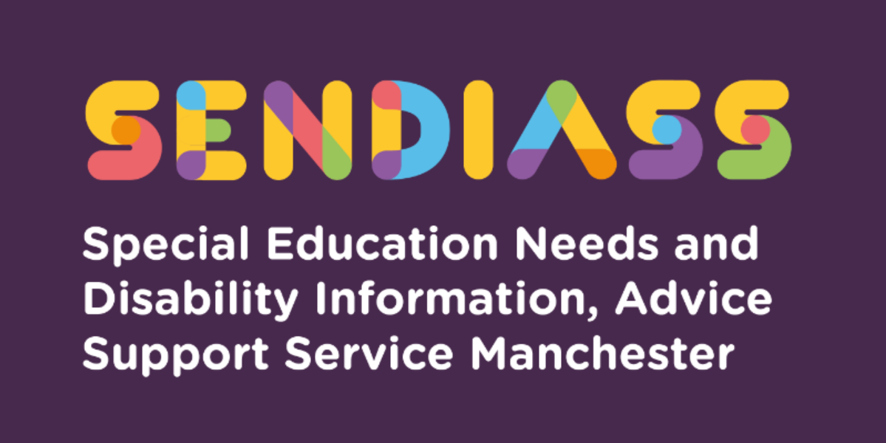

horizontal line

**Mental capacity and decision making**

**Factsheet Number 30 August 2025**

horizontal line

**Disclaimer**: This is a guide and should not be treated as legal advice. Although SENDIASS Manchester makes all reasonable efforts to ensure that the information contained in this factsheet is accurate and up to date at the time of publication, we cannot accept responsibility for outcomes suffered because of reliance placed upon it.

The hyperlinks in this factsheet are correct as at August 2025.

**Background to Mental Capacity and Decision Making**

Under the Children and Families Act 2014, a child becomes a young person at the end of compulsory school age (i.e., the last Friday of June in the year in the academic year in which the child turns 16). At that point parental rights under the law in relation to the young person's education will automatically pass to the young person themselves.

The Mental Capacity Act 2005 (MCA) provides a comprehensive framework for decision making on behalf of adults aged 16 and over who are unable to make decisions for themselves, i.e. they lack capacity.

**Involvement of parents and decision-making post 16**

The SEN and Disability Code of Practice 2015 (“the Code”) makes it clear that once a child becomes a young person at the age of 16, local authorities and others should normally engage directly with the young person rather than their parents. However, the Code also makes it clear that the young person's family and parents should continue to be involved in discussions about the young person's future. The young person may also ask them to help in other ways such as attending meetings, filling in forms or receiving correspondence on their behalf. This is particularly important for 16- and 17-year-olds, for whom parents will retain parental responsibility until they reach the age of 18.

**The concept of ‘mental capacity’**

The legal concept of mental capacity is defined in the Mental Capacity Act 2005 and the [Mental Capacity Act Code of Practice](https://www.gov.uk/government/publications/mental-capacity-act-code-of-practice), which is statutory guidance.

Mental capacity is assessed in relation to the decision which needs to be made. This means that whether a young person has mental capacity to make a particular decision or not has to be considered on an individual basis in the light of the circumstances at the time. You cannot just say that someone lacks mental capacity generally. For example, whilst a young person may be able to make daily decisions, such as what choice of dinner they want or things they would like to learn about, they may not be capable of deciding what school or college they want to attend. If a young person lacks the mental capacity to make a particular decision, then someone else (usually their parent) will be able to make that decision for them.

A person must be assumed to have capacity unless there is evidence that they are not able to make the relevant decision. Someone is treated as being unable to make a decision if they are not able:

* Understand the information relevant to the decision,
* Retain that information, long enough to make a decision
* Use or weigh that information as part of the process of making the decision,
* Communicate their decision (whether by talking, using sign language or any other means).

Before concluding that a young person is unable to make a decision, all practicable steps should be taken to help them make the decision without success. You may find using a decision-making profile helpful [**Decision Making Profile - NDTi**](https://www.ndti.org.uk/resources/publication/decision-making-profile)

Importantly, the Mental Capacity Act is clear that a person is not to be treated as unable to make a decision merely just because they make an unwise decision. If a young person lacks capacity to make a particular decision, the person making the decision on their behalf must act in the young person’s best interests.

**Agreement**

The decision as to whether a young person has mental capacity to make a particular decision is something that they and their parents should make in the first instance. It would be rare for a school, college, or LA not to agree with their assessment of the situation.

When it is agreed that a young person does not have the capacity to decide about appropriate education needs, then parents will automatically make that decision for them unless the Court of Protection has appointed a different person to be their Deputy. They would have to make the decision which was in the best interests of the young person concerned. The local authority would also still have to seek the young person's views as part of any decision-making process.

**Disagreement**

There may be disagreement between the parents, the young person, the school, or college being attended, and/or the local authority, regarding a young person's mental capacity to make a decision. It may then be necessary to seek an assessment to provide a professional opinion of the young person's capacity to make the decision.

The Mental Capacity Code of Practice confirms that this opinion could come from a psychiatrist, psychologist, speech and language therapist, occupational therapist, or social worker. It might also come from someone like a GP or other medical professional who is involved with the young person. It is especially important that such assessments are done by professionals who have acquired the necessary skills. A decision on a young person's mental capacity should not be made by a school/college.

A mental capacity assessment might be helpful to support a parent who wished to take a decision on behalf of a young person and was being challenged by a local authority about their right to do so.

A parent would be expected to explain the basis of their belief that the young person lacked capacity and an assessment might help them to do so. Such an assessment may not be necessary in all cases, depending on the other evidence available to support the parent's belief.

“*Mental Capacity is the ability to make decisions for yourself. People who cannot do this are said to ‘lack capacity.’ This might be due to illness, injury, a learning disability, or mental health problems that affect the way their brain works.”*

**To have capacity a person must be able to**:

Understand the information that is relevant to the decision they wish to make.

* Retain the information long enough to be able to make the decision.
* Weigh up the information available to make the decision.
* Communicate their decision by any means, including talking, using sign language, or through simple muscle movements such as blinking an eye or squeezing a hand.
* People should be assumed to have capacity unless there is clear evidence that shows otherwise. Where capacity is in question, the person should be assessed by a suitably qualified professional on whether they have the ability to make a particular decision at a particular time. The mental capacity of the person can fluctuate. As an example, for a person with dementia there might be times of the day when they are able to think more clearly. Where a person has fluctuating capacity, they should, where possible, be assisted to make the decision at the time that they have the capacity to do so.

**For more information:****<https://www.ipsea.org.uk/faqs/young-people-and-mental-capacity>**

|  |
| --- |
| **Contact Details for SENDIASS Manchester**  Helpline Telephone number: 0161 209 8356. Please clearly leave your name, contact number and a brief message on the answerphone and a member of the team will contact you within 24 hours or the next working day.  **Or**  Email your query to us: [**sendiass@manchester.gov.uk**](mailto:sendiass@manchester.gov.uk) leaving your name, child’s name and their date of birth.  You can complete our website contact form: [**Contact Us (iasmanchester.org)**](https://www.iasmanchester.org/contact)  Visit Manchester SENDIASS website [**About SENDIASS Manchester (iasmanchester.org)**](https://www.iasmanchester.org/)  Manchester SENDIASS Podcasts [**Listen to our SEND Talk podcasts**](https://www.iasmanchester.org/podcasts)  Manchester SENDIASS YouTube channel [**https://www.youtube.com/@SENDIASSManchester**](https://www.youtube.com/@SENDIASSManchester)    **QR code for the website QR code for Facebook page** |