SENDIASS service logo. A colourful text on a purple background


horizontal line

**Annual Reviews of EHC plans (Education, Health, and Care plan)**

**Fact Sheet 3 August 2025**

# horizontal line

**Disclaimer:** This is a guide and should not be treated as legal advice. Although SENDIASS Manchester makes all reasonable efforts to ensure that the information contained in this factsheet is accurate and up to date at the time of publication, we cannot accept responsibility for outcomes suffered because of reliance placed upon it.

All hyperlinks in this factsheet were correct as of August 2025.

## **Annual Review Meeting**

Children and Families Act 2014 [Section 44 – Reviews and Re-assessments of EHC Plans](https://www.legislation.gov.uk/ukpga/2014/6/section/44)If a child or young person has an EHC plan the Local Authority (LA) must review the EHC plan.

* At least every12 months starting on the date the plan was first made

and

* In each subsequent period of 12 months starting with the date on which the plan was last reviewed.

The Special Educational Needs and Disability Regulations 2014 [Regulation 18 – Circumstances in which a local authority must review an EHC plan](https://www.legislation.gov.uk/uksi/2014/1530/regulation/18/made) provides further specific circumstances where plans must be reviewed:

* Where a child or young person is within 12 months of a transfer between phases of education, the LA must review and amend the plan to include the placement the child/young person will attend following transfer no later than:
* **31st March** in the calendar year of the child or young person’s transfer from secondary school to post 16 institutions, and
* **15th February** in the calendar year of the child’s transfer in any other year.

## **Phase transfer means:**

Phase transfer means moving from one stage of education to another, like:

* Nursery School
* Infant school Junior school
* Primary school Secondary school
* Secondary school College or sixth form

If a young person is moving from one **post-16 setting** to another (like changing colleges), the Local Authority (LA) must update their EHC plan at least 5 months before the move. This is so the plan names the new place they will go to.

**Under 5 years old**

LAs should consider reviewing EHC plans for a child under five at least every three to six months to ensure that provision continues to be appropriate. Such reviews would be in addition to the annual review and are not subject to the same requirements regarding invitations and advice. However, the child’s parents must be fully consulted on any proposed changes to the plan.

Parents must be made aware of their right to appeal to the SEND Tribunal if:

* They disagree with proposed changes following an annual review, or
* The LA decides not to make any changes after an annual review.

**Annual Reviews**

The Annual Review must focus on progress towards achieving the outcomes or goals set out in the EHC plan. The review must consider the views, wishes and feelings of children, young people, and parents.

The review must also consider whether the outcomes and goals remain appropriate, and whether the provision is effective in helping the child make progress.

If there are concerns about the child’s progress, the review can be brought forward. This is sometimes referred to as an interim or emergency review, and can be requested by the school, parents, or professionals involved.

## **Early reviews**

EHC plans must be reviewed annually but you can ask for an early review – also known as an “emergency” or “interim” review. The parent/young person only gets the right of appeal if the parties agree that it is the annual review.

You should consider requesting an early review of an EHC plan if:

* The child or young person’s education, health, or social care needs have changed and are no longer accurately described in the plan.
* The provision in the EHC plan is no longer meeting their needs.
* The child or young person has been excluded from school or is at risk of exclusion.
* There is no legal right of appeal if the LA refuses to carry out an early review.
* However, if the LA does agree to hold an early review and then decides not to amend the plan, you may have a right of appeal at that point.

**If the LA refuse an Early Review, you could**:

* Wait until the next annual review.
* Gather further evidence to support the need for an early review, and then make another request; or
* If appropriate, request a re-assessment of the child or young person’s education, health and care needs.

## **Why does there need to be an Annual Review?**

An Annual Review of an Education, Health, and Care (EHC) Plan is a legal requirement under the Children and Families Act 2014 and the SEND Code of Practice.

It serves several important purposes to ensure that the plan remains relevant, effective, and responsive to the child or young person’s evolving needs. New outcomes and provision can be set if needed and aspirations changed.

The purpose of the meeting is to review the EHC plan by:

* Bringing together all those involved in helping achieve the outcomes set out in the plan.
* Gathering and considering information so that it can be used to support future progress.
* Reviewing the effectiveness of any special educational, health or social care provision made for a child or young person.
* Considering whether any changes need to be made to the EHC plan including medium- and long-term outcomes.
* Considering whether an EHC plan should continue.

## **What should I include in my parent/young person report?**

Comments on:

* Progress over the last year, what has the child or young person learned or improved at?
* Are they happier or more confident?
* What needs to be considered in school/college for the coming year?
* What you think you and the school/college can do to help meet those needs
* The child or young person’s views about school/college

## **How children and young people are involved?**

* Children and young people should be encouraged to share their views.
* They can talk about what they like, what they find hard, and what they want to get better at.
* They should help to set new goals for the future.
* Wherever possible they should attend all or part of the annual review meeting especially from year 9.

## **What happens before the meeting?**

Usually, the LA will ask school or college to arrange the review meeting.

# The Head Teacher/Principal/SENCO must ask for written reports from:

# You

# Teachers or tutors

# Other people invited to the review meeting e.g. health.

# 

# The Head Teacher/Principal/SENCO must then:

# Send copies of the written reports to all those invited to the review meeting at least two weeks before it takes place.

# Invite further views, including comments from those who are unable to attend the meeting.

**Important:** It is often the SENCO (Special Educational Needs and Disability Coordinator) at the school who will make all the arrangements for the meeting.

# 

## **Who may attend?**

The Head Teacher/Principal/SENCO must invite: [The Special Educational Needs and Disability Regulations 2014](https://www.legislation.gov.uk/uksi/2014/1530/regulation/20/made)

* Parent/carers and/or the young person

# A relevant teacher who may be the class teacher or form/year tutor, the Special Educational Needs Coordinator (SENCO), or some other person responsible for the provision of their education

# A representative from the LA - your EHC plan Coordinator will be invited; however, they will not be able to attend every review. If you have any concerns, make sure that you contact them to let them know that you would like them to be at the meeting.

# A Health Service representative to provide advice about health care provision in relation to the child/young person if relevant and a LA Social Care representative, who exercises the LA’s social service function in relation to children/young people with SEND.

# Anyone else the Head Teacher/Principal considers appropriate.

# It is unlikely that everyone invited will be able to attend the review meeting but if unable to attend they can send a report.

## **What happens at the review meeting?**

The review meeting must focus on progress made towards achieving the outcomes set out in the EHC plan. The EHC plan must be looked at to see if it still meets the needs.

**The meeting will normally include the following**:

* The extent to which the outcomes (goals) in the EHC plan, or those agreed at the previous annual review have been met. The child/young person’s progress towards achieving the outcomes specified in the plan MUST be considered at the meeting. This requirement is particularly important for young people aged over 18 as the educational and training outcomes will determine whether the plan ceases.
* Medium- and long-term outcomes for the next year
* Planning the support from school/college and other people to help achieve these objectives.
* Any further action required and who will be responsible for this.
* Whether the EHC plan needs amending or is no longer needed
* If you do not agree with what is being suggested at the meeting, try to make that clear and if not present then contact your EHCP Coordinator.
* Review or request a personal budget.
* From year 9 onwards there must be a focus on Preparing for Adulthood (PfA) and independent living.

## **Annual reviews from Year 9**

When the child/young person is in or beyond Year 9 the review **MUST** consider what is required to assist in “Preparation for adulthood and independent living” (PFA). Ideally planning can begin before Year 9.

PFA in the annual review needs to support preparation for higher education and employment.

## **Support to prepare for independent living.**

Support in maintaining good health in adult life including planning transition to adult services.

Support to participate in society including mobility, friendships, and transport support.

Identify what support is needed to achieve the young person’s aspirations.

For 16-18-year-olds who are not in education and training (NEET) the LA must review the EHC plan and amend it to ensure the young person is in education and training and ensure the young person has something to do.

Over 18’s -when carrying out a review for the young person aged 18+ the LA must have regard to whether the education/training outcomes have been achieved. If the young person stops attending college, the LA cannot cease the EHC plan unless they have checked that the young person does not want to go back to education/training. If they do wish to return/do something else, then the LA must amend the plan to help them do so.

## **What happens next?**

Within **two weeks** of the review meeting the school must prepare a written report of the meeting and send it to everyone invited.

The report must set out recommendations on any amendments or changes required to the EHC plan and should refer to any differences between the schools’ recommendations and those of others attending the meeting and include the advice and information obtained prior to the annual review. The report would also need to include details of any disagreements between the parties. The right of appeal only happens if one of the decisions below is made/notified.

Within **four weeks** of the meeting, the LA must let the child’s parent/young person know their decision and decide whether to:

* Keep the EHC plan the same.
* Amend or change the EHC plan.
* Cease to maintain the EHC plan.

**Their letter must also tell you about:**

* Your right to appeal that decision and the time limits for doing so.
* The requirement for you to consider mediation should you wish to appeal.
* Contact information for Disagreement Resolution and advice.
* Support from Special Education Needs and Disability Information, Advice and Support Service Manchester (SENDIASS Manchester).

**Case overview If the LA decide to amend the EHC.**

|  |
| --- |
| (R L, M & P vs Devon County Council 2022) has established that where the LA decide to amend the EHCP they must notify the parent or young person of the decision to amend the EHC plan AND what the proposed changes are within four weeks of the annual review meeting. The final EHC plan must be issued as soon as practicable and within a further 8 weeks maximum. Therefore, the LA must send the parent or young person the final amended EHC plan within a maximum of 12 weeks of the annual review meeting.  You can read the full summary and legal implications of the case R (L, M & P) Devon County Council [2022] EWHC 493 (Admin) on IPSEA’s official website here:[**Read the case summary on IPSEA**](https://www.ipsea.org.uk/r-l-m-and-p-v-devon-county-council-2022-ewhc-493-admin?Title=r-l-m-and-p-v-devon-county-council-2022-ewhc-493-admin) |

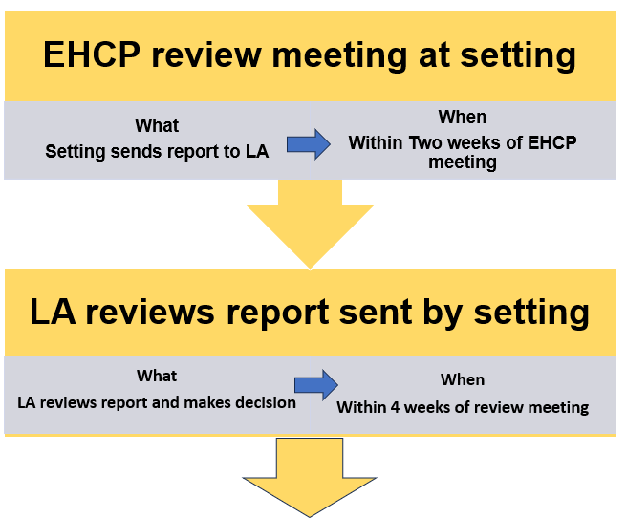

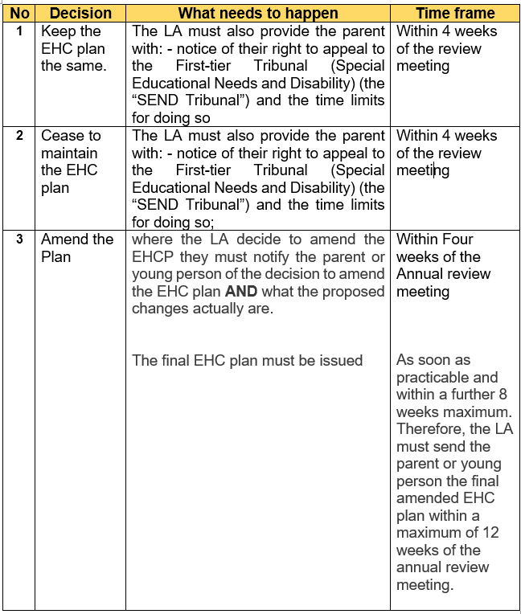

For a detailed guide on annual reviews refer to the [IPSEA annual review checklist](https://www.ipsea.org.uk/Handlers/Download.ashx?IDMF=af64e2ac-1af7-4f83-aa27-d759059e7814) (link correct as of August 2025)

## **Re-assessments**

Provided that an assessment has not been undertaken within the previous 6 months and the LA considers it is necessary, the LA must carry out a re-assessment of the educational, health and social care needs of the child/young person for whom it maintains a plan if a request is made to it by:

* The child’s parent or the young person
* The school, post 16 institution or other institution attended by the child/young person.
* The responsible Clinical Commissioning Group (CCG)

The LA may secure a re-assessment of those needs at any other time if it thinks it necessary.

The LA must notify the child’s parents/young person whether or not it is necessary to re-assess them within 15 days of receiving the request to re-assess. Where the LA does not consider it is necessary to re-assess they must notify them of:

* Their right to appeal with the time limits for doing so.
* The information regarding mediation and the availability of Disagreement and Resolution services
* SENDIASS Manchester

## **Amending an EHC plan without a review or reassessment**

* A Local Authority (LA) can amend an EHC plan at any time, not just after an annual review or reassessment. However, they must still follow the legal amendment process, which includes:
* Telling the parent or young person that they intend to amend the plan.
* Sending a draft of the proposed changes.
* Giving the parent or young person 15 days to comment and request a meeting.
* Informing them of their right to appeal to the SEND Tribunal if they disagree with the final amended plan.

So even if the amendment is not following a review or reassessment, the same rights and procedures apply.

Local Government Ombudsman decision look at individual complaints about local public services and all registerable social care providers in England.

**An example of a council failing to issue the decision letter or securing special education provision after a review.**

EHCP

* Failure to secure provision (Section F)
* Failure to issue decision letter after review.

Summary: Mr X complained the Council failed to ensure his son, Y, received any education and the provision set out in his Education, Health, and Care Plan (EHCP). He also complained the Council failed to review Y’s EHCP between September 2020 and October 2022. Mr X complained the Council failed to send out reports before the annual review in October 2022. Mr X complained the Council did not inform him of the outcome of the October 2022 annual review within timescales and delayed responding to his complaints. Mr X said this caused him distress and uncertainty. He said Y missed out on education and EHCP provision. There was fault in the way the Council did not ensure Y received an education or the provision specified in his EHCP. There was also fault in the complaint handling and the Council did not issue its decision letter after the annual review. Mr X was frustrated by the fault. He was put to time and trouble to complain. Y missed out on education and EHCP provision. The Council has agreed to apologise, make a financial payment and remind officers of the Council’s statutory duties.

Further information regarding reviews and re-assessments is set out at [SEND Code of Practice – Reviews and Re-assessments (Paragraphs 9.166–9.210)](https://localoffer.northlincs.gov.uk/documents/send-documents/ehcp-annual-review-guidance-for-sencos/)

You may wish to listen to our podcast regarding annual reviews, Series 1, episode 5. [SEND Talk Podcasts](https://www.iasmanchester.org/podcasts#S1E5)

More information about annual review duties during ongoing appeals available here:

[The annual review is due, but we are involved in an ongoing appeal to the SEND Tribunal about the EHC plan. How does this affect the process? | (IPSEA) Independent Provider of Special Education Advice](https://eur03.safelinks.protection.outlook.com/?url=https%3A%2F%2Fwww.ipsea.org.uk%2FFAQs%2Fthe-annual-review-is-due-but-were-involved-in-an-ongoing-appeal-to-the-send-tribunal-about-the-ehc-plan-how-does-this-affect-the-process&data=05%7C01%7Cmargarette.lee-chapman%40manchester.gov.uk%7C04b761bd472945a12c5308dbec10541c%7Cb0ce7d5e81cd47fb94f7276c626b7b09%7C0%7C0%7C638363327089829539%7CUnknown%7CTWFpbGZsb3d8eyJWIjoiMC4wLjAwMDAiLCJQIjoiV2luMzIiLCJBTiI6Ik1haWwiLCJXVCI6Mn0%3D%7C3000%7C%7C%7C&sdata=2Fiz2t7gz7bokD%2FDNhDmRU8%2FlXazNaI4emMkNcm%2FC04%3D&reserved=0)

|  |
| --- |
| **Contact Details for SENDIASS Manchester**  Helpline Telephone number: 0161 209 8356. Please clearly leave your name, contact number and a brief message on the answerphone and a member of the team will contact you within 24 hours or the next working day.  **Or**  Email your query to us: [**sendiass@manchester.gov.uk**](mailto:sendiass@manchester.gov.uk) leaving your name, child’s name and their date of birth.  You can complete our website contact form: [**Contact Us (iasmanchester.org)**](https://www.iasmanchester.org/contact)  Visit Manchester SENDIASS website [**About SENDIASS Manchester (iasmanchester.org)**](https://www.iasmanchester.org/)  Manchester SENDIASS Podcasts [**Listen to our SEND Talk podcasts**](https://www.iasmanchester.org/podcasts)  Manchester SENDIASS YouTube channel [**https://www.youtube.com/@SENDIASSManchester**](https://www.youtube.com/@SENDIASSManchester)    **QR code for the website QR code for Facebook page** |