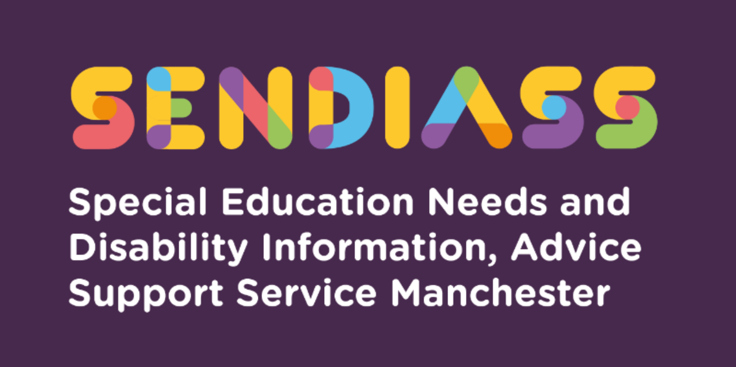

horizontal line

**Can parents refuse SEN entitlements which come from the SEND legal framework?**

**Factsheet Number 29 August 2025**

horizontal line

**Disclaimer**: This is a guide and should not be treated as legal advice. Although SENDIASS Manchester makes all reasonable efforts to ensure that the information contained in this factsheet is accurate and up to date at the time of publication, we cannot accept responsibility for outcomes suffered because of reliance placed upon it.

All hyperlinks in this factsheet are correct as of August 2025.

**Glossary**

**Local Authority (“LA”)** is the body who is responsible in law for carrying out an Education, Health Care and Social Care **(“EHC”)** needs assessment and making/maintaining EHC plans.

**The Children and Families Act (“C&FA) 2014** is the law, which places legal duties on schools and Local Authorities (LA’s) towards children and young people who have or may have special educational needs (“SEN”) including the duty to identify and assess the SEN of children and young people for whom they are responsible.

**The Special Educational Needs and Disability Code of Practice 2015 (“The SEND Code”)** is statutory guidance, which explains the duties which various professionals, including LAs, have towards children and young people with SEN. When guidance is ‘statutory’ this means all the professionals it applies to must have regard to it. Put simply, they are expected to follow the guidance unless they have a good reason to depart from it.

**Children and the SEND legal framework.**

We sometimes receive queries from families, who are concerned about children being identified as having SEN and assessed by the LA with the potential of an EHC plan being put in place. Generally, identifying SEN is a positive step in ensuring children receive the support they require to succeed and the SEND legal framework supports this position. Equally, if a child requires an EHC plan following an EHC needs assessment, the provision which comes because of the EHC plan can be invaluable to achieving successful outcomes for children in education.

The information below explains the various legal duties on schools and LAs in circumstances where a child has been identified as having SEN and then meets the legal threshold for an EHC needs assessment, once an assessment has been carried out, meets the threshold for an EHC plan. We also explain the rights of parents and what they can do if they disagree with the school or LA.

**What is an SEN?**

The Children & Families Act 2014 (C&FA) states that a child or young person has special educational needs if he or she has a learning difficulty or disability which calls for special educational provision to be made for him or her. There is no exhaustive list, but this could include needs such as communication difficulties including social communication; sensory needs; mental health and emotional difficulties; behaviour difficulties; physical difficulties; cognition and learning needs. As the legal definition can include many different types of difficulties, a child or young person can have SEN even when they are considered ‘academically able.’

When a school has initial concerns about a child’s rate of progress, they would be expected to target any area of weakness with high quality teaching rather than immediately conclude a child has SEN. High quality teaching is something which is available to all children so is not SEN specific. However, if a child failed to make expected progress, despite high quality teaching, a school would be obliged to take steps to assess and decide whether the child has SEN.

**Can I refuse my child being identified as having SEN and receiving SEN support?**

Under section 66 of the C&FA 2014, it is a legal requirement for mainstream schools including maintained nursery schools, 16 to 19 Academies; alternative provision Academies; institutions within the further education sector and pupil referral units to use their ‘best endeavours’ to ensure the special educational provision (extra help) a child requires is provided. This means the school must identify and address the SEN of the children that they are responsible for. As this is an obligation, a parent could not refuse their child being identified as having SEN and receiving support by the school. However, as part of that process, mainstream schools must inform parents if they believe a child has SEN and they are providing special educational provision for that child.

The SEND Code 2015 recognises the importance of parents knowing their children best. Therefore, it would be important for you to express any concerns and views through discussion with the school. It is not uncommon for some children to be different in school to how they are at home. If your child learns and behaves at home in a way which is different to in school, then it would be important for the school to consider this. If you have any examples or evidence of this, then you should consider sharing this with the school, so they have all the necessary information before a decision is made.

**EHC needs assessments.**

Most children with SEN have their needs met in mainstream schools through SEN support. However, some children may require more support and an EHC needs assessment for the LA to decide whether it is necessary to make special educational provision through an EHC plan.

Section 36 of the C&FA 2014 requires the LA to carry out an EHC needs assessment if a child has or may have SEN and it may be necessary for special educational provision to be made through an EHC plan. This test is a low legal threshold. It is important to note that an EHC needs assessment does not mean the LA is going to make an EHC plan, they are simply assessing to decide whether one is needed. See factsheet 28 on EHCPs [Factsheets](https://www.iasmanchester.org/factsheets-new)

**Can I refuse an EHC needs assessment?**

A request to carry out an EHC needs assessment can be made by a parent or a school. If the school wanted to make a request for an EHC needs assessment their first step would be discussing this with you. If you did not want the request to be made it would be important for the school to be aware of your reasons.

If the school remained concerned about your child’s progress and after discussion with you then made a request to the LA for an EHC needs assessment, the LA would have to consider the request.

When considering whether an EHC needs assessment is necessary, the SEND Code 2015 states that LAs should consider whether there is evidence that despite the school having taken relevant and purposeful action to identify, assess and meet the SEN of the child, the child has not made expected progress. To inform their decision the LA would be expected to consider evidence from the school and potentially other professionals who may have been involved such as a Speech and Language Therapist or an Education Psychologist.

As part of their consideration, the LA must consult you before it decides whether to assess. There is an important set of principles, (which are contained in section 19 of the C&FA 2014) which the LA must consider:

* The views, wishes and feelings of the child and his or her parent, or the young person.
* The importance of the child or young person, and the child’s parents, participating as fully as possible in decisions.
* Parents, children, and young people being provided with the information and support necessary to enable participation in those decisions.
* The need to support the child or young person, and the child’s parents, to facilitate the development of the child or young person and to help them achieve the best possible educational and other outcomes.

This means the LA must consider your views including any view that you **do not** want them to carry out an EHC needs assessment. Your reasons and any evidence that you have which suggests the LA should not carry out the assessment would be important. For example, if you have evidence which suggests your child does not have the difficulties which are being suggested by others, you can include this in your views. Although the LA must consider your views, if the obligation to carry out an EHC needs assessment is triggered under Section 36 C&FA 2014, parents are not entitled to decide that the assessment should not be carried out or appeal to the SEND Tribunal against the LA deciding to conduct an assessment. However, LAs must make dispute resolution arrangements with a view to avoiding or resolving disagreements so although you cannot appeal against the LA’s decision to carry out an EHC needs assessment, you could request dispute resolution. (see factsheet 13 which explains dispute resolution in more detail)

If the LA informs you that they are going to carry out the EHC needs assessment the Section 19 C&FA 2014 obligations which are referred to above continue to apply. Additionally, paragraph 9.18 of the SEND Code 2015 states:

*If the local authority intends to conduct an EHC needs assessment, it must ensure the child’s parent, or the young person is fully included from the start and made aware of opportunities to offer views and information.*

This means that even though you may disagree with the LA’s decision to assess, the LA must ensure you are included and that you can continue to offer your own information and views throughout the process. It is likely you will be asked for information about your child’s aspirations and goals for the future and details about play, health, independence, and friendships.

As part of the process, the LA must discuss information sharing with you. They may ask you to sign a consent form for information to be shared as part of the assessment. Although you are not obliged to sign the form or consent to information being shared, you should consider this carefully as information sharing is often an important part of everyone having a joined up and shared understanding of a child’s SEN and the support they require. In some circumstances information must be shared even without consent.

Appeals to the SEND Tribunal and the right to mediation would apply if the LA **refused** to carry out an EHC needs assessment (see guide 42 for more information [Factsheets](https://www.iasmanchester.org/factsheets-new))

**Can I refuse an EHC plan?**

When the assessment process is complete the LA must decide whether to make an EHC plan. Section 37 of the C&FA 2014 states that an EHC plan will be required if it is necessary for the LA to make the special educational provision the child requires through an EHC plan. Typically, this will arise in circumstances where the EHC needs assessment findings have concluded that the child’s school cannot meet their SEN through their usual resources. Although the LA must consider your views, if the obligation to make an EHC plan under Section 37 C&FA 2014 is met, parents are not entitled to decide or appeal to the SEND Tribunal that an EHC plan should not be made.

Once an EHC plan is made, it must first be sent in draft and you must be given at least 15 days to comment on the content of the EHC plan, tell the LA which school you would like to be named in the EHC plan and you also have the right to ask for a meeting with the LA to discuss the content of the EHC plan. Although an EHC plan may have been made against your wishes, your views about the content of the EHC plan, including which school you would like the EHC plan to name are your rights.

**Education and Health Care Plans** **section A**

The views the LA asked you for about your child during the EHC needs assessment process should be reflected in Section A of the EHC plan. If no views were put forward, then it is likely that Section A will reflect what others have said about your child’s this will include information about the child's history, aspirations, communication preferences, and decision-making. Section A is **not** legally binding but provides an overview of your child/young person.

Once the EHC plan is finalised, there will be a right of appeal to the SEND Tribunal about the educational contents (Sections B, F, and I) of the EHC plan.

[**Right of Appeal**](https://www.iasmanchester.org/tribunals)

Once the EHC plan has been finalised it must be formally reviewed every 12 months. You can listen to our Podcast number 5 which explains about annual reviews [SEND Talk Podcasts](https://www.iasmanchester.org/podcasts) or read the fact sheet number 3 [Factsheets](https://www.iasmanchester.org/factsheets-new) for more information.

|  |
| --- |
| **Contact Details for SENDIASS Manchester**  Helpline Telephone number: 0161 209 8356. Please clearly leave your name, contact number and a brief message on the answerphone and a member of the team will contact you within 24 hours or the next working day.  **Or**  Email your query to us: [**sendiass@manchester.gov.uk**](mailto:sendiass@manchester.gov.uk) leaving your name, child’s name and their date of birth.  You can complete our website contact form: [**Contact Us (iasmanchester.org)**](https://www.iasmanchester.org/contact)  Visit Manchester SENDIASS website [**About SENDIASS Manchester (iasmanchester.org)**](https://www.iasmanchester.org/)  Manchester SENDIASS Podcasts [**Listen to our SEND Talk podcasts**](https://www.iasmanchester.org/podcasts)  Manchester SENDIASS YouTube channel [**https://www.youtube.com/@SENDIASSManchester**](https://www.youtube.com/@SENDIASSManchester)    **QR code for the website QR code for Facebook page** |