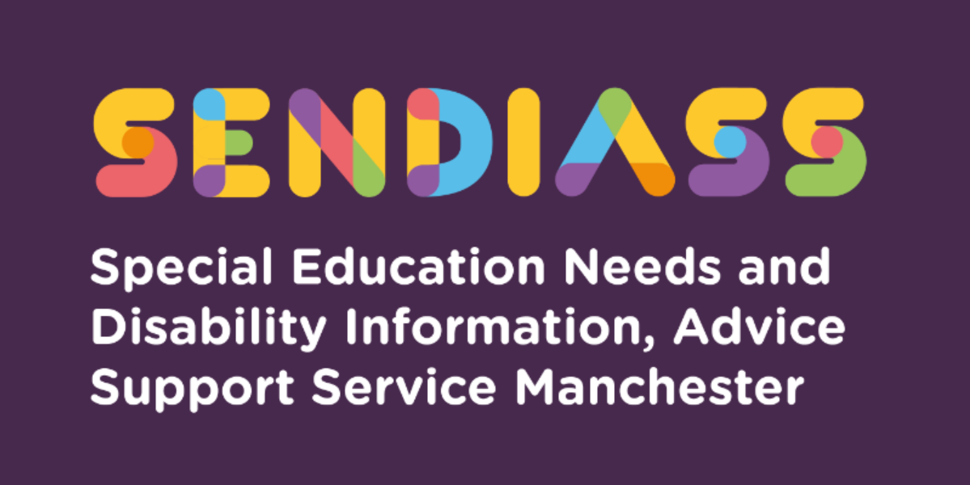

horizontal line

# **Applying for an Education, Health and Care (EHC) Assessment**

**Factsheet Number 28 August 2025**

horizontal line

**Disclaimer**: This is a guide and should not be treated as legal advice. Although SENDIASS Manchester makes all reasonable efforts to ensure that the information contained in this factsheet is accurate and up to date at the time of publication, we cannot accept responsibility for outcomes suffered because of reliance placed upon it.

All hyperlinks in this factsheet are correct as of August 2025.

## **About this guide**

This guide is to help parent/carers, who wish to apply for an Education Health and Care Needs assessment. It sets out some of the key points to consider before applying and outlines the steps to be taken in the application process. We advise that parents considering an EHC request contact SENDIASS to discuss their child's requirements in greater detail.

In England, there is a system of support for learners with Special Educational Needs and Disability (SEND), which is intended to ensure SEND are properly identified and catered for. Most learners with SEND will be supported in their education setting with support (see our SENDIASS factsheet 4 on SEND support [**Factsheets**](https://www.iasmanchester.org/factsheets-new) or listen to our Podcast [**SEND Talk Podcasts**](https://www.iasmanchester.org/podcasts).

For those with the most complex needs, additional assessment, support, and funding is available from the local authority.

If you think your child may have SEND, the first step will be to speak with your child’s teacher or nursery class leader. They will then speak with the member of staff appointed to manage SEND the special educational needs coordinator (SENCO).

## **Using this guide**

We have set out some of the key points about Education Health and Care needs assessments including relevant law surrounding the process.

We do recommend that you read the whole of this guide and discuss any queries you have with SENDIASS Manchester.

**For ease we have set out the guide as follows.**

* Section 1 – What you need to know before applying for an EHC needs assessment.
* Section 2 – How to apply for an EHC needs assessment.
* Section 3 – What happens after you have applied for an EHC needs assessment.

## **Key to Terms used in this guide.**

## 

* LA - Local Authority
* SENCO - Special Educational Needs Coordinator - The teacher, who has the responsibility for coordinating the special educational needs provision within a school or setting. Your child's school may also call the person who does this an Inclusion Manager
* C and F Act - Children and Families Act 2014 - Legal guidance that sets of the duties for Local Authorities when providing services for children, young people and families
* CAMHS - Children and Adolescent Mental Health Service
* SEND Support - Special Educational Needs Support for a child or young person, who is having difficulties at school or in their early years (pre-school) setting. It involves giving them extra or different help. This used to be called school action or school action plus before the reforms in 2014 and should no longer be used.
* Educational Health and Care Plan (EHC plan or EHCP)- A document which records the outcome of a statutory assessment of a child/young person's needs and sets out longer term aspirational outcomes for a child or young person aged between 0 and 25, as well as any support required.
* EP (or Educational Psychologist) - Educational Psychologist - a qualified teacher who has had training in psychology to understand more about the ways children learn, think and behave.
* Special Educational Needs and Disability (SEND) - A child has special educational needs if he or she has learning difficulties or disabilities that make it harder for him or her to learn than most other children of about the same age.

**This could include:**

* Learning difficulties – in acquiring basic skills in school.
* Specific learning difficulty – with reading, writing, number work or
* Understanding information.
* Medical or health conditions – which may slow down a child’s progress.

and/or involve treatment that affects his or her education.

* Emotional and behavioural difficulties – making friends, relating to

adults, or behaving properly in school.

* Sensory or physical needs - such as hearing or visual impairment, Fine

and gross motor skills which might affect them in school.

* Communication problems – in expressing themselves or understanding.

what others are saying.

# **Section 1 – What you need to know before applying for an EHC needs assessment.**

## **What is an EHC Needs Assessment?**

An EHCP assessment (also known as Statutory Assessment)

An education, health and care plan (EHC plan) is a legal document which describes a child or young person’s special educational needs, the support they need and the outcomes they would like to achieve. is defined as in law:

* An assessment of educational, health and social care needs of a child or young person. **(Section 36 (1)-(9) Children and Families act 2014)**

**It is a required step in obtaining an EHC plan**.

## Who can request an EHC Needs Assessment?

1. A child's parent.
2. A young person (Aged 16- 25, who wants an EHC needs assessment)
3. A person acting on behalf of a school or post 16 institutions.

## **What is the legal test that is applied as to whether the Local Authority (LA) will carry out an assessment once requested?**

This is covered by **section 36 (8) of the Children and Families Act 2014** [**Children and Families Act 2014**](https://www.legislation.gov.uk/ukpga/2014/6/section/36). This is especially important as it is the key legal test as to whether the LA carry out an assessment. The law states:

* The local authority must secure an EHC needs assessment for the child or young person if, after having regard to any views expressed evidence submitted under subsection (7), the authority is of the opinion that:

1. the child or young person has or may have special educational needs.

**And**

1. It may be necessary for special educational provision to be made for the child or young person in accordance with an EHC plan.

**The SEND Code of Practice (9.14)** [**SEND_Code_of_Practice_January_2015.pdf**](https://assets.publishing.service.gov.uk/media/5a7dcb85ed915d2ac884d995/SEND_Code_of_Practice_January_2015.pdf) sets out guidance for Local Authorities when they are considering whether to assess:

* In considering whether an EHC needs assessment is necessary, the local authority should consider whether there is evidence that despite the early year’s provider, school or post-16 institution having taken relevant and purposeful action to identify, assess and meet the special educational needs of the child or young person, the child or young person has not made expected progress. To inform their decision the local authority will need to consider a wide range of evidence, and should pay particular attention to:
* Evidence of the child or young person’s academic attainment (or developmental milestones in younger children) and rate of progress
* Information about the nature, extent and context of the child or young person’s SEN
* Evidence of the action already being taken by the early year’s provider, school, or post-16 institution to meet the child or young person’s SEND.
* Evidence that where progress has been made, it has only been as the result of much additional intervention and support over and above that which is usually provided.
* Evidence of the child or young person’s physical, emotional, social development and health needs, drawing on relevant evidence from clinicians and other health professionals and what has been done to meet these by other agencies, and
* Where a young person is aged over 18, the local authority **must** consider whether the young person requires additional time, in comparison to most others of the same age who do not have special educational needs, to complete their education or training. Remaining in formal education or training should help young people to achieve education and training outcomes, building on what they have learned before and preparing them for adult life.

**What are Special Educational Needs? Legal definition**

The legal definition is defined in **Section 20 of the Children and Families Act**. The legal definition is:

1. A child or young person has SEN (Special Educational Needs) if he or she has a learning difficulty or disability which calls for special educational provision to be made for him or her.
2. A child of compulsory school age or a young person has a learning difficulty or disability if he or she:
3. has a significantly greater difficulty in learning than the majority of others of the same age, or
4. has a disability which prevents or hinders him or her from making use of facilities of a kind generally provided for others of the same age in mainstream schools or mainstream post-16 institutions.
5. A child is under compulsory school age has a learning difficulty or disability if he or she is likely to be within subsection (2) when of compulsory school age (or would be likely if no special education provision were made).
6. A child or young person does not have a learning difficulty or disability solely because the language (or form of language) in which he or she is or will be taught is different from a language (or form of language) which is or has been spoken at home.
7. This section applies for the purposes of this part.

## **Things to consider before applying for an EHC needs assessment**.

1. Are the child’s / young person's Special Educational Needs being met with existing support in their setting (nursery / school / further education)?

Paragraph **1.24 SEN Code of Practice 2014**:

High quality teaching that is differentiated and personalised will meet the individual needs of the majority of children and young people. Some children and young people need educational provision that is additional to or different from this. This is special educational provision under Section 21 of the Children and Families Act 2014. Schools and colleges **must** use their best endeavours to ensure that such provision is made for those who need it. Special educational provision is underpinned by high quality teaching and is compromised by anything less.

There is existing guidance and funding to meet Special Educational Needs that all settings have access to. For more information see factsheet 4 SEN support in mainstream schools [**Factsheets (iasmanchester.org)**](https://www.iasmanchester.org/factsheets-new)

Another useful guide to help ascertain your child’s level of need is the Matching Provision to Need Tool produced by Manchester City Council [**Matching Provision to Need for Children with SEND | Help & Support Manchester**](https://hsm.manchester.gov.uk/kb5/manchester/directory/service.page?id=QcWCK_h_jzI)which you can download – you can discuss this with your child’s teacher.

## **2.** Is the educational setting supportive of an EHC application?

SENDIASS usually recommend that you talk with the educational setting your child attends before you make an application for an EHC Needs Assessment.

It may be that school are already using a range of interventions to support your child and this can be immensely helpful if at a later stage an EHC application is made as there will then be evidence to include in the application see factsheet 4 for more information [Factsheets (iasmanchester.org](https://www.iasmanchester.org/factsheets-new)

## **3.** Is the educational setting willing to write and request an EHC needs assessment (statutory assessment) on your behalf? Schools often submit EHC needs requests, and we recommend that you speak to the SENCO about an application before you consider making the request yourself.

# **Section 2 - How you apply for an EHC Needs Assessment**

## **What evidence will you need?**

If you make a Parental request for an EHC Needs Assessment, you should provide evidence that supports the legal test in **section 36 (8) of the Children's and families act**. Some suggestions are given below.

* CAMHS report
* School reports
* Educational Psychology reports
* Any professional reports or assessments
* diagnosis letters
* CAMHS report
* Educational Psychology report
* School reports (report from SENCO or a record of how school have used a graduated response to support your child’s needs
* Speech and language therapy report
* Occupational therapy report

**(a)** The child or young person has or may have special educational needs

**(b)** It may be necessary for special educational provision to be made for the child or young person inaccordancewith an EHC plan.

**Section 36(8) Children’s and Families Act 2014**

**How do you tell the Local Authority that you want then to carry out an Education Health and Care Needs Assessment?**

You can use the following template to request an assessment - remember to attach additional evidence with this letter: [Template letter 1: asking for an EHC needs assessment](https://www.ipsea.org.uk/making-a-request-for-an-ehc-needs-assessment) You can also copy the one below.

|  |
| --- |
| **Template letter to request an EHC needs assessment** |
| **[Your address and contact details]**  Dear Sir or Madam,  (Child/young person’s name) (date of birth) Request for an EHC needs assessment.  I am writing as the parent of the above child/young person to request an assessment of their Education, Health and Social Care needs under section 36 (1) of the Children and Families Act 2014.  (Child/young person’s name) currently attends ............................. nursery/school/ college/ is out of nursery/school/ college. [delete as applicable]  I understand that the test that the LA must apply in considering this request is contained in section 36 (8) of the Children and Families Act 2014 and has two parts.  Part one of the test is that the child or young person has or may have special educational needs.  **If your child has already been identified as having SEN by their nursery/school/ college then** ***Delete the paragraphs below which are not applicable***-  (Child/young person’s name)'s has already been identified as having special educational needs by his current nursery/school/ college (name of nursery/school/ college). They identified them as:  (List SEN already identified by nursery/school/ college)  **Or**  **If your child has not yet been identified as having SEND by a nursery/school or college then** –  We feel that (Child/young person’s name)'s has or may have special educational because:  (List the reasons why you feel your child has SEN and any evidence you must support what you are saying i.e., school reports, evidence of exclusions, letters from medical or other experts)  Part two of the test is that it may be necessary for special educational provision to be made for the child/young person through the issuing of an EHC plan.  My reasons for believing that my child/young person may need an EHC Plan are:  (List any reasons you have which show why you think that an EHC Plan may be needed i.e., specialist teaching, individual support, therapies)  I understand that you are required by law to reply to this request within six weeks and that if you refuse, I will be able to appeal to the Special Educational Needs Tribunal.  Yours sincerely,  [Your name]  **Send to:**  Manchester City Council,  Education Health and Care Planning Team  Town Hall Extension  Manchester  PO Box 532  M60 2LA  E-mail: **sen@manchester.gov.uk** |

# **Section 3 – What happens when you have applied for an EHC assessment?**

# 

Once you have submitted your request the LA have 6 weeks to decide whether they will carry out an assessment. The LA will write to tell you whether they will carry out an Assessment.

## **In Cases where the LA decide not to assess**

The LA will write to you and tell you their reasons for not carrying out an assessment and advise you of your right to appeal this decision. Make sure you keep this letter as you will need it if you do decide to appeal.

The deadline for appealing is two months from the date of the decision or one month from the date of the mediation certificate, whichever is the later. You must consider mediation.

SENDIASS Manchester have more information on mediation and appeals, and we recommend that you contact us to talk things through.

If you appeal the LAs decision the appeal is heard by the Tribunals service. Tribunals normally hear refusal to assess appeals on paper - this means that they will look at the evidence you have submitted and decide whether the legal tests set out in Section 36 [8) of the Children’s and families can has been met.

If the Tribunals service rule in your favour, they will write to tell you and write to the Local Authority. The Local Authority will then be legally obliged to carry out an assessment.

The diagram below shows the statutory assessment process:

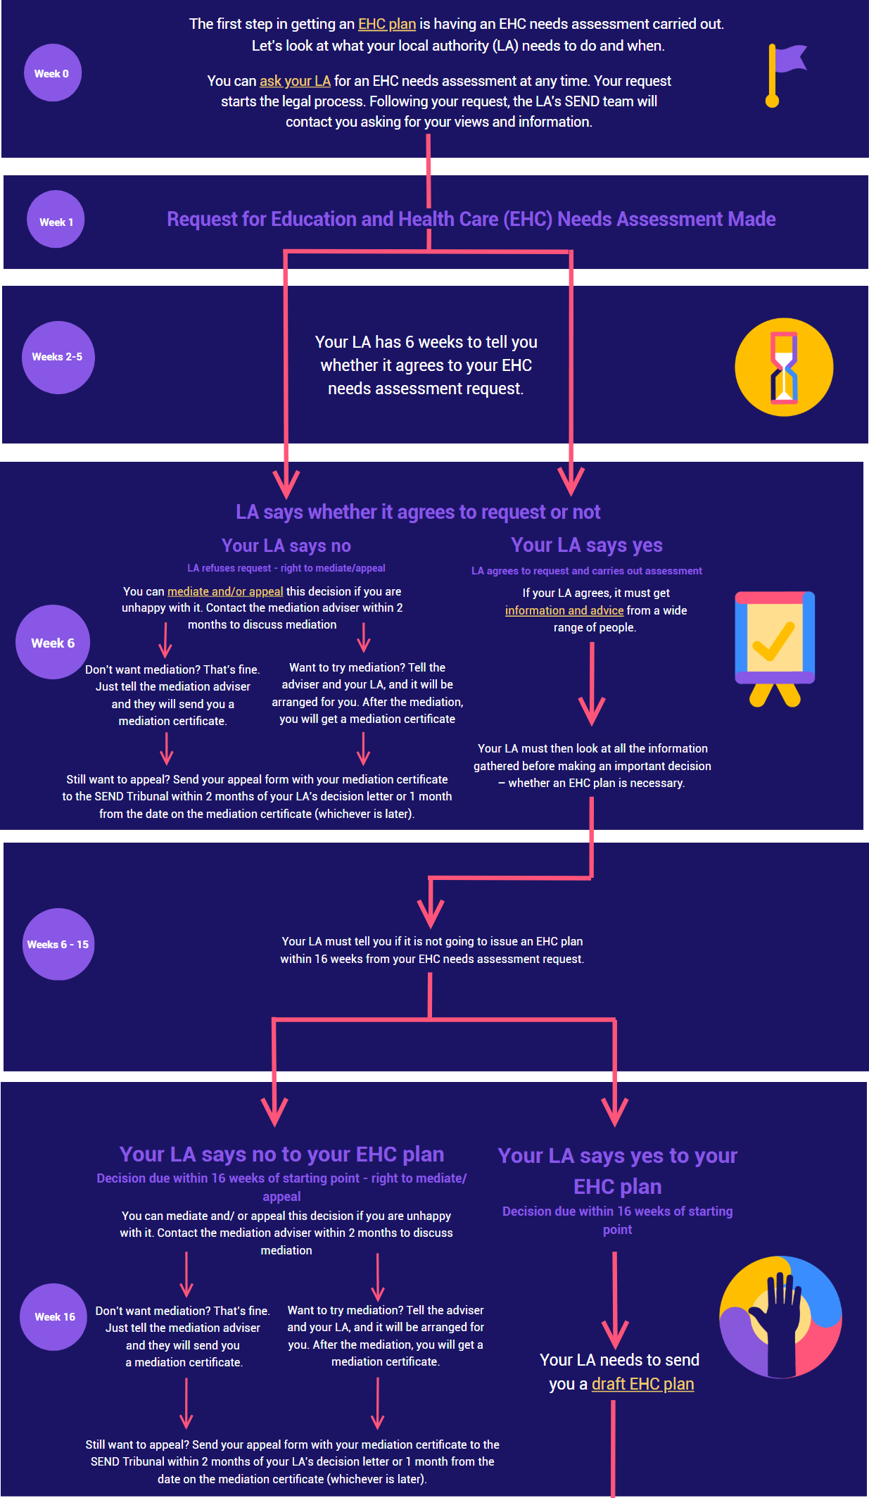

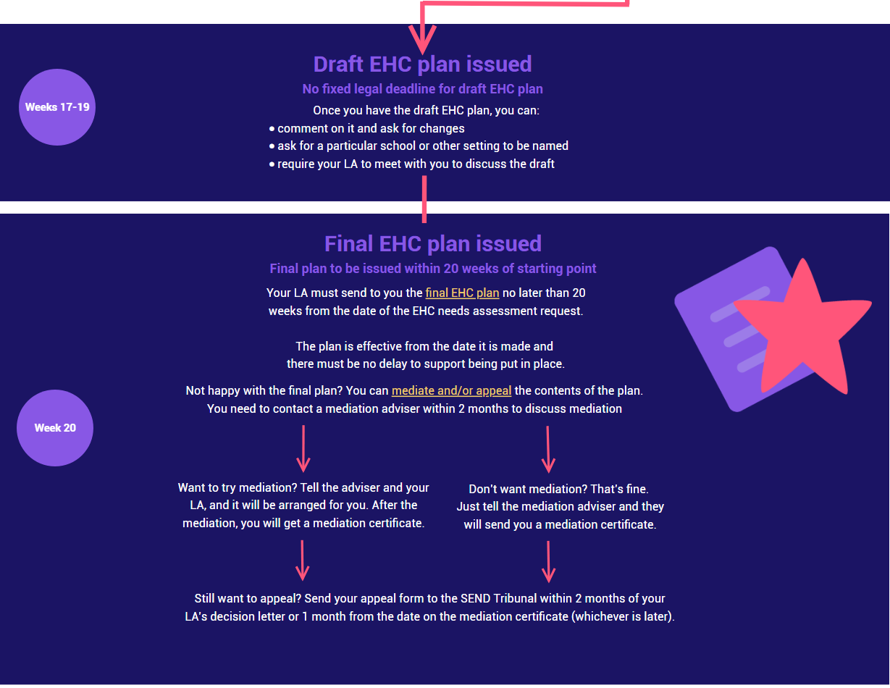

|  |
| --- |
| **Contact Details for SENDIASS Manchester**  Helpline Telephone number: 0161 209 8356. Please clearly leave your name, contact number and a brief message on the answerphone and a member of the team will contact you within 24 hours or the next working day.  **Or**  Email your query to us: [**sendiass@manchester.gov.uk**](mailto:sendiass@manchester.gov.uk) leaving your name, child’s name and their date of birth.  You can complete our website contact form: [**Contact Us (iasmanchester.org)**](https://www.iasmanchester.org/contact)  Visit Manchester SENDIASS website [**About SENDIASS Manchester (iasmanchester.org)**](https://www.iasmanchester.org/)  Manchester SENDIASS Podcasts [**Listen to our SEND Talk podcasts**](https://www.iasmanchester.org/podcasts)  Manchester SENDIASS YouTube channel [**https://www.youtube.com/@SENDIASSManchester**](https://www.youtube.com/@SENDIASSManchester)    **QR code for the website QR code for Facebook page** |