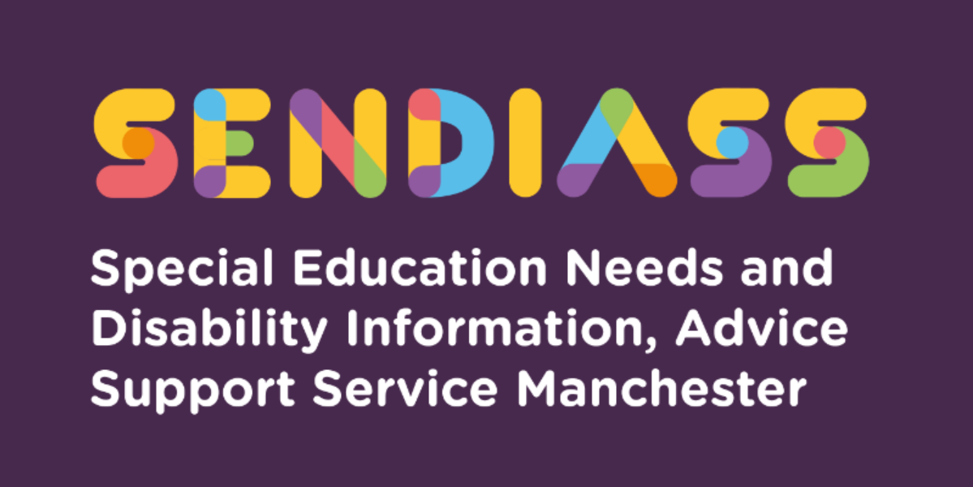

horizontal line

# **Transferring between Phases of Education and Transferring from Year 6 to Year 7**

**Factsheet Number 27 August 2025**

horizontal line

**Disclaimer**: This is a guide and should not be treated as legal advice. Although SENDIASS Manchester makes all reasonable efforts to ensure that the information contained in this factsheet is accurate and up to date at the time of publication, we cannot accept responsibility for outcomes suffered because of reliance placed upon it.

All hyperlinks in this factsheet are correct as of August 2025.

Transferring between phases of education can be a source of both excitement and anxiety for children/young people and parents alike. Change is challenging for all pupils but for children/young people with Special Educational Needs (SEND), moving to a different key stage or a different school can cause additional worries and stress.

Apart from when an Education, Health, and Care plan (EHCP) is first issued, the move between phases of education is the most common time that parents, carers, or young people must think about what school or college should be named in the EHC (Education Health Care) plan.

**What is a new phase of education?**

The definition of a "new phase of education" is found in Regulation 2 of the Special Educational Needs and Disability Regulations 2014.

You can view the official legal definition here:

[**Regulation 2 – Interpretation (SEND Regulations 2014)**](https://www.legislation.gov.uk/uksi/2014/1530/regulation/20)

A new phase of education refers to a transfer from:

(a) Early years education school

(b) Infant school Junior school

(c) Primary school Middle school (Key Stage 2)

(d) Primary school Secondary school

(e) Middle school Secondary school

(f) Secondary school A post-16 institution

**Transferring from Year 6 to Year 7**

**The top 5 concerns for children starting high school are:**

1. Getting Lost
2. Losing old friends
3. Homework
4. Discipline and detentions.
5. Being Bullied

**The top 5 concerns for parents are:**

1. Bullying
2. Safety
3. The amount of homework
4. Adjusting to having lots of teachers
5. Making new friends

## **Some solutions / Good practice for transition:**

* Ask the new school to provide schedules and a homework diary / planner. Many high schools have online homework and give parents a log in as well. However, a written planner might be more useful and work as a visual reminder.
* Keep a school timetable / schedule and a list of equipment and books needed for each day somewhere visible at home, e.g., the fridge. It could help you and your child settle into a new routine.
* Key worker. Ask the school to identify a staff member to be the person your child goes to with concerns/worries. This does not have to be the SENCO; it could be the head of year for example or pastoral support. Print out a photo of the staff member plus their name and how to contact them (e.g., where their office/classroom is and what times of the day they are available) to give your child a visual reminder of how to get help.
* Share any transition booklets and planning with your child. Go through the booklet to make sure your child understands everything and to find out if there is anything else which needs to be addressed
* Effective communication. Realistically a positive transfer to a new phase of education will not be perfect on day one of the move – despite how much preparation has taken place beforehand. But continued effective communication between school and home will ensure any potential difficulties are identified and addressed quickly.

**What happens to the EHC Plan?**

**Regulation 18 of the SEN Regs** requires that the EHC plan must be reviewed and amended before—

**(a)** 31 March if the transfer is from secondary school to a post-16 institution

**(b)** 15 February in any other case, or

**(c)** If a young person is moving from one post-16 institution to another post-16 institution at any other time, at least five months before that transfer takes place.

This means the local authority (“LA”) should start the annual review process in the autumn term of the year before the child or young person moves setting. If the LA are late in starting the annual review process, you can use the model letter below to complain.

There should always be an annual review of the EHC plan before a transfer to a new phase of education – see our factsheet on annual reviews for more information. [Factsheets](https://www.iasmanchester.org/factsheets-new) number 3

## **Reviewing an Education, Health, and Care Plan (EHC plan) Phased Transfer**

9.179 SEN Code of Practice States:

|  |
| --- |
| An EHC plan must be reviewed and amended in sufficient time prior to a child or young person moving between key phases of education, to allow for planning for and, where necessary, commissioning of support and provision at the new institution. |

## **Statutory process of phase transfer – 4-part process**

1. Review of the EHC Plan- The local authority (LA) must review the EHC plan in preparation for the phase transfer
2. LA sends proposed amendments and a copy of the plan to the parent or young person with the section naming the school/college/educational setting left blank (section I) within 4 weeks of the annual review meeting.
3. Parent or young person has at least 15 days to make representations about the proposed amendments and content of the plan and to either request that a particular school (from the list in section 38(3) Children and Families Act 2014) [**Children and Families Act 2014 (legislation.gov.uk)**](https://www.legislation.gov.uk/ukpga/2014/6/section/38/enacted) is named or to express a preference for an independent placement (see choosing a school for more information [**Choosing a school or college | (IPSEA) Independent Provider of Special Education Advice**](https://www.ipsea.org.uk/pages/category/choosing-a-school-or-college)
4. LA issues a final amended plan, with notice of appeal rights, by the statutory deadlines in Regulation 18 [**The Special Educational Needs and Disability Regulations 2014 (legislation.gov.uk)**](https://www.legislation.gov.uk/uksi/2014/1530/regulation/18/made)

Deadlines for the final amended plan are:

31st March if moving from secondary to post-16 provision or by

15th February in every other case.

Local authorities must not make children and young people with EHC plans go through usual admissions process and cannot require them to express a preference for an educational placement before the proposed amendments have been issued (step 2 above).

Local authorities cannot get around the statutory process of phase transfer where a child or young person has an Education and Health Care Plan and is moving to a new phase of their education. The 4-part process outlined above must be carried out in the order listed.

The LA will send the parent or young person an Amendment Notice, setting out their proposed amendments to the EHC plan. The parent or young person must be given the chance to make representations about these proposed amendments and about the school or college they want named in the EHC plan. If the parent or young person does not agree with the amendments, or wants further amendments made, see the section on objecting to proposed amendments to an EHC plan. There is a model letter for objecting to amendments here: [**Template letter 4: objecting to the amendments the local authority is proposing to make to an EHC plan (ipsea.org.uk)**](https://www.ipsea.org.uk/objecting-to-the-amendments-the-la-is-proposing-to-make-to-an-ehc-plan)

A refusal to name a particular school at phase transfer can be appealed to the SEND (Special Educational Needs and Disabilities) Tribunal. You can read more about this on[**Factsheets (iasmanchester.org)**](https://www.iasmanchester.org/factsheets-new) guide number 45.

If a child is undergoing statutory assessment during the transfer periods, then the parent is advised to complete the normal admissions route in case the plan is not completed before the child moves or starts school.

**Applying for a school place**

Under the law, there is no requirement for parents of a child with an EHC plan, or young people with an EHC plan, to go through the normal admissions process. EHC plans should be dealt with separately to this.

Many local authorities will ask parents or young people to fill in forms with their preference of school/ setting. While it is not lawful for LAs (Local Authorities) to impose this requirement on parents or young people, there might be a risk in not following this process; if the LA refuses to name your choice of school, they may name a school that you would be particularly unhappy with.

It is important to remember, however, that even if you do list several preferences the LA can only refuse to name your first preference if one of the legal reasons for refusal applies. **(Section 39(4) of the Children and Families Act.**

**a)** the school or other institution requested is unsuitable for the age, ability, aptitude or special educational needs of the child or young person concerned, or

**(b)** the attendance of the child or young person at the requested school or other institution would be incompatible with—

(i) the provision of efficient education for others, or

(ii) the efficient use of resources

Additionally, parents or young people who do express preferences prior to the annual review can change their mind in the exercise of their statutory right to request a school place for their child. [Children and Families Act 2014](https://www.legislation.gov.uk/ukpga/2014/6/section/39/enacted?msclkid=e291cac8a6c611ecbf862fcf8e994d99)

## **What type of school can I choose?**

**Section 38 (3) of the Children’s & Families Act** States; A school or other institution is within this subsection if it is:

|  |
| --- |
| Section 38 (3) - A school or other institution is within this subsection if it is:   1. a maintained school. 2. a maintained nursery school. 3. an Academy. 4. an institution within the further education sector in England. 5. a non-maintained special school. 6. an institution approved by the Secretary of State under section 41. |

**“Maintained schools”** funded and maintained by a local authority – any community, foundation or voluntary school, community special or foundation special school.

**“Academies”** are not maintained schools. They are state-funded schools, directly funded by the Department for Education, through the Education Funding Agency. Free schools are a type of academy.

**“Non-maintained special schools”** are schools approved by the Secretary of State under section 342 of the Education Act 1996 as special schools which are not maintained or state-funded but charge fees on a non-profit-making basis. Most non-maintained special schools are run by major charities or charitable trusts.

“**An institution approved under section 41”** is an independent special school which has applied for and been approved by the Secretary of State as one which a parent or young person can request to be named in an EHC plan.

## **Have I got a right to request my choice of school?**

You have the right to request your choice of school. If you ask the LA to consult with a school, they must do so although they may not name it.

**Section 9 Education Act** states:

Pupils to be educated in accordance with parents’ wishes. In exercising or performing all their respective powers and duties under the Education Acts, the Secretary of state and Local Authorities shall have regard to the general principle that.

Pupils to Pupils are to be educated in accordance with the wishes of their parents, as far as that is compatible with the provision of efficient instruction and training and the avoidance of unreasonable public expenditure.

## **Are there any reasons that the LA can justify not naming my choice of school?**

Yes, and this is set out in **Section 39 (4) of the Children and Families Act 2014**

**(a)** the school or other institution requested is unsuitable for the age, ability, aptitude or special educational needs of the child or young person concerned, or

**(b)** the attendance of the child or young person at the requested school or other institution would be incompatible with—

(i) the provision of efficient education for others, or

(ii)the efficient use of resources.

**Can I challenge the LA’s decision?**

Yes, you can – there is a route that leads to Tribunal, and this is the most effective path to follow as it:

* Is the official route.
* Can lead to a legally binding decision.
* Can take some of the “heat “out of your dispute with the LA.

See factsheet 44 **Appeals – Challenge section I** [**Factsheets**](https://www.iasmanchester.org/factsheets-new)

|  |
| --- |
| **Contact Details for SENDIASS Manchester**  Helpline Telephone number: 0161 209 8356. Please clearly leave your name, contact number and a brief message on the answerphone and a member of the team will contact you within 24 hours or the next working day.  **Or**  Email your query to us: [**sendiass@manchester.gov.uk**](mailto:sendiass@manchester.gov.uk) leaving your name, child’s name and their date of birth.  You can complete our website contact form: [**Contact Us (iasmanchester.org)**](https://www.iasmanchester.org/contact)  Visit Manchester SENDIASS website [**About SENDIASS Manchester (iasmanchester.org)**](https://www.iasmanchester.org/)  Manchester SENDIASS Podcasts [**Listen to our SEND Talk podcasts**](https://www.iasmanchester.org/podcasts)  Manchester SENDIASS YouTube channel [**https://www.youtube.com/@SENDIASSManchester**](https://www.youtube.com/@SENDIASSManchester)    **QR code for the website QR code for Facebook page** |