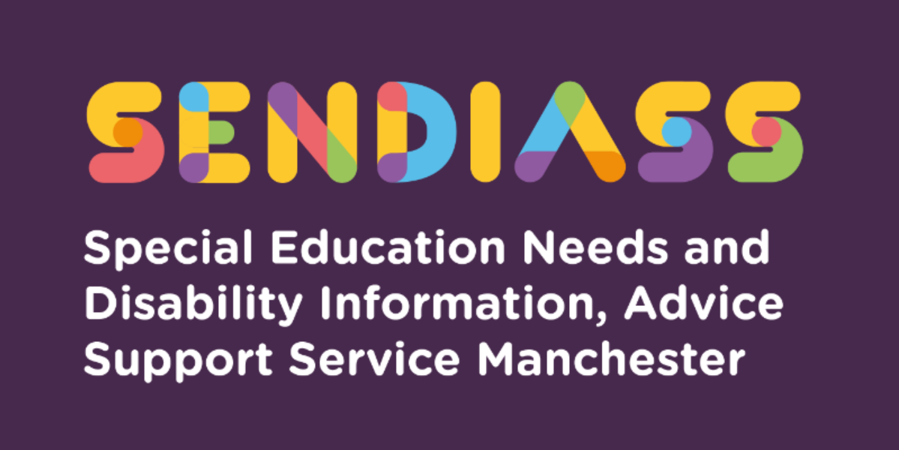

horizontal line

**Elective Home Education / EHE**

**Factsheet Number 21 August 2025**

horizontal line

**Disclaimer**: This is a guide and should not be treated as legal advice. Although SENDIASS Manchester makes all reasonable efforts to ensure that the information contained in this factsheet is accurate and up to date at the time of publication, we cannot accept responsibility suffered because of any reliance placed upon it.

The hyperlinks in this factsheet are correct as of August 2025.

Elective Home Education (EHE) is the term used by the Department for Education (DfE) to describe a parent’s decision to take full responsibility for the education of their child (of compulsory school age) instead of sending them to school.

EHE is different to home tuition and education other than at school (EOTAS) provided by the local authority (LA). Children educated at home are not registered at mainstream special or independent schools, academies, free schools, Pupil Referral Units (PRUs), fulltime college courses or children’s homes with education facilities.

EHE is different to flexi-schooling arrangements, which are agreed to at the discretion of the headteacher of the school where the child is on roll.

EHE is different from ‘home-schooling’ or ‘remote learning’ such as during the pandemic when schools were closed to all but vulnerable children and children of keyworkers. Children then remained on their school roll and parents taught them using resources and online learning provided by the school.

## **Parents’ rights**

Parents have a duty to ensure that a child of compulsory school age receives efficient full-time education either by regular attendance at school or otherwise. Parents therefore have a right, if they chose, to educate their children at home.

Parents are not required to inform the Local Authority (LA) if their child is home educated and has never attended school. If the child is a registered pupil at a mainstream school, the parent must send written notification to

1) the school, to inform them of their wish to educate their child at home and

2) the Local Authority (if the child has an EHC plan) to ask them to remove the school named from section I of the plan.

If the child attends a specialist school, the Local Authority must be notified and they must agree to allow the child’s name to be taken off the school roll. (This is not the case for mainstream schools).

## **Local Authorities’ responsibilities**

If a parent has decided to electively home educate, and the Local Authority is satisfied that the parent has made suitable arrangements, the parent takes on full responsibility for the child’s education, including all associated costs.

LA officers do not have the right to enter the family home, although more recent guidance does suggest that working with the Local Authority may increase the success of home education being agreed by them.

LAs have a responsibility to identify children, who are not registered at a school and who are not otherwise receiving suitable education.

If it appears to an LA that a child is not receiving suitable education, they should start procedures for issuing a school attendance order under 437 Education Act 1996. LAs should try to resolve the situation informally before issuing a school attendance order.

As with any child, the LA has a duty to request to see a child if there are serious concerns about a child’s welfare.

**Guidance on Elective Home Education** – this link contains the statutory guidance for both parents and for Local Authorities: [Elective home education - GOV.UK (www.gov.uk)](https://www.gov.uk/government/publications/elective-home-education)

## **Elective Home Education of children with EHC plans**

The LA **no longer has** a legal duty to secure ***any*** of the special educational provision in a child’s or young person’s EHC plan, if they are being electively home educated.

If an LA is satisfied that parents have made suitable arrangements under section 7 Education Act 1996, the LA is not obliged to name a school on section I of an EHC plan. However, the LA is still responsible for monitoring and reviewing the plan. The Local Authority should not stop an EHC plan because the parents have chosen to home educate.

If the parent does not make suitable provision, then the LA has a duty to arrange the provision specified in the EHC plan.

It is noted that some parents of children with SEND select home education for the following reasons:

* Exclusion/asked to leave school.
* Withdrawal as a result of bullying
* Inadequacy of SEND provision.
* Failure to implement an EHC plan.
* Withdrawn pending tribunal hearing.
* Child’s anxiety/mental health
* School phobia

On the next page is a helpful diagram of the Elective Home Education process, courtesy of the Elective Home Education Team at Manchester City Council.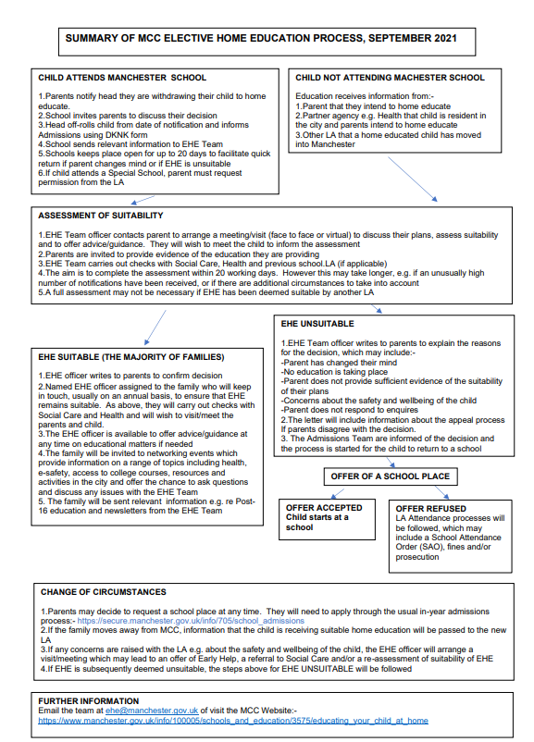

|  |
| --- |
| **Contact Details for SENDIASS Manchester**  Helpline Telephone number: 0161 209 8356. Please clearly leave your name, contact number and a brief message on the answerphone and a member of the team will contact you within 24 hours or the next working day.  **Or**  Email your query to us: [**sendiass@manchester.gov.uk**](mailto:sendiass@manchester.gov.uk) leaving your name, child’s name and their date of birth.  You can complete our website contact form: [**Contact Us (iasmanchester.org)**](https://www.iasmanchester.org/contact)  Visit Manchester SENDIASS website [**About SENDIASS Manchester (iasmanchester.org)**](https://www.iasmanchester.org/)  Manchester SENDIASS Podcasts [**Listen to our SEND Talk podcasts**](https://www.iasmanchester.org/podcasts)  Manchester SENDIASS YouTube channel [**https://www.youtube.com/@SENDIASSManchester**](https://www.youtube.com/@SENDIASSManchester)    **QR code for the website QR code for Facebook page** |