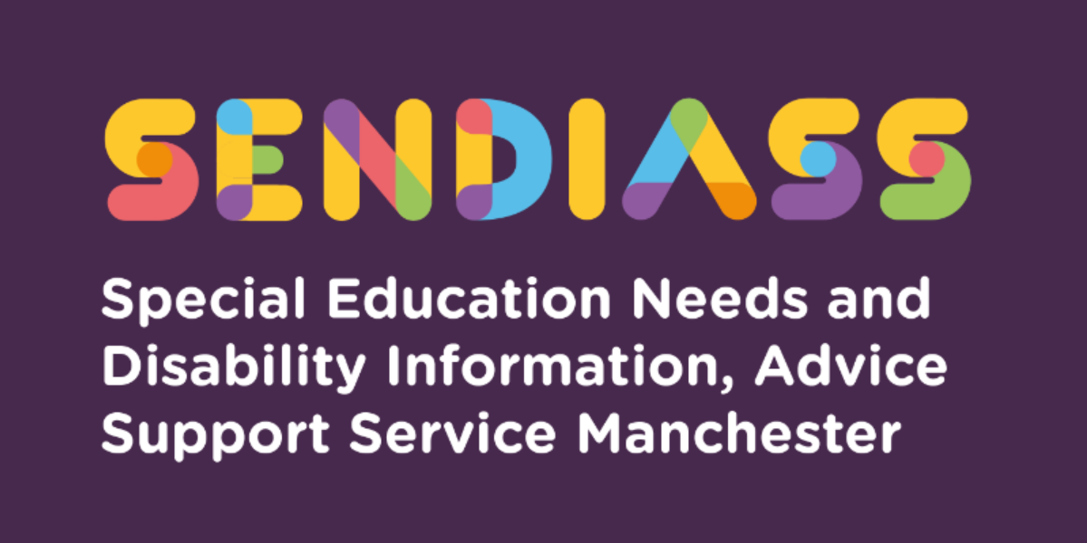

Mental Health Resources

Factsheet Number 18 August 2025
Disclaimer: This is a guide and should not be treated as legal advice. Although SENDIASS Manchester makes all reasonable efforts to ensure that the information contained in this factsheet is accurate and up to date at the time of publication, we cannot accept responsibility for any outcomes suffered because of reliance placed upon it.
All hyperlinks checked August 2025.
Mental Health Resources
Below are resources which are dedicated to children and young people’s general mental health and wellbeing, with a particular focus on mindfulness with developing coping skills in young people.
- Calm Harm is an app designed to help people resist or manage the urge to self-harm. Link to the website explaining the app and links to downloads.
- Catch It is an app aimed to help people better understand their feelings like anxiety and depression and improve mental wellbeing through use of a mood diary.
- The Student Health app is designed to reduce your worries, feel more confident and get the support you need at what can be a challenging time for any university student.
- Students Against Depression is a website offering advice, information, guidance and resources to those affected by low mood, depression and suicidal thinking.
- Togetherall is available for students at eligible universities and colleges who are feeling stressed, anxious, low or not coping. It provides an anonymous online community who share troubles and support each other. It is a safe space as it is moderated by trained professionals who are available 24/7.
- Place 2 Be: https://www.place2be.org.uk/ has a host of mental health resources available. They organise Children's Mental Health Week every year.

- SafeSpot is an iPhone and Android app that promotes positive mental wellbeing in children and young people and has been designed to help children and young people with their coping skills.
- MindEd’s advice and resources for families on supporting children’s mental health. This includes the Education Hub (which hosts a short Wellbeing for Education Return training webinar for education staff as well as more in-depth content covering wellbeing and resilience, bereavement and loss, stress, trauma, anxiety and low mood).
- BBC’s wellbeing resources for families. BBC Bitesize parents’ toolkit.
- Young Minds: a letter about how I’m feeling: worksheet to help pupils express their feelings and understand what may have triggered them. For use with pupils in school or at home.
- NHS: Mental Health Helplines for Urgent Help - NHS 24-hour advice and support for you, your child, your parent or someone you care for. Help is available to speak to a mental health professional.
- NHS IAPT: free online NHS adult psychological therapies, such as cognitive behavioural therapy (CBT), for common problems involving stress, anxiety and depression. IAPT services can be accessed either through a self-referral by contacting your Local IAPT or via your GP.
- Cruse Bereavement Care: Coronavirus, Bereavement and Grief online information, advice and support. Helpline: 0808 808 1677.
- Headspace: Headspace for Educators offers educators access to free mindfulness and meditation exercises and resources for every age group, and a free Headspace Meditation App.
- Public Health England Every Mind Matters: Looking After Your Mental Health Resources aims to support everyone to feel more confident in taking action to look after their mental health and wellbeing by promoting a range of self-care actions including a mind plan quiz.
- Public Health England: School zone. Resources for educators covering a range of topics including mental wellbeing. Free to register to access.
- Young Minds: 10 Wellbeing Tips for School Staff
- Anna Freud: self-care strategies for young people feeling low or anxious and self-care tips for parents and carers.
- MIND Mental Health Information on how to access the MIND support helpline, which provides a safe place to talk about mental health with trained advisors who can listen and help to find specialist support if needed.
Issue and group specific children and young people’s mental health and wellbeing support.
Sometimes, children need specific and targeted resources to help with problems they are facing. Below we have outlined some support available for issues, including loneliness, suicide prevention, eating disorders and domestic abuse.
NHS Mental Health Services
https://www.nhs.uk/using-the-nhs/nhs-services/mental-health-services/how-to-access-mental-health-services/

Community Mental Health Teams in Manchester | Greater Manchester Mental Health NHS FT
Community mental health teams (CMHTs) provide multi-disciplinary assessment, treatment and care of individuals with severe and enduring mental health problems. They provide a service to individuals from 18 years of age up to 70 years of age with a diagnosed functional mental health problem, unless the service users’ needs would be best met by the Older Adults CMHT or vice versa.
Community mental health teams care for people resident in Bolton, Salford, Trafford and the City of Manchester who are suffering from mental illness, typically those who are suffering from schizophrenia, severe affective disorder or a complex personality disorder. This could include people with Autism Spectrum Conditions, whose needs can resemble those of a complex personality disorder. They will provide a service for people with a substantial disability as a result of their illness, such as an inability to care for themselves independently, sustain relationships or employment.
We aim to provide the highest quality and comprehensive care to support the recovery of our service users in the community, enabling them to live as independently as possible within their own home environment.
Summer self-care toolkits for Primary and Secondary Schools
Self-care summer toolkit: Mentally Healthy Schools
https://www.mentallyhealthyschools.org.uk/resources/helping-children-after-long-holidays-and-key-transitions/
Kooth - Online emotional and mental health support ages 11-18
https://www.kooth.com/
kooth.com/urgent support for a crisis service
Samaritans
116 123
jo@samaritans.org
Barnardos helpline – Helpline and webchat for 11+ for Black, Asian and Ethnic Minority children and young people
0800 151 2605
https://helpline.barnardos.org.uk/
Shout – for anyone in crisis at any time.
Text 85258
Mood Swings
MoodSwings 36 New Mount St, Manchester M4 4DE. Helpline staffed from 10am to 4pm Monday to Friday – 0161 832 37 36. Online and Skype support – contact them on info@moodswings.org.uk or https://www.facebook.com/Moodswings-289363603529/
Anna Freud Centre resources
For adoptive parents, special guardians and foster parents
https://www.annafreud.org/parents-and-carers/adoptive-parents-special-guardians-and-foster-carers/
For parents and carers
https://www.annafreud.org/parents-and-carers/resources/
Self-Care resources for children and young people
https://www.annafreud.org/resources/children-and-young-peoples-wellbeing/self-care/
Childline – online and on the phone
https://www.childline.org.uk/kids/
0800 1111
Report online abuse.
https://www.ceop.police.uk/safety-centre
Peer Pressure – PSHE Guidance – Childnet
Childnet, an excellent resources provider, currently has a PSHE toolkit on their site designed to produce lessons on the topic of peer pressure. For more information, please follow this link Childnet peer pressure toolkit :
SEND
- The SEND Gateway is a good source of information for professionals, containing resources on responding appropriately to children and young people with SEND with emotional wellbeing needs.
Bullying, harassment, and abuse
- The government tool Respectful school communities: a tool to support school staff to combat bullying, harassment and abuse of any kind.
Bereavement support
- Childhood Bereavement Network has a range of resources to help schools to respond to a bereavement and to provide support to bereaved pupils and their families. It also includes signposting to local bereavement services.
- Cruse Bereavement Care: Coronavirus, Bereavement and Grief online information, advice and support. Helpline: 0808 808 1677.
Self-harm
- University of Oxford guide for parents and carers on supporting their child or young person in dealing with self-harm.
Eating disorders
- BEAT advice and support on eating problems and disorders, with general downloads and resources and advice for school and college teachers and staff:
- Helpline (England): 0808 801 0677
- The Sanctuary chat room for people with an eating disorder, created specifically in response to coronavirus.
Suicide prevention.
- Papyrus (Prevention of Young Suicide)* provides confidential advice and support for young people who feel suicidal
HOPEline UK: 0800 068 41 41 Text: 07786 209 697 Email:pat@papyrus-uk.org
- The Zero Suicide Alliance collaboration of National Health Service trusts, charities, businesses and individuals offers free suicide prevention training.
- Samaritans is a national organisation for anyone in distress and in need of immediate support: Tel: 0116 123 Email: jo@samaritans.org
Domestic abuse
- Operation Encompass Teachers’ Helpline staffed by educational psychologists, to support staff working with children and young people at risk of or experiencing domestic abuse (0204 513 9990, weekdays during term-time, 8-11am).
Drug and alcohol support.
- Find confidential local drug and alcohol support services here or phone 03001236600 for confidential support from Talk to Frank.
- Children and young people can access free confidential support anytime from Government-backed voluntary and community sector organisations by:
- texting SHOUT to 85258 *
- calling Childline on 0800 1111 *
- calling the Mix on 0808 808 4994 or texting THEMIX to 85258 *
Mental Health Resources- Government website

Contact Details for SENDIASS Manchester

Helpline Telephone number: 0161 209 8356. Please clearly leave your name, contact number and a brief message on the answerphone and a member of the team will contact you within 24 hours or the next working day.
Or
Email your query to us: sendiass@manchester.gov.uk leaving your name, child’s name and their date of birth.

You can complete our website contact form: Contact Us (iasmanchester.org)

Visit Manchester SENDIASS website About SENDIASS Manchester (iasmanchester.org)

Manchester SENDIASS Podcasts Listen to our SEND Talk podcasts

Manchester SENDIASS YouTube channel https://www.youtube.com/@SENDIASSManchester

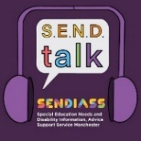
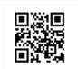
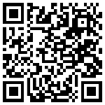

QR code for the website QR code for Facebook page

