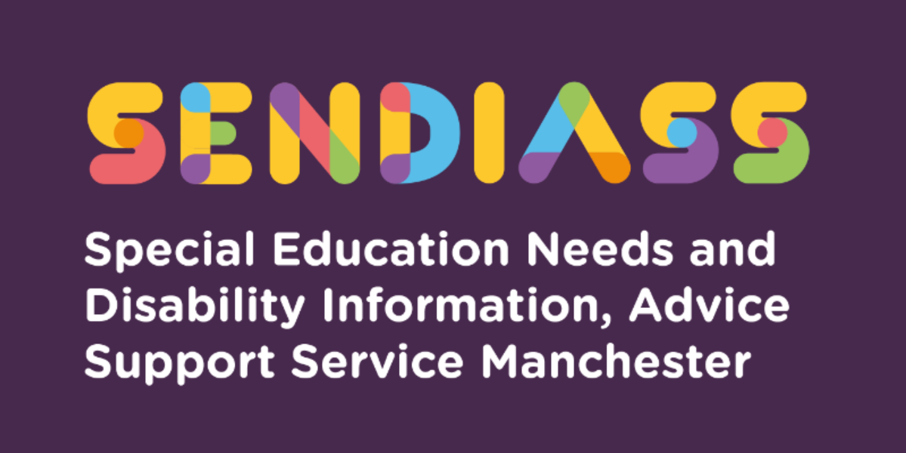

horizontal line

# **Disability Discrimination Act (DDA) and the Equality Act (EQA)**

**Factsheet Number 16 August 2025** horizontal line

**Disclaimer**: This is a guide and should not be treated as legal advice. Although SENDIASS Manchester makes all reasonable efforts to ensure that the information contained in this factsheet is accurate and up to date at the time of publication, we cannot accept responsibility for any outcomes suffered because of reliance placed upon it.

## **Definition of Disability – Section 20 Equality Act 2010.**

A person has a disability if:

|  |
| --- |
| *They have a physical or mental impairment.’*  And  *‘The impairment has a substantial and long-term adverse effect on their ability to carry out normal day to day activities.* (Equality Act 2010 Part 2 - S.6)’ |

## **Four elements of disability:**

* The person has a physical or mental impairment
* That the impairment is substantial
* That it is long term
* That it has an adverse effect on the ability to carry out normal day to day activities

Some conditions are automatically, under the law, deemed to be disabilities such as cancer, HIV Infection, multiple sclerosis, or a person certified as blind or partially sighted by a consultant ophthalmologist.

A key area within potential discrimination cases is “tendency to violence” under the current law this does not amount to a disability/impairment. For example, it will be irrelevant that the reason may be classed as a disability i.e., autism. It will not be classed as disability discrimination; this is however under review following a recent upper tribunal case where section 4(1) was deemed to contravene the Human Rights Law.

There are factors, to be taken into account when considering if a school has acted in a discriminatory way, for example they are allowed to “maintain academic and other standards” and “ensure the health and safety and welfare of pupils.” This is often cited by schools in defence of alleged discrimination.

## **Schools and Discrimination**

## Governing bodies when considering exclusion of a pupil must have regard to both the Disability Discrimination Act (DDA) and the Equalities Act (EQA).

There are two main potential types of discrimination:

|  |
| --- |
| Section 13 EQA - Direct Discrimination –  A person (A) discriminates against another (B) if, because of a protected characteristic, A treats B less favourably than A treats or would treat others.  Section 15 EQA - Discrimination arising from disability.  A treats B unfavourably because of something arising in consequence of B’s disability, and  A cannot show that the treatment is a proportionate means of achieving a legitimate aim. |

The failure to comply with the duty to make reasonable adjustments **is** disability discrimination.

## **Reasonable Adjustments**

EQA splits the duty to make reasonable adjustments into three requirements only two of these apply to schools.

|  |
| --- |
| **Section 20 (3) EQA:**   1. The first requirement is a requirement, where a provision, criterion or practice puts a disabled person at a substantial disadvantage in relation to a relevant matter in comparison with persons who are not disabled, to take such steps as it is reasonable to have to take to avoid the disadvantage. 2. The second requirement is where a physical feature puts a disabled person at a substantial disadvantage in relation to a relevant matter in comparison with persons who are not disabled, to take such steps as it is reasonable to have to take to avoid the disadvantage. This one does not apply to schools, but they do have a duty to publish “accessibility plans.” 3. The third requirement is a requirement, where a disabled person would, but for the provision of an auxiliary aid, be put at a substantial disadvantage in relation to a relevant matter compared with persons, who are not disabled. |

Auxiliary aids can include equipment such as a special chair, adapted text etc. or also a service such as personal assistance or therapy.

## **Send Tribunal**

Parents can consider lodging a DDA claim against a school through the tribunal service (other claims such as against a Further Education college must be through the County Court), this can be done either independently of or together with an appeal relating to the pupils Education Health and Care Plan.

### Outcomes from claims vary some of the below are typical:

* A formal written apology to the child
* Disability training for staff
* Review or alteration of school or local authority policies.
* Additional tuition
* Relocation of facilities

### What cannot be ordered?

* Financial compensation
* Changes to the child’s EHCP (different appeal process)
* Removal or alteration of physical features
* Dismissal of a teacher

All schools should have their own internal complaints procedure, which can be explored first, but it is worth remembering that claims through the tribunal need to be brought within six months to be valid.

|  |
| --- |
| **Contact Details for SENDIASS Manchester**  Helpline Telephone number: 0161 209 8356. Please clearly leave your name, contact number and a brief message on the answerphone and a member of the team will contact you within 24 hours or the next working day.  **Or**  Email your query to us: [**sendiass@manchester.gov.uk**](mailto:sendiass@manchester.gov.uk) leaving your name, child’s name and their date of birth.  You can complete our website contact form: [**Contact Us (iasmanchester.org)**](https://www.iasmanchester.org/contact)  Visit Manchester SENDIASS website [**About SENDIASS Manchester (iasmanchester.org)**](https://www.iasmanchester.org/)  Manchester SENDIASS Podcasts [**Listen to our SEND Talk podcasts**](https://www.iasmanchester.org/podcasts)  Manchester SENDIASS YouTube channel [**https://www.youtube.com/@SENDIASSManchester**](https://www.youtube.com/@SENDIASSManchester)    **QR code for the website QR code for Facebook page** |