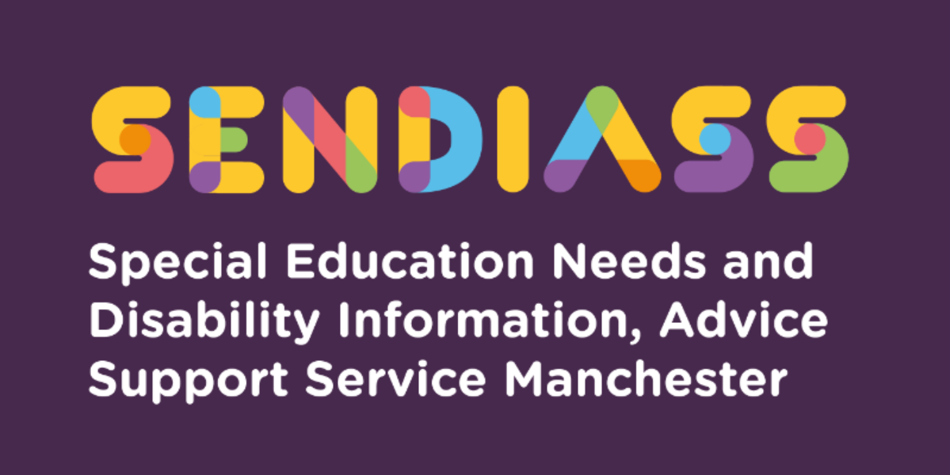

horizontal line

**Personal Budgets**

**Factsheet Number 14 August 2025**

horizontal line

**Disclaimer**: This is a guide and should not be treated as legal advice. Although SENDIASS Manchester makes all reasonable efforts to ensure that the information contained in this factsheet is accurate and up to date at the time of publication, we cannot accept responsibility for any outcomes suffered because of reliance placed upon it.

**All hyperlinks in this factsheet were correct as of August 2025.**

## **Personal Budgets - What are they?**

A personal budget is defined by the 0-25 SEND Code of Practice as an amount of money that has been identified by the Local Authority to deliver some or all of the provision set out in an Education, Health, and Care (EHC) Plan, in order for the child or young person to achieve an agreed set of educational outcomes. Personal budgets can be agreed for education, health and/or social care.

You can only have a personal budget for education if you have an EHC plan.

An education personal budget is a ‘notional’ amount and not a cash sum which you can expect to be paid. It is an estimated amount of money which would be required to deliver the special educational provision specified in section F the EHC plan.

Usually, the Local Authority would send funding to the school /college and the educational placement, which would then deliver the special educational provision set out in the plan.

However, it is possible for the LA to make a payment to the parent (or a nominated person) for the purposes of organising the special educational provision themselves.

Personal budgets are not in addition to the funding sent to school. They are a different way to access / deliver the education funding.

**When can you ask for an Education personal budget?**

Families can ask for or request a personal budget at the point when a new EHC Plan is drawn up following an EHC assessment (or a re-assessment) or when an EHC Plan annual review takes place.

## **Important key points about Personal budgets:**

* Direct payments can be used for special educational provision in a school or college only if the school or college agree.
* Personal Budgets can only be used to fund the support set out in an EHC plan. This must be agreed by the local authority for education and care support, and by the health authority for the health provision.
* Personal Budgets for educational provision cannot cover payment for a place at a school or college.
* Personal Budgets cannot be used for something that the child/young person’s school or setting already provides.

## **What is the difference between a Personal Budget and a Direct Payment?**

A Personal Budget shows you what money there is for the provision specified in an Education Health Care (EHC) plan, and who provides it.

The parent or young person does not actually manage the funds directly. With a Direct Payment the parent or young person is given the money for some services and manages the funds themselves.

With a Direct Payment, the parent or young person is responsible for buying the service and paying for it. A Personal Budget can include a Direct Payment if it is agreed that this is the best way to manage part of the Personal Budget.

Direct payments can be used for special educational provision in a school or college only if the school or college agree. Local authorities can refuse a direct payment for special educational provision if it would make things worse for other children and young people with an EHC plan, or if it would be an inefficient way to pay for services.

It is also possible to have a Third-Party Arrangement to manage a Direct Payment.

## **Who can have a Personal Budget?**

* If you are the Parents of a child with an EHC plan, or a young person with an EHC plan, you can request a Personal Budget either during the drafting of an EHC plan or at a review once the plan has been issued.
* A young person with an EHC plan can ask for their own Personal Budget after the end of the school year in which they become sixteen. There is a right to request a personal budget (in education) but not a right to have a personal budget.
* You do not need to have an EHC plan to get Personal Budgets for social and health care, but once you have an EHC plan, or one is being prepared, you can request budgets for all three areas of support.
* You must have an EHC plan to get a Personal Budget for special educational provision. However, you do not have to have a Personal Budget.

## **What can a Personal Budget be used for?**

Personal Budgets can only be used to fund the provision set out in an EHC plan. This must be agreed by the local authority for education and care support, and by the health authority for the health provision.

The EHC plan will then set out how a personal budget is going to deliver support and outcomes. While there is a degree of flexibility in how Personal Budgets can be used you must be able to demonstrate that your child’s assessed needs would be met and that it contributes to the outcomes in the education, health and care plan. A Personal Budget will use any top up funding (known as Element 3 funding). It can also include support that is managed by the school or college – but only if the Head teacher or Principal agree.

Sometimes the local authority or the health authority may not agree to a Personal Budget. If the local authority refuses a personal budget for special educational provision, they must tell you why. You cannot appeal to the Special Educational Needs and Disability Tribunal over this refusal but could use the ‘disagreement resolution processes.

**For further information:**

Manchester City Council’s information page on Personal Budgets for SEN:

<https://hsm.manchester.gov.uk/kb5/manchester/directory/advice.page?id=_gZy8TOzjDQ>

Manchester city council policy: Personal Budgets for Education Health and Care plan:

<https://search3.openobjects.com/mediamanager/manchester/fsd/files/personal_budgets_ehcp_final_2017_2.pdf>

IPSEA resources:

[Personal Budgets | (IPSEA) Independent Provider of Special Education Advice](https://eur03.safelinks.protection.outlook.com/?url=https%3A%2F%2Fwww.ipsea.org.uk%2FFAQs%2Fpersonal-budgets&data=05%7C01%7Cmargarette.lee-chapman%40manchester.gov.uk%7C4c9e2e4276ba4a87151308dba233345c%7Cb0ce7d5e81cd47fb94f7276c626b7b09%7C0%7C0%7C638282114617922188%7CUnknown%7CTWFpbGZsb3d8eyJWIjoiMC4wLjAwMDAiLCJQIjoiV2luMzIiLCJBTiI6Ik1haWwiLCJXVCI6Mn0%3D%7C3000%7C%7C%7C&sdata=6ICZuLTPnjeJLUKobqiBhfW0DP5YGw1NclSWXy5bJA0%3D&reserved=0)

[Personal budgets and direct payments | (IPSEA) Independent Provider of Special Education Advice](https://eur03.safelinks.protection.outlook.com/?url=https%3A%2F%2Fwww.ipsea.org.uk%2Fpersonal-budgets-and-direct-payments&data=05%7C01%7Cmargarette.lee-chapman%40manchester.gov.uk%7C4c9e2e4276ba4a87151308dba233345c%7Cb0ce7d5e81cd47fb94f7276c626b7b09%7C0%7C0%7C638282114617922188%7CUnknown%7CTWFpbGZsb3d8eyJWIjoiMC4wLjAwMDAiLCJQIjoiV2luMzIiLCJBTiI6Ik1haWwiLCJXVCI6Mn0%3D%7C3000%7C%7C%7C&sdata=Da2qswLmVYHgNVC3M5OdhU9bNQrVaFyQCYAf%2Bl%2FA3KM%3D&reserved=0)

**Kids**

* Personal budgets information - [Personal budgets - Kids](https://www.kids.org.uk/sendiass/advice/personal-budgets/)

**SEND Talk podcast.**

Listen to our podcast [SEND Talk Podcasts](https://www.iasmanchester.org/podcasts#S2E4)

Series 2, Episode 4: “Do I want a personal budget?”

|  |
| --- |
| **Contact Details for SENDIASS Manchester**  Helpline Telephone number: 0161 209 8356. Please clearly leave your name, contact number and a brief message on the answerphone and a member of the team will contact you within 24 hours or the next working day.  **Or**  Email your query to us: [**sendiass@manchester.gov.uk**](mailto:sendiass@manchester.gov.uk) leaving your name, child’s name and their date of birth.  You can complete our website contact form: [**Contact Us (iasmanchester.org)**](https://www.iasmanchester.org/contact)  Visit Manchester SENDIASS website [**About SENDIASS Manchester (iasmanchester.org)**](https://www.iasmanchester.org/)  Manchester SENDIASS Podcasts [**Listen to our SEND Talk podcasts**](https://www.iasmanchester.org/podcasts)  Manchester SENDIASS YouTube channel [**https://www.youtube.com/@SENDIASSManchester**](https://www.youtube.com/@SENDIASSManchester)    **QR code for the website QR code for Facebook page** |