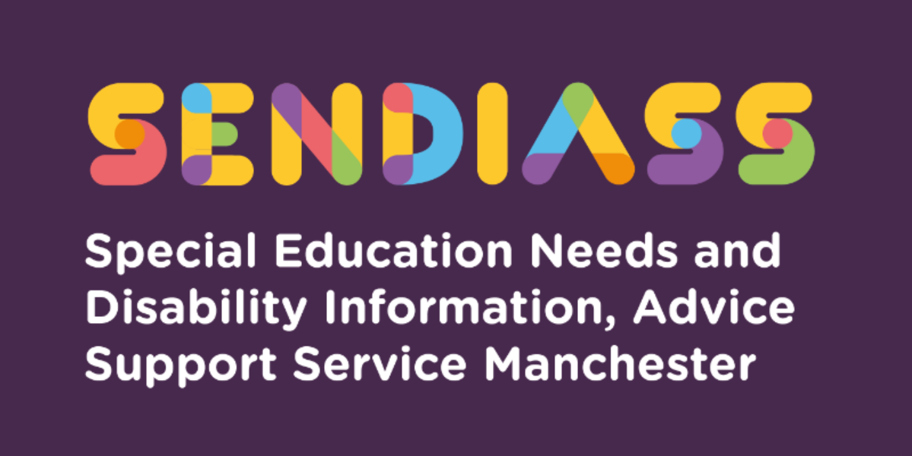

horizontal line

**Special Educational Needs and Disability (SEND) in the Early Years**

**Factsheet Number 12 August 2025**

horizontal line

**Disclaimer**: This is a guide and should not be treated as legal advice. Although SENDIASS Manchester makes all reasonable efforts to ensure that the information contained in this factsheet is accurate and up to date at the time of publication, we cannot accept responsibility for outcomes suffered because of reliance placed upon it.

The hyperlinks in this factsheet are correct as of August 2025.

In September 2014, the Special Educational Needs and Disability (SEND) reforms set out in the Children and Families Act (CAFA) came into force.

The Act:

* Requires a joint approach across education, health, and social care to commission services and cooperate at a local level to meet children’s needs.
* Requires local authorities to publicise these services as a local offer so that parents are clear what support is available locally.
* Establishes a SEND and disability framework from birth to 25 years.
* Requires an Education, Health, and Care (EHC) needs assessment for children who may need provision in accordance with an Education, Health, and Care Plan (EHC plan). In Manchester, this process is usually referred to as the Statutory Assessment Process.

**What does this mean for early years settings?**

One of the most significant changes brought in by the CAFA is the set of principles that underpins SEND responsibilities.

**1.**The wishes, views and feelings of children and their parents:

Early years settings need to listen and respond to the views of parents and promote communication with children about their views, whether verbally or using signs and symbols or pictures.

2.The participation of children and their parents in decision making about SEN:

Working with parents and children from the earliest concerns, through decisions about identification, outcomes, and support.

3.Providing children and their parents with information and advice to support participation:

Early years settings should provide information to parents about

* How the setting supports disabled children and children with SEND
* Their child’s progress

The settings should also provide wider information about:

* The local Offer
* The SEND Information, Advice and Support Service (SENDIASS)

4.The best possible outcomes for children

Early years settings should focus on improved outcomes and closing the achievement gap.

**Three sets of Duties combined.**

In early years settings, the CAFA sits alongside the requirements of the Early Years Foundation Stage (EYFS) and the Equality Act 2010.

**Children and Families Act 2014:**

All early years providers must:

* Have regard to the SEND Code of Practice (COP). This means they must consider the Act whenever they act for children with SEND, for example, by putting SEND support in place.
* Cooperate with the local authority in meeting its duties to children with SEND.
* Maintained nursery schools must appoint a suitably qualified Special Educational Needs Co-ordinator (SENCO). Other early years providers are expected to identify a SENCO.

**Early Years Foundation Stage key points:**

The Statutory Framework for the Early Years Foundation Stage (EYFS) applies to all early years providers and promotes equality of opportunity and anti-discriminatory practices, ensuring that every child is included and supported.

EYFS:

* Sets out an inclusive approach designed to be responsive to individual needs.
* Requires settings to have arrangements in place to identify and support children with SEND or disabilities.
* Requires all providers to make information available to parents about how the setting supports disabled children and children with SEND.
* Requires practitioners to review children’s progress and share a summary with parents.
* Requires all settings to promote the good health of children and have and implement a policy and procedures for administering medicines.
* Expects all providers of group provision to appoint a SENCO.
* Focuses on delivering improved outcomes and closing the achievement gap.

**The Equality Act 2010**

The definition of disability is wider than many may think, and so includes a greater number of children in early years settings.

Settings must:

* promote equality of opportunity.
* not discriminate against, harass, or victimise disabled children.
* not discriminate directly, indirectly, or for a reason arising in consequence of a disability.
* make reasonable adjustments for disabled children. This duty is anticipatory: settings must look ahead and anticipate what disabled children might need and what adjustments might need to be made to prevent any disadvantage.

**Roles and responsibilities in the early years**

**The Proprietor**

The legal responsibilities for disabled children and children with SEND lie with the proprietor that is the owner or the management committee, of a private, voluntary, or independent nursery.

**The Manager**

The manager or head of the setting has responsibility for the day-to-day management of all aspects of the setting’s work, including work with disabled children and children with SEND. The manager works closely with the SENCO on the implementation of SEND and disability policies and has a vital role in enabling the SENCO to meet their responsibilities.

**The SENCO (Special Educational Needs Coordinator)**

The SENCO works closely with the manager and with all practitioners in the setting. The role of the SENCO involves:

* Ensuring all practitioners in the setting understand their responsibilities to children with SEND and the setting’s approach to identifying and meeting SEND.
* Advising and supporting colleagues
* Ensuring parents are involved throughout and that the insights inform action taken by the setting.
* Liaising with professionals or agencies beyond the setting

**Key person**

Each child must be assigned a key person. Providers must inform parents and/or carers of the name of the key person and explain their role when a child starts attending a setting. The key person:

* Must help ensure that every child’s learning and care is tailored to meet their individual needs.
* Must seek to engage and support parents and carers in guiding their child’s development at home.
* Should also help families engage with more specialist support if appropriate.

**All practitioners**

In addition to the manager of the setting and the SENCO, all members of staff have responsibilities to disabled children and children with SEND and need to understand these and the setting’s approach to identifying and meeting SEND.

**Transferring from an Early Years (EY) setting to a reception class**

Transferring between phases of education can be a source of both excitement and anxiety for children and parents alike. Change is challenging for all pupils but for children with Special Educational Needs (SEND), moving to a different key stage or a different setting can cause additional worries and stress.

**What does a new phase of education refer to?**

This is defined in Regulation 2 of the SEN and Disability Regulations 2014 (the “SEN Regs”) as a transfer from:

* Home to pre-school or nursery
* Pre-school/nursery to reception class/main school

**How to ensure transfer between phases of education is a success?**

Success lies in preparation and planning beforehand and then the settling in or follow up afterwards. Honest communication between the parents, child and the educational setting will help at every stage. Listening to the child’s concerns is vital – to provide the right practical and emotional support.

Parent preparation in choosing a school:

* Ensure you carefully consider the school’s ability to meet your child’s needs.
* Discuss this at your child’s SEND annual review or transition review if moving to reception class in September.
* Use the school webpage to look at information, policies, etc.
* Go on the open day/evenings (usually held in autumn term)
* Talk to the new school’s Special Educational Needs Co-ordinator (SENCO) and staff about your child’s additional needs/SEND.
* Arrange a separate meeting if you have not managed to speak to the SENCO.
* Keep a paper trail of evidence, emails are useful.
* If school suggest they cannot meet your child’s need, ask for it in writing.
* Apply for a place at your chosen school in good time.
* If your child has an EHC plan your school application will be done through the EHC plan review (see end of document for more information).

Preparation once a school place is allocated:

* Ask for photographs of the school, classroom, and staff.
* Use fairs and open days to familiarise your child with the school.
* Liaise with the school to try and arrange additional transition visits.
* Ensure all relevant information is shared with the new school (e.g., update and share your child’s one-page profile)
* Some children benefit from a transition diary or book.
* Ask the SENCO in your child’s current early years setting/school to support by organising additional transition visits to the new school.

**How to help your child transferring to a new setting/school**

Talk to your child about what you are both worried about – this is likely to help you both and help you get the right support / information.

For example:

Some solutions / Good practice:

* Keep a school schedule for each day somewhere visible at home, e.g., the fridge. It could help you and your child settle into a new routine. Schools are great at sending home newsletters and updates and the school website will have lots of information.
* Pre-visits. School will offer pre-visits to help the child familiarise themselves with the rooms and will invite parents to an afternoon/evening to meet the staff who will be looking after and teaching your child. Many schools hold curriculum events also to support parents with what and how they teach so parents have a greater understanding of how they can support their child- usually after the first half term for settling in
* Ask the setting/school to identify a staff member to be the person your child goes to with concerns/worries i.e., their class teacher/teaching assistant for their year group.
* Settling in. Many children do not automatically settle in on their first day as everything is new and your child may be concerned about you leaving them. Many school settings have a phased intake especially in the reception class, so children start for a few hours either morning or afternoon and then build up their staying time over an agreed number of weeks with the parent. Parents often stay initially and over a period of time withdraw gradually as the child becomes more confident and secure with the adults around them. Moving at the pace of the child rather than rushing the child into full time is advisable as a great settling in period will help the child to feel secure and build up relationships with the adults who will be supporting them. It also greatly helps the staff to have quality individual time with your child to understand better their needs and be able to plan to support them.
* Realistically a positive transfer to a new phase of education will not be perfect on day one of the move – despite how much preparation has taken place beforehand but continued honest communication between school and home will ensure any potential difficulties are identified and addressed quickly.

**Phase transfers - what happens when you have an EHC plan?**

Regulation 18 of the SEN Regulations requires that if your child has an EHC plan it must be reviewed.

This means the local authority (LA) should start the annual review process in the autumn term of the year before the child or young person moves setting.

There should always be an annual review of the EHC plan before a transfer to a new phase of education.

So – where a child or young person is moving to a new phase of their education, the process is as follows:

**Statutory process of phase transfer – 4-part process**

1. LA reviews the plan.
2. LA sends proposed amendments and a copy of the plan to the parent or young person with the section naming the school/college/educational setting left blank (section I).
3. Parent or young person has at least 15 days to make representations about the proposed amendments/content of the plan and to either request that a particular school/college is named or to express a preference for an independent placement.
4. LA issues a final amended plan, with notice of appeal rights, by the statutory deadlines in Regulation 18.
5. Local authorities must not make children and young people with EHC plans go through usual admissions process and cannot require them to express a preference for an educational placement before the proposed amendments have been issued (step 2 above).

Local authorities cannot circumvent the statutory process of phase transfer where a child or young person has an EHC plan and is moving to a new phase of their education. The 4-part process outlined above must be carried out in the order listed.

Therefore, if you have a child with an EHC plan who is moving to a school nursery/reception class, you should have received an amended plan on or by the 15th of February of the transition year, stating the new placement in part I of the plan. The EHCP team in Manchester are the team who arrange your child’s school placement and therefore it is advised to stay in communication with your allocated EHCP case coordinator throughout this process. If you are not sure who to contact in the EHCP team email them on [sen@manchester.gov.uk](mailto:sen@manchester.gov.uk)

**Rodney House Outreach Service for Early Years (RHOSEY)**

Rodney House provides a valuable outreach service for families and settings of children 0 - 5 years across the City of Manchester.

Rodney House has an outreach team made up of teachers and family workers.

The Rodney House Outreach for settings teachers’ role is to work with practitioners from Early Years settings throughout Manchester in an outreach capacity, offering advice and support in working with children, who have been identified as having additional needs. RHOSEY also supports children who are not yet in a setting but still at home.

More information about RHOSEY: [Rodney House Specialist Support School - RHOSEY Outreach](https://rodneyhouse.manchester.sch.uk/outreach)

|  |
| --- |
| **Contact Details for SENDIASS Manchester**  Helpline Telephone number: 0161 209 8356. Please clearly leave your name, contact number and a brief message on the answerphone and a member of the team will contact you within 24 hours or the next working day.  **Or**  Email your query to us: [**sendiass@manchester.gov.uk**](mailto:sendiass@manchester.gov.uk) leaving your name, child’s name and their date of birth.  You can complete our website contact form: [**Contact Us (iasmanchester.org)**](https://www.iasmanchester.org/contact)  Visit Manchester SENDIASS website [**About SENDIASS Manchester (iasmanchester.org)**](https://www.iasmanchester.org/)  Manchester SENDIASS Podcasts [**Listen to our SEND Talk podcasts**](https://www.iasmanchester.org/podcasts)  Manchester SENDIASS YouTube channel [**https://www.youtube.com/@SENDIASSManchester**](https://www.youtube.com/@SENDIASSManchester)    **QR code for the website QR code for Facebook page** |