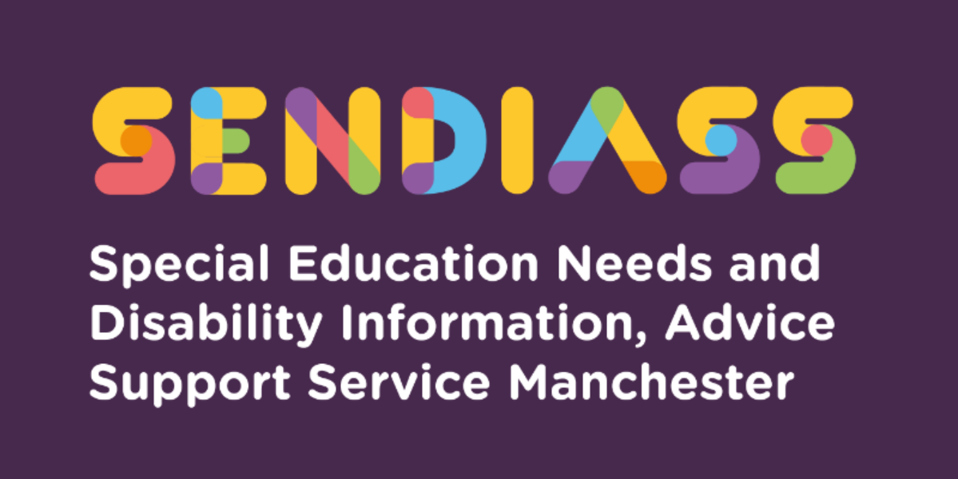

horizontal line

# **Access arrangements for exams**

**Factsheet Number 11 August 2025**

horizontal line

**Disclaimer**: This is a guide and should not be treated as legal advice. Although SENDIASS Manchester makes all reasonable efforts to ensure that the information contained in this factsheet is accurate and up to date at the time of publication, we cannot accept responsibility for any outcomes suffered because of reliance placed upon it.

## The hyperlinks in this factsheet are correct as of August 205.

## **What are access arrangements?**

Access arrangements allow candidates/learners with special educational needs, disabilities or temporary injuries to access the assessment without changing the demands of the assessment, for example using readers, scribes and braille question papers. In this way, Awarding Bodies will comply with the duty of the Equality Act 2010 to make reasonable adjustments.

Things to consider for access arrangements:

* Is the learner disabled under the terms of the Equality Act 2010?
* What is the learner’s normal way of working (NWW) in the classroom?
* Does the learner need access arrangements for all exams or just some exams?

For most access arrangements, an assessment by a specialist teacher in school is required. Students with known disabilities will only need to provide medical evidence, for example, a student who requires a word processor due to a physical disability. If your child has a completed Educational Psychologist assessment, the report may recommend exam access arrangements, and this can be passed on the school.

Any access arrangements applied for must either be dependent on need and be the student’s normal way of working in the classroom. For example, if they need any assistive technology e.g., tablet, they should be using this in class too.

Parents should speak with the Special Educational Needs Co-ordinator in the school (SENCO) ideally before the student starts their course of study i.e., from the end of Year 9 ready for their General Certificate of Second Education (GCSEs) in Year 11.

Pupils must ensure they are (re)assessed for exam access arrangements by school in Autumn term of year 11. This is to give time for the arrangements to be agreed and allows the SENCO to send the request to the relevant Awarding bodies before the February deadline before GCSEs. Parents of pupils in year 11 can ask the school SENCO of a copy of the agreed exam access arrangements.

Colleges do not have to have a SENCO, but they should have an equivalent. The earlier the discussion the better so that access arrangements can be trialled and become the student’s normal way of working.

## **What Access Arrangements are possible?**

Access arrangements might include:

* Additional time
* Reader (human or computer, e.g. a reader pen)
* Word processor
* Scribe
* Prompter
* Practical assistant
* Enlarged papers.
* Modified paper (colour, font size, braille, language etc.)
* Smaller/individual room
* Read aloud
* Rest breaks

The access arrangement must be appropriate to the exam and the student. It would be inappropriate to have a reader for an exam testing reading skills (although a computer reader is allowed if this is the student’s normal way of working). Likewise, a student with dyslexia may require additional time for a written exam but not for a practical one.

If a parent/carer believes that their child/young person is likely to fall within the remit of access arrangements, it would be perfectly reasonable to ask the school or college to assess for this, giving reasons why. Alternatively, a parent could commission an independent report and ask the school/college to act on this.

## **What may prompt a request for access arrangements?**

* Making frequent spelling/grammatical errors
* Reading a passage but unable to answer questions about it
* Struggling with reading/slow reading
* Words moving around on the page or blurring (check eyesight first)
* Running out of time to copy work off the whiteboard
* Unable to keep up with taking notes
* Untidy/slow handwriting
* Pain when writing for prolonged periods
* Generalised exam anxiety
* Reading questions and thinking aloud
* Having problems getting ideas down on paper, despite doing an essay plan
* Getting “stuck” and unable to move on
* Sensory needs, difficulty sitting a busy exam hall

## **Hidden Access Needs**

Many students are quite adept at covering up any issues they may have, so while they may look all calm in class, they may be really struggling. Alternatively, they may be exhibiting disruptive behaviour to avoid work they cannot access. It is hard to hide during an assessment and better to find a problem before sitting a GCSE than after whenever possible.

**Special consideration**

Special consideration is a post examination adjustment to a candidate’s mark or grade to reflect temporary injury, illness or other indisposition at the time of the examination / assessment.

## **Post 16 Access Arrangements**

For students who move to college post-16, a new assessment will normally be needed unless there is an established working relationship between the school and college and the Form 8 has been transferred over. A form 8 is the document required to apply for access arrangements.

Form 8 must be completed correctly and appended to an EHC plan. It must be hand signed by someone qualified to do so and be in date. It is wise to be careful regarding access arrangements written into Education, Health, and Care Plans (EHC plans).

The SENCO or specialist advisor will still need to ensure that these are appropriate and write a statement to confirm this. It can be frustrating for both student and parent to find that no access arrangements are in place despite any being written on the EHC plans.

An appointment should be made with the appropriate person in the education setting. Form eight covers GCSE and many other level 1/2/3/ exams and must be submitted in February for exams in June.

## **Reasonable Adjustments**

Parent/carers should keep a copy of all requests for reasonable adjustments including access arrangements and the response received. Email is preferable.

If access arrangements have been granted in school, the parent/carer should ask for a copy of the Form 8 and send it to the next post 16 placement. Even if a new one is required, it can give valuable information to the next placement. Reports expire after 26 months and must be in date at the time the exam is taken. The Governors or equivalent have a duty to use their” best endeavours” to secure the special educational provision required. This includes auxiliary aids such as a tablet.

**IPSEA** (Independent Provider of Special Education Advice) have a model letter 13 on their website: [IPSEA Model Letter - Asking for help with exams](https://www.ipsea.org.uk/asking-for-help-in-exams).

Resits are not the end of the world and students do them alongside other higher-level or vocational qualifications.

Joint council for Qualifications (JCQ) information sheet for parents: [PLMR JCQ1799 Parent EAA JCQ Info sheet A4 1pp PDF v2.indd](https://cdn.bdadyslexia.org.uk/uploads/documents/About/Policy/JCQ-Parent-guidance-information-sheet-2024.pdf?v=1708522305)

[Access Arrangements, Reasonable Adjustments and Special Consideration - JCQ Joint Council for Qualifications](https://www.jcq.org.uk/exams-office/access-arrangements-and-special-consideration/)

[Key stage 2 tests: access arrangements - GOV.UK](https://www.gov.uk/government/publications/key-stage-2-tests-access-arrangements)

|  |
| --- |
| **Contact Details for SENDIASS Manchester**  Helpline Telephone number: 0161 209 8356. Please clearly leave your name, contact number and a brief message on the answerphone and a member of the team will contact you within 24 hours or the next working day.  **Or**  Email your query to us: [**sendiass@manchester.gov.uk**](mailto:sendiass@manchester.gov.uk) leaving your name, child’s name and their date of birth.  You can complete our website contact form: [**Contact Us (iasmanchester.org)**](https://www.iasmanchester.org/contact)  Visit Manchester SENDIASS website [**About SENDIASS Manchester (iasmanchester.org)**](https://www.iasmanchester.org/)  Manchester SENDIASS Podcasts [**Listen to our SEND Talk podcasts**](https://www.iasmanchester.org/podcasts)  Manchester SENDIASS YouTube channel [**https://www.youtube.com/@SENDIASSManchester**](https://www.youtube.com/@SENDIASSManchester)    **QR code for the website QR code for Facebook page** |