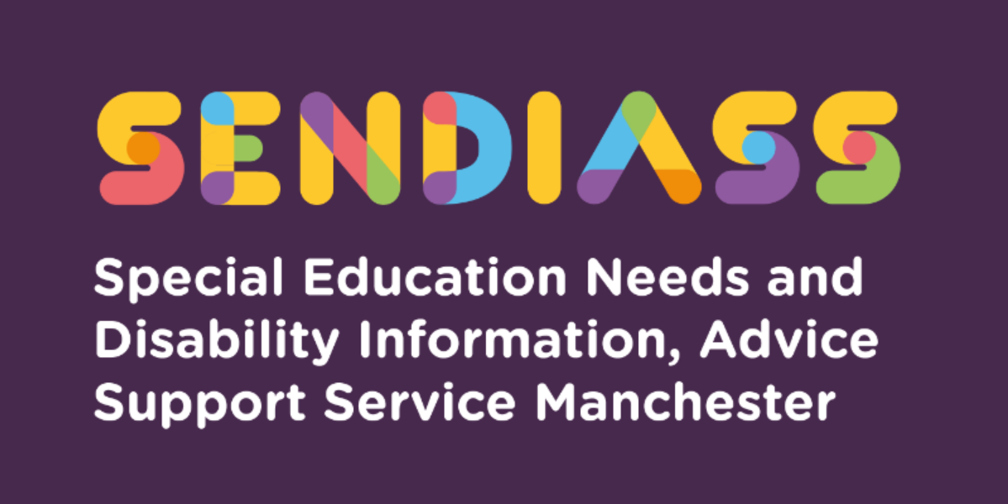

horizontal line

**Education Health and Care Plans (EHC plan)**

**Factsheet Number 1 August 2025**

horizontal line

**Disclaimer**: This is a guide and should not be treated as legal advice. Although SENDIASS Manchester makes all reasonable efforts to ensure that the information contained in this factsheet is accurate and up to date at the time of publication, we cannot accept responsibility for outcomes suffered because of reliance placed upon it.

All hyperlinks in this factsheet were correct as of August 2025.

Number references in this factsheet refer to the [Special educational needs and disability code of practice: 0-25 years](https://www.gov.uk/government/publications/send-code-of-practice-0-to-25)

[Education, health and care plans: England 2025 - GOV.UK](https://www.gov.uk/government/statistics/education-health-and-care-plans-england-2025)

## **What is an EHC Plan?**

An EHC plan describes your child’s special educational needs and/or disability (SEND) and the help they will get to meet these needs. An EHC plan also describes any health or social care provision needed to meet your child’s identified SEND.

EHC plans are legal documents written by the local authority and are for children and young people (aged 0-25 years)

who need a high level of support, over and above what can be provided from within the resources normally available to mainstream education and training providers.

For most children under 2 years of age any SEND needs are likely to be best met from locally available services. If a child has complex developmental or sensory needs the local authority may need to consider whether an early year’s setting can support the child’s SEN or whether they need to offer additional support through an EHC plan.

For children within one or two years of starting compulsory education, who are likely to need an EHC plan in primary school, it will often be appropriate to prepare an EHC plan during this period, so the plan is in place to support transition to primary school.

Young people who do not have an EHC plan have the right to request an assessment of their SEN at any point prior to their 25th birthday.

### **The****SEND Code of Practice says:**

The purpose of an EHC plan is to make special educational provision to meet the special educational needs of the child or young person, to secure the best possible outcomes for them across education, health, and social care and, as they get older, prepare them for adulthood.

## **Who needs an EHC plan?**

EHC plans are for children and young people, who have a special educational need and/or disability that cannot be met by the ordinary support that is available at their school or college.

Most children and young people with special educational needs will have help given to them without the need for an EHC Plan. Some children and young people will require additional resources and support from delegated budgets at the SEN Support level and the purpose of SEN Supportis to helpchildrenachieve the outcomes or learning objectivesthat have been set for them.

Some children and young people may not make the progress expected of them even with this help. When this happens, the Local Authority should conduct an EHC needs assessment. A few children and young people have such significant difficulties that an EHC needs assessment should not be delayed.

You or your child’s education setting can ask the local authority to complete an EHC needs assessment. When this assessment is finished the local authority must decide whether to issue an EHC plan. (See SENDIASS Factsheet 28 if you want to apply for an EHC needs assessment yourself)

### **The SEND Code of Practice says:**

In considering whether an EHC needs assessment is necessary, the local authority should consider whether there is evidence that despite the early year’s provider, school or post-16 institution having taken relevant and purposeful action to identify, assess and meet the special educational needs of the child or young person, the child or young person has not made expected progress. (9.14)

## **What does an EHC plan include?**

The SEND Code of Practicesays that EHC plans should:

* Be based on decisions made openly, and with parents, children, and young people.
* Describe what the child or young person can do.
* Be clear, concise, understandable, and accessible.
* Consider how best to achieve the outcomes for the child or young person. It must consider the evidence from the EHC needs assessment.
* Specify clear outcomes.
* Consider alternative ways of providing support if a parent or young person wishes it. This could include having a Personal Budget
* Show how education, health and care provision will be co-ordinated.
* Be forward looking – for example, anticipating, planning, and commissioning for important transition points in a child or young person’s life.
* Describe how informal support as well as formal support from statutory agencies can help in achieving agreed outcomes.
* Have a review date.

There is a full list of principles and requirements in the SEND Code of Practice section 9.61.

Every EHC plan must include the following sections and each local authority can decide how to set these out:

**The sections are:**

A:   The views, interests and aspirations of you and your child/young person

B:   Your child’s or young person’s special educational needs

C:   Health needs related to their SEN or to a disability

D:   Social care needs related to their SEN or to a disability

E:   Planned outcomes for your child/young person

F:   Special educational provision. Provision must be specified for each need shown in section B.

G:   Any health provision required that is related to their SEN or to a disability

H1: Any social care provision that mustbe made for your child or young person under eighteen.

H2: Any other social care provision required that is related to their SEN or to a

        disability

I:    The name and type of the school-maintained nursery school, post-sixteen institution or other institution to be attended.

J:   Details of how any personal budget will support outcomes and the

       provision it will be used for.

K:   The advice and information gathered during the EHC needs assessment

Section I of the EHC plan will only be filled in when the final EHC plan is issued. Where the child or young person is in or beyond Year 9, the EHC plan must also include the provision required to help prepare them for adulthood and independent living.

You can read the full list of what must be included in each section in the SEND Code of Practicesections 9.62 and 9.63. Manchester Local Authority’s EHC plan templates can be viewed on the Local Offer.

## **Can I request a particular school?**

The law says that parents or the young person has a right to request that a particular school, college, or other institution is named in the EHC plan. The Local Authority must agree to this request unless:

* it would be unsuitable for the age, ability, aptitude or SEN of the child or young person, or
* the attendance of the child or young person there would be incompatible with the efficient education of others, or the efficient use of resources.

You can find out more about your rights to request a particular school or college in the [SEND Code of Practice](https://www.gov.uk/government/publications/send-code-of-practice-0-to-25) sections 9.78 to 9.90 or you can call our confidential help line. Contact details for SENDIASS Manchester are at the end of this factsheet.

## **How will I be involved?**

#### The SEND Code of Practice says:

“Local authorities must consult the child and the child’s parent or the young person throughout the process of assessment and production of an EHC plan. (9.2)

Reviews must be undertaken in partnership with the child and their parent or the young person, and must take account of their views, wishes and feelings, including their right to request a Personal Budget.”  (9.168)

Your views, and your child’s views, are important. The local authority, school or college should help you take part and involve you in decision making. If you would like help to do this, please contact SENDIASS Manchester for impartial advice and support. We can also give you information on other sources of help, and on what to do if you do not feel that you have been heard or listened to.

## **Will there be a review of the EHC plan?**

The local authority must make sure the EHC plan is reviewed at least once every 12 months ([Section 44 Children’s and Families Act 2014](https://www.legislation.gov.uk/ukpga/2014/6/section/44)). This must be done in partnership with you and your child or the young person, and must take account of all your views, wishes and feelings.

The local authority must decide whether to keep the plan as it is, make changes, or cease to maintain it within four weeks of the review meeting and let you know. Read more in SENDIASS Fact sheet 3)

EHC plans are not expected to be amended on a very frequent basis however if the local authority decides to amend the EHC plan this must be issued within 8 weeks of the date of notice. You have the right to make representations regarding proposed changes.

If the local authority decides not to amend the EHC, they must write to you to tell you this and you will then have the right to challenge this.

You have a right of appeal if the local authority makes changes with which you do not agree.

The local authority can decide to withdraw the EHC plan if any of the following conditions apply:

* The child or young person no longer requires the special educational provision specified in the EHC plan.
* The young person takes up a higher education qualification.
* The young person aged sixteen or over gets a job.
* If the young person is eighteen or over and no longer wishes to engage in further learning

You or the young person has the right of appeal if you or they do not agree with the decision to cease the EHC plan.

## **Where does the funding come from?**

The local authority is responsible for ensuring that all the needs set out in the EHC plan are met and that the provision is made. Funding for EHC plans usually comes from a number of sources.

For children in mainstream school some of the funding comes from the school. The local authority may ‘top up’ this funding from their ‘High Needs Block.’ 

Special schools have a standard amount of funding for each pupil. This can also be ‘topped up’ with Element 3 funding when necessary.

For young people in sixth forms or attending college some of the funding will come from the college budget. This may be ‘topped up’ by the local authority if the amount of funding needed is more than the ‘nationally prescribed threshold.’ This is an amount of money that is decided on each year.

#### All young people with an EHC plan and all parents of children with an EHC plan can ask for a Personal Budget. The SEND Code of Practice says:

A Personal Budget is an amount of money identified by the local authority to deliver provision set out in an EHC plan where the parent or young person engages in securing that provision. (9.95)

Sections 9.110 to 9.118 of the [SEND Code of Practice](https://www.gov.uk/government/publications/send-code-of-practice-0-to-25)tell you more about what can be included in a Personal Budget.

## **What can I do if I am not happy about the EHC plan?**

The first step is to contact the school, college, or local authority to discuss your concerns.

[SENDIASS Manchester](http://www.manchester.gov.uk/info/500132/special_educational_needs/628/information_advice_and_support_ias_manchester) (Special Educational Needs and Disabilities Information, Advice Support Service) can give you impartial advice and support if you are unhappy with the content of the EHC plan, including the health and social care sections.  Your options could include independent disagreement resolution, mediation or going to appeal.

**Read more** in SENDIASS Factsheets 13 &15. There are also SENDIASS guides to different types of challenge – See Fact sheets 42-47.

|  |
| --- |
| **Contact Details for SENDIASS Manchester**  Helpline Telephone number: 0161 209 8356. Please clearly leave your name, contact number and a brief message on the answerphone and a member of the team will contact you within 24 hours or the next working day.  **Or**  Email your query to us: [**sendiass@manchester.gov.uk**](mailto:sendiass@manchester.gov.uk) leaving your name, child’s name and their date of birth.  You can complete our website contact form: [**Contact Us (iasmanchester.org)**](https://www.iasmanchester.org/contact)  Visit Manchester SENDIASS website [**About SENDIASS Manchester (iasmanchester.org)**](https://www.iasmanchester.org/)  Manchester SENDIASS Podcasts [**Listen to our SEND Talk podcasts**](https://www.iasmanchester.org/podcasts)  Manchester SENDIASS YouTube channel [**https://www.youtube.com/@SENDIASSManchester**](https://www.youtube.com/@SENDIASSManchester)    **QR code for the website QR code for Facebook page** |