
Robert Patton
Swampguana Diving LLC
2572 Lakeview Road
Barton, VT 05822
Swampguana@gmail.com
(802) 274-7016

2025 Lake Willoughby Eurasian Milfoil Report

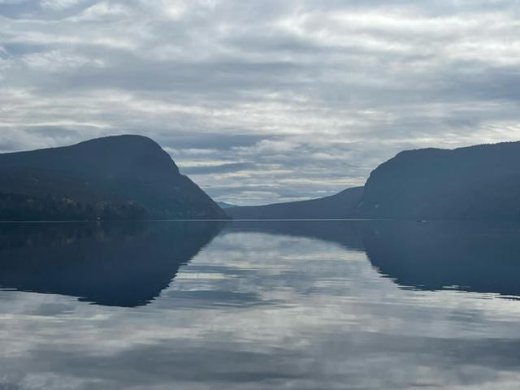

Submitted to:
The Town of Westmore
54 Hinton Hill Road
Westmore, VT 05860

Summary of Work

First Day of Work: July 28, 2025
Last of Work: September 25, 2025
Total Days worked: 16.5 Days
Total Hours worked: 132 Hours
Total Buckets Removed: 144.25

Areas of Milfoil Found from Survey:
Boat Launch
Crescent Bay
Mill Brook/Red Camps
Willoughvale-Grey Rock
North Beach-NW Shoreline
Grey Rock-Boat Launch
South End of Old 5A – Mill Brook/Red Camps

Total Milfoil Removed from Each Location 2021

(1 Bucket = 18 Gallons / 25-75 lbs)

LOCATION | BUCKETS | HOURS
Boat Launch | 185 | 88
Crescent Bay | 4 | 5
Mill Brook/Red Camps | 22 | 16
Willoughvale-Grey Rock | 51 | 26
North Beach-NW Shoreline | 12 Plants | 2
Grey Rock-Boat Launch | 3 | 6
South End Old 5A (New Area) | 1 | 1
TOTAL | 266 | 158
TOTAL GALLONS | 4788
TOTAL POUNDS | 6650-19950

Total Milfoil Removed from Each Location 2022

(1 Bucket = 18 Gallons / 25-75 lbs)

LOCATION | BUCKETS | HOURS
Survey |  | 7
Boat Launch | 381 | 110
Crescent Bay | 2 Buckets and 20 Plants | 5
Mill Brook | 14 | 9
Willoughvale-Grey Rock | 5 | 4
North Beach-NW Shoreline | 8 | 11
Grey Rock-Boat Launch | 2 Plants | 0
South End Old 5A – Mill Brook | 4 | 6
TOTAL | 414 and 22 Plants | 152
TOTAL GALLONS | 7452
TOTAL POUNDS | 10350-31050

Total Buckets Removed from Each Location 2023

(1 Bucket = 18 Gallons / 25-75lbs)

LOCATION | BUCKETS | HOURS
Survey |  | 8
Boat Launch | 244 | 91
Crescent Bay | 3 | 3
Mill Brook | 11 | 6
Willoughvale-Grey Rock | 18 | 5.5
North Beach-NW Shoreline | 4 | 8
Grey Rock-Boat Launch | 3 | 4
South End Old 5A – Mill Brook | 1 | 3
TOTAL | 284 | 128.5
TOTAL GALLONS | 5112
TOTAL POUNDS | 7100-21300

Total Buckets Removed from Each Location 2024

(1 Bucket = 18 Gallons / 25-75lbs)

LOCATION | BUCKETS | HOURS
Survey |  | 8
Boat Launch | 134 | 75
Crescent Bay | ½ Bucket and 4 Plants | 10
Mill Brook/Red Camps | 54 | 22
Willoughvale-Grey Rock | 14 | 22
North Beach-NW Shoreline | 7 | 6
Grey Rock-Boat Launch | 4 | 3
South End Old 5A – Mill Brook | ½ Bucket and 20 Plants | 7
TOTAL | 214 and 24 Plants | 153
TOTAL GALLONS | 3852
TOTAL POUNDS | 5370-16050

Total Buckets Removed from Each Location 2025

(1 Bucket = 18 Gallons / 25-75lbs)

LOCATION | BUCKETS | HOURS
Survey |  | 6
Boat Launch | 58 | 18
Crescent Bay | 7.5 | 7.5
Mill Brook/Red Camps | 6.75 | 10.5
Willoughvale-Grey Rock | 73.5 | 69
North Beach-NW Shoreline | 0 | 0
Grey Rock-Boat Launch | 4 | 19
South End Old 5A – Mill Brook | 0.5 | 2
TOTAL | 144.25 | 126
TOTAL GALLONS | 2596.5
TOTAL POUNDS | 3606.25-10818.75

Map of all areas worked 2022 (Highlighted in Blue)

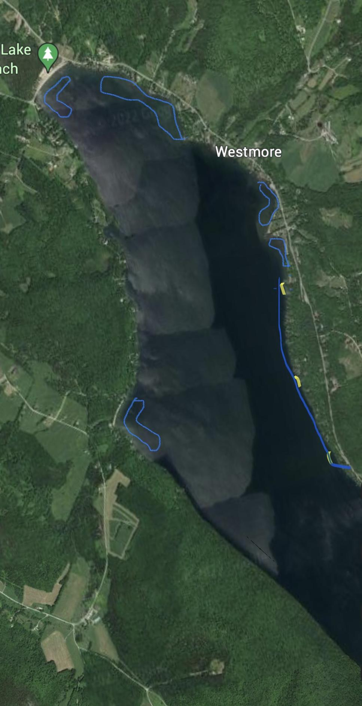

BOAT LAUNCH:

This was a very different year from previous years we worked. This is mainly because of the native plant that was mentioned to be a concern in 2024. The native plant, known as Potamogeton Foliosus or Potamogeton Pusillus, was becoming the main plant in the Boat Launch area. We also were seeing it in almost every other area we harvest in Willoughby. Our concerns last year were accurate and this plant was so abundant in the Boat Launch that we were unable to work in the majority of the area because it consumed almost every part that plants could grow. From around 3 feet of water to 15 feet of water it was within a couple feet of the surface and reached 12 feet deep at the deepest area of its growth. It is so dense and bushy that when we would pick one milfoil plant we would end up filling an entire 18 Gallon bucket. To continue harvesting in these conditions was not practical in our opinion. While this is an issue there is a positive aspect. This plant is so dense it has been choking out the Milfoil and as a result has helped decrease the amount of Milfoil in this area. This is good for the fight against Milfoil but it has also choked out almost all of the other native plants. This is a very interesting situation and brings up a lot of questions about what should be done in the future. There are other factors to consider, as this summer was extremely dry and sunny bringing the water level to the lowest I've ever seen it. Perhaps more sunlight makes this plant thrive more than normal. However this plant also thrived last summer when circumstances weren't the same. We never know what's going to happen with mother nature and we will have to wait until next summer to see if this plant will continue to take over. Hopefully this native weed will back off such as the experts in the state expect based on the conditions of this summer.
As a result, we were not able to harvest because of the density of this plant, and our numbers are significantly lower than any other year. We only worked 18 hours removing 52 Buckets (most of the buckets consisted of this plant) compared to 75 Hours and 134 Buckets in 2024. The majority of where we worked was the outer areas where this native plant was growing. This was along the drop off and the much shallower parts of the Boat Launch.
Another positive aspect of these conditions is that it allowed us to spend the majority of our time at all the other locations on the lake and make a very large impact. The North Beach area to the NW Shore was an exception which had the same issue as the Boat Launch with this native plant.

Here are a couple pictures of Potamogeton Foliosus or Potamogeton Pusillus to help everyone understand what it looks like and the density of the plant.

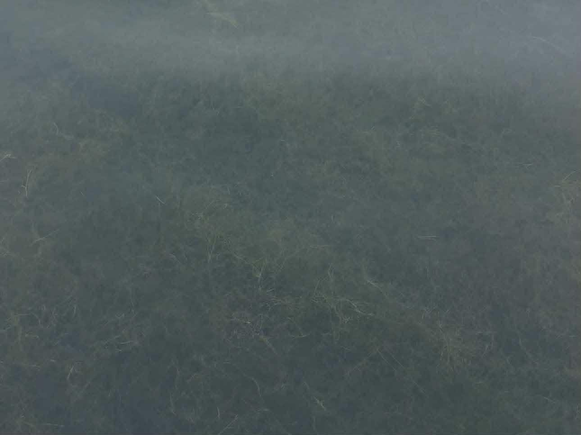
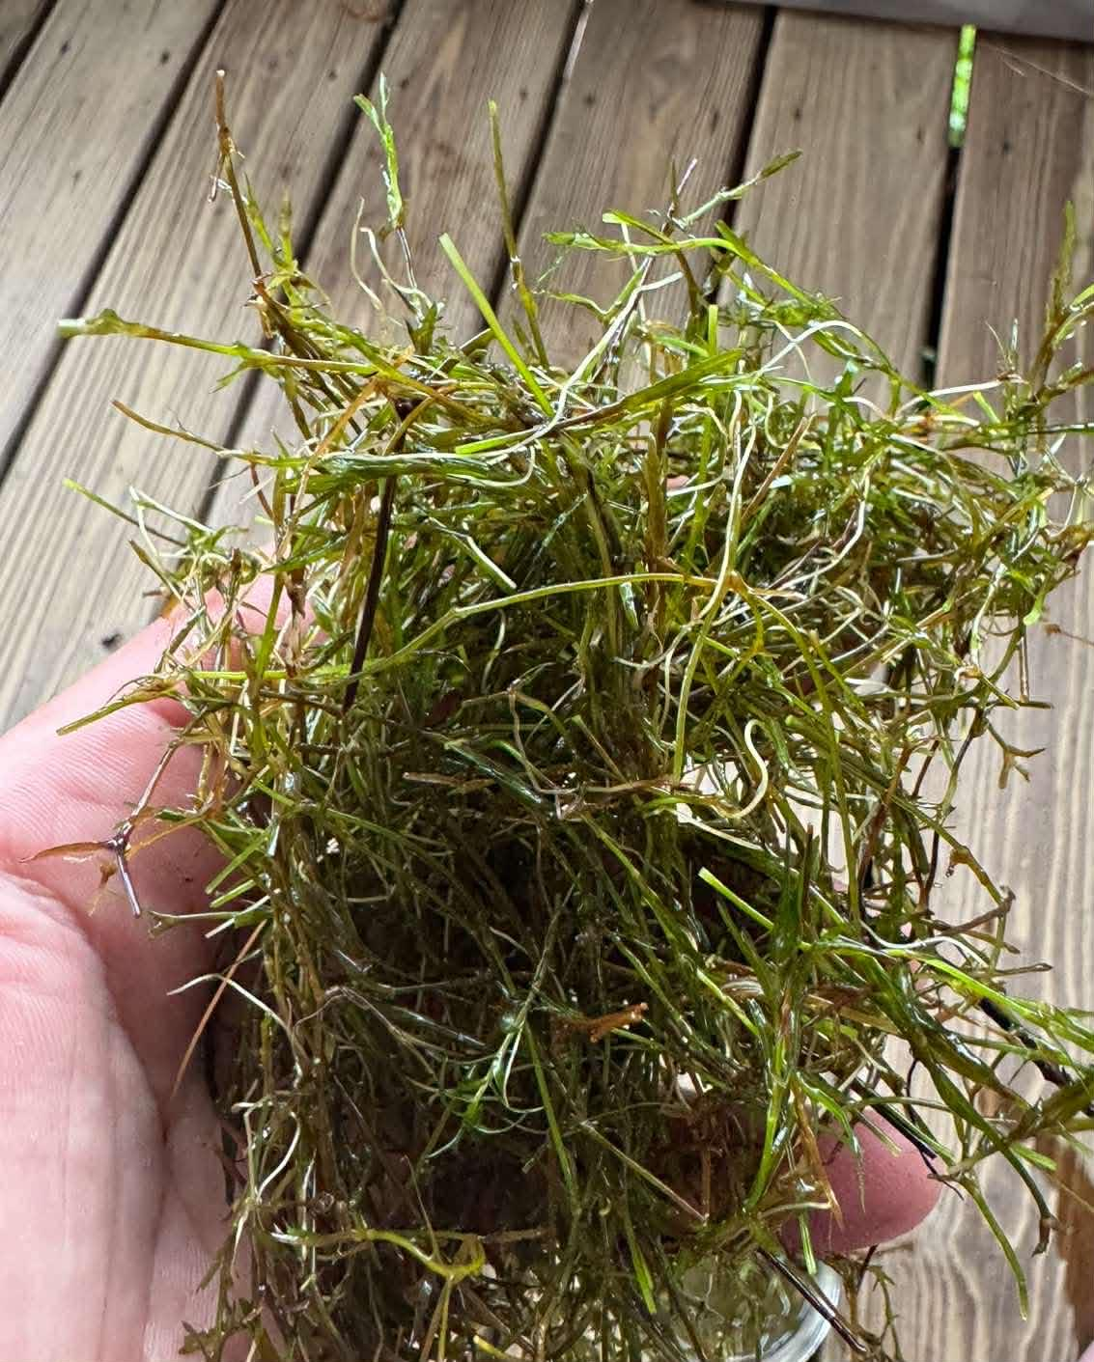

It's hard to tell in the first picture but it shows how close to the surface this plant was and this is in about 10-12 feet of water. The second photo is a good example of how to identify it.

This photo is the area of the Boat Launch and where we worked was mostly around the Blue line.

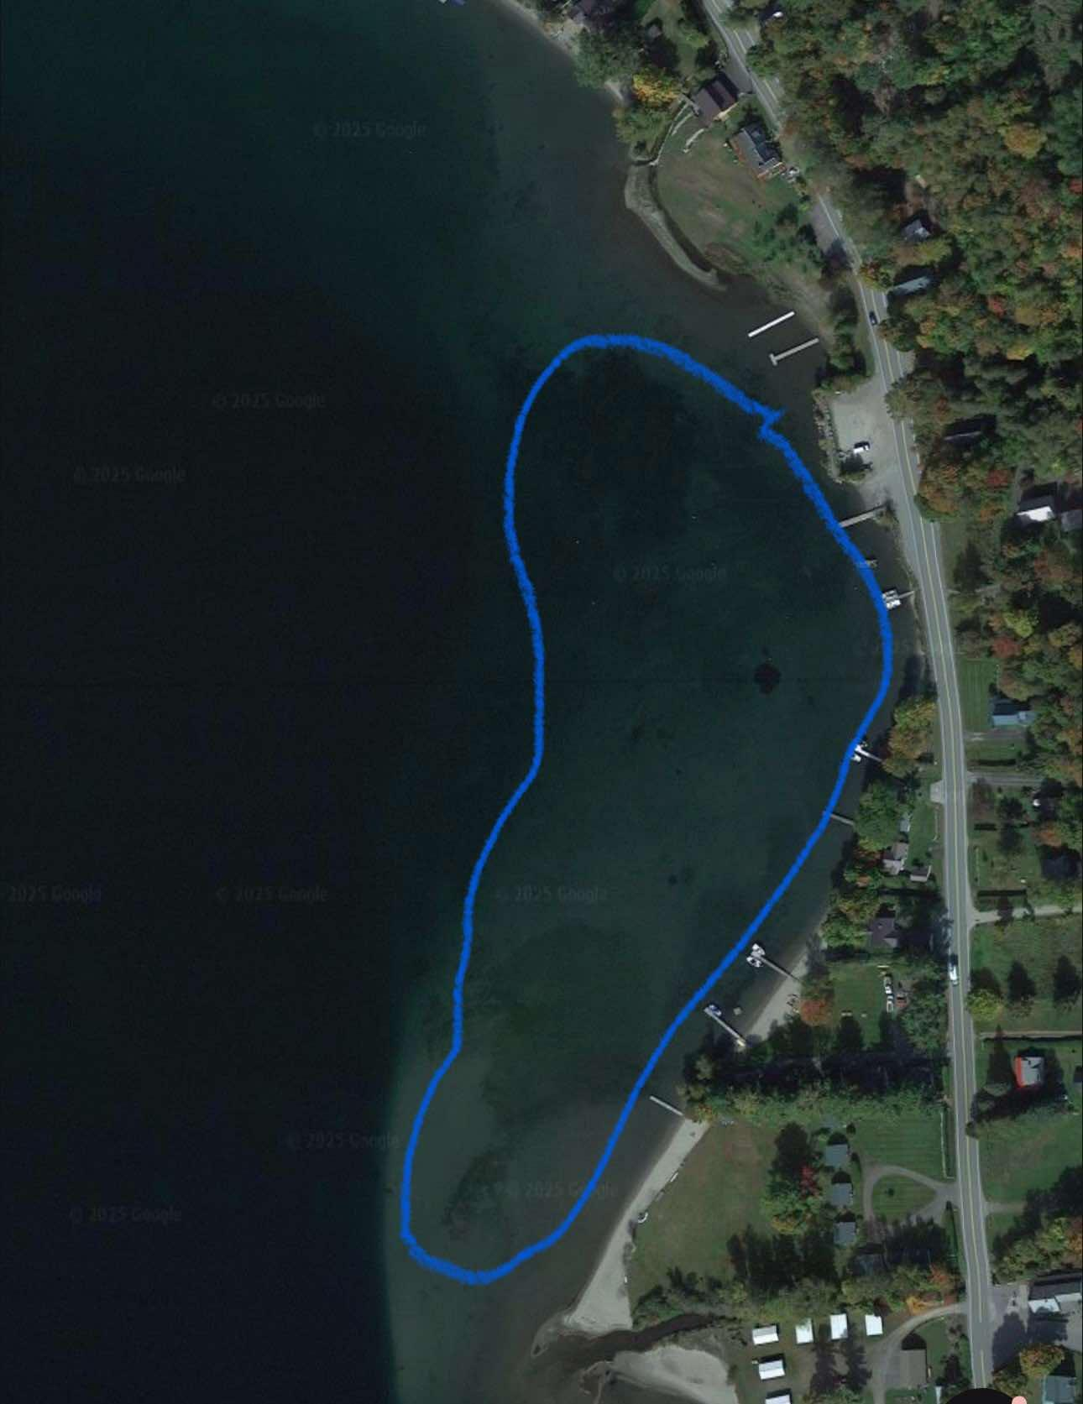

Crescent Bay:

In this area we removed 7.5 Buckets in 7.5 Hours. Mostly in the bottom of the Blue area while only finding a handful of plants in the Left corner of the Blue line. While last year we spent more time here and picked less Buckets we were able to cover the entire area 6-7 times. We believe the only reason there were more plants this year was because of the lower water level allowing more sunlight to impact the speed and growth of the Milfoil plants.
We also found the native plant in a few areas here which we have not seen before. It is being discovered in more locations and considering how it has thrived at the Boat Launch and the North Beach area it has become concerning. Hopefully it doesn't have the same impact as the other locations. Regardless, we will find out next summer and will consider if anything should be done if that's the case.
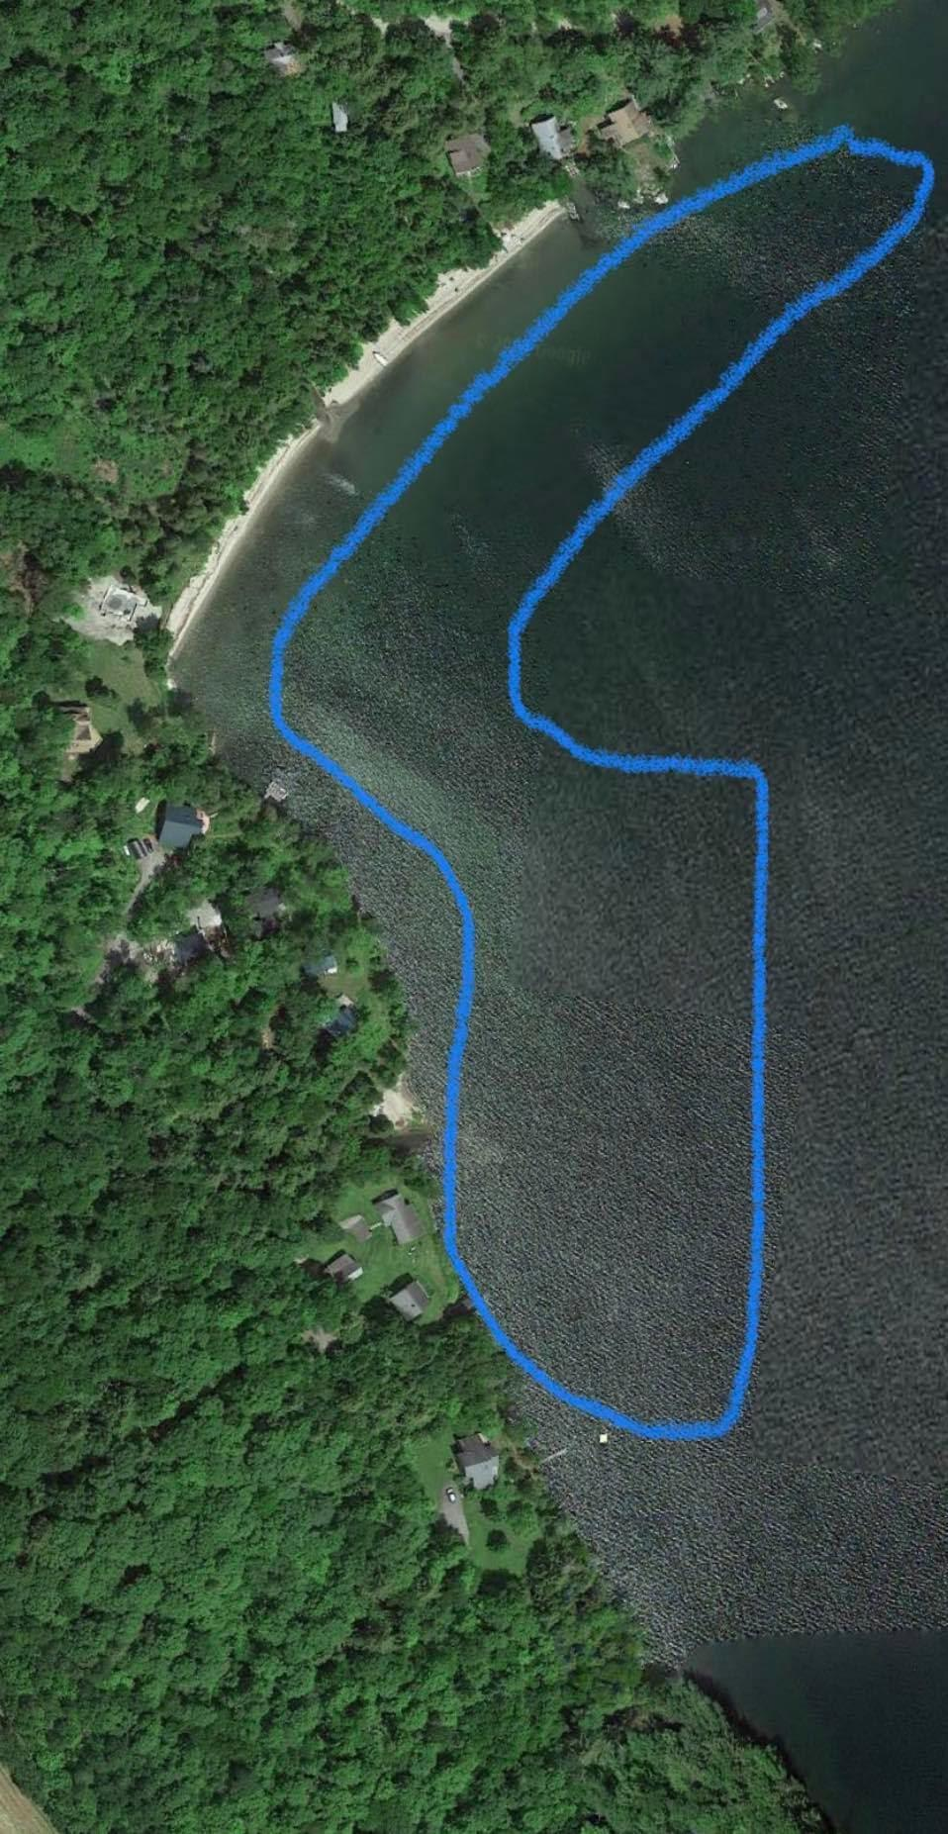

Mill Brook/Red Camps:

This year we are very pleased with the continuing decline of Milfoil harvested as we only spent 10.5 Hours removing 6.75 Buckets compared to 22 Hours and 54 Buckets in 2024. This is a large area and we were able to cover the entire area 3 different times.
Once again, the native plant had an impact on the fight against Milfoil. We are pleased but still concerned and will have to wait until next year to see its effect. Hopefully its growth declines but we are very confident the amount of Milfoil will decrease.

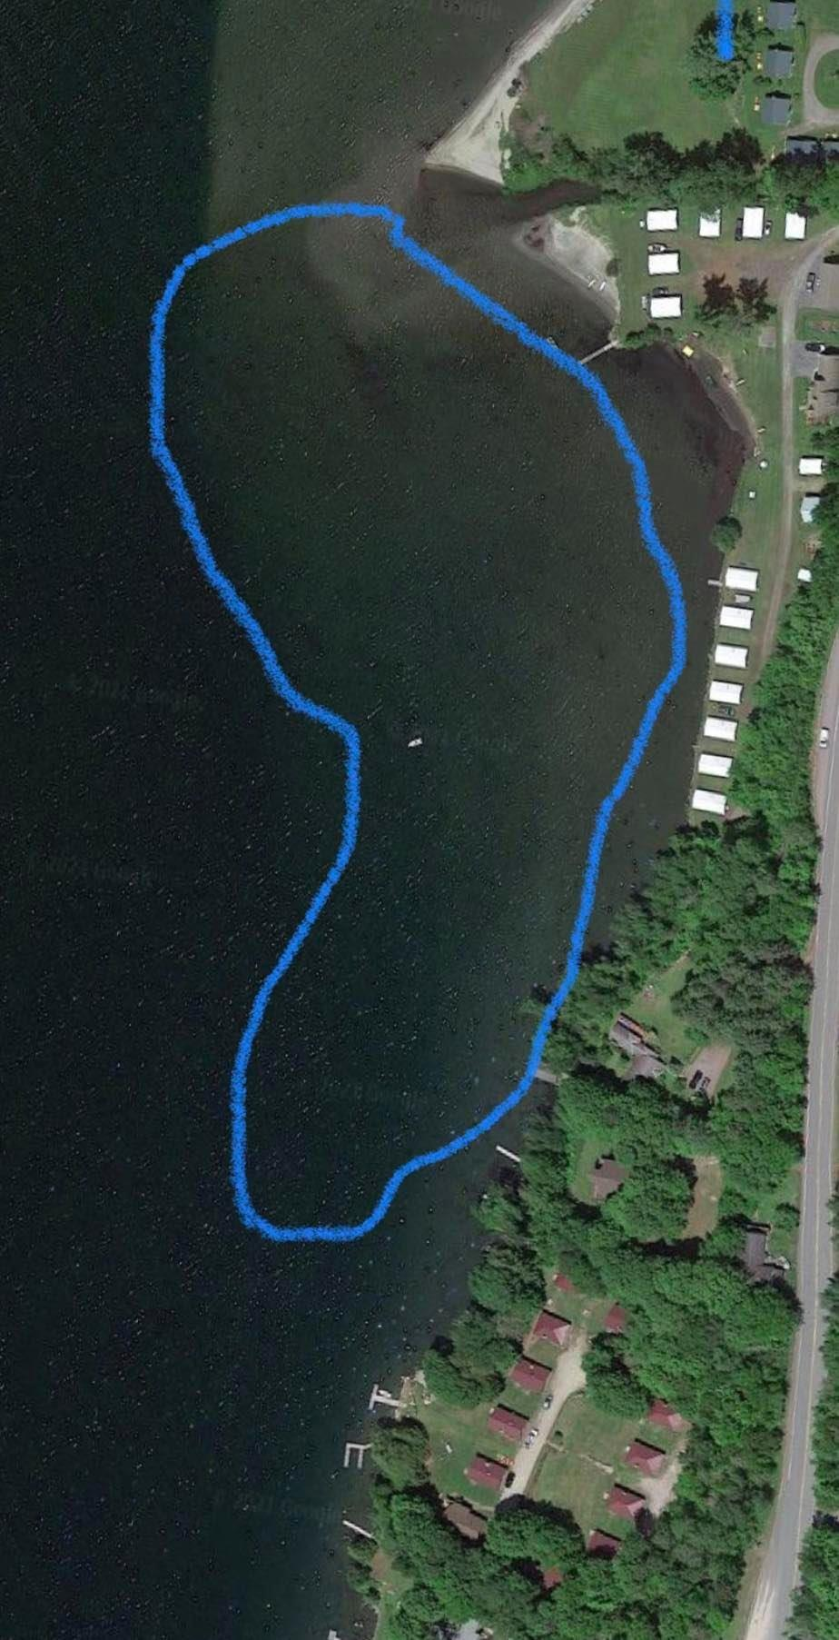

Willoughvale-Grey Rock:

This area was very surprising for us when we discovered a patch of Milfoil that was the biggest in the lake this year. Most likely because of the weather conditions this year this patch was given the ability to thrive and grow quickly. This was because we must have missed a small patch last year. The summer conditions this year allowed the patch to grow very quickly. This patch was shallow, directly in front of the Willoughvale and we found very small amounts in the rest of the area in Blue. As a result we ended up spending the majority of our time in front of the Willoughvale since it was the largest and densest area in the entire lake. We ended up spending 69 Hours here removing 73.5 Buckets compared to 22 Hours removing 14 Buckets in 2024.
It's very difficult to harvest Milfoil in this location because the sand is so compacted and makes it more difficult to remove all the roots needed to prevent the regrowth of the plants and creating longer efforts to remove each plant effectively. This is also why we went over the same spot 3 different times to remove any plants that came back.
There are almost no native plants here.This is giving the Milfoil no competition and allowing it to spread faster than most other locations.
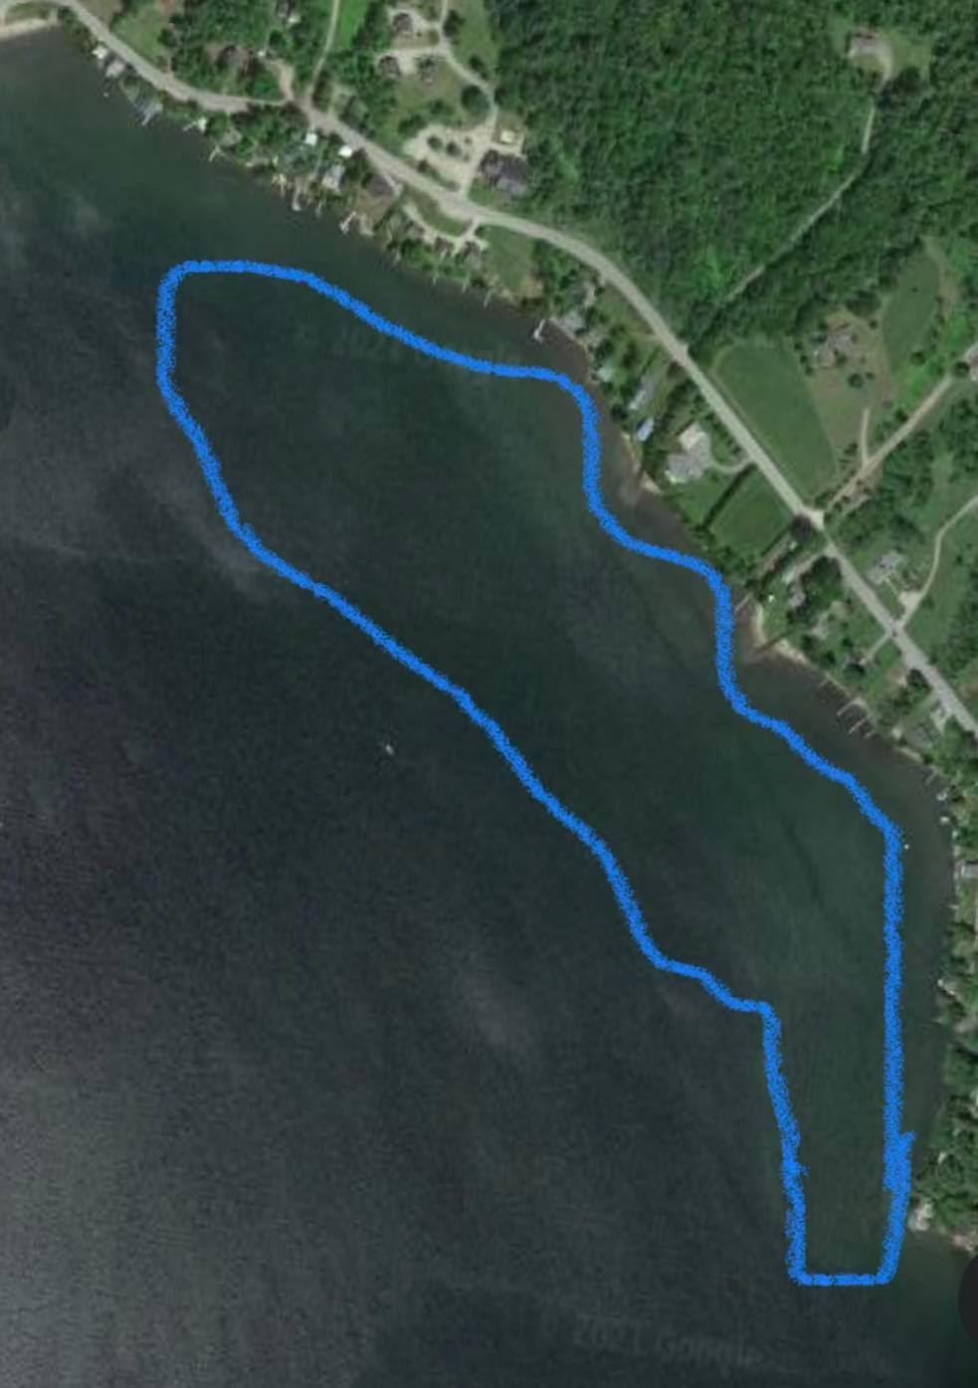

North Beach-NW Shoreline:

This year we only surveyed this area 4 different times and resulted in no Harvesting at all because of how much the native plant has grown here. It has basically consumed their entire bottom area and was the same circumstance as the Boat Launch. However it wasn't as close to the surface.
This area is the largest area in the lake where we have found this plant and it has spread the most here since last year. Its growth from last year at this location and the Boat Launch is why we are so concerned about this plant. It is more abundant than any other plant that is in Willoughby, this includes Milfoil. We still believe something should be done about how fast and widespread it has become. I am hoping that this is only because of the circumstances of this summer's weather and lower water level.
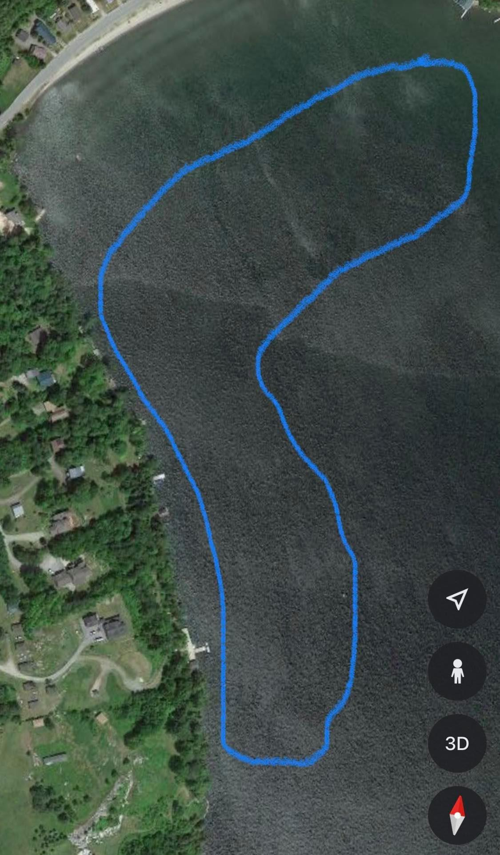

Grey Rock-Boat Launch:

This area we spent a significant amount of time surveying but wanted to make sure there wasn't anything like we discovered in front of the Willoughvale. We thought this was a higher possibility because it's such a larger area just north of the Boat Launch that always had the most Milfoil growth (with the exception of this year). This would mean it had the highest chance of having fragments and as we know creates more plants. Thankfully this was not the case. We only removed 4 Buckets within 19 Hours of surveying and Harvesting. Compared to last year where we spent 22 Hours removing 14 Buckets. This shows a large decrease in the Milfoil and allowed us to go over the entire area more times and more thoroughly this year.
This is very satisfying considering it's probably about 10-12 acres of area where plants can grow. We are very confident that we are making the most progress here.
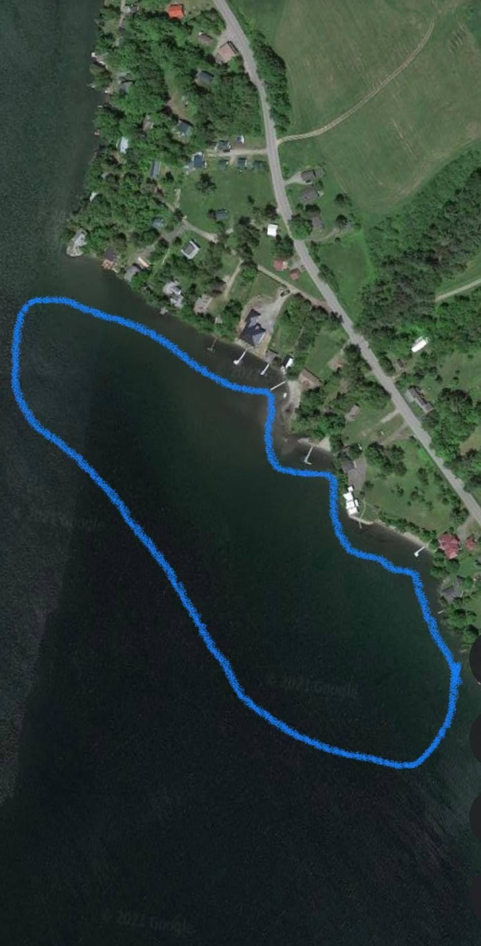

South End of Old 5A – Mill Brook/Red Camps:

We went over this entire area twice again this year and only found plants on the north end of this area close to Mill Brook. We removed .5 Buckets in 2 Hours of time and thankfully still haven't found any plants as far south as previous years. This is very good as we want to continue to make sure there are no plants spreading to the South End.
It looks like we can focus more time on other locations besides the Boat Launch in the coming years since the amount of Milfoil harvested is almost the same as the last one. We are planning on spending more time here next year.

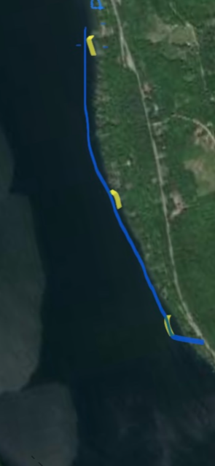

DASH was only used a little south of Milbrook/Red Camps marked with the furthest north part shown in Yellow on this map.

Conclusion:

Just as last year we are pleased with how everything is going with our progress on the Milfoil and are impressed with the impact of our work and adding the help of the troubling native plant (Potamogeton Foliosus or Potamogeton Pusillus). However, its positive influence doesn’t mean it's not harmful for the lake. Its vastness is becoming a genuine concern for us. The unknown effects it could have towards the lake are troubling. We are aware that this seems like a minor issue to some people and that the experts from the state have their opinions, said to be possible effects from the unique conditions of this summer. However, for us we spend more time under the water at Willoughby than anyone else and are seeing the changes first hand. The mass amount of this plant and the way it has expanded, making itself far more abundant than Milfoil ever has, justifies our concerns. Our buckets that we harvested demonstrate the significance of this and should never have looked as these photos display.

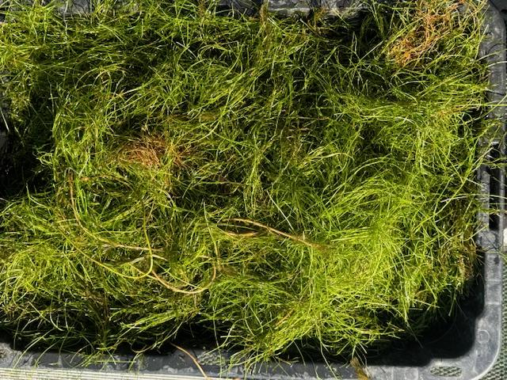
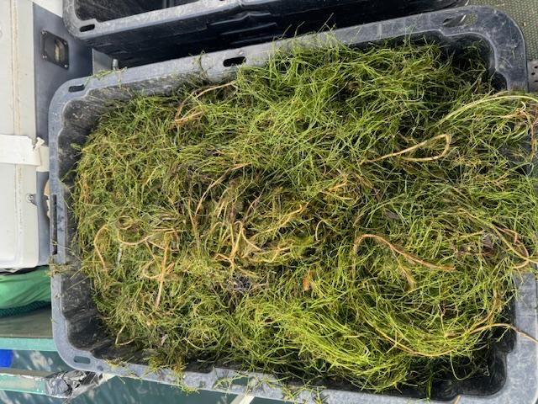

Even though this continues to be an ongoing issue, we really can’t know until next summer. Furthermore, our job is to help maintain the quality of all the lakes we work at, which has always been our focus. We are trying our best to control the spread and growth of Milfoil. This being the first time that a native plant has been a larger concern than Milfoil for any lake we have worked at. We're focusing on what we believe is the best way to maintain the health and quality of the lakes we work. Mostly we are just being over cautious because of the circumstances from this summer and want to emphasize that if we are right with this plant's persistent progress and the unknown negative effects it may have, actions should be taken to at least support and prevent possible or irreversible damage. This is one of our most precious lakes in Vermont and our goal is to keep it that way.
I want to make sure it's clear that this is part of our job and we are proud of what we do and want what is best for the lakes we work. That is and always will be our main goal.We have had dozens of people approach us about this plant this year because they also have never seen this at Willoughby. Their concerns should be valued because this isn't normal. We know we all want the same thing in the end and that is to not lose the quality and health of this incredible lake.

The Milfoil is still our main focus and we are all noticing how each year is looking better and better. We see in some areas how much progress there is and since we are getting ahead of it it allows us to survey more and more allowing us to find areas missed like in front of the Willoughvale.We believe this will be a continuing part of our work. Having to cover more ground means less dense areas and fewer and fewer plants.

We really appreciate your trust in our work and we are determined to continue making Milfoil a smaller issue each year.

Thank you so much for the opportunity to work in Lake Willoughby!

End Of Report

