EXECUTIVE SUMMARY: Tallassee Mill Sites Redevelopment
(derived from TRA Sponsored studies)
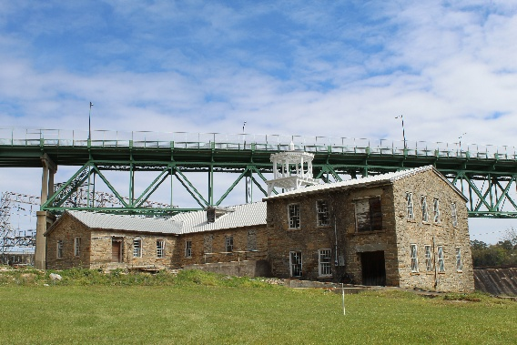
The Opportunity
The historic Tallassee Mill sites represent a premier 4.9-acre riverfront investment opportunity to transform Alabama’s oldest continuously operating textile mill complex (1844–2005) into a world-class mixed-use destination. Located at the heart of the Montgomery-Auburn corridor, the site offers exceptional historic significance combined with established community support and regional highway access.
Strategic Development Options
Current market analysis identifies three high-yield tracks designed to fill existing regional gaps in cultural and community amenities:
- Option 1: Heritage Tourism & Creative Hub: Leveraging the unique Civil War Armory history to create artist studios, maker spaces, and a flagship farm-to-table riverfront restaurant.
- Option 2: Community Event & Recreation Hub: A focused entry point for premium wedding/event venues and outdoor river recreation programming, such as kayak launches.
- Option 3: Mixed-Use Innovation District: Coworking and prototyping facilities targeting the 63% of residents who currently work outside the county.
Financial & Economic Highlights
- Narrative Arbitrage: The site’s historic character justifies premium rental rates of $12–$18/SF, compared to the local conventional retail market of $5–$10/SF.
- Job Creation: Projected to create 75–125 permanent full-time positions.
- Economic Impact: Estimated $8–$12 million annual impact over a 10-year horizon.
- Investment Tiers: Conceptual estimates range from $1.5M to $7M depending on the selected development track.

Asset Specifics: Building Inventory
The site features approximately 126,500 GSF of high-volume stone and brick structures ideal for adaptive reuse:
- Main Mill (1852): Approximately 80,000 GSF proposed for hotel, restaurant, and office use.
- Duck Mill (1878 attached to Main Mill): Approximately 30,000 GSF planned for a conference center, meeting rooms, or additional lodging.
- The Armory (1844): Approximately 12,200 GSF; the only standing Confederate Armory, proposed for museum and gallery space.
- Warehouse (1884): A 4,300 GSF single-story structure with stone bearing walls. Proposed uses include a brewery, coworking areas, small-scale manufacturing, or a farmer’s market.
Incentives & De-risking Strategy
- Capital Stack Optimization: Direct access to a 45% Historic Tax Credit (20% Federal, 25% State) for qualified rehabilitation costs.
- Environmental Management: Manageable contamination typical of historic textile sites with an estimated remediation cost of $275,000–$650,000.
- Grant Eligibility: The site is eligible for EPA Brownfields Grants ($200k–$500k) and USDA Rural Development funding.
Market Dynamics
- Regional Reach: Accessible to 750,000+ residents within a 45-minute drive (Montgomery/Auburn/Birmingham).
- Tourism Synergy: Strategic proximity to Lake Martin, which draws over 100,000 annual tourists seeking cultural activities beyond water recreation.

Strategic Readiness: The City of Tallassee and the Tallassee Redevelopment Authority (TRA) have established a phased implementation roadmap, prioritizing environmental clearance and professional partnership development with entities like Auburn University. For full prospectus and site access, visit tallasseeredevelopment.com.

