 

**Horticulture**

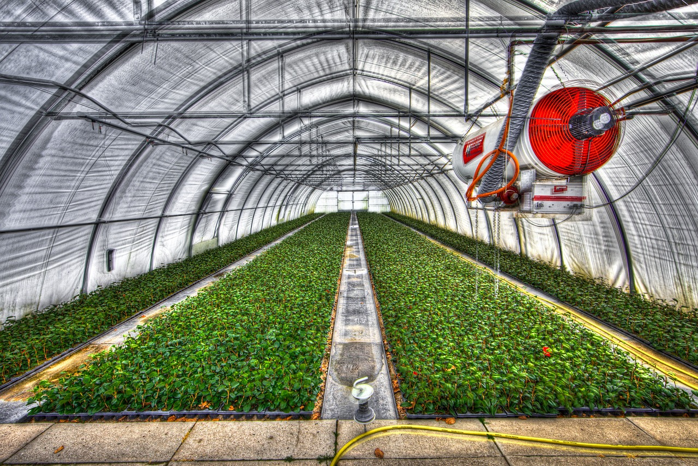

**Video Feedback**

Please list the video or videos you watched and write down the key points you learnt

**NAME: DATE:**

1. What type of Horticulture Career/s are you interested in? (You can put more than one)
2. What qualifications (GCSEs etc) do you need to go into a career in Horticulture?
3. Are you applying for: Sixth Form College Apprenticeship Not Sure

Put X in relevant box or boxes

1. What Skills do you need to work in Horticulture? Please list at least four:

1 2 3 4 4

1. What Horticulture jobs are available in your area? (list two examples from www.indeed.co.uk):

Company Job Title Salary

Company Job Title Salary

1. Now, a task that will require some research:
2. Please list three websites where you can gain information regarding Horticulture Careers

1

2

3

1. Where could you volunteer to get experience to support your career?
2. Please answer the following questions:

**Why do you want to work in Horticulture?**

**Why do you believe the Horticulture is important?**

**How does Horticulture support the environment?**

**Would you like to specialise in any area? i.e. plants, trees, food, groundwork etc**

**What is a Soil Specialist?**

**Why are photography skills useful to a Horticulturist?**

**What Apprenticeships are available in Horticulture?**

**What is the role of the Royal Horticultural Society?**

**What is an Agronomist?**

**Please write a short essay explaining your route to work in Horticulture:**

Where you are now?

Steps to get qualified?

What experience do you need?

Further research required?

**Are you considering any other careers?**

**If you have completed all sections, go back to the Main Menu to find the link to download and complete your certificate.**

**You will find that this worksheet forms part of the certificate, so don’t think you can just get one without doing the work.**

