
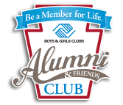
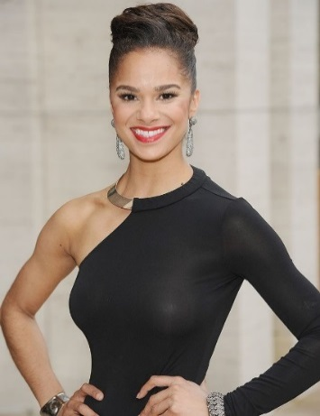

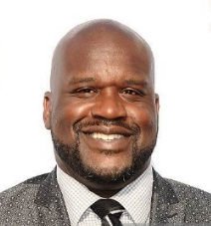

Did you know the Boys & Girls Club movement has a wide variety of celebrity alumni? Denzel Washington, Jennifer Lopez, Michael Jordan, Nick Cannon, Misty Copeland, Kerry Washington, and Shaquille O’Neal are just a few. The list goes on and on!

Calling All Alumni of the Boys & Girls Club!

Alumni Membership Application
Contact Information

Name: _________________________________________ Class Year(s): __________________________________
Address: __________________________________________________________________________________________
City, State, Zip: _____________________________________________________________________________________
Phone Number: _______________________________ What is your current/most recent job? ____________________
Email Address: ________________________________________________ Facebook: Yes_____ No______
Did you serve in the military? _____ Which Branch?_________________ How long? _________
With what companies have you worked since attending the Boys & Girls Club?
____________________________________________________________________________________________________________________________________________________________________________________________________
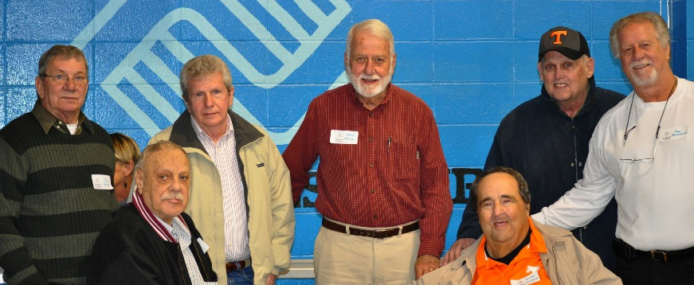
Membership Levels (Please JOIN our Team at any level)
We too have community alumni who are celebrities to us because they are a part of OUR history! We are tracking any member who has participated in our Club’s activities as a member from 1944 to today. We are collecting old photos and stories to share with the community on social media. Please reach out to us if you are one of our many alumni.

Your Annual Membership:
- Places you as a leading alumni insider.
- Entitles you to member benefits for latest listing
- Sets you for special invitations and opportunities with BGC
- Supports alumni outreach, programs, and youth services.
- Creates changes to improve BGC services

Please make checks payable to:
Boys & Girls Club of Johnson City/ Washington County
P.O. Box 5219, Johnson City, TN 37602

Level:
$1-$99 Friend
$100-$999 Builder
$1000-$2499 Believer
$2500-$4999 Advocate
$5000-$9999 Leader
$10000-$24999 Mentor
$25000-$49999 Challenger
$50000-$99999 Champion
$100000 & over Circle of Excellence



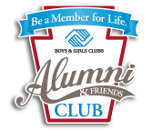

From National: Alumni & Friends represents a global network of former Club members and passionate supporters of Boys & Girls Clubs. The mission of Alumni & Friends is to advance the development of Club alumni and enable all young people to reach their full potential. We are advocates, donors and champions for Clubs and youth. We serve as a peer network of support and resource for young Alumni transitioning into life beyond the Clubhouse. We provide access to exclusive scholarships and career opportunities dedicated to advance Club alumni. We launched in 2016, and today we stand thousands of Alumni & Friends strong. Join Alumni & Friends today to connect, develop or give back! Boys & Girls Club alumni come from all walks of life but share a common bond through their Club Experience. We hope you find inspiration in these stories as you remember your time with the Boys & Girls Club.
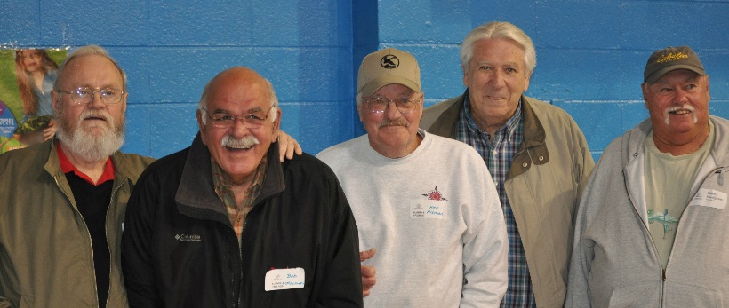What stories do you remember and want to share from your time at the Boys & Girls Club? Please sign your name to authorize any photos or stories to be printed or shared.
_______________________________________________________________________________________________________________________________________________________________________________________________________________________________________________________________________________________________________________________________________________________________________________________________________________________________________________________________________________

__________________________________________________________
Your Stories
“While playing a football game, my cousin ran for a touchdown. On about the 5 yard line, he held the ball up in the air. He was so proud as he thought he had scored but instead he got smeared and fumbled the ball. We still sit and laugh at that today!”
David Abel, 1974-1979
“I used to play basketball and volleyball down there. We had a lot of fun and got to meet a lot of great people and still meet up with some of them forty or fifty years later.”
Earl Yates, 1960s
“One of our new kids was sitting in the gym during rest period. Three other kids started picking on him. The kid bent over and untapped something on his right leg. He had a wooden leg; took it off and hit one of the kids with it. They did not bother him anymore.”
Richard Dugger 1988

Please send other stories/photos to rcrumley@gokidz.org or PO Box 5219, Johnson City, TN 37602

GREAT FUTURES START HERE!
Our Mission: To inspire and enable all young people,
Contact Us!
2210 W Market Street, Johnson City, TN 37604
423-461-4560
Find us on Facebook at Boys & Girls Club of Johnson City/Washington County

especially those who need us the most, to realize their full potential as productive, responsible and caring citizens.

