
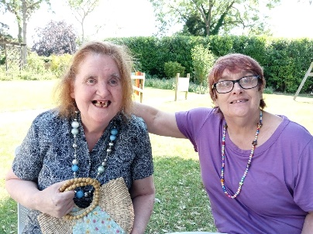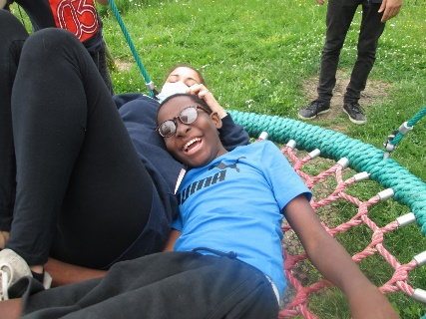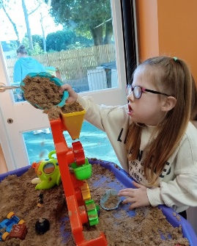
About Us
Watford Mencap supports people with learning disabilities and their families in South West Herts. We are affiliated to Royal Mencap but are a self-funding and independent local charity that has provided services and support to local families for the past 70 years.
We are passionate about providing opportunities for people with learning disabilities to live the life they want for themselves.
We currently operate across 11 sites in Hertsmere, Three Rivers and Watford. We moved to a new Hub in central Watford in 2021 which we continue to expand and develop into a multipurpose site used by the charity and other local groups.
We are proud to have a strong presence in the local voluntary sector, and you will be joining an expanding team, representing our charity to the local community.
We are seeking an experienced Communications and Marketing Officer who will enjoy working in a small team, developing and delivering the communications and marketing strategy to highlight the charity across the community, ensuring our public image reflects the high quality of services we offer.
You will be confident engaging with people at all levels. Whether talking to a service user, funder, colleague or supporter your enthusiasm for Watford Mencap will shine through whether face to face or in written word.
With your excellent communication skills and ability to showcase the services we offer, you will be able to use and grow your talents to make a tangible difference to people with learning disabilities.
You must have excellent interpersonal skills as well as flexibility, creativity and great organisation skills. There will be regular team meetings and office-based activities that you will need to be part of, but once your induction is complete we will happily consider opportunities for hybrid working being partially home based. You will however need to develop and maintain strong links and positive relationships with our operational teams and activities.
This is an exciting time to be joining the organisation; we are continuing the expansion of our operations to reflect the needs and choices of the 400+ local people with learning disabilities who we support.
You will be joining an award-winning social care organisation that makes a real difference to people’s lives. We are rated Silver in Investors in People due to the robust support and development we offer.
We offer excellent terms and conditions of employment. Full details of this are included in a separate document.

OUR VALUES
Our values are key to how we do what we do. If you share our values we want to hear from you!

We are INCLUSIVE. People with learning disabilities are at the heart of everything we do.

We are RESPECTFUL. We work in a person centred way, whilst listening to the views of all.

We are WELCOMING. We are approachable and value all.

We are PROGRESSIVE. We promote learning to support everyone to achieve their potential.

We are CHALLENGING. Through our work we will push the boundaries for individuals, organisations and society.
Communications and Marketing Officer

Hours: up to 20 hrs per week

Reporting to: Fundraising Manager

Reports: None

Location: Based at our Hub in central Watford with option for hybrid working

Salary: £25,000 FTE

Main purpose of the role:
To work with the Fundraising Manager to develop and deliver a communications and marketing strategy which portrays a strong and quality image of the charity. This is a new post which will have significant impact on the public profile of the charity.
The Communications and Marketing Officer will be someone with strong communication and IT skills, with a creative streak, who enjoys a challenge.

The post holder will be an experienced communications professional with an understanding of the charity sector. A flexible and creative individual who reflects the charity’s values – welcoming, inclusive, respectful, progressive and challenging.

We want to build awareness and understanding of learning disabilities and to engage more people in Watford Mencap’s work, enabling us to offer more opportunities for our community.

This role is for up to 20 hours a week. The pattern of hours worked can be discussed and negotiated. There is the opportunity for hybrid working with the understanding that office and project presence is an important part of the role.

Weekend and bank holiday working may be required, for which time off in lieu is given.

The successful candidate will have:
- good interpersonal skills working as part of the fundraising team
- high attention to detail and a high standard of literacy
- excellent organisational skills working in a timely manner
- be confident and flexible, representing Watford Mencap

We are looking for an experienced communications professional who has an understanding of the charity sector, to join us and make a significant impact on our work.

Main duties and responsibilities
Create and manage a rolling plan covering communications and marketing. Our objective is to reach new audiences using existing and developing platforms.

You'll be working closely with colleagues across the charity. You'll be part of the fundraising team, developing relationships across the community to raise awareness and understanding of learning disabilities and the opportunities that the charity offers to people with those conditions.

Key tasks:
- To create compelling long form content including website articles, information for print material, case studies, media releases, photo and film library and similar.
- To oversee adherence to key messaging, branding and voice across all external communications.
- To keep the charity’s website up to date, and to co-ordinate technical and design updates.
- To work with the Fundraising Manager to develop communication templates and instructions as appropriate.
- Running social media accounts and co-ordinating other teams’ content.
- Creating promotional materials including images and video clips
- Writing newsletters for different audiences, including accessible formats.
- To oversee the distribution of regular media releases.
- To work to a planned calendar of events and activities across all of the charity’s projects.
- To create responsive publicity as necessary.
- Actively promote and work within Watford Mencap’s equal opportunities and diversity policy
- To be self-sufficient in own administration using relevant IT
- To provide information and reports as required to the Fundraising Manager
- To take responsibility for own performance and personal development, actively seeking opportunities to train, network, project manage whilst keeping up to date with developments in the field
- Work alongside the wider Fundraising team to support major initiatives and activities.
- Work to support the mission, ethos and values of Watford Mencap
- Abide by organisational policies, codes of conduct and practices.
- Treat with confidentiality any personal, private or sensitive information about individual organisations and/clients or staff at Watford Mencap.
- To undertake such additional duties as required.

You don't need to have all of the knowledge, skills and experience listed in the role profile; this is just to provide a full picture of what’s possible in this role.

Who we're looking for
We'd love to hear from you if you’re:
- familiar and confident with various marketing techniques, including digital and social media, website management
- experienced in writing and speaking clearly
- someone who puts people first, and understands why great customer service matters
- skilled in working with IT (including Microsoft Office, mailchimp, website editing)
- able to work on your own initiative
- someone who enjoys meeting with people and families who the charity supports
- Comfortable around and experienced of people with physical or learning disabilities
- Ideally, you will have some knowledge of the social care or disability sector or have prior experience working at a charity

We are looking for
- Recent evidence of success in a communications-focused role.
- An understanding of the charity sector and the key issues for communication with stakeholders, supporters and the broader public.
- Exceptionally strong written communication skills, a strong command of grammar and meticulous attention to detail.
- Able to build relationships and articulate Watford Mencap’s work effectively to a range of audiences.
- Experience of graphic design work (we work on Canva).
- Self-motivated and self-supporting, with the ability to work methodically and efficiently, programming work to allow for unexpected or short-notice opportunities / needs.

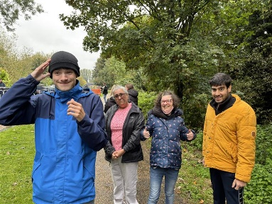

Person Specification:
 | Qualities Required | Essential/ Desirable
Education & qualifications | Good IT skills and experience using Microsoft Windows. | Essential
 | High level of numeracy, accuracy and an eye for detail | Essential
Experience | Proven track record of managing a varied and flexible communications schedule. | Essential
 | Knowledge of using social media and website platforms | Essential
 | Knowledge and understanding of key issues for people with learning disabilities and their carers | Desirable
 | Knowledge of regulatory requirements and best practice policy and guidance relating to communications and marketing | Essential
 | Working within the learning disability and charity/social care sector | Desirable
Skills | Excellent organisational and project management skills to manage a complex workload and meet deadlines. Ability to work independently, with prioritisation skills. | Essential
 | Excellent communication, presentation, research skills | Essential
 | Commitment to maintaining up to date knowledge around the fast pace of communication platforms | Essential
 | Good knowledge of Word, PowerPoint, Excel and internet research | Essential
Personal Attributes | Flexible ‘can do’ approach, work well under direction and also use initiative and work autonomously, as required. | Essential
 | Emotional resilience, able to remain calm when others maybe anxious | Essential
 | Able to work flexibly to occasionally include evenings and weekends to meet the demands of the job, for which notice and time off in lieu will be given where this exceeds the normal working hours | Essential
 | Commitment to anti-discriminatory practice and equal opportunities. An ability to apply awareness of diversity issues to all areas of work. | Essential
 | Car owner with current driving licence | Desirable
 | Ability to work as part of a team, with people at all levels, gets on well with colleagues and supporters across all areas of the organisation. | Essential
 | Ability to maintain confidentiality | Essential

Our Values
To be successful in this role we expect you to share and live our values:
Value | Behaviour
Inclusive | You involve the people we support by listening to them and ensure their needs are considered in the trusts and grants applications you make.
 | You are able to communicate effectively with people with a learning disability and your colleagues, adapting your approach to the needs of the person at the time.
Respectful | You demonstrate through your actions respect, dignity, diversity, and privacy for people we support.
 | You develop and maintain effective working relationships with managers, project staff, partner organisations, suppliers and groups that you liaise with
 | You work flexibly and can adapt to changes in workload as necessary.
Welcoming | Develop and maintain a welcoming atmosphere for the people we support and their families.
 | Develop and maintain a welcoming atmosphere within our projects for the people we support and their families.
 | Provide a safe, secure, clean, warm and stimulating environment for the people we support, staff and visitors.
Progressive | Keep your trusts, foundations and other grant-making bodies knowledge and skills up to date and share appropriately.
 | Able to record information, access and manipulate data stored in IT systems and share information easily and appropriately.
 | Be innovative with ideas and passionate about developing the most effective and efficient communications for the services we offer.
 | Be able to think creatively and pro-actively to develop communications as the needs of the services and people change
Challenging | Professionally challenge prejudices that cause barriers for people living with learning disabilities.
 | Using all available information to ensure that the Communications meets the needs of Watford Mencap staff, volunteers and the people we support; whilst working in partnership with the people with learning disability.

