Funeral Program Guide
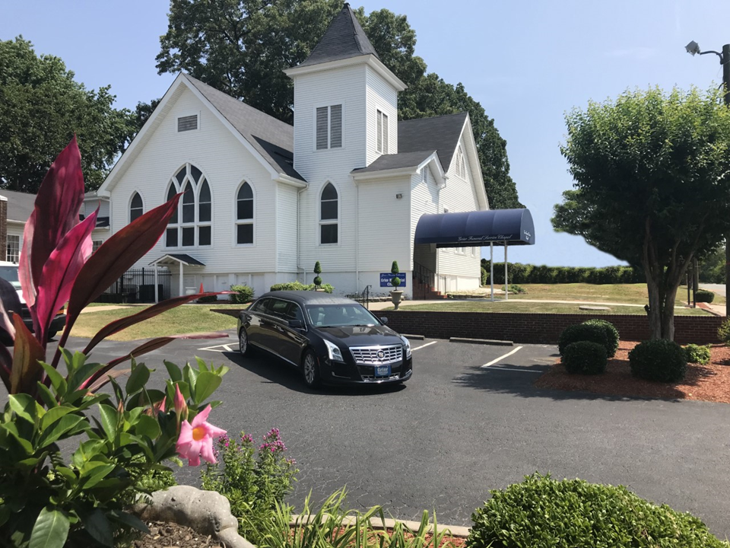

115 John McCarroll Avenue
Charlotte, NC 28216
Telephone: 704-332-7109
Fax: 704-332-5273

Instructions

Please print clearly and complete all areas that apply. If something does not apply, please write “N/A”. If you need to use additional pages, please staple or paper clip them to the guide. The printers are not able to include any information that is not included in the guide, so please make sure that you include all relevant details in this document.
TITLE HEADING FOR COVER OF PROGRAM
(Please select one of the following or prepare your own)
- A Memorial Service For | - Homegoing Celebration For
- A Service of Memory Celebrating the Life of | - In Loving Memory of
- A Service of Memory for | - In Memoriam
- Final Services for | - In Remembrance of Our Beloved
- Funeral Service for the Late  - Other: ______________________________ | - Obsequies for

Deceased’s Information
Please print clearly and do not abbreviate (text will be printed as it appears)
Name of Deceased: ______________________________________________________
Day and Date of Funeral: _____________________________________________________
Time of Funeral: _____________________________________________________________
Location and Address of Funeral: ________________________________________________ ___________________________________________________________________________
Officiating Minister: __________________________________________________________

Contact Information For Person Completing Obituary
Name: ______________________________________________________________________
Phone Number: _______________________________________________________________
Email Address: ________________________________________________________________
Funeral Director in Charge: ______________________________________________________

ORDER OF SERVICE
Please provide details on specific songs, scriptures, and participants/speakers

Processional ________________________________________
Prelude ________________________________________
Invocation ________________________________________
Hymn ________________________________________
Scripture
Old Testament ________________________________________
New Testament ________________________________________
Prayer of Comfort ________________________________________
Selection ________________________________________
Obituary ________________________________________
Remarks ________________________________________
Acknowledgements ________________________________________
Selection ________________________________________
Eulogy ________________________________________
Recessional ________________________________________
Benediction ________________________________________
Interment (Location) ________________________________________
ACKNOWLEDGMENTS
Please check one of the following or write your own
- The family of the late____ acknowledges with sincere appreciation your understanding, your prayers, and all acts of kindness shown at this time of bereavement.
- The family of the late ___acknowledges with sincere appreciation the many comforting messages, floral tributes, and other expressions of kindness evidence at this time in thought and deed.
- The family of the late __sincerely appreciates your thoughtfulness and prayers during their time of sorrow. May God bless you always.
- With sincere appreciation, we wish to thank our many friends for their expressions of kindness during our bereavement for our loved one. May God bless each of you.
OBITUARY
(Please print clearly and confirm that everything is spelled correctly)
_______________________________________________________________________________________________________________________________________________________________________________________________________________________________________________________________________________________________________________________________________________________________________________________________________________________________________________________________________________________________________________________________________________________________________________________________________________________________________________________________________________________________________________________________________________________________________________________________________________________________________________________________________________________________________________________________________________________________________________________________________________________________________________________________________________________________________________________________________________________________________________________________________________________________________________________________________________________________________________________________________________________________________________________________________________________________________________________________________________________________________________________
- Casket Bearers
_____________________________________________________________________________
- Flower Bearers
_____________________________________________________________________________

