
BE SWEET, BUY A TREAT
St. Louise de Marillac # 2703 will be having a sweet sale on Sunday, February 14th following the 10:45 am Mass. Help support St. Stephen's Catholic Daughters so they can fund a variety of events for our parish and community.
Louisiana Right to Life March
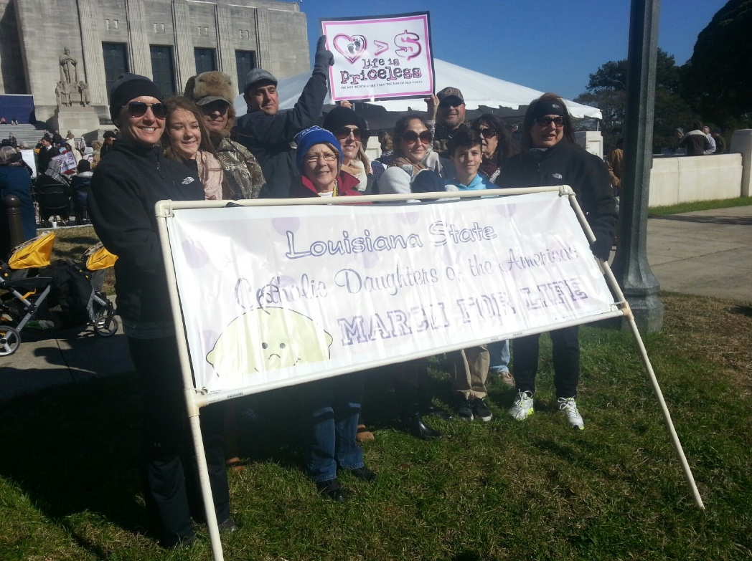
The St. Stephen’s Catholic Daughters of the Americas Court, St. Louise de Marillac, participated in the Right to Life march held Saturday, January 23rd in Baton Rouge. This was the court’s first official event and we are so proud to have been a part of this important issue that faces the world today. Court members who were able to attend were: Tona Babin, Lacy Cornett, Aimee McGrew, Angie Scivicque, Tanil Thacker, and Dana Vicknair. We were also blessed to have some of our family participate. While it was a very brisk morning, the walk was invigorating as we recited the rosary on our way to the new State Capitol. The speakers gave very moving accounts and sparked a desire in everyone to continue the March for Life every day.
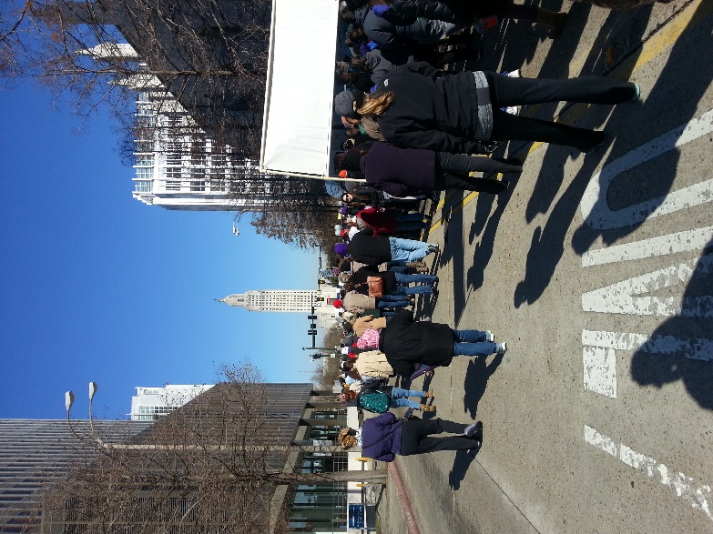

Attention Business Owners, Professionals and Self Employed
Liturgical Publications Inc. (LPI), our Bulletin publisher, will have Kim Charles, the bulletin representative, at the St. Joseph Church office within a few weeks to service our bulletin. We would like to encourage all present advertisers to renew their ad, thereby continuing their support of our Church. For those interested in placing a new ad, this is your opportunity.

The bulletin is a primary way to communicate with parishioners and, through the arrangement with the Liturgical Publications Inc., the Church will not pay for bulletin printing, saving thousands of dollars every year. The bulletin is supported through the generosity of the advertisers—many of whom are our own Church parishioners or members of the local community.

We ask that parishioners and community members support the bulletin advertisers with their patronage during these difficult economic times. We ask that you tell the business owner that you appreciate their support of our Church through their advertising in the bulletin. This is one small way each person can work within our own community to weather these challenging times. A strong and vibrant bulletin is good for our community and a strong business community is good for our Church.

As an added bonus, LPi has recently formed an advertisers buying group of 100,000+ businesses called LPI Family. Advertisers now can save more than the cost of an ad in buying group savings. Membership in the LPI Family buying group is FREE to all advertisers. To learn more about how LPI Family can reward you for being an advertiser please check out the website at www.4LPi.com/family.

