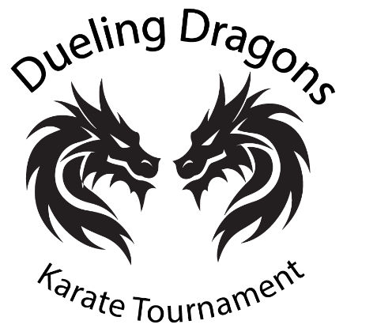

Black Dragon Martial Arts Academy
113 Salem Turnpike, Suite 102
Norwich, CT 06360
August 1, 2025
Subject: Invitation to Participate in the Expanding Dueling Dragons Karate Tournament
Dear Sensei,
We are pleased to invite you to join us in the continued growth of the Dueling Dragons Karate Tournament, as we expand onto regional, national, and global stages. In 2025, we will proudly host our 7th Annual Tournament at the prestigious Mohegan Sun Casino in Uncasville, Connecticut. Looking ahead to 2026, we are excited to announce that the tournament will evolve into a multi-regional circuit across the United States, with dates and locations to be announced soon via our website and social media platforms.
Since its inception in 2020, the Dueling Dragons Karate Tournament has grown into a premier martial arts event, attracting competitors and spectators from across the country. More than just a competition, it is a family-friendly celebration of martial arts that emphasizes fair play, respect, and sportsmanship. Our mission is to foster a community-centered experience—and your support is essential in helping us realize that vision.
We would be honored to welcome your organization to our upcoming tournaments, beginning with our next event at the Gateway Center in Collinsville, Illinois on September 12, 2026. Please note that participation is by invitation only, and all competitors must be pre-registered to ensure smooth and efficient tournament operations.
The Dueling Dragons Karate Tournament is professionally organized by Master Daniel Jenkins, 8th Degree Black Belt, who brings over 20 years of experience in promoting martial arts tournaments.
For more information or to inquire about your school's participation, please contact Master Jenkins at (860) 892-5425 or via email at ctkarate@gmail.com.
We would be privileged to host your school and are deeply grateful for your support as we expand the Dueling Dragons Karate Tournament to new cities across the United States. Together, we can create an unforgettable experience for all involved.
Thank you for your time and consideration. We look forward to the opportunity to welcome your organization.
With sincere appreciation,
Master Daniel Jenkins
8th Degree Black Belt
Event Director

