
Early Learning Resource Center Membership

The Early Learning Resource Centers (ELRC) provide a wondrous collection of educational toys, books, and materials that can open the world of discovery for young children, ages birth through five years. An annual ELRC membership allows early childhood professionals and families the opportunity to check out books, games, and other materials; produce their own learning games, books, and projects; and offers access to knowledgeable staff who can share ideas, information, and a variety of resources to support young children and families in our community.

ELRC Annual Membership Fees
Family Membership | $10.00 | Early Childhood Professionals | $10.00
Family Membership (Medicaid Eligible) | FREE | Child Care Center/Preschools | $25.00
College Students | FREE | Family Child Care Home | $10.00

Statesville ELRC | Hours of Operation | Mooresville ELRC
734 Salisbury Rd.  Statesville, NC 28677  Pamela Petty, 980-759-1520 | Monday-Friday 8:30-12:00, 1:00-5:00 (closed for lunch from 12-1) | 919 N. Main Street  Mooresville, NC 28115  Kristy McKito, 980-759-1515

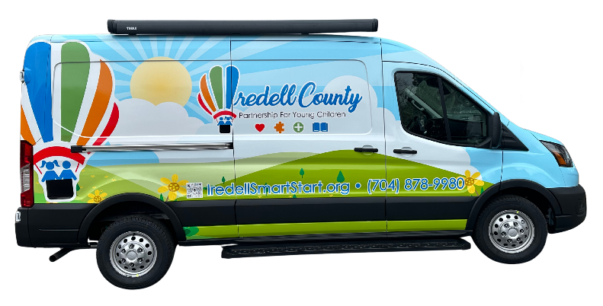
Scan the QR Code to Explore ELRC Resources


www.iredellsmartstart.org/elrc

ELRC Membership Privileges
- Complete access to lending library including resource books, educational toys, children’s books, games, and themed activity collections.
- Complete access to the production area which includes laminators, Ellison die cuts, bookbinding device, Cricut, and photocopier.

Mobile Resource Van Membership Privileges (licensed child care centers ONLY)
- Books and materials that are checked out are due back within 4 (four) weeks.
- Materials from the mobile resource van can be reserved online at www.iredellsmartstart.org/elrc. Check with your Family Support Specialist for the delivery options.
- Please contact the ELRC to renew items when needed. Renewals can be made no more than two (2) times.
- When borrowing materials from the mobile resource van, child care programs can borrow one bin per classroom at a time.
- Items should be returned in clean condition. If items show extensive damage or are lost, a fee will be charged for replacement (No new items may be checked out until damage fees are paid).
- Fees for laminating and/or Cricut usage will be invoiced quarterly.
- For safety reasons, the ELRC production area equipment is restricted to ADULTS only.

Early Learning Resource Center (ELRC) Membership Application
July 2025-June 2026

Families, Individual Early Childhood Professionals, College Students

Name:

Street Address: City: Zip:

Phone Number: Email:

Please select the option that best describes your role:
¨ Early Childhood Teacher/Director ¨ Student ¨ Not Yet Employed in Child Care
¨ Technical Assistant ¨ Parent/Relative/Guardian ¨ Home Visitor or Family Support Staff
¨ Therapist or Other Medical Professional ¨ Other
If you selected “Other,” briefly describe your role. Otherwise, leave blank:

Child: Date of Birth:

Child: Date of Birth:

Child: Date of Birth:

Child: Date of Birth:

I have read and understand the Policies and Procedures for use of the Early Learning Resource Center. ICPYC reserves the right to deny membership to anyone not adhering to the Policies and Procedures.

Signature: ________________________________________________________ Date: __________________
For Office Use Only

Annual Membership Fee Paid: Date: Member #

Access Limitations: Membership List ¨ Tiny Cat ¨



Child Care Centers, Head Start, Preschool Programs, Family Child Care Homes

Facility:
Street Address: City: Zip:
Phone Number: Email:

Authorized Members

Staff Name | Staff Email | Patron Number  (office use only)

I have read and understand the Policies and Procedures for use of the ELRC. ICPYC staff reserves the right to deny membership to anyone not adhering to the Policies and Procedures.

Signature of Center Administrator: ___________________________________ Date: ___________________________
For Office Use Only

Annual Membership Fee Paid: Date: Member #

Access Limitations: Membership List ¨ Tiny Cat ¨

