
Unit Overviews

Science: Living Things
- Life Cycles of Plants and Animals in our Local Area
- Reproduction in Plants
- Life Cycles of Mammals and Amphibians
- Life Cycles of Insects and Birds
- The Work of David Attenborough and Jane Goodall

Geography: Spatial Sense
- East Anglia : Physical Geography
- East Anglia : Land Use
- The Midlands : Settlements
- Yorkshire and Humberside : Physical Geography
- Yorkshire and Humberside : Human Geography

History: The Industrial Revolution
1. The Industrial Revolution
2. Cotton Production
3. Steam Engines and Trains
4. Iron and Coal
5. Children at Work

Numeracy
This term, children will be learning:
Fractions
- Equivalent fractions
- Simplifying fractions
- Comparing and ordering
- Adding and subtracting fractions
- Multiplying and dividing fractions
- Improper and mixed numbers

Topic Web
Class: Year 5/6

Autumn A 2026

General Reminders
- Please ensure your child comes to school dressed in their P.E kit on Mondays and Thursday.
- The spelling test will continue to be on a Friday.
- Homework: Please encourage your child to complete the weekly spelling tasks which will be stuck in their homework books.
- Currently, spelling homework is sent out on a Monday and is expected in the following Monday.

Other Foundation Subjects
Art: African Art
Design and Technology: Next half term
Computing: Spreadsheets
R.E.: Does creativity matter in religious worldviews? (ART)
PSHE: Working Together
PE: Gymnastics/Tag-Rugby

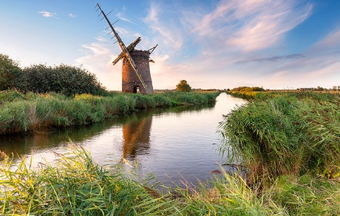
Writing
This half-term we will be using Skellig by David Almond as our focus for writing and will complete the following genres:
- Weeks 1 & 2 Recount: biography
- Weeks 3-6 Balanced argument
- Weeks 7-10 Narrartive: short story
- Weeks 11-12 Character analysis

SPaG focus: Simple, compound and complex sentences; speech punctuation; relative clauses; semi-colons and colons; parenthesis

Reading
- Whole Class Reading: The Boy In the Tower by Polly Ho-Yen

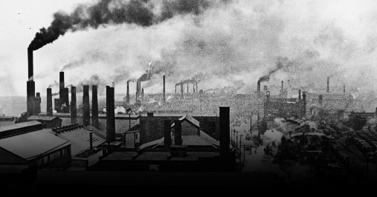
Ideas of ways you can help your child
- Please continue to encourage your child to read regularly.
- Support them with any homework they may receive.
- During the weekend or holidays, you may choose to visit a particularly place of interest which is linked to our learning in History, geography or science.
- Please encourage your child to read at home at least 4 times a week – please sign their reading record which we will check every Friday.

Dear Parent/Carer,
Hello and welcome to a new academic year! I hope you all managed to have a lovely summer!
With your children settling back into school routines, I hope this message finds you and your families happy and healthy and I must say that I have been very impressed with how all of the year 5/6 children have settled in, particularly the new year 5 children who are already showing amazing confidence and a great attitude to learning.
In my role as the year 5/6 class teacher, I am very much looking forward to teaching your children this year. I am also looking forward to continuing the strong and productive partnership with yourselves, as parents to ensure all the children are happy in school and can achieve their highest potential. As a school we recognise that in order to be successful in school, your children need support from both the home and school and we certainly appreciate all the support you give your children each and every day.
If you have any queries do not hesitate to contact me via the school or office or catch me at the end of the school day.
Kind regards,
Mr D. Disney & Mrs Salmons (teaching assistant)

