
Unit Overviews

Science: The Human Body
1. Gestation and Infancy
2. Adolescence and Puberty
3. Slowing Down
4. Growth in Humans and Animals
5. Preparation for Assessment (research and scientific drawing)

Geography: Spatial Sense
1. Maps: dividing the world into sections.
2. Eastern and Western hemispheres
3. Maps: using co-ordinates to locate places.
4. Maps: drawn to different scales.
5. Relief maps

History: Baghdad 900CE
1. The Rise of Islam
2. Baghdad : A City of Peace
3. Baghdad : Building a City
4. Baghdad : A Centre for Learning in the Islamic Golden Age
5. The Mongol attack on Baghdad and the Regional Powers

Numeracy
This term, children will be learning:
- Place Value:
- Numbers to a million
- Comparing and ordering numbers
- Rounding numbers
- Negative numbers
- Roman numerals
- Multiplication, Division, addition and subtraction

Topic Web
Class: Year 5/6

Autumn A 2025

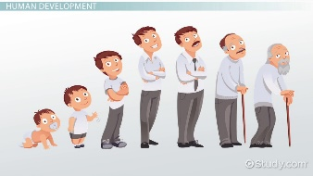
General Reminders
- Please ensure your child comes to school dressed in their P.E kit on Mondays and Thursday.
- The spelling test will continue to be on a Friday.
- Homework: Please encourage your child to complete the weekly spelling tasks which will be stuck in their homework books.
- Currently, spelling homework is sent out on a Monday and is expected in the following Monday.

Other Foundation Subjects
Art: Style in Art
Latin: Minimus 5 Romans and Britons

Design and Technology: Cam Toys
Computing: Vector Drawing/Online bullying and reputation
Music: Lark ascending
R.E.: Does creativity matter in religious worldviews?
PSHE: Beginning and belonging
PE: Football/swimming

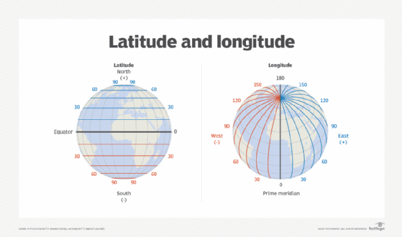

Writing
This half-term we will be using Skellig by David Almond as our focus for writing and will complete the following genres:
- Weeks 1 & 2 Recount: biography
- Weeks 3-6 recount: narrative
- Weeks 7-10 discussion: balanced argument
- Weeks 11-12 History report

SPaG focus: Simple, compound and complex sentences; speech punctuation; relative clauses; bullet points

Reading
- Whole Class Reading: Skellig by David Almond

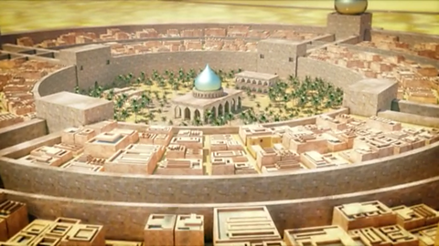
Ideas of ways you can help your child
- Please continue to encourage your child to read regularly.
- Support them with any homework they may receive.
- During the weekend or holidays, you may choose to visit a particularly place of interest which is linked to our learning in History, geography or science.
- Please encourage your child to read at home at least 4 times a week – please sign their reading record which we will check every Friday.

Dear Parent/Carer,
Hello and welcome to a new academic year! I hope you all managed to have a lovely summer!
With your children settling back into school routines, I hope this message finds you and your families happy and healthy and I must say that I have been very impressed with how all of the year 5/6 children have settled in, particularly the new year 5 children who are already showing amazing confidence and a great attitude to learning.
In my role as the year 5/6 class teacher, I am very much looking forward to teaching your children this year. I am also looking forward to continuing the strong and productive partnership with yourselves, as parents to ensure all the children are happy in school and can achieve their highest potential. As a school we recognise that in order to be successful in school, your children need support from both the home and school and we certainly appreciate all the support you give your children each and every day.
If you have any queries do not hesitate to contact me via the school or office or catch me at the end of the school day.
Kind regards,
Mr D. Disney & Mrs Salmons (teaching assistant)

