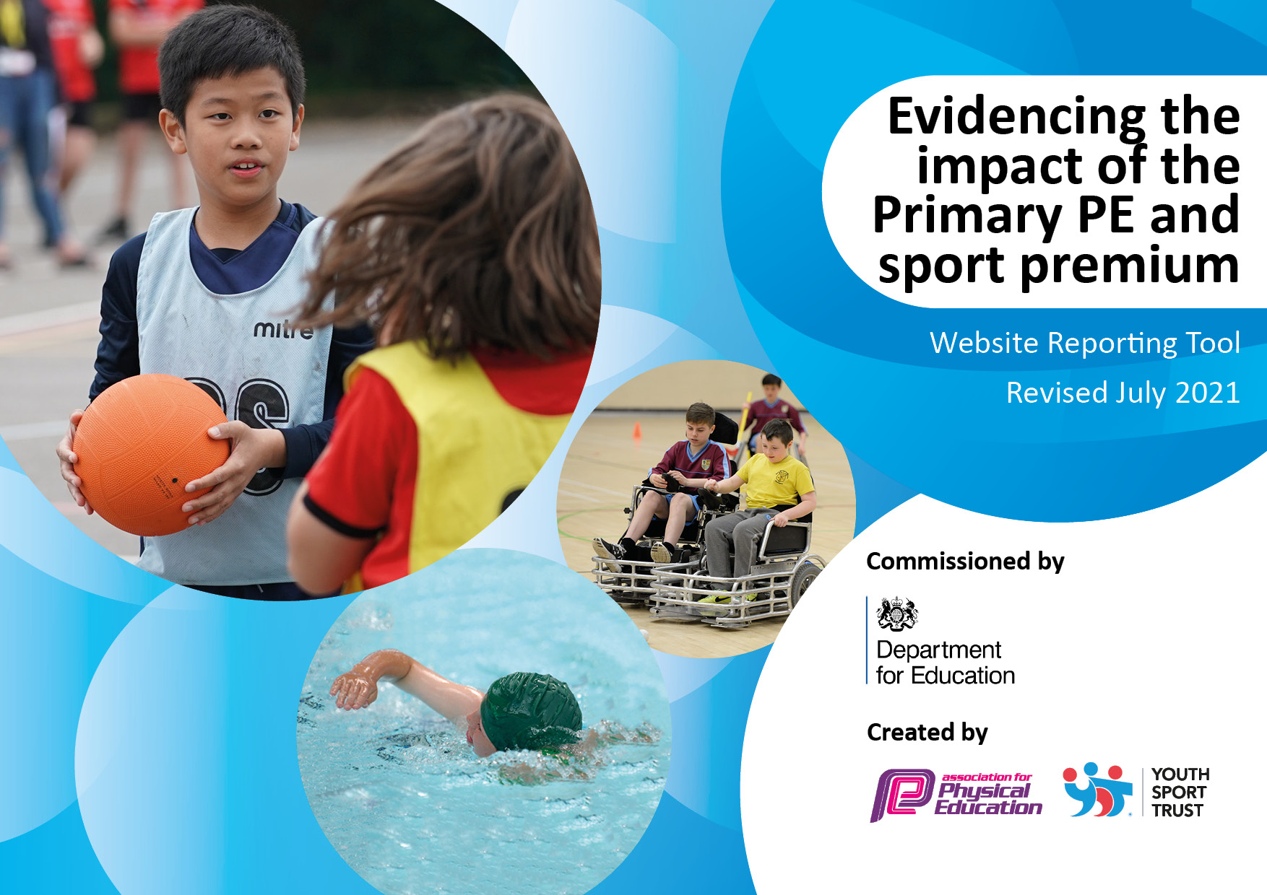

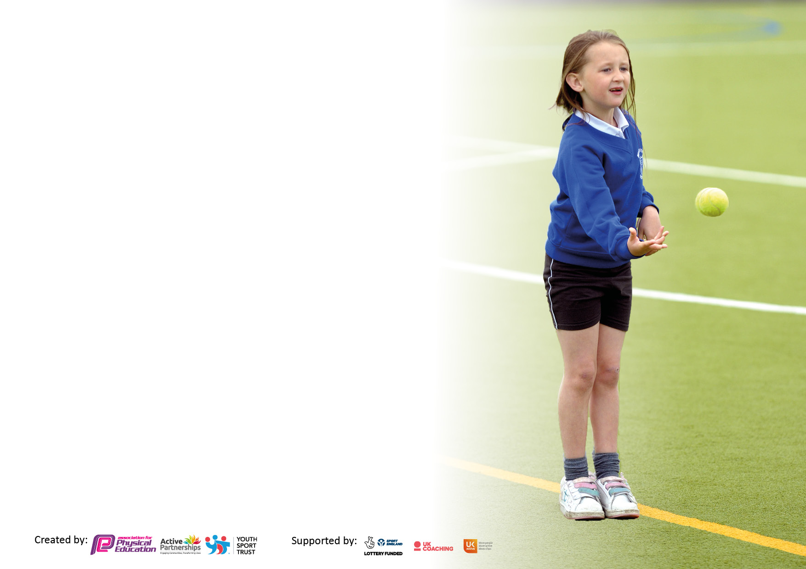

It is important that your grant is used effectively and based on school need. The [Education Inspection Framework](https://assets.publishing.service.gov.uk/government/uploads/system/uploads/attachment_data/file/843108/School_inspection_handbook_-_section_5.pdf) makes clear there will be a focus on **‘whether leaders and those responsible for governors all understand their respective roles and perform these in a way that enhances the effectiveness of the school’**.

Under the [Quality of Education](https://assets.publishing.service.gov.uk/government/uploads/system/uploads/attachment_data/file/843108/School_inspection_handbook_-_section_5.pdf) Ofsted inspectors consider:

**Intent** - Curriculum design, coverage and appropriateness

**Implementation** - Curriculum delivery, Teaching (pedagogy) and Assessment

**Impact** - Attainment and progress

To assist schools with common transferable language this template has been developed to utilise the same three headings which should make your plans easily transferable between working documents.

Schools must use the funding to make **additional and sustainable** improvements to the quality of Physical Education, School Sport and Physical Activity (PESSPA) they offer. This means that you should use the Primary PE and sport premium to:

* Develop or add to the PESSPA activities that your school already offer
* Build capacity and capability within the school to ensure that improvements made now will benefit pupils joining the school in future years
* The Primary PE and sport premium should not be used to fund capital spend projects; the school’s budget should fund these.

Pleasevisit[gov.uk](https://www.gov.uk/guidance/pe-and-sport-premium-for-primary-schools)fortherevisedDfEguidanceincludingthe5keyindicatorsacrosswhichschoolsshoulddemonstrate animprovement.Thisdocumentwillhelpyoutoreviewyourprovisionandtoreportyourspend.DfEencouragesschools to use this template as an effective way of meeting the reporting requirements of the Primary PE and sport premium.

We recommend you start by reflecting on the impact of current provision and reviewing the previous spend.

Schools are required to [publish details](https://www.gov.uk/guidance/what-maintained-schools-must-publish-online#pe-and-sport-premium-for-primary-schools) of how they spend this funding, including any under-spend from 2019/2020, as well as on the impact it has on pupils’ PE and sport participation and attainment. **All funding must be spent by 31st July 2022.**

We recommend regularly updating the table and publishing it on your website throughout the year. This evidences your ongoing self-evaluation of how you are using the funding to secure maximum, sustainable impact. Final copy must be posted on your website by the end of the academic year and no later than the 31st July 2021. To see an example of how to complete the table please click [HERE](http://www.afpe.org.uk/physical-education/wp-content/uploads/afPE-Example-Template-Indicator-2018-Final.pdf).



**Details with regard to funding**

Please complete the table below.

|  |  |
| --- | --- |
| Total amount allocated for 2024/25 | £16800 |
| How much (if any) do you intend to carry over from this total fund into 2021/22? | £0 |
| Total amount allocated for 2025/26 | £16800 |
| Total amount of Sports funding for 2024/25 spent and reported on by 31st July 2025. | £16927 |

**Swimming Data**

Please report on your Swimming Data below.

|  |  |
| --- | --- |
| Meeting national curriculum requirements for swimming and water safety.  N.B. Complete this section to your best ability. For example you might have practised safe self-rescue techniques on dry land which you can then transfer to the pool when school swimming restarts.  **Due to exceptional circumstances priority should be given to ensuring that pupils can perform safe self rescue even if they do not fully meet the first two requirements of the NC programme of study** |  |
| What percentage of your current Year 6 cohort swim competently, confidently and proficiently over a distance of at least 25 metres?  **N.B.** Even though your pupils may swim in another year please report on their attainment on leaving primary school at the end of the summer term 2020.  Please see note above | 100% |
| What percentage of your current Year 6 cohort use a range of strokes effectively [for example, front crawl, backstroke and breaststroke]?  Please see note above | 81.25% |
| **What percentage of your current Year 6 cohort perform safe self-rescue in different water-based situations?** | 81.25% |
| Schools can choose to use the Primary PE and sport premium to provide additional provision for swimming but this must be for activity **over and above** the national curriculum requirements. Have you used it in this way? | No |

**Action Plan and Budget Tracking**

Capture your intended annual spend against the 5 key indicators. Clarify the success criteria and evidence of impact that you intend to measure to evaluate for pupils today and for the future.

|  |  |  |  |  |  |  |  |  |
| --- | --- | --- | --- | --- | --- | --- | --- | --- |
| **Academic Year:** 2021/22 | **Total fund allocated:** | | | **Date Updated:** | | |  | |
| **Key indicator 1:** The engagement of all pupils in regular physical activity – Chief Medical Officers guidelines recommend that primary school pupils undertake at least 30 minutes of physical activity a day in school | | | | | | | Percentage of total allocation: | |
| % | |
| **Intent** | **Implementation** | | | | | **Impact** |  | |
| Your school focus should be clear what you want the pupils to know and be able to do and about  what they need to learn and to  consolidate through practice: | Make sure your actions to achieve are linked to your intentions: | | | Funding allocated: | | Evidence of impact: what do pupils now know and what can they now do? What has changed?: | Sustainability and suggested next steps: | |
| To continue with the wide extra-curricular offer.  All pupils are given the opportunity to learn new games to then carry this over to their own time both in and out of school, while working with peers of different school years.  The children are given access to improve their games skills, helping them to gain confidence and form social connections.  To encourage an active curriculum and be able to have suitable resources to provide instant and effective use of time and lesson transition.  Continue to improve varied provision to provide opportunity to participate and for personal challenge.  Young leaders used to run varied activities at break and lunchtimes. | EXRA CURRICULAR   1. Gymnastics Club – Resources and staff to promote an extra hour of physical activity for all groups including PP, FSM and SEND. 2. Multiskills Club – To provide an alternative inclusive and active school club for year groups from Y3 to year 6, including access for all vulnerable groups. | | | £5780  Total KI 1 = £5780 | | Understand how to read and understand rules and translate those to others and develop as a life skill, listening skills have improved along with team work and tolerance of each other.  26 Pupils engaged including PP, FSM, SEND. Skills have improved to give more confidence to individuals, the ability to perform on stage in front of a full audience.  Pupils play as a whole and support each other this has become embedded as the expected to support and help each other.  Children have become more confident to be active in their outside play area. Staff have also become more confident to let children experiment with significantly less risk of harm.  Activity at break and lunch have become more varied. Ownership of the tasks by the young leaders, more opportunities to be more inventive with games to engage all pupils including the least active. Behaviour continues to be good, inclusive and supportive. | To continue to provide a wide range of curricular activities by:  Further increasing participation where Social skills are embedded in to everyday school life. New games played and rules are passed down through pupils.  Continue links with local external provider.  Children continue to be more confident to be active. Staff are able to encourage a wider range of active activities in this    Continue to train young leaders to support and engage their peers. | |
| **Key indicator 2:** The profile of PESSPA being raised across the school as a tool for whole school improvement | | | | | | | Percentage of total allocation: | |
| % | |
| **Intent** | **Implementation** | | | | | **Impact** |  | |
| Your school focus should be clear what you want the pupils to know and be able to do and about  what they need to learn and to  consolidate through practice: | Make sure your actions to achieve are linked to your intentions: | | | Funding allocated: | | Evidence of impact: what do pupils now know and what can they now do? What has changed?: | Sustainability and suggested next steps: | |
| Sports leader course to give the older children the tools they require to help support and lead physical activity, in lessons, lunch and breaktimes.  To provide a safe and organised environment for pupils to access resources easily, while protecting the equipment for longer life.  Children to be able to take ownership of their break and lunch times and set timed personal challenges.  To make sure equipment is fit for safe use to maximise | 1. Young leaders - Year 5&6 to undertake leader course to support personal individual and team development. Lead activities at break and lunchtime having a positive impact on behaviour and team/peer support. Learn to organise run and take ownership of events such as sports day.   Maintenance of the sports equipment  Purchase of New netball posts  Purchase of new PE Mats  Repairs to EYFS climbing area  PE equipment inspection  Purchase of new PE equipment for multi sport games | | | £300.00  £570  £1615  £1136  £160  £622  KI 2 Total =  £4403 | | Leaders are fully engaged in all areas of school life to help and support others, while developing themselves as young leaders. Creating an inclusive and positive environment as a school culture.  Pupils proud to share their ideas with the rest of the school. While coaching and supporting others.  Pupils develop or enhance their love of the outdoors and learn in an actual farm environment making it a memorable adventure.  Pupils feel proud of their achievements we are able to share our successes.  Children are able to safely partake in all aspects of physical activity and feel safe in their environment. | Skills and behaviours are passed down from year group to year group to maintain the current culture of inclusive, positive active lifestyle. Continue to support and guide the young leaders. Creating independence and choice making.  Continue to have these afternoons, implement themes to them to give focus.  Once installed share with staff and pupils and encourage how it can be used.  Keep providing the provision we do for the whole school. Develop and get back into more external experiences for our pupils.  Continue to provide these opportunities. Outside clubs to come and share their own achievements to inspire.  Continue to maintain to the correct safety standards. | |
| **Key indicator 3:** Increased confidence, knowledge and skills of all staff in teaching PE and sport | | | | | | | | Percentage of total allocation: |
| % |
| **Intent** | | **Implementation** | | | **Impact** | | |  |
| Your school focus should be clear | | Make sure your actions to | Funding | | Evidence of impact: what do | | | Sustainability and suggested |
| what you want the pupils to know | | achieve are linked to your | allocated: | | pupils now know and what | | | next steps: |
| and be able to do and about | | intentions: |  | | can they now do? What has | | |  |
| what they need to learn and to | |  |  | | changed?: | | |  |
| consolidate through practice: | |  |  | |  | | |  |
| Staff able to use as a learning tool across the curriculum.  Provides a consistent and progressive curriculum which is accessible and continuous. A platform to see pupil attainment and progression.  Staff able to work alongside other coaches to develop skills and confidence.  To gain knowledge and upto date information with regards to PE, sport and physical wellbeing. | | Introduction of Get set 4 PE use of PE platform – This has helped staff be more confident and to provide further training through teacher meetings.  Use of coaches to support staff confidence with implementing and using the new platform  PE lead has coordinated new PE curriculum across school using Get Set 4 PE resources | £656  £300  £689  Total: £1645 | | Pupils are engaging in lessons throughout the curriculum whatever their ability, also using the trail at break and lunchtimes for their own games.  Accurate log and assessment to identify next steps and gaps a tool available to all staff to access where everyone is and progression and participation. Logs to ensure all pupils are given opportunity.  More evidence gathered for assessment.  Staff gaining skills to be able to transfer to their own practice.  All children learn and improve their skills through consistently high quality PE | | | Continue the use of Get set 4 PE platform. New staff to be trained and refresher staff training.  Continue use of this ict platform and develop the links to the for evidence.  Staff more confident to deliver sessions and support pupils. Staff to attend sessions to continue further development.  Look in to some of the areas from the conference to be able to further develop whole school physical wellbeing.  Implement in school and feed back to other staff and pupils the differences from HI5. |
| **Key indicator 4:** Broader experience of a range of sports and activities offered to all pupils | | | | | | | | Percentage of total allocation: |
|  |
| **Intent** | | **Implementation** | | | **Impact** | | |  |
| Your school focus should be clear | | Make sure your actions to | Funding | | Evidence of impact: what do | | | Sustainability and suggested |
| what you want the pupils to know | | achieve are linked to your | allocated: | | pupils now know and what | | | next steps: |
| and be able to do and about | | intentions: |  | | can they now do? What has | | |  |
| what they need to learn and to | |  |  | | changed?: | | |  |
| consolidate through practice: | |  |  | |  | | |  |
| To provide opportunity for every child whatever their ability to a range of different and varied sports.  To encourage whole school physical activity throughout the school day, and provide opportunities for learning life skills.  .  Provide exposure to a different sport to encourage the less active and build confidence.  For young leaders to provide a varied form of exercise at break and lunchtimes.  For engaging children at a younger age to encourage physical exercise as a lifestyle choice while developing individual skills and confidence.  Encourage teamwork and support for one another, celebrate achievements. | | Witchford SSP Membership  Hilltop Residential trip – To give all pupils including vulnerable groups experiences of a variety of physical activities. Promoting physical and mental wellbeing, enjoyment of a variety of sports, exposure to new challenges.  Opportunities to try out different sports  Lunchtime activity clubs aimed at KS1 and KS2 | £ 100  £371 Bowling trip Y6  £2640  KI 4 Total: £3111 | | To access a variety of external provision and give experiences to our children.  All pupils have had the opportunity to experience a variety of sports. Pupils have brought these games back to the playground.  Pupils have become more active through the school day. Life skills such as navigation, teamwork and patience have developed.  Children inspired, showing perseverance and commitment to achieve. While supporting each other.  Less active pupils felt comfortable and gained confidence, all children enjoyed the challenges.  Result of pupil voice pupils have become more active at break and lunchtimes, an inclusive activity for all ages.  Without the transport we would not be able to access the event and give the experiences to our children, so transport is a vital cost to be able to access external events as a very rural school.  Children have become more active. Young leaders ran the sports day, organised the events, supported the younger children, did the scoring and gave out prizes developing and encouraging a whole school fun and supportive event. | | | Continue to forge links with SSP to enhance our provision.  To keep providing these links and work with Witchford to support all our children being active.  Continue to ask pupil voice to support any other ideas they may want to try.  Pupil voice to add to the experience.  .  Continue to support young leaders in organising sports day and other events. |
| **Key indicator 5:** Increased participation in competitive sport | | | | | | | |  |
| **Intent** | | **Implementation** | | | **Impact** | | |  |
| Your school focus should be clear | | Make sure your actions to | Funding | | Evidence of impact: what do | | | Sustainability and suggested |
| what you want the pupils to know | | achieve are linked to your | allocated: | | pupils now know and what | | | next steps: |
| and be able to do and about | | intentions: |  | | can they now do? What has | | |  |
| what they need to learn and to | |  |  | | changed?: | | |  |
| consolidate through practice: | |  |  | |  | | |  |
| Pupils encouraged to reach a goal as a team.  Organised and lead by Young leaders to develop skills. Also to encourage the understanding of rules and boundaries, Teamwork and sportsmanship.  To engage in competitive sport and understand the ned to train to reach full potential. | | Membership & registration to competitions  Active travel to attend competitions  Additional staffing costs to attend competitions | £240  £1248  £500  KI £1988 | | Increase in social skills and acceptance of others choices, decisions and differences.  Children develop sportsmanship and understand values helping them to be supportive in all areas of school life. Giving them an understanding of why we follow rules and manage feelings weather they win or lose.  Children show support for one another, get a scenes of achievement, and keenness to better themselves. | | | Develop opportunities for personal challenge.  Provide more opportunity for in school events.  Provide more pre event focused sessions. |
|  | |  | Total Spend  £16927 | |  | | |  |

|  |  |
| --- | --- |
| Signed off by | |
| Head Teacher: | S L Durrant |
| Date: | 17/07/2025 |
| Subject Leader: | S Durrant |
| Date: | 08/07/2025 |
| Governor: | Chika Akinwale |
| Date: | 08/07/2025 |