Holgate Community Church
“Making new disciples of Jesus Christ for the transformation of the world”
April 2026/May 2026
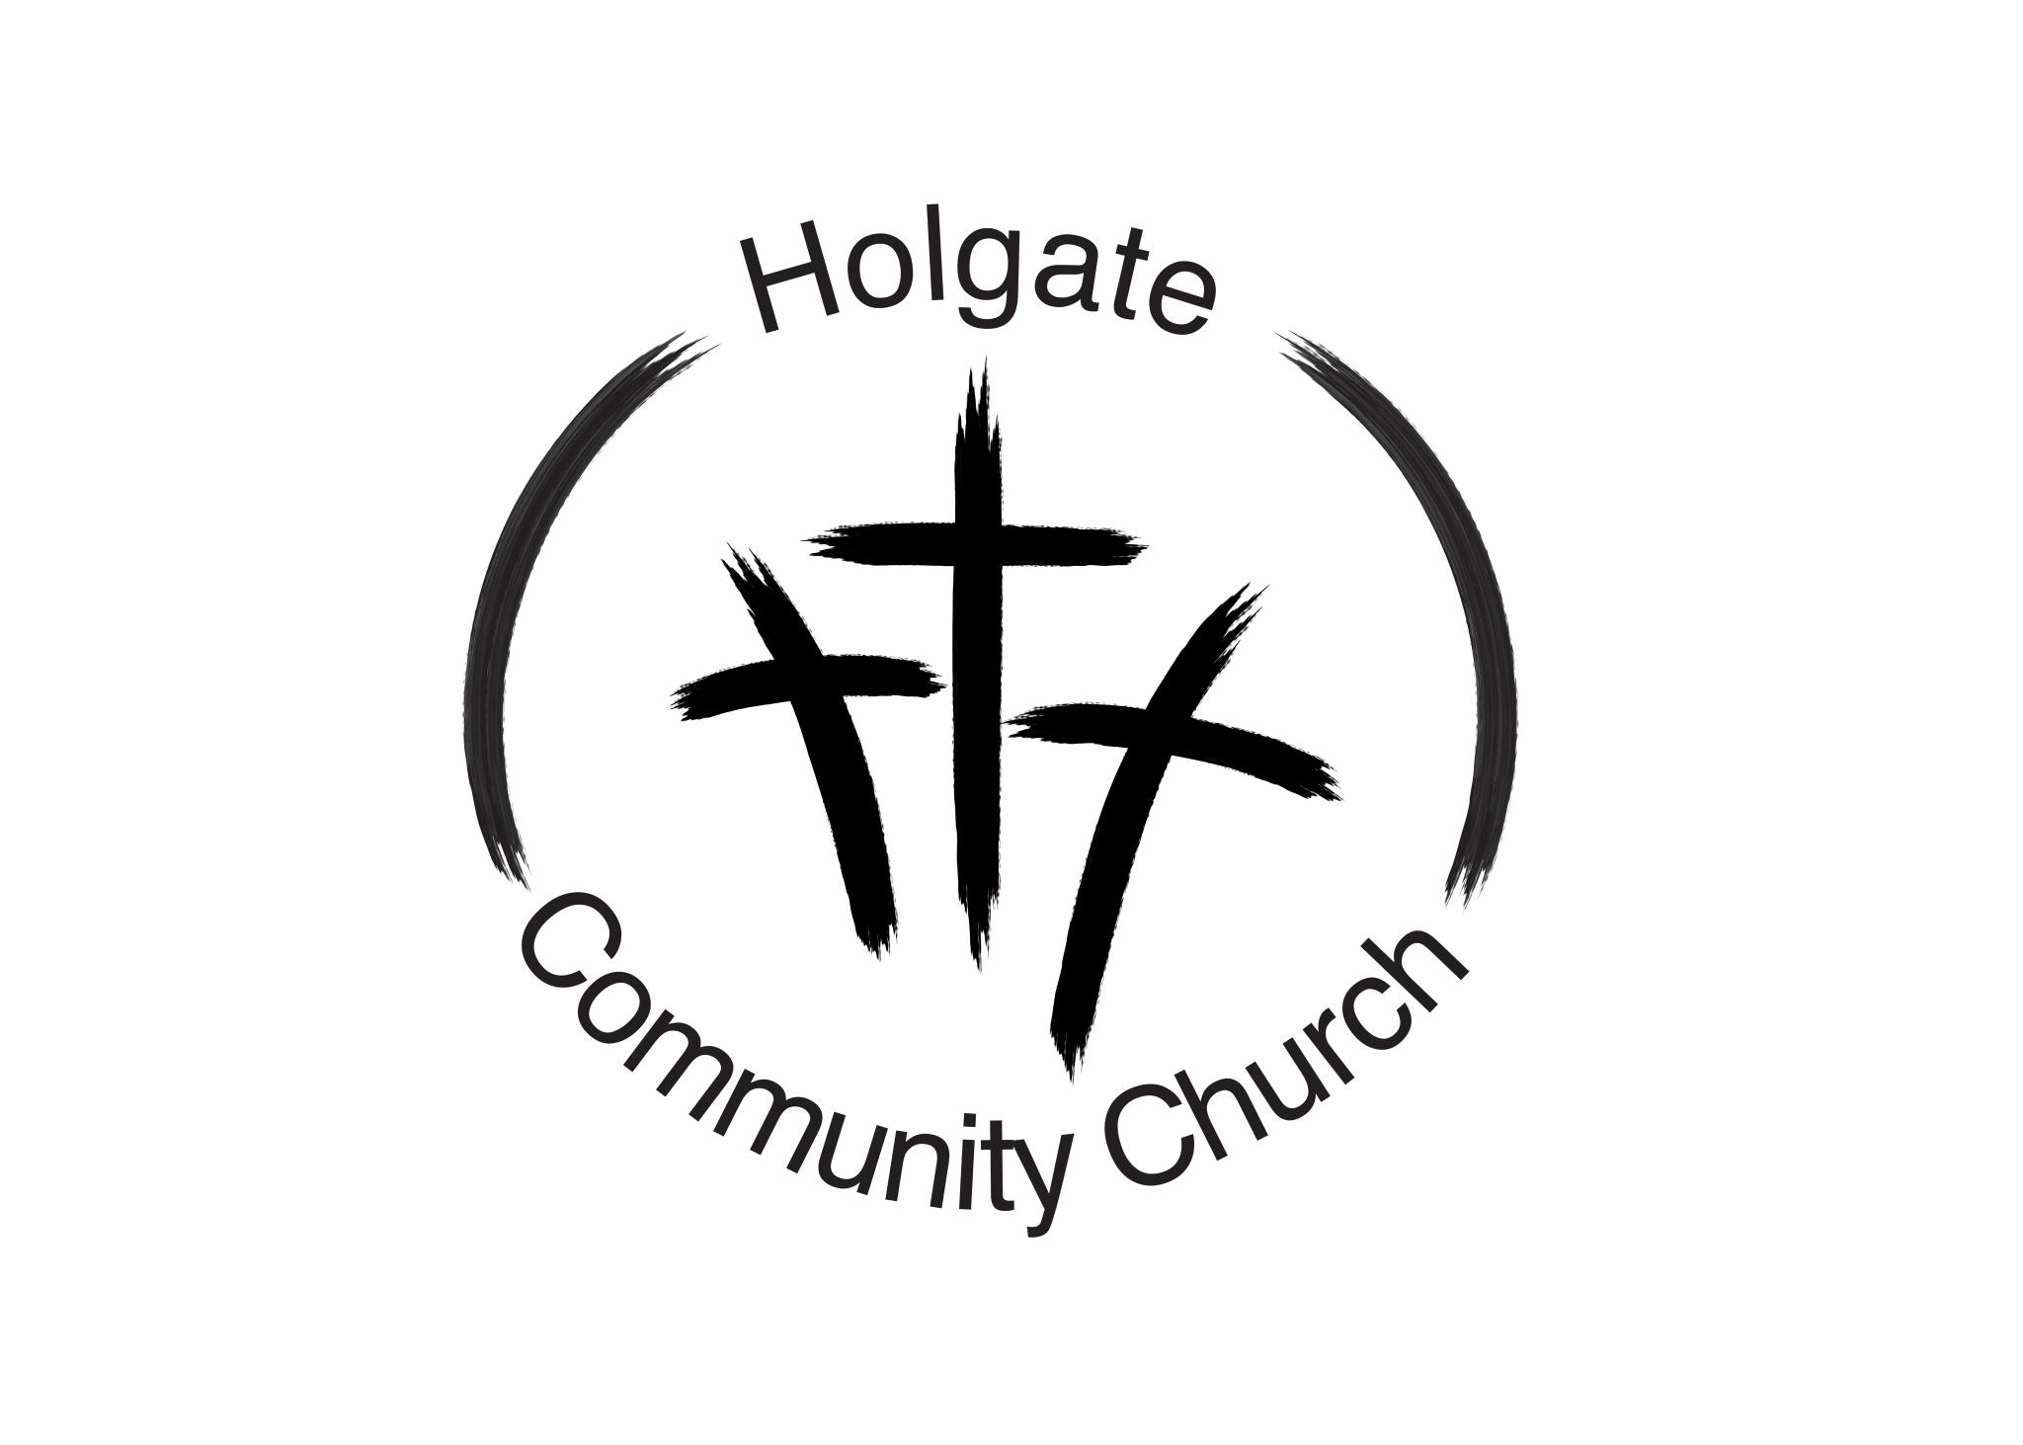
Message from the Pastors:
The largest set of garage doors in the world belong to the NASA Vehicle Assembly Building on the campus of the Kennedy Space Center in Cape Canaveral, Florida. The doors are higher and broader than Niagara Falls, and they take a full 45 minutes to completely open or close them. This is the home of multiple space vehicles, where Saturn V and the Space Shuttles have been assembled and stacked. The immense nature of the doors protect some immense space travel vehicles. But believe it or not, that is not the most impressive set of doors in our history. For the ancient doors of the Jewish temple were intimidating as well. Creating division of the women from the men, division of humans from their God. Located at the innermost part of the temple was the most holy place, the chamber which held the Ark of the Covenant. The place where God would convene with man. This chamber had limited access; it was where only a priest could enter, and that occurred only once a year. Serving as the door of that most holy place was a veil. Not a lacy, delicate piece of fabric. This veil measured seventy feet wide, thirty feet high, and was four inches thick! It was an unmistakable, impenetrable separation between humans and God. Then Jesus came. He worked, He taught, He served, He healed. He was a threat to the status quo and for the elite of that temple who had gamed religion for their profit. He had to be stopped, and they had a way to wrap it all up in a nice tidy package. Get one of His own to turn on Him, then set up the Romans to be executioner. And on a Friday afternoon, the Son of God was crucified and died. What followed after that was the stuff of action movies. The sky turned dark. The earth shook. Thunder rolled. Graves popped open and many of the dead were alive again. But perhaps most symbolic, the veil in the temple separating the most holy place from the people would separate no more. The Scriptures tell us that it was torn in half, from top to bottom. God was now accessible to man. The writer of Hebrews states it best. In Hebrew 10:20, it is written that ‘just as the veil was torn in two, the body of Jesus was torn for us’. With His death and resurrection, a new way was made for us. A new forgiveness was given to us. A new door was opened for us. Sin would not separate us from God any longer for our sins were covered by Christ’s blood on the cross. He opens the door of His throne room and invites us to come boldly to Him. No veil to dodge. No rocket ship needed to blast us to heaven. We simply go in the door opened by Him who said, ‘I am the door.’
Happy Easter to us all! He is risen indeed!!!
Pastor Diane and Pastor Shawn
Joy and Hope Youth Group

The Youth have been venturing through the life of Moses, and are talking 10 commandments right now. We are mapping out the journey of the Exodus as we go along.
We have only one graduate this year. Holden Hartman will be graduating from Holgate High School on May 24th. As we all are aware, Holden has already completed his basic training for the Ohio Army National Guard. Following graduation, he will be returning to Fort Leonard Wood and will be stationed in Missouri. He plans to specialize in combat engineering. Holden, we have already been praying for you, and we will continue to do so. We are so proud of you!!!

BREAKTHROUGH PRAYER:

Scripture Verse: Psalm 8:3

‘When I consider Your heavens, the work of Your fingers, the moon and the stars, which You have set in place, what is mankind that You are mindful of them, human beings that You care for them?’

Prayer:

You have made us for Yourself, to know Your goodness and display Your glory. May this truth be established deep in our hearts. Help us to desire to know You in such a way that every day will be a new discovery of who You are and how Your sovereignty works in our lives. We give You all praise. Amen.

PRAYER CONCERNS
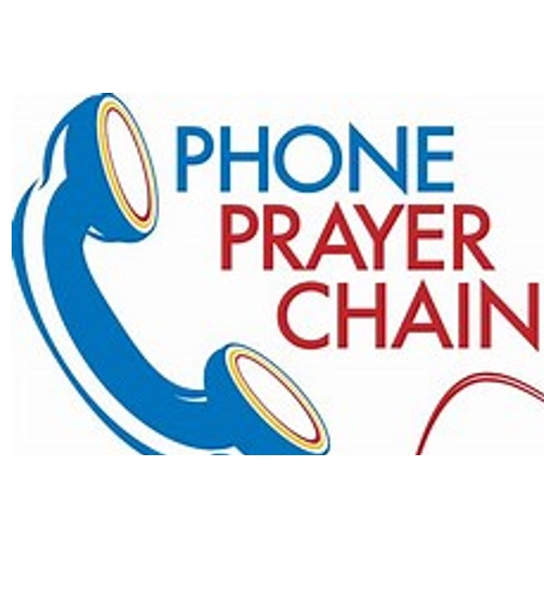
As a reminder, if you have a prayer request that you would like shared with the Prayer Chain, please contact either:
Pastor Shawn: 313-999-2653 Pastor Diane: 419-438-0685

Stay in touch ONLINE and through our SOCIAL MEDIA CHANNELS:
Facebook, Instagram
Website: holgatecommunitychurch.org
Email: hcc@holgatecommunitychurch.org
YouTube Channel: Search Holgate Community Church

LifeWise

LifeWise is coming to an end for this 2025-2026 school year in a few weeks. We are talking about Easter, about the love we have from God through the death and resurrection of our Savior, Jesus. The Kindergarten, third grade and fifth grade students will receive their own Bibles to take home. If you would like to help with paying for these Bibles let me know or you can write a check to: Holgate LifeWise and in memo write Bibles. We love being able to send home Bibles to the students but can only do that through donations. April 11, we will be taking 14 fifth grade students and 2 High School students to the Ark Encounter and they are very excited. It will be a great visual for them to see the Ark size and methods used to sustain those on the Ark. God had everything planned to save His people and other creatures. We are able to do this due to the kindness and generosity of people like you! Blessings to you all. We thank you for your prayers, donations and continued support for the Holgate LifeWise program.
Please continue to pray for all the LifeWise programs, Staff and Students. On Sunday, May 3rd, we plan on having a Potato Bar Fundraiser to help raise funds for our program. It will be from 4pm-6pm at our church. This will be a freewill donation and we will have more information coming. Save the date, bring a friend or two or three. Thank you.

Missions

Sunday, April 5th to Sunday, May 3rd, we will be taking monetary donations for Holgate’s Graduating Seniors. We will use the money to get them gift certificates as well as other meaningful gifts and sweet treats. There will be envelopes placed by the offering plates that you can put a donation in and then place in the offering plate. We have been doing this since 2020 and it is such a joy to be able to give them a gift, pray with them and get to talk with them. Thank you.
Update on Serving Opportunities
We still have the following areas open as opportunities for serving within our church:
- Song leader/Praise Leader
- Children’s Sunday School teacher
- Camera operator
- AudioVisual creator/presenter
- Any new ministry opportunity you can think of!! Serving in the church is the greatest gift we can give to others and give to ourselves. Let us know what you would like to do!
Holgate Community Church - What’s Next??

As spring comes around again, we hope to continue more projects at Holgate Community Church. But first, an update on some completed projects:
- Our Emergency Care area is now complete. Our AED is on the wall in the vestibule, along with our bleeding control resources and a Narcan kit. All of this is to the left of the door as you enter the building, and it is all centered near the fire extinguisher. Any imaginable emergency within the building should direct us to the supplies on that wall.
- We have also completed our second craft night. Many thanks to Grace Byram for the inspiration and motivation to prepare for these evenings and host the events. Our ‘crafty’ members have been quite pleased with the projects they have created and we have had great turnout for the events.

Additionally, we want to update you on the plans for the addition to the front of the Church. We have received more enhanced sketches of the proposed addition, with more detail added. These have been reviewed by the Leadership team, but we are now waiting on the architect to obtain some bids from contractors. We are working off of the preferred plans as directed by our members. We will maintain transparency as we continue to move ahead with the project.
We encourage all members to come forward with any ideas for service projects, ministries, or other ways we can serve our community as a church who is an extension of Christ. We must reach beyond our walls, we must reach beyond our campus, to be the hands and feet of God. Sometimes an inkling or an intuition becomes a new ministry, so let us know!
Worship Plans for April

Date | Pastor | Message
5 | Diane Simon | ‘And the Veil was Torn’
12 | Shawn Moore
19 | Shawn Moore
26 | Diane Simon | ‘Out of Focus (Part i): Where Are Our Eyes?’

April Worship Leaders

APR | PASTOR | LITURGIST | ACOLYTE | CAMERA | AUDIO/VISUAL | TRANSPORTATION
5 | Diane Simon | Kevin Simon | Hudson Hartman | Gabe Moore | Nikki Hastings | Chris Kelly and Deb Wagner
12 | Shawn Moore | John Fritz | Haizel Hartman | Levi Zachrich | Stephanie Zachrich | Barb Fritz and Kevin Simon
19 | Shawn Moore | Levi Zachrich | Jack Hastings | Nikki Hastings | Stephanie Zachrich | Chris Kelly and Deb Wagner
26 | Diane Simon | Nikki Hastings | Hollis Hartman | Gabe Moore | Stephanie Zachrich | Barb Fritz and Kevin Simon

Worship Plans for May

Date | Pastor | Message
3 | Diane Simon | ‘Out of Focus (Part II): ‘Who Are We Working For?’
10 | Shawn Moore
17 | Shawn Moore
24 | Diane Simon | “The Greatest Sacrifice’
31 | Diane Simon | ‘A Closer Walk with Jesus’

May Worship Leaders

MAY | PASTOR | LITURGIST | ACOLYTE | CAMERA | AUDIO/VISUAL | TRANSPORTATION
3 | Diane Simon | Barb Fritz | Hudson Hartman | Gabe Moore | Nikki Hastings | Chris Kelly and Deb Wagner
10 | Shawn Moore | Chris Kelly | Haizel Hartman | Levi Zachrich | Nikki Hastings | Barb Fritz and Kevin Simon
17 | Shawn Moore | John Fritz | Jack Hastings | Gabe Moore | Stephanie Zachrich | Chris Kelly and Deb Wagner
24 | Diane Simon | Deb Wagner | Hollis Hartman | Levi Zachrich | Stephanie Zachrich | Barb Fritz and Kevin Simon
31 | Diane Simon | Kevin Simon | Hudson Hartman | Levi Zachrich | Nikki Hastings | Chris Kelly and Deb Wagner

April Events
Birthdays
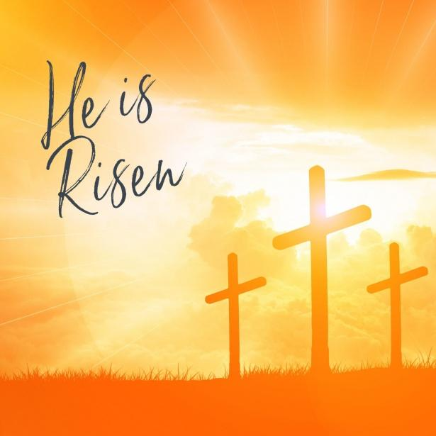
1 Meredith Bowers
5 Jo Ordway
Emberli Byram
8 Lindsey Hartman
11 Carmen Knipp
13 Stephanie Zachrich
15 Pat Cooper
17 Corey Tobias
22 Adam Byram
27 Cole Baker
29 Emma Bowers
30 Aaron Simon
Brian Baker

Anniversaries

23 Pat & Deb Ehlers

Events

5 Easter Sunday
8 Leadership Meeting-7pm
8 Together We Can Make A Difference-6pm-7pm
22 Together We Can Make A Difference-6pm-7pm

May Events
Birthdays

1 Jackson Hastings
5 Kim VonDeylen
Michael Kern
7 Mary Evans
10 Harlene Stober
14 Barb Fritz
15 Kayden Wellman
17 Gabe Moore
19 Diane Simon
23 Michelle Dopp
29 Grace Byram
30 Nickie Cole

Anniversaries

6 Jamey & Gina Wellman
18 Jim & Deb Burkhart

Events

10 Mother’s Day
13 Leadership Meeting-7pm
13 Together We Can Make A Difference-6pm-7pm
27 Together We Can Make A Difference-6pm-7pm

Holgate Community Church
677 Joe E. Brown Ave.
Holgate, Ohio 43527

