Community Participation Coordinator
Job Pack

Closing Date Sunday 19th July
Interviews Thursday 23rd July
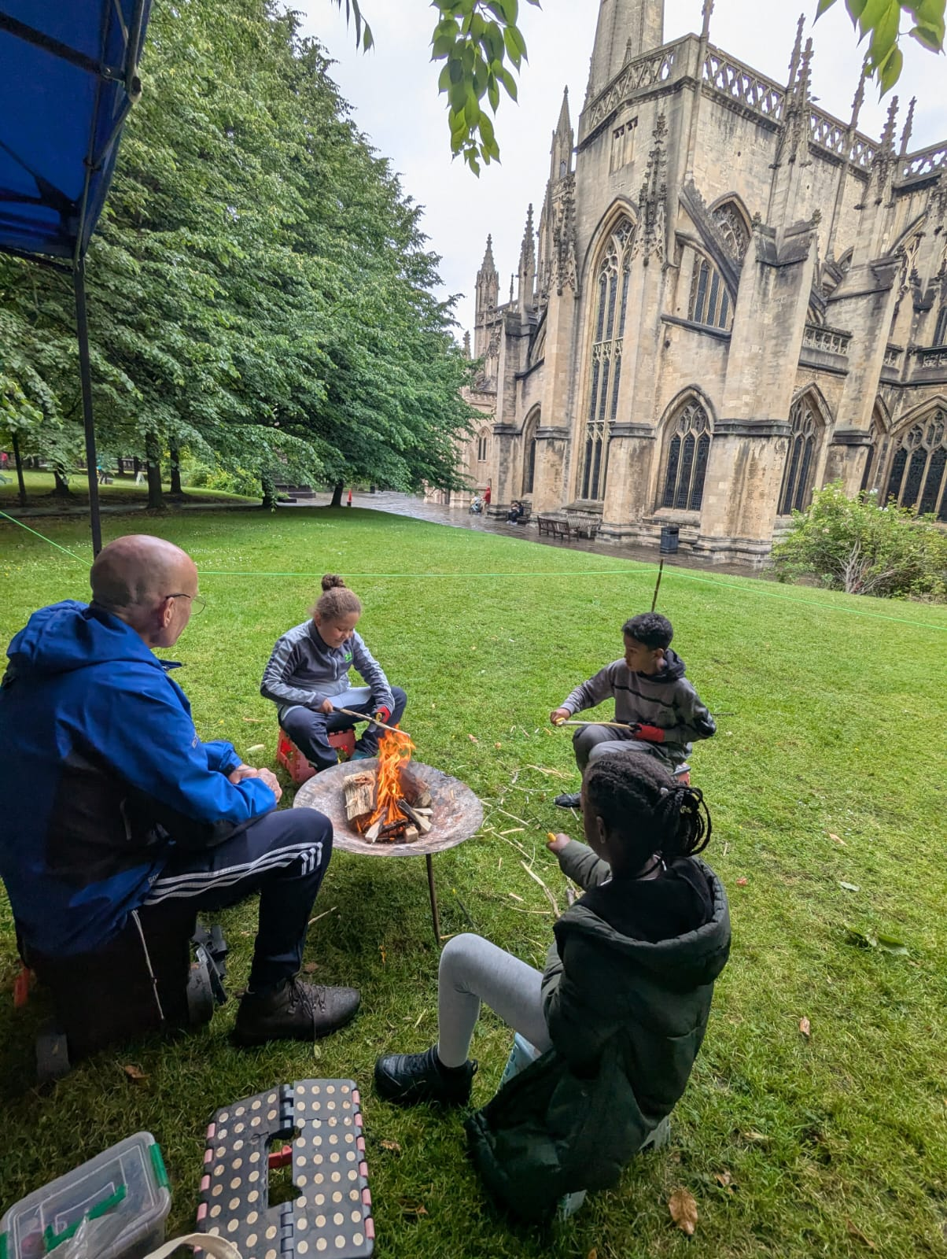

INTRODUCTION AND CONTEXT
St Mary Redcliffe PCC (SMR) has a long-standing and trusted presence in Redcliffe and across the city. The church aims to be a good neighbour to the people in this parish regardless of their age, gender, race and religion. One of our four strategic objectives is to make a positive difference within the parish by working alongside residents to strengthen community life. Our approach is rooted in asset-based community development, identifying and building on the many strengths within our neighbourhood so that local people can take the lead in creating positive change where they live.
Over the past three years, SMR has intentionally invested in building the foundations for an independent, community-led organisation to take forward this work. Through sustained community engagement we have supported the development of Redcliffe Community Voice, a group of around 15 local people now forming a new organisation to lead community development activity in the area. Together they have developed a clear theory of change and a five-year vision to ensure Redcliffe is a vibrant and welcoming place where people feel proud to live, connected to others with a strong sense of community, confident that their voices matter, and that they are valued and included.
St. Mary Redcliffe PCC is the responsible organisation for the National Lottery Community Fund grant, and the employer for new and existing posts. Over a period of three years, with the agreement and support of the Church, it is the intention that Redcliffe Community Voice becomes fully independent with the systems and processes in place to be the recognised community anchor organisation for Redcliffe.
This is an exciting time to join the community team, as we continue to grow our work in Redcliffe, always building on strengths and interests in the community. Everything we do is designed to:
- Maintain consistent, visible presence across Redcliffe.
- Build trust and participation.
- Inspire others and provide visible community role models from different backgrounds.
- Develop resident leadership capacity.
- Ensure engagement is geographically balanced across the estate.
- Provide practical routes into volunteering, employment, leadership and governance.

We are building the community team to include a Community Participation Co-ordinator and Community Welcomer, working alongside our existing Youth Worker and Community Development Worker.

Our neighbourhood
Redcliffe is a diverse inner-city community with a strong sense of identity and significant community strengths, but it also faces challenges including high levels of poverty, social isolation, overcrowded housing, and barriers linked to race and migration. The Redcliffe housing estate is home to around 2,000 residents living primarily in high-rise flats, with a large proportion of children and families, and a richly multicultural population. Many residents experience financial hardship, loneliness, insecure housing, or limited access to opportunities and services.
At the heart of the neighbourhood is the Redcliffe Community Hub, a trusted and welcoming space where people can access support, build relationships, and participate in community life without formal barriers. Through drop-in sessions, outreach work, resident-led activities, and partnerships with local organisations, we work alongside people from a wide range of backgrounds, including families, people living alone, older people, young people and asylum seekers.
Our approach is rooted in community development: building trust, strengthening connections, nurturing local leadership, and creating opportunities for residents to shape the future of their neighbourhood. The Community Participation Co-ordinator will play an important role in this work, helping people feel valued, included, and connected to their wider community, while helping to broaden community representation in volunteering, leadership and governance roles.
TERMS AND CONDITIONS

Title Community Participation Co-ordinator
Hours per week 18.75 hours per week
Salary £26,500 pro rata
Post Permanent (following a 3-month probationary period)
Pension Employer Contribution of 8%
Employer St Mary Redcliffe Parochial Church Council
Annual Leave 25 days plus bank holidays, pro-rated
Other benefits Tea & Coffee provided

Any offer of employment will also be subject to an enhanced Disclosure and Barring Service check and ongoing Safeguarding training will be a requirement.

PURPOSE
The Community Participation Co-ordinator is a new role, funded by a grant from the National Lottery Community Fund. Working across the community and youth team, alongside a Community Welcomer, Youth Worker and Community Development Worker, you will lead the recruitment, support and development of volunteers to create a sustainable leadership pipeline and broaden community representation in volunteering, leadership and governance.
Volunteers play a vital role in building strong communities and creating opportunities for people to contribute their skills, experience and ideas. The Community Participation Co-ordinator will develop an inclusive and supportive volunteering programme that reflects the diversity of Redcliffe, helping people gain confidence, build relationships and play an active role in shaping their community.
The Community Participation Co-ordinator will develop the systems, processes and support needed to ensure volunteers are recruited, supported and valued across the organisation and wider community. Working alongside staff who directly support volunteers, the role will promote best practice in volunteer management, strengthen volunteer involvement, and create pathways into leadership and community participation.
As a new role, there will be opportunities to shape the future direction of community participation and volunteering across the newly emerging Redcliffe Community Voice. The role will ensure that community volunteering provides meaningful routes into employment, democratic participation, leadership and community action.

REPORTING STRUCTURE

Reports to the Director of Youth and Community

LINE MANAGEMENT RESPONSIBILITIES

None

KEY RESPONSIBILITIES

Support Volunteer Management
- Work alongside the Community Development Worker, new Community Welcomer and Youth Worker to ensure that Redcliffe Community Hub can operate with the support of a team of well-supported and competent volunteers.
- Ensure that staff managing volunteers understand and use national best practice in volunteer management.
- Ensure that there are practical routes into volunteering for people using our services or attending our groups.
- Increase volunteer-led facilitation of activities.

Recruit volunteers
- Recruit volunteers from across Redcliffe bringing together existing residents, asylum seekers, businesses, sixth formers and church volunteers.
- Ensure that relevant volunteer opportunities are advertised on citywide platforms (such as Voscur, universities, Can Do Bristol and Neighbourly).
- Develop partnerships with businesses, universities and public sector partners to encourage volunteering.
- Create an effective and appropriate onboarding process for volunteers including recruitment pack and induction pack.

Develop Volunteers and Support Wider Participation
- Deliver quarterly volunteer development sessions combining training (safeguarding, boundaries, signposting) and peer support.
- Develop training plans for volunteers to support their development inside and outside the organisation.
- Establish supervision and support structures for volunteers.
- Identify emerging leaders and develop pathways for volunteers to move into leadership and governance roles.
- Organise quarterly volunteer social events to strengthen relationships across different groups.
- Use an Asset-Based Community Development (ABCD) approach to working with volunteers, always looking to build on individual strengths and skills.

Relationship Management
- Develop good relationships within the local community.
- Promote community cohesion by creating volunteering opportunities that bring together people from different backgrounds and experiences.
- Work closely with other volunteer co-ordinators locally and nationally.
- Represent the work of SMR positively, acting as an advocate and representative for SMR at community level, and attending appropriate meetings and forums as required.

PERSON SPECIFICATION
COMMUNITY PARTICIPATION CO-ORDINATOR

Category | Quality | Essential or Desirable
Knowledge and Experience | Awareness of Asset-Based Community Development (ABCD) and understanding of community development practice and theory. | Desirable
Knowledge and Experience | Knowledge of best practice in volunteer management | Essential
Knowledge and Experience | Experience of working with volunteers, community groups, or community-led activity | Essential
Knowledge and Experience | Experience of establishing partnerships with organisations from different sectors | Essential
Knowledge and Experience | Able to effectively manage diversity and proactively challenge discrimination | Essential
Knowledge and Experience | Experience of managing volunteers | Desirable
Skills and Abilities | Excellent communication skills (written and spoken) | Essential
Skills and Abilities | Excellent people skills and ability to engage with a wide range of people, including community members, professionals and outside agencies | Essential
Skills and Abilities | Excellent organisational skills with the ability to prioritise and organise conflicting work tasks within specific timescales | Essential
Skills and Abilities | Ability to establish and manage effective systems and processes | Essential
Skills and Abilities | Ability to use Microsoft Office applications and learn how to use our database software (Charity Log) | Essential
Other qualities | Motivation and reflective skills to engage in continuous professional development | Essential
Other qualities | Positive attitude towards work and colleagues, with strong team- working skills | Essential
Other qualities | Be comfortable working on behalf of St Mary Redcliffe Church in the community. | Essential
Other qualities | Understanding of diverse backgrounds and the impact of disadvantage, with the ability to create an inclusive and welcoming environment for everyone. | Essential

How to Apply
Applicants are invited to submit their CV and a covering letter outlining their experience of the key responsibilities and fit to the person specification contained in the recruitment pack.

Applications must be emailed back to jobs@stmaryredcliffe.co.uk no later than 19 July 2026, or received by post at the Parish Office, 12 Colston Parade, Bristol BS1 6RA by that date. Please contact David Cousins, Director of Youth & Communities on 07928249523 or at david.cousins@stmaryredcliffe.co.uk if you would like to have an informal conversation about the role.

Selection
We shall be interviewing and assessing candidates on Thurs 23 July 2026. Candidates will be informed by Tuesday 21 July if they have been selected for interview.

Safeguarding
SMR’s Safer Recruitment process can be found within the Safeguarding policy on the church website. As part of our recruitment process, anyone to whom an offer of employment is made will be required to complete a Confidential Declaration Form. This form is strictly confidential and, except under compulsion of law, will be seen only by those involved in the recruitment/appointment process and, when appropriate, the nominated safeguarding lead or someone acting in a similar role/position. All forms will be kept securely in compliance with the General Data Protection Regulation within the Data Protection Act 2018. Any offer of employment will also be subject to a basic Disclosure and Barring Service check.


St Mary Redcliffe Church
www.stmaryredcliffe.co.uk
jobs@stmaryredcliffe.co.uk

