RECREATIONAL SOCCER COACHING MANUAL

PLAYER DEVELOPMENT FOCUS

Developmental focus is based on age level. Developmentally appropriate practice sessions should be geared to the cognitive, emotional, and physical needs based on individual and team strengths and weakness. Coaches should consider the cognitive development, psychomotor development, psychosocial development of the players along with the individual’s previous experiences, learning curve and styles and current performance level. There should be an emphasis on the enjoyment of play over an emphasis of winning. As coaches, we must find a way to protect the setting in which youth players enjoy the game. This includes positive environment, feedback and should include parent education.

THE FOUR FOCUSES OF DEVELOPMENT

Technical

This includes content regarding the game of soccer including skill development, mastery of ball skills and techniques.

- Passing
- Dribbling
- Turning while Dribbling
- Dodges, Fakes and Feints
- Kicking
- Throw-Ins
- Ball Control (Touch)
- Heading (U13 and older – not for Rec. League)
- 1v1 Attacking
- Shielding the Ball
- Receiving to Turn
- Crossing and Finishing
- 1v1 Defending
- Tackling

Tactical

Tactical Aspects of the game to develop include game play, attacking and defending along with movement with and without the ball.

Attacking Principles

  - Penetration
  - Support
  - Mobility off the ball
  - Use of Field Width
  - Improvisation
  - 1 v 1 Attacking

Defense Principles

  - 1 v 1 Defense
    - Shut down, slow down
    - Block/Poke Tackle
    - Prevent to Turn
  - Pressure the Offense
  - Delay the Offense
  - Attack Coverage
  - Balance of Defense on the Field
  - Compact the Offense

Physical

Physical development incorporates physical movement skills including agility, balance, coordination, and speed. As players get older, the physical challenges should increase accordingly.

- Strength
- Endurance
- Speed
- Flexibility/Mobility
- Coordination
- Balance
- Agility
- Basic Motor Skills
- Perception and Awareness

Psychological

Psychological Development includes learning to play the game of soccer and how to cope with the different situations that are created on the field. It also covers the social aspect of team play and includes learning life skills through the game.

Basic
  - Motivation
  - Self Confidence
  - Cooperating
  - Decision Making
  - Dealing with Adversity

Advanced

  - Competitiveness
  - Concentration
  - Commitment
  - Self-Control

Social
  - Communication
  - Respect
  - Responsibility
  - Sportsmanship

GOALKEEPER DEVELOPMENT

At younger years, all players should experience playing goalkeeper. As children age, development of game play becomes more position specific. Goalkeepers should work on all aspects of the game as listed above to include the following

Technical

Ball Handling
Throws
Footwork
Long Balls
Dives and Saves
Positioning
Shot Stopping and Blocking
Dealing with Crosses

Tactical

Ball Distribution
Support Play
Control Tempo of the Game
Perception and Field Awareness

Physical

Agility
Reaction Time
Coordination and Balance
Perception and Field Awareness

Psychological

Focus/Attention (often staying focused in early years)
Decision-Making
Determination
Communication

GOAL SETTING – Both individual and team mental preparation is important as the athlete develops. Coaches can mental preparation at a young age by discussing ideas. Individual goals and team goals can be implemented.

INDIVIDUAL

U07 – U10 Players leaving these levels should have the following competencies:
  - Dribbling – Dribble with head up and using purposeful fakes and feints to penetrate the defense.
  - Passing – Passing with correct technique with improved weight and accuracy of pass from short to medium range.
  - Receiving – Moving forward towards player’s first touch, maintaining possession and moving the ball to somewhere new.
  - Shooting – Players should be able to shoot off the dribble with correct surface selection (laces versus instep) in relation to their shooting depth
  - Attacking Principles – Moving with and without the ball to penetrate the defense. Start to use the depth and width of the field in attacking and utilization of team members.
  - Defending Principles – Moving with the ball and off the ball to create pressure and coverage with some idea of team balance.

GOAL SETTING – TEAM

Setting team goals should involve and be discussed with the team. It is recommended that coaches discuss both goals and values and their differences at the beginning of each season. Introducing values such as hard work, courage, respect, sportsmanship, and integrity in age-appropriate vocabulary. Team goals can be as general as showing up to practice on time, efficiently participating in an organized warm up

- Practice Goals – Coach sets the tone during Warm Up. “Today we will focus on …. And we will do so by … .”
  - In younger athletes, creating a reward such as scrimmage at the end or doing their favorite game/drill is beneficial and keeps players on task and target time.

- Game Goals – Team Game goals can be set at the beginning of the practice week, after the last practice of the week or during Game warm ups.
  - Younger athletes will benefit to make goals closer to game time.
  - Older athletes may benefit from making goals earlier in the week. Gives the opportunity to improve upon previous game play and use practice to work towards Game goal.
  - Goal Examples: Making a certain number of passes before shooting, clearing the ball quickly from the back field, and capitalizing on free kicks. For younger athletes, this can be as simple as performing a proper throw-in every time.

Age Consideration for Practice Sessions

U08 and Under 7v7

Practices should be focused on player development in the following order: Technique, Tactics, Psychological/Social Growth, Physical Growth/Fitness. Practicing individual technical skills when alone or in pairs is strongly recommended. This allows for more touches on the ball. Training sessions should include fun skill building activities and the emphasis at this level should lie on player’s individual technique. Game play or scrimmage at this level is still very important. During this crucial developmental stage, players will move from the “how technique” to the “when, where and with/against who techniques or tactics.” Small-sided game-based approach is extremely beneficial at this level and highly encouraged. Defensive tactics should include one on one defensive play/stance, running with the ball/offender, and proper tackle technique. Players should rotate through all positions, including goalkeeper, at this level. Positive feedback is always encouraged along with healthy competition.

U09 - U10

At the U09 - U10 level, the focus is still on individual technique with movement towards tactical team play. Player development focus should be in the same order as U08-U09 moving towards more physical development. For individual technical development, drills should include individual play, pairs, and small group drills. Attacking the ball and gaining control is one focus for individual ball control. Tactical development starts to include offensive positioning on the field such as staying to one’s assigned role and early spatial awareness. Defense development includes one on one defending, proper tackle technique and defensive position without the ball. Team and individual development of spatial awareness on the field and team communication during play.

Age Considerations for Goalkeepers

U8 – U10

All players should experience the goalkeeper position. Development of GKs should concentrate on the following:
- Basic ball handling skills: catching in all positions – above head, on ground, sides and keeping ball in front of body
- Ball Distribution: throws, rolls (no punts)
- Basic positioning on the field and within the goal
- Balance and coordination

Creating the Practice Session

Play-Practice-Play Model

- Warm Up with Play (15mins) – Players will be engaged if warm-up is in a game like scenario. Warm up games should be small sided. Create a focus for this game play. Have players start the warm up game. Stop midway to explain and ask questions about the day’s focus. Then have players return to Warm Up Play.
- Practice –
  - Technical (10 mins) – Choose a foot skill technique of the day to work on in a drill or game play form.
  - Tactical (10 mins) Choose a technical aspect of play to work on. Will likely utilize a small-sided game like situation. For example: 1v1 games to work on dribbling and foot skills along with 1v1 defending.
- Play – Scrimmage for remainder of time.

7v7 GAME FORMATIONS

The U08 through U10 levels play with seven players a side. The seven players include the Goalkeeper. For players new to 7v7, the field is much larger than their previous small-sided 4v4 games and athletes may tire easily in their first season. There are multiple formations used at the 7v7 game.

1-3-2-1 Defense-Minded

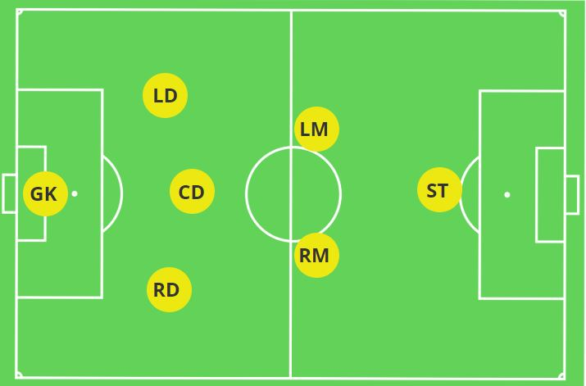

1 – Goalkeeper (GK) – Protects the goal.

Distributes the ball wide and quickly as the first line of attack. Communicates and organizes the defense and the field. Works to create balance in the back field.

3 – Defenders (Left Defender, Central Defender, Right Defender)

Wide Defenders (WD)– Pressure opponents and cover players off the ball to create balance. Play the ball out the back up the field and join the play on Right/Left side of the field on offense as a supporting offender.

Central Defender (CD)– Pressure opponents and cover players off the ball to create balance. Works secondary to the GK to organize the back field and communicates to the midfield on defense. Distributes the ball to penetrate with passing.

2 – Wide Midfielders

Supports both the defense and offense. They penetrate the opponents with dribbling, passing, and shooting. WMs fill the central space between attack and defense taking cues from the CD on defense and both WMs work together to formulate the offensive attack. WMs help to create the width of the field on the attack in this formation.

1 – Striker

Create movement off the ball during transition. Penetrate with dribbling, shooting, and passing. The Striker provides the length of attack in this formation staying high into the opponent’s defense. They defend from the front against opponents’ defenders.

Key Notes:

- This is a strong defensive formation with three strong defenders.
- There is no Central Midfielder, and it is crucial for the Central Defender to step up in central areas when required on the attack.
- The defense gives midfield support providing a possession-based style of play.
- Easy for strong defense to play against more skillful teams who will play with more fluid attacking formations.
- Midfielders must learn to utilize the width of the field but to also be conscious of the center.

1-2-3-1 Hardworking Midfield

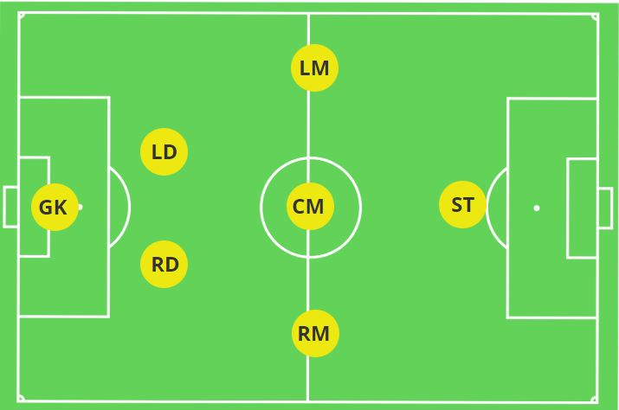

1 – Goalkeeper

Distributes the ball wide and quickly as the first line of attack. Communicates and organizes the defense and the field. Works to create balance in the back field.

2 – Wide Defenders

Pressure opponents and cover players off the ball to create balance. These two defenders are in constant communication with each other and with the GK to create balance in the back field. Often the defender on the opposite side of the ball is covering space and directing the midfield to the back field. Play the ball out the back field and join the offensive play on their respective side of the field on offense as a supporting offender and penetrate through give and go technique.

3 – Midfielders

Three hard-working midfielders offer plenty of support at the back without overloading defensive areas and formulate a strong offense.

The Center Midfielder is the key to transition up field in this formation as they are the link between the defense and offense. The CM is a key playmaker on the offense.

The Wide Midfielders support the defense and are key to stopping the ball prior to the defensive build-out line. As attackers, they create the width of the field using dribbling and passing to penetrate the defense. They create the balance in the offense and find space when off the ball.

1 – Striker

A lone striker is what creates the length of the field. This player stays up high penetrating the opponent’s defense. They are supported by the CM and work with the Right and Left Midfielders to create and find space on attack. The striker’s role in defense is to keep pressure on the opponent’s defense to win the ball back in the front field.

Key Notes:

- Midfielders work extremely hard during this formation, particularly the Central Midfielder. They are non-stop runners on the field.
- The Wide Midfielders are stressed to stay wide.
- Two very strong Defenders that can independently slow down the ball and who work together with the GK to create balance in the backfield. Requires good communication as to NOT create a gap in the center of the back field.
- Strikers need to learn to create space and get open. They must also be the first line of defense in the front field.

1-2-1-2-1 Attack-Minded

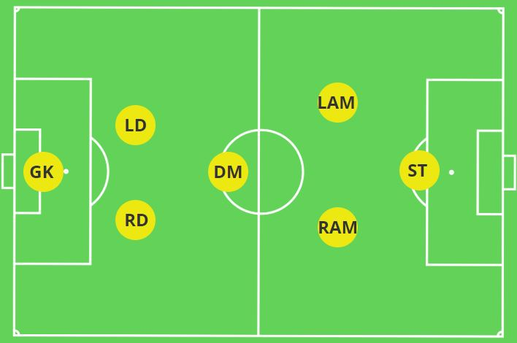

1 – Goalkeeper

Distributes the ball wide and quickly as the first line of attack. Communicates and organizes the defense and the field. Works to create balance in the back field. GKs in this formation can clear the ball long with throws and strong goal kicks to initiate a strong attack from the back field.

2 – Wide Defenders

Pressure opponents and cover players off the ball to create balance. These two defenders are in constant communication with each other and with the GK to create balance in the back field. Often the defender on the opposite side of the ball is covering space and directing the midfield to the back field. Play the ball out the back field and join the offensive play on their respective side of the field on offense as a supporting offender and penetrate through give and go technique.

1 – Defensive Midfielder

The Defensive Midfielder is the key to transition up field in this formation as they are the link between the defense and offense. The DM can cover a lot of ground and has good control of the ball. The DM is a key initial playmaker on the offense and supports their attacking teammates.

2 – Attacking Midfielders

The Attacking Midfielders support the defense especially during transition. As attackers, they must use and create the width of the field using dribbling and passing to penetrate the defense. They create the balance in the offense and find space when off the ball. Along with the DM these attack players can transition the ball quickly on attack and will often catch their opponents in a man down situation such as a 4v3.

1 – Striker

A lone striker is what creates the length of the field. This player stays up high penetrating the opponent’s defense. They are supported by the DM centrally and work with the Attacking Midfielders to create and find space on attack. The striker’s role in defense is to keep pressure on the opponent’s defense to win the ball back in the front field.

Key Notes:

- This is an attack-oriented formation and supports a very fast style of play.
- Defenders must be able to control the backfield and get the ball out quickly to create an off-balance situation for the opposing team.
- Players clearly know their roles as defense-minded or attack-minded and are able to stay in the role.
- Allows for a lot of creativity on the attack.
- Attacking midfielders must continue to play defense in the front field to not create a significant gap on defense between them and the Defensive Midfielder.
- Two very strong Defenders that can independently slow down the ball and who work together with the GK to create balance in the backfield. Requires good communication with the Defensive Midfielder as to NOT create a gap in the center of the back field.
Final Note on 7v7 Formations

The formations noted above and placed in order of team strength and skill. Younger teams will benefit from a Defense-Minded formation and allows for support when skills are weaker as the defense is able to support the attack and the goalkeeper.

As teams get stronger in individual skill and defense along with team communication, teams should be able to progress to the other formations. The Hardworking Midfield is a good transition and requires a lot of physicality amongst the midfield players to be able to continuously run for the duration of play. This may require frequent substitutions in the midfield.

The Attack-Minded formation is a great formation for teams who are confident in their defense, individual skills, and creativity on offense.

Of note, all formations have a good transition to the next level, 9v9 formations. It is recommended that planned formations are not changed during the season as it creates confusion of the players regarding their roles at this early stage of development.

