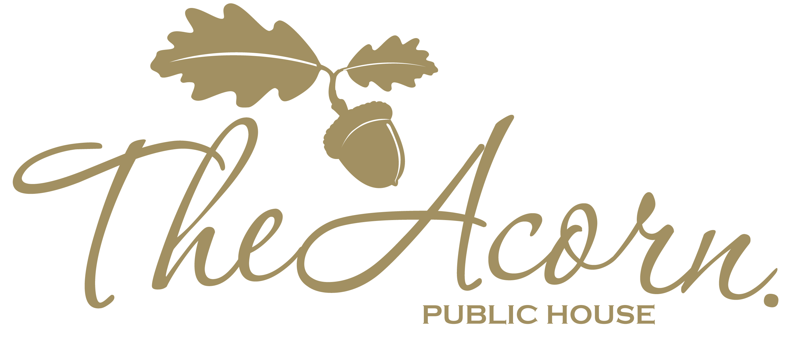
CHILDREN'S MENU
£7.50

Beef Burger
Served with chips and peas, beans or salad.

Chicken Nuggets
Served with chips and peas, beans or salad.

Spaghetti Bolognese
Served with garlic bread and salad.

Sausages
Served with chips and peas, beans or salad.

Macaroni Cheese
Served with garlic bread and salad.

Fish Fingers
Served with chips and peas, beans or salad.

Drink:
Pepsi Max, Diet Pepsi, Lemonade
Orange/Blackcurrant Squash
Or
A Cawston Press Carton for an extra 75p.

Don’t forget to check out our freezer for
Ice Cream and Ice Lollies!

