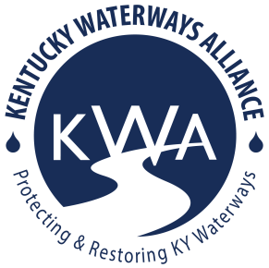
Kentucky Waterways Alliance
2027-2029 Watershed Grant Application

Thank you for your interest! To apply for KWA’s Watershed Grant Program, complete, in full, the following form. Please follow this format and do not rearrange information. Note the maximum word count for each question. We strongly suggest that you refer to the Grant Guidelines here: https://www.kwalliance.org/watershed-grants for additional, important information. *Grant reviewers may not have previous knowledge of your organization, watershed, or project so write your responses as though you are explaining to someone for the first time.
Contact laura@kwalliance.org for any additional questions or support.

1. Applicant

Organization Name:

Organization Contact Name:

Is organization a 501c3? Yes/no:

If no, what is the 501c3 organization that is fiscally sponsoring your group?

EIN number:

Address:

Contact phone:

Contact e-mail address:

What is applicant organization's annual operating budget? (Priority will be given to organizations below $750,000)

Organization mission & brief history (300 words):

2. Focus Waterway

- Name of major river basin (if known – see 7 major river basin map below or ask!):

- Project location (name of stream, river or lake, etc.): (Please attach or include a map of the focus area, if possible.)

- Is this project part of a more comprehensive plan for improving the watershed? Please explain. (300 word limit)

3. Project Details

- Project title:

- Describe project activities (400 word limit). Note: IF you have a design element as part of your project, describe the expertise you will utilize to make this possible (project partner, a consultant, a volunteer, etc).

- Include an expected project timeline for project activities on the milestone chart below, keeping in mind the reporting deadlines and KWN Summit info (if applicable) included in the grant guidelines. Don’t forget to include design in your milestone timeline, if applicable. Add more rows if necessary.
Milestone | Expected start | Expected completion

4. List project partner organizations or agencies (name and contact information), if applicable. Include roles of partners if applicable (300 word limit).

5. Nonpoint Source Pollution

- How will your project prevent or address nonpoint source pollution? What aspects of the watershed and its water quality do you plan to improve (600 word limit)?

- Do you have any documentation of impacts on the water quality in the project location (i.e. photographs, reports, stream sampling results, etc.)? Send attachments if applicable (400 word limit).

6. Project Budget & Grant Request

- Is this project part of a larger project? If yes, include total budget, who the other funders are and if the funding is already secured. If no, continue to the next question (7b).

- Total amount requested from KWA Seed Grants (up to $4,500): ___________

- Please use the chart below for a detailed budget of project expenditures. See more info at Section 319 Resources – General Guidance – 319 Ineligible Expenses

**Don’t forget: you can write in travel cost assistance to attend KWA’s annual KY Watershed Network Summit into your grant request for up to $250 per year/Summit (up to $500 for both Summits during this grant project period). We would love to see you at the Summit and share your project with other watershed stewards across KY!
Line Item | Budget

- Project Budget narrative: for each line item in the chart, include a brief description of the cost below.

7. When thinking about KWA’s mission to protect, restore, and celebrate waterways of Kentucky, please provide a brief description (100 words or less each) of how, if at all, your project will impact Kentucky Waterways through the lens of:
- Protect

- Restore

- Celebrate

Please e-mail your completed application and supporting documents to laura@kwalliance.org. Deadline to submit: November 4, 2026 at 11:59pm. *Hard deadline. There will not be an extension.

Contact Laura Gregory, KWA’s Watershed Program Director (laura@kwalliance.org), with questions about the application process or project requirements and opportunities.

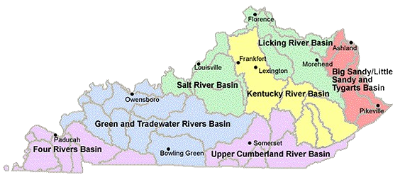

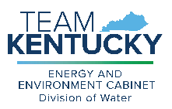

This work was funded in part by a grant from the U.S. Environmental Protection Agency under §319(h) of the Clean Water Act.

