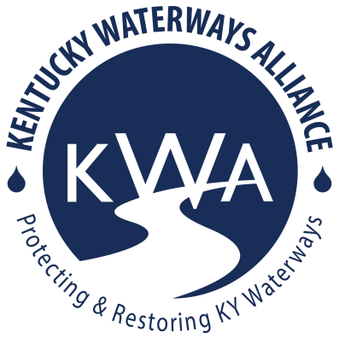
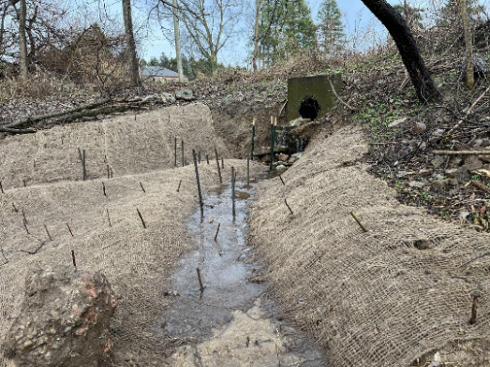
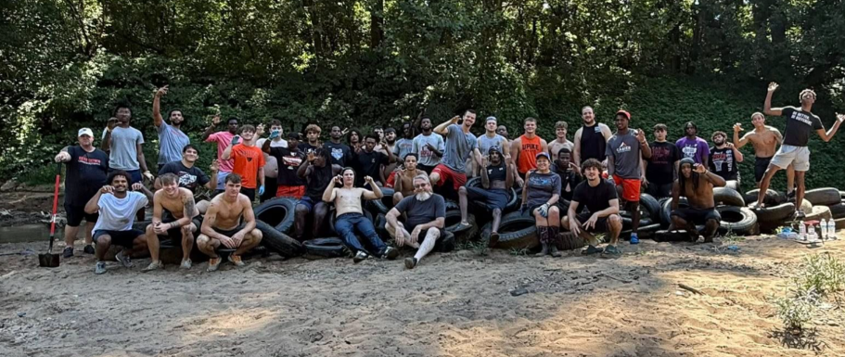
KWA 2026-2028 Watershed Grants Guidelines
Kentucky Waterways Alliance (KWA) is excited to announce the 2026-2028 Watershed Grants program. This initiative offers seed funding to support organizations committed to protecting and restoring Kentucky’s rivers, streams, and watersheds across all seven major river basins. KWA’s goal is to fund one grant award to at least one project in each of Kentucky’s seven major river basins.

Projects must address nonpoint source (NPS) pollution, which comes from dispersed, indirect sources rather than a single, identifiable point. Unlike point source pollution—where contaminants are discharged from a specific location such as a pipe, well, or boat—NPS pollution occurs when rainfall or snowmelt moves across the land, picking up natural and human-made pollutants before depositing them into lakes, rivers, wetlands, and groundwater (EPA). Common sources of NPS pollution include pathogens from human and animal waste, excess sediment from erosion, and excess nutrients from poor land and waste management techniques. Other contributors include livestock in streams, failing septic systems, and eroding streambanks. As these pollutants accumulate, they degrade water quality, harming aquatic ecosystems and threatening our drinking water supply.
KWA grant funding can support stream cleanups, tree plantings, educational signage, educational water festivals, water quality sampling, rain gardens, rain barrels, and many more beneficial activities and best management practices. These are examples but by no means an exhaustive list.
If you are interested in addressing NPS Pollution in your area, please consider applying for this grant opportunity:
- ALL communities are encouraged to apply.
- Eligible to any organization (nonprofit, alliance, fiscally sponsored, etc.) with a NPS pollution-related project and an annual operating budget of $700,000 or below. For-profit businesses are not eligible for KWA grant funds.
- Funding amounts up to $4,500 per project – In some circumstances KWA may only award partial funding.
- Requests must align with the EPA’s guidelines that prohibit the following ineligible expenses:
  - Developing or purchasing promotional materials (t-shirts, bumper stickers, mugs, etc.)
  - Food, beverage, alcohol
  - Entertainment at an event (bounce house, bands/music, etc.)
  - Research, faculty salaries, and development of college credit courses or tuition
  - See more info at Section 319 Resources – General Guidance – 319 Ineligible Expenses
- If you are a state or basin wide organization, at least 1 local letter of support should be included with the application.
- 50% of funds will be distributed upon project award agreement, 25% at mid-project report with supporting documentation submission and approval, and 25% upon project completion and final report and supporting documentation submission and approval.
- Funds can be applied to approved project expenses incurred during project timeline from February 2026 (once grant agreement is complete) until February 2028. Project activities that occur outside of the grant term, including prior to the completion of a signed grant agreement between KWA and its grantee, are ineligible for funding under this award.
- Project completion timeframe
  - 11/6/25 12:00-1:00pm EST optional virtual grant info session – sign up here
  - 11/20/25 6:30-7:30pm EST optional virtual grant info session – sign up here
  - 12/15/25 grant applications due to Laura@kwalliance.org by 11:59pm
  - February 2026 grant awards announced, grant agreements signed, and awards distribution.
  - March 31, 2027 COB mid-project report and supporting documents due on or before.
  - Final project report and supporting documents due 30 days after project completion, and no later than COB March 30, 2028
  - Please note: projects must meet or be earlier than these deadlines.
KWA encourages, but does not require, all applicants and awarded organizations to attend the KWA’s Annual Kentucky Watershed Network Summit to share your successes, struggles, ideas with other watershed stewards and leaders from across the commonwealth. The Summit is tentatively scheduled for September 2026 and 2027, locations TBD. You can write in up to $250 for travel cost assistance per year/Summit into your grant request (up to $500 for both Summits during this grant project period)!
Grant applications can be found by visiting: https://www.kwalliance.org/watershed-grants. Applicants are strongly encouraged to contact Laura Gregory directly to discuss your project or join KWA’s optional virtual seed grant workshops.
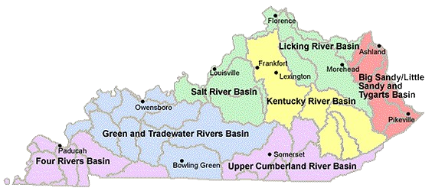
Questions? Please contact Laura Gregory, Kentucky Waterways Alliance’s Watershed Program Director, at laura@kwalliance.org

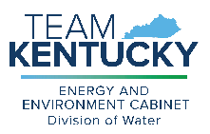

This work was funded in part by a grant from the U.S. Environmental Protection Agency under §319(h) of the Clean Water Act.

