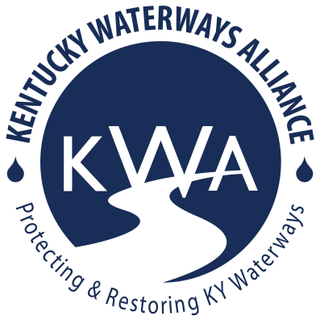
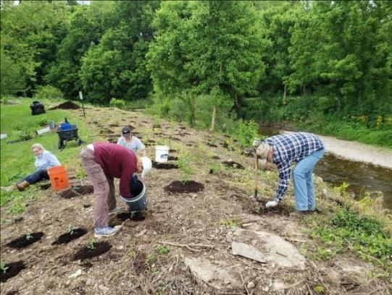
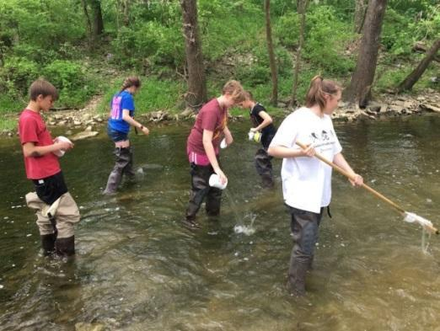
KWA 2025-2027 Watershed Grants Guidelines
Kentucky Waterways Alliance (KWA) is excited to announce the 2025-2027 Watershed Grants program. This initiative offers seed funding to support organizations committed to protecting and restoring Kentucky’s rivers, streams, and watersheds across all seven major river basins. Funding will be awarded to at least one project in each basin.

Projects must address nonpoint source (NPS) pollution, which comes from dispersed, indirect sources rather than a single, identifiable point. Unlike point source pollution—where contaminants are discharged from a specific location such as a pipe, well, or boat—NPS pollution occurs when rainfall or snowmelt moves across the land, picking up natural and human-made pollutants before depositing them into lakes, rivers, wetlands, and groundwater (EPA). Common sources of NPS pollution include oil and gas runoff from roads and driveways, lawn fertilizers, agricultural pesticides, soap from car washes, and sediment from construction sites. Other contributors include livestock in streams, failing septic systems, and eroding streambanks. As these pollutants accumulate, they degrade water quality, harming aquatic ecosystems and threatening our drinking water supply.
KWA grant funding can support stream cleanups, tree plantings, educational signage, water festivals, water quality sampling, rain gardens, rain barrels, and many more beneficial activities and best management practices. These are examples but by no means an exhaustive list.
KWA is committed to supporting and empowering underserved communities as well as advancing environmental justice. Environmental justice (EJ) is the fair treatment and meaningful involvement of all people regardless of race, color, national origin, or income with respect to the development, implementation and enforcement of environmental laws, regulations and policies.
If you are interested in addressing NPS Pollution in your area, please consider applying for this grant opportunity:
- ALL communities are encouraged to apply.
- Eligible to any organization (nonprofit, alliance, fiscally sponsored, etc) with an NPS pollution-related project and an annual operating budget of $700,000 or below.
- Funding amounts up to $3,000 per project – In some circumstances KWA may only award partial funding.
- Requests must align with the EPA’s guidelines that prohibit the following ineligible expenses:
  - Developing or purchasing promotional materials (t-shirts, bumper stickers, mugs, etc)
  - Food, beverage, alcohol
  - Entertainment at an event (bounce house, bands/music, etc)
  - Research, faculty salaries, and development of college credit courses or tuition
  - See more info at Section 319 Resources – General Guidance – 319 Ineligible Expenses
- 50% of funds will be distributed upon project award agreement, 25% at mid-project report, and 25% upon project completion and final report submission.
- Funds can be applied to approved project expenses incurred during project timeline from May 2025 (once grant agreement is complete) until April 29, 2027. Project activities that occur outside of the grant term, including prior to the completion of a signed grant agreement between KWA and its grantee, are ineligible for funding under this award.
- Project completion timeframe
  - 3/13/25 6:30-7:30pm EST optional virtual grant info session – sign up here
  - 3/18/25 12:30-1:30pm EST optional virtual grant info session – sign up here
  - 4/8/25 grant applications due to Laura@kwalliance.org by 11:59pm
  - May 2025 grant awards announced
  - May 2025 awards distribution
  - Mid-project report due on or before April 30, 2026.
  - Final project report due one month after project completion, and no later than COB April 29, 2027
  - Please note: projects must meet or be earlier than these deadlines
KWA encourages (not required) all applicants and awarded organizations to attend the KWA’s Annual Kentucky Watershed Network Summit to share your successes, struggles, ideas, and learn with and from watershed stewards and leaders from across the commonwealth. The Summit is tentatively scheduled for October 2025 in Louisville and a similar time in 2026. 2026 Summit location TBD. You can write a travel stipend into your grant request!
Grant application can be found by visiting: https://www.kwalliance.org/watershed-grants. Applicants are strongly encouraged to contact Laura Gregory to discuss your project or you can join KWA’s optional virtual seed grant workshop.
Questions? Please contact Laura Gregory, Kentucky Waterways Alliance’s Watershed Program Director, at laura@kwalliance.org

