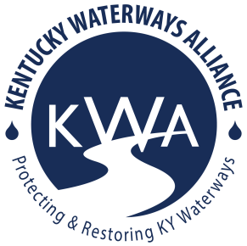
Kentucky Waterways Alliance
2025-2027 Watershed Grant Application

Thank you for your interest! To apply for KWA’s Watershed Grant Program, complete the following form. Please follow this format and do not rearrange information. Note the maximum word count for each question. Refer to the Grant Guidelines here: https://www.kwalliance.org/watershed-grants for more information or contact laura@kwalliance.org.

1. Applicant

Organization Name:

Organization Contact Name:

Is organization a 501c3? Yes/no:

If no, is applicant organization fiscally sponsored? Yes/no:

EIN number:

Address:

Contact phone:

Contact e-mail address:

Is the applicant organization's annual operating budget $700,000 or less? Yes/No

Organization mission & brief history (300 words):

2. Focus Waterway

- Name of major river basin (if known – see 7 major river basin map below or ask!):

- Project location (name of stream, river or lake, etc): (Please attach or include a map of the focus area, if possible.)

- Is this project part of a more comprehensive plan for improving the watershed (300 word limit)?

3. Project Details

- Project title:

- Describe project activities (400 word limit):

- Include an expected project timeline for project activities on the milestone chart below. Add more rows if necessary.
Milestone | Expected start | Expected completion

4. List project partner organizations or agencies (name and contact information), if applicable. Include roles of partners if applicable (300 word limit).

5. Nonpoint Source Pollution

- How will your project prevent or address nonpoint source pollution? What aspects of the watershed and its water quality do you plan to improve (600 word limit)?

- Do you have any documentation of impacts on the water quality in the project location (i.e. photographs, reports, stream sampling results, etc)? Send attachments if applicable (400 word limit).

6. How does your project focus on environmental justice? You may use census tract data to support your argument about demographics and populations that your project serves. See our description of environmental justice here. (300 word limit).

7. Project Budget & Grant Request

- Is this project part of a larger project? If yes, include total budget, who the other funders are and if the funding is already secured. If no, continue to the next question (7b).

- Total amount requested from KWA Seed Grants (up to $3,000):

- Please use the chart below for a detailed budget of project expenditures.
**Don’t forget: you can write in travel cost to attend KWA’s annual KY Watershed Network Summit into your grant request.
Line Item | Budget

- Project Budget narrative: for each line item in the chart, include a brief description of the cost below.

Please e-mail your completed application and supporting documents to laura@kwalliance.org. Deadline to submit: April 15, 2025 at 11:59pm.

Contact Laura Gregory with questions about the application process or project requirements and opportunities:

Laura Gregory, Watershed Program Director
Kentucky Waterways Alliance
E-Mail: laura@kwalliance.org

