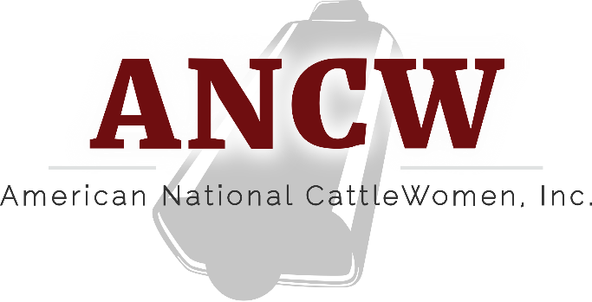
Region IV Meeting
Eureka Springs, AR
May 4, 2024

The Region IV meeting was called to order by Cheyenne Sparks.
Suzanne Menges of CKP gave a sponsor update.
Nikki Weston gave an ANCW update.
Elections were held and nominations were taken from the floor for the open positions.
Region Director nominees were Cheyenne Sparks and Linda Thorman. Ballets were given and counted. Linda Thorman was voted the new Region IV Director.
Budget committee nominations were taken with Kathy Ferguson as the nominee. Debbie Gill moved to cease nominations, 2nd by Geniece McCall. Kathy Ferguson is the Budget Committee Region IV representative.
PR Committee nominations were taken with Emily Haubner as the nominee. Debbie Gill moved to cease nominations, 2nd by Linda Thorman. Emily Haubner is the PR Committee Region IV representative.
Ways & Means committee nominations were taken with Debbie Powers as the nominee. Debbie Gill moved to cease nominations, 2nd by Cheyenne Sparks. Debbie Powers is the Ways & Means Committee Region IV representative.
Membership committee nominations were taken with Pam Bothe as the nominee. Debbie Gill moved to cease nominations, 2nd by Debbie Powers. Pam Bothe is the Membership Committee Region IV representative.

